Project Report
On
Automatic Accident Detection and Rescue Management System


Submitted
In partial fulfilment
For the award of Degree of
PG Diploma in Embedded Systems and Design
(PG-DESD)
(C-DAC, ACTS (Pune))

Guided By: Submitted By:
Mr. Bhupendra Pratap Singh Abhishek Fartade (230340130001)
Ankita Singh (230340130009)
Gaikwad Atul Jalindar (230340130019)
Jadhav Abhishek Devidas (230340130020)
Riya Soni (230340130043)
Centre for Development of Advanced Computing (C-DAC), ACTS (Pune- 411008)

Acknowledgement

This is to acknowledge our indebtedness to our Project Guide, Mr. Bhupendra Pratap Singh C-DAC ACTS, Pune for his constant guidance and helpful suggestion for preparing this project Automatic Accident Detection and Rescue Management System.

We express our deep gratitude towards him for his inspiration, personal involvement, constructive criticism that she provided us along with technical guidance during the course of this project.

We take this opportunity to thank Program head Ms. X and Head of the department Mr. X for providing us such a great infrastructure and environment for our overall development.

We express sincere thanks to Ms. X, Process Owner, for their kind cooperation and extendible support towards the completion of our project.
It is our great pleasure in expressing sincere and deep gratitude towards Ms. X (Course Coordinator, PG-DESD) for their valuable guidance and constant support throughout this work and help to pursue additional studies.

Also our warm thanks to C-DAC ACTS Pune, which provided us this opportunity to carryout, this prestigious Project and enhance our learning in various technical fields.

Abhishek Fartade (230340130001)
Ankita Singh (230340130009)
Gaikwad Atul Jalindar (230340130019)
Jadhav Abhishek Devidas (230340130020)
Riya Soni (230340130043)

Abstract

Table of Contents

S. No | Title | Page No.
 | Front Page Acknowledgement Abstract  Table of Contents | I  II III  IV
1  1.1  1.2 | Introduction  Introduction  Objective and Specifications | 5  x
2 | Literature Review | x
3 | Methodology/ Techniques
3.1 | Approach and Methodology/ Techniques | x
3.2 | x Preparation | x
3.3 | x Description | x
4 | Implementation
4.1 | Implementation | x
4.2 | Flow Chart of Application | x
5 | Results
5.1 | Results | x
6 | Conclusion
6.1 | Conclusion | x
7 | References
7.1 | References | x

Introduction

1.1 Introduction

The constant improvement of technology, population and economy is leading to expansion of human civilization in search of better prospects. As expected an implosion of transportation system is observed and managed everyday. These increment in number of vehicles on road, air or sea result in increased chance of vehicular accidents [1][2].

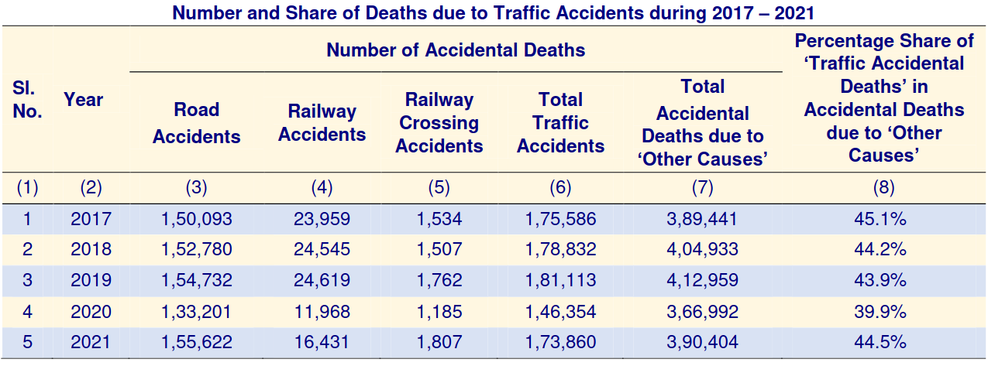
Figure 1 Rise of accidents according to National Crime Records Bureau of India

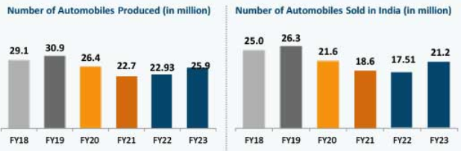
Figure 2 Rise in vehicles in India according to India Brand Equity Foundation

The accidents must be reported immediately in order to provide quick and proper medical assistance. There is also rise in unreported accidents and undocumented amount of property damage [3].

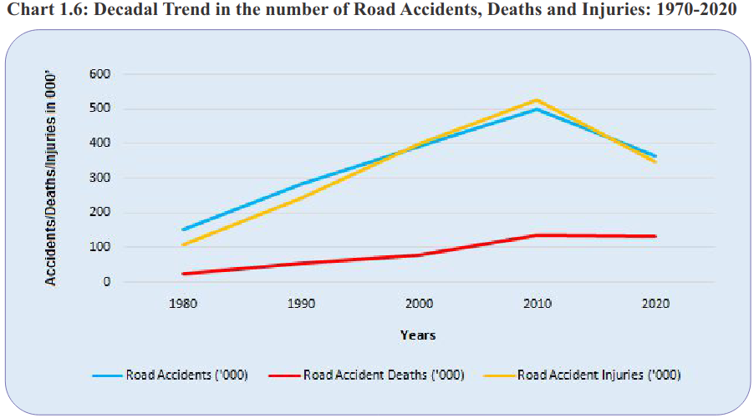
Figure 3 Rise in vehicular accident related deaths according to Ministry of Road Transport and Highways

1.2 Objective and specification

Objective:
The objective of our project are:
1. Detect accident as quickly as possible.
2. Have minimum false detection.
3. Immediately message current location and call for help.

Specification:
Components: 1x ESP32-WROOM-32
1x MPU-6050
1x SIM900A
1x HCSR-04
1x BH1750
1x Buzzer
1x Display
1x Piezoelectric crystal

OS: FreeRTOS

Protocol: MQTT
UART

Literature Review

[1]https://ncrb.gov.in/sites/default/files/ADSI-2021/adsi2021_Chapter-1A-Traffic-Accidents.pdf :
This Report states record of rise of accidents by to National Crime Records Bureau of India. There is increment in recorded number of vehicular accidents as years pass, 2020 being outlier due to COVID-19 pandemic

[2] https://www.ibef.org/uploads/industry/Infrographics/large/automobile-infographic-may-2023.pdf
This report records rise in vehicles sales in India according to India Brand Equity Foundation. There exists a constant rise in number

[3] https://morth.nic.in/sites/default/files/RA_2021_Compressed.pdf

Methodology/Techniques

3.1 Approach and Methodology/ Techniques

3.2 x preparation

3.3 x preparation

Implementation

4.1 Implementation

4.2 Flow Chart Of Application

Results

5.1 Results

Conclusion

6. Conclusion

References

7.1 References

[1] https://ncrb.gov.in/sites/default/files/ADSI-2021/adsi2021_Chapter-1A-Traffic-Accidents.pdf

[2] https://www.ibef.org/uploads/industry/Infrographics/large/automobile-infographic-may-2023.pdf

[3] https://morth.nic.in/sites/default/files/RA_2021_Compressed.pdf

