**Project Report**

On

**Automatic Accident Detection and Rescue Management System**

*Submitted*

*In partial fulfilment*

*For the award of Degree of*

**PG Diploma in Embedded Systems and Design**

**(PG-DESD)**

**(C-DAC, ACTS (Pune))**

**Guided By: Submitted By:**

**Mr. Bhupendra Pratap Singh Abhishek Fartade (230340130001)**

**Ankita Singh (230340130009)**

**Gaikwad Atul Jalindar (230340130019)**

**Jadhav Abhishek Devidas (230340130020)**

**Riya Soni (230340130043)**

**Centre for Development of Advanced Computing (C-DAC), ACTS (Pune- 411008)**

## **Acknowledgement**

This is to acknowledge our indebtedness to our Project Guide, **Mr. Bhupendra Pratap Singh** C-DAC ACTS, Pune for his constant guidance and helpful suggestion for preparing this project **Automatic Accident Detection and Rescue Management System**.

We express our deep gratitude towards him for his inspiration, personal involvement, constructive criticism that she provided us along with technical guidance during the course of this project.

We take this opportunity to thank Program head **Ms. X** and Head of the department **Mr. X** for providing us such a great infrastructure and environment for our overall development.

We express sincere thanks to **Ms. X**, Process Owner, for their kind cooperation and extendible support towards the completion of our project.

It is our great pleasure in expressing sincere and deep gratitude towards **Ms. X** (Course Coordinator, PG-DESD) for their valuable guidance and constant support throughout this work and help to pursue additional studies.

Also our warm thanks to C-DAC ACTS Pune, which provided us this opportunity to carryout, this prestigious Project and enhance our learning in various technical fields.

**Abhishek Fartade (230340130001)**

**Ankita Singh (230340130009)**

**Gaikwad Atul Jalindar (230340130019)**

**Jadhav Abhishek Devidas (230340130020)**

**Riya Soni (230340130043)**

## **Abstract**

## **Table of Contents**

| **S. No** | **Title** | **Page No.** |
| --- | --- | --- |
|  | **Front Page Acknowledgement Abstract**  **Table of Contents** | **I**  **II III**  **IV** |
| **1**  **1.1**  **1.2** | **Introduction**  Introduction  Objective and Specifications | **5**  **x** |
| **2** | **Literature Review** | **x** |
| **3** | **Methodology/ Techniques** |  |
| **3.1** | Approach and Methodology/ Techniques | **x** |
| **3.2** | x Preparation | **x** |
| **3.3** | x Description | **x** |
| **4** | **Implementation** |  |
| **4.1** | Implementation | **x** |
| **4.2** | Flow Chart of Application | **x** |
| **5** | **Results** |  |
| **5.1** | Results | **x** |
| **6** | **Conclusion** |  |
| **6.1** | Conclusion | **x** |
| **7** | **References** |  |
| **7.1** | References | **x** |

## **Introduction**

**1.1 Introduction**

The constant improvement of technology, population and economy is leading to expansion of human civilization in search of better prospects. As expected an implosion of transportation system is observed and managed everyday. These increment in number of vehicles on road, air or sea result in increased chance of vehicular accidents [1][2].

Figure 1 Rise of accidents according to National Crime Records Bureau of India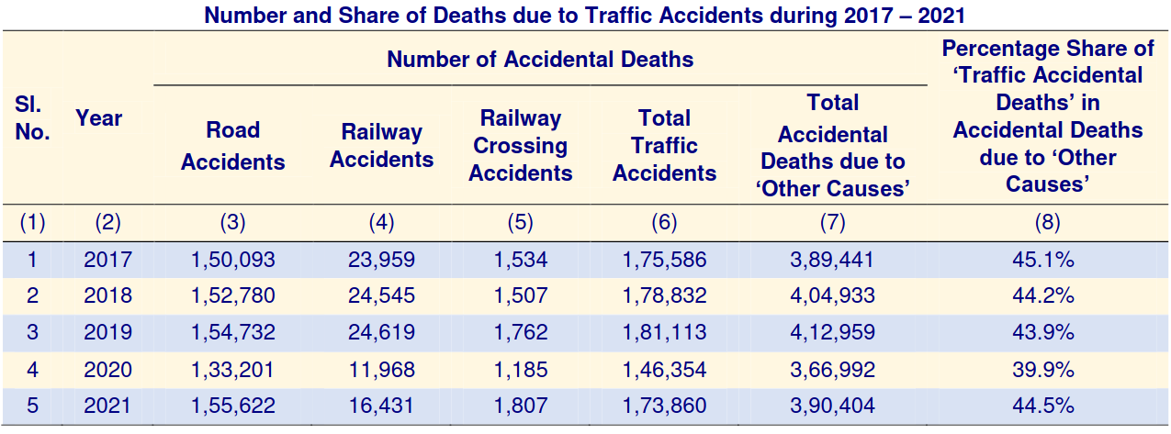

Figure 2 Rise in vehicles in India according to India Brand Equity Foundation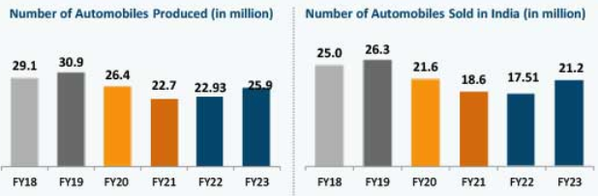

The accidents must be reported immediately in order to provide quick and proper medical assistance. There is also a rise in unreported accidents and undocumented amounts of property damage [3].

Figure 3 Rise in vehicular accident related deaths according to Ministry of Road Transport and Highways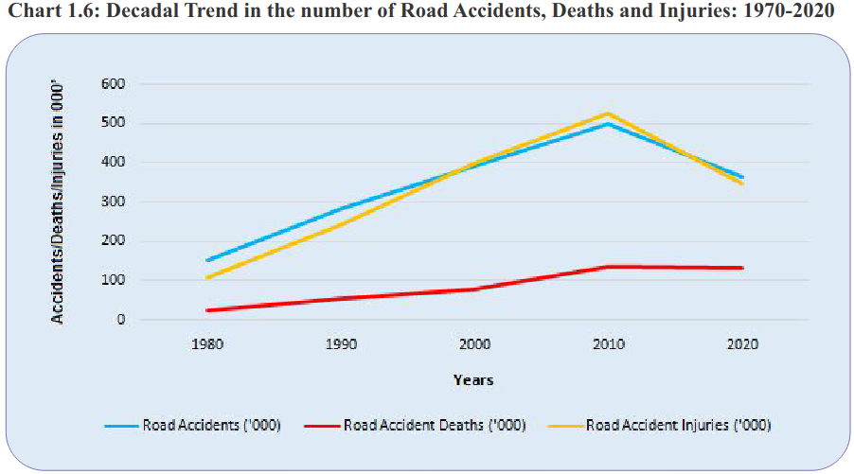

**1.2 Objective and specification**

**Objective:**

The objective of our project are:

1. Detect accidents as quickly as possible.

2. Have minimum false detection.

3. Immediately message the current location and call for help.

**Specification:**

Components: 1x ESP32-WROOM-32

1x MPU-6050

1x SIM900A

1x HCSR-04

1x BH1750

1x Buzzer

1x Display

1x Piezoelectric crystal

OS: FreeRTOS

Protocol: MQTT

UART

**Literature Review**

[1]https://ncrb.gov.in/sites/default/files/ADSI-2021/adsi2021_Chapter-1A-Traffic-Accidents.pdf :

This Report states the record of rise of accidents by National Crime Records Bureau of India. There is increment in recorded number of vehicular accidents as years pass, 2020 being outlier due to COVID-19 pandemic

[2] https://www.ibef.org/uploads/industry/Infrographics/large/automobile-infographic-may-2023.pdf

This report records rise in vehicles sales in India according to India Brand Equity Foundation. There exists a constant rise in number

[3] https://morth.nic.in/sites/default/files/RA_2021_Compressed.pdf

**Methodology/Techniques**

**3.1 Approach and Methodology/ Techniques**

**3.2 x preparation**

**3.3 x preparation**

**Implementation**

**4.1 Implementation**

**4.2 Flow Chart Of Application**

**Results**

**5.1 Results**

**Conclusion**

**6. Conclusion**

**References**

**7.1 References**

[1] https://ncrb.gov.in/sites/default/files/ADSI-2021/adsi2021_Chapter-1A-Traffic-Accidents.pdf

[2] https://www.ibef.org/uploads/industry/Infrographics/large/automobile-infographic-may-2023.pdf

[3] https://morth.nic.in/sites/default/files/RA_2021_Compressed.pdf