Homework 5 Journal

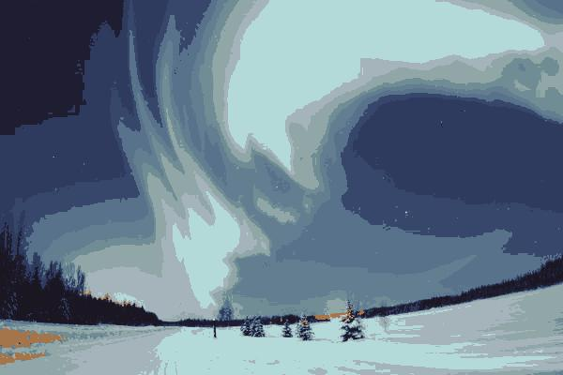

Figure 1: polarlights.jpg with 20 clusters and kmeans initialization.

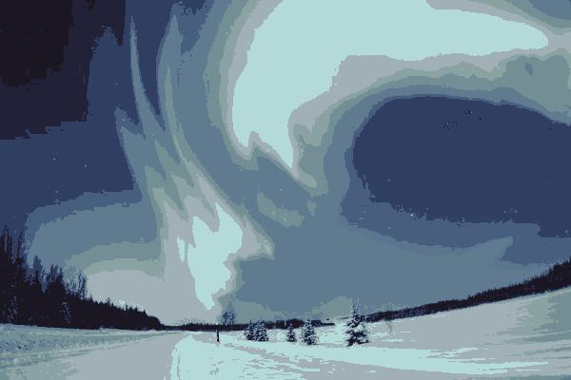

Figure 2: polarlights.jpg with 20 clusters and random initialization.

The two figures above show the difference between the EM algorithm with kmeans initialization and without kmeans initialization. The kmeans initialized clustering was run for two iterations with random initialized centers, whereas the no kmeans image clustering just used random sampling of image pixels as the initial cluster centers. The distinguishing feature between both output images is that the kmeans initialized image was able to capture colors in the orange range shown in the bottom left hand corner. The no kmeans initialized image only had shades and colors ranging from blue to black. Kmeans helps the EM algorithm capture the most distinct colors in the image by moving at least one center towards pixels of farthest distances—in this case orange. In the case of randomly sampling pixels from the image, most of the cluster centers will be the same shade and color as the majority of the image. The EM algorithm will continue to pull these centers towards colors that have the most frequency in the image.