Homework 8 Report

**Part 1**

Accuracy Over 2000 Steps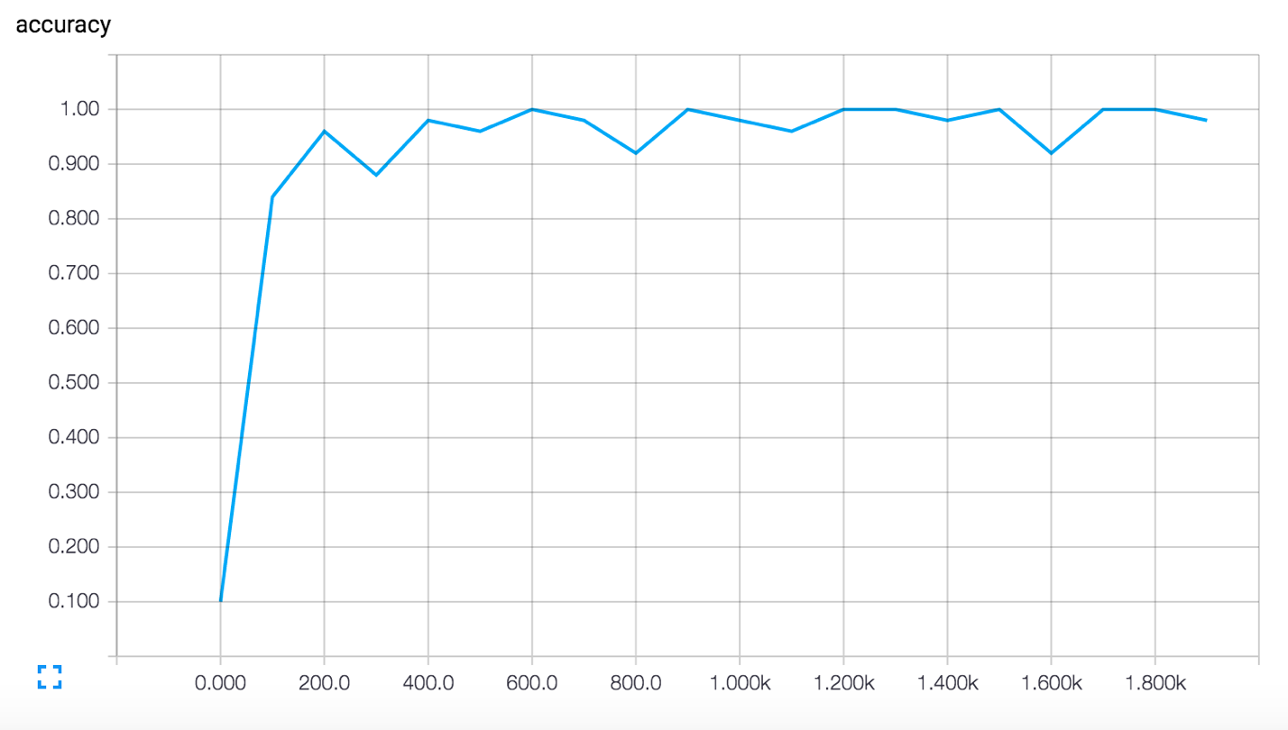

**Part 2**

Accuracy Over 2000 Steps

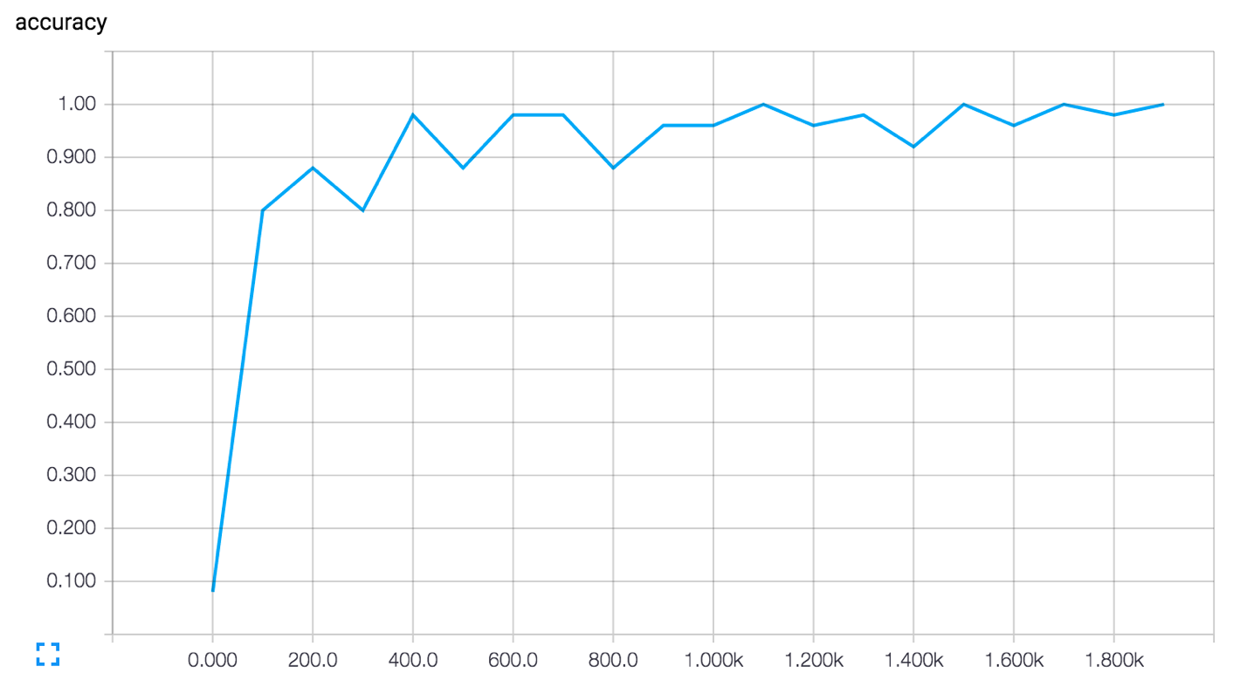

Revisions and Changes

The figure below is a comparison of the two graphs for part 1 and part 2. I added another convolutional neural network, got rid of the pooling layers, and reduced the outputs of several layers. For example, my first convolutional layer outputs 16 dimensions, my second convolutional layer outputs 32 dimensions, and my third convolutional layer outputs 64 dimensions. The revised neural network performed similarly to the neural network in part 1 at about a 99.1-99.4% evaluation accuracy.

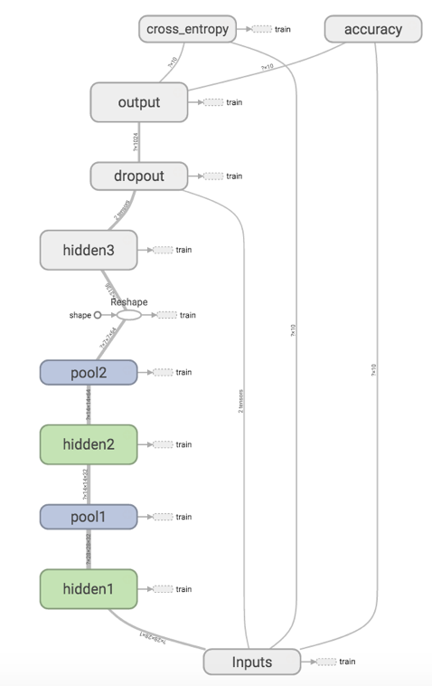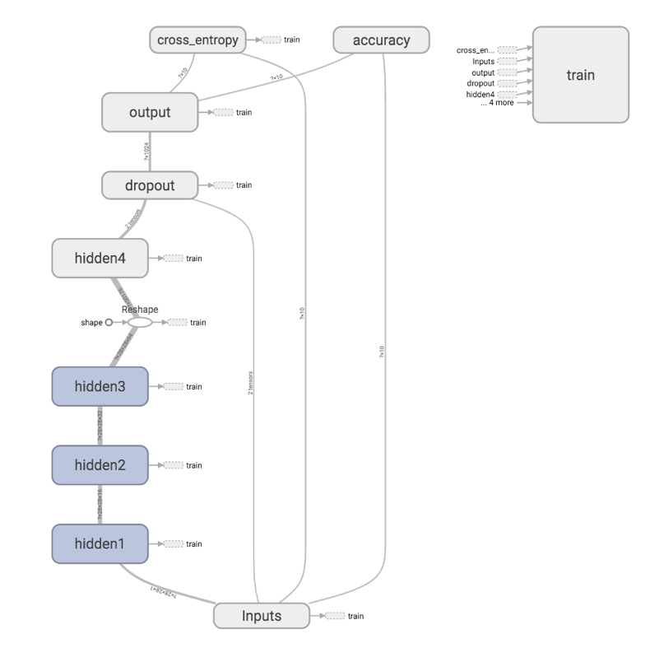

The graph on the left is the Expert Mnist Tutorial tensorflow graph whereas the graph on the right is my modified convolutional neural network for part 2.

**Part 3**

Accuracy Over 20000 Steps

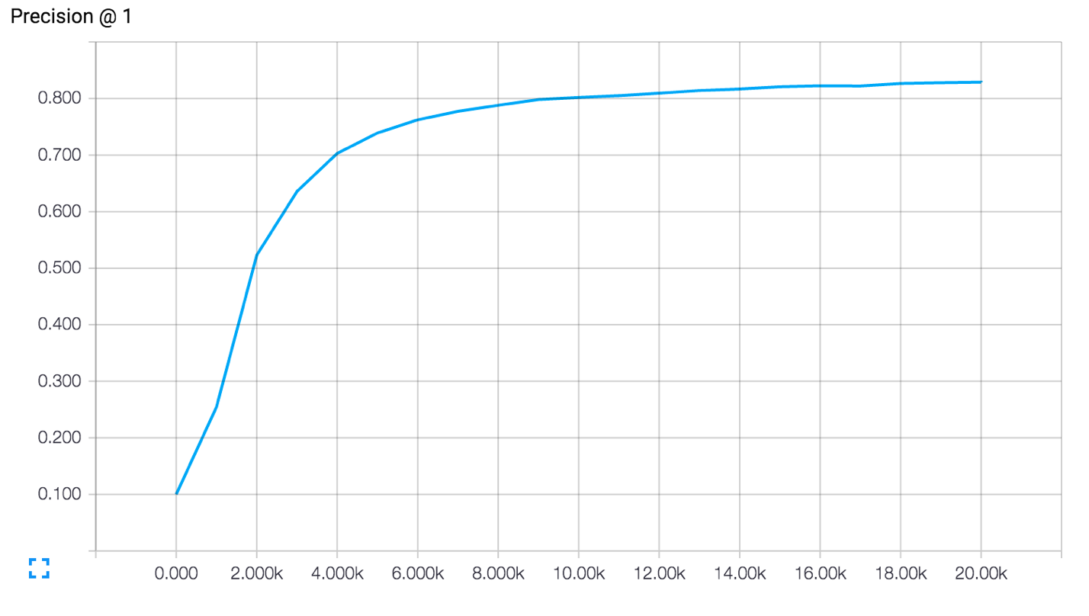

**Part 4**

Accuracy Over 20000 Steps

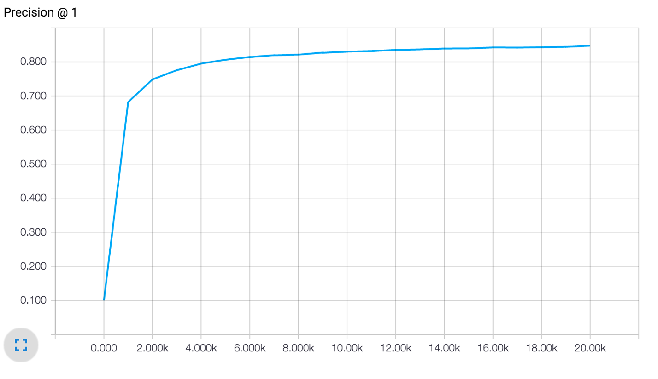

Revisions and Changes

For my revised neural network, I implemented batch normalization with learned parameters representing the scale and shift of the layer output. I also added another convolutional layer to the network in order to increase the overall accuracy. The results were that the model seemed to train much faster as seen by the higher convergence rate in the accuracy graph for part 4 in comparison to part 3. The overall part 4 accuracy at the end of 20,000 training steps was also greater by 1 to 2% than the overall part 3 accuracy.

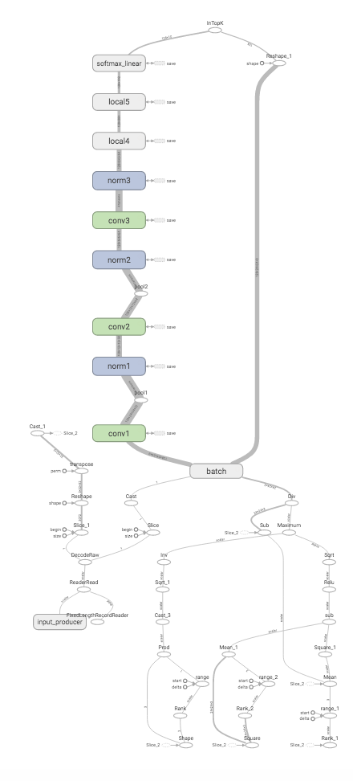

The figure above shows the revised neural network for part 4. Notice that norm1, norm2, and norm3 are batch normalized not local response normalized.