1. Test to see if CURL is working from your command line

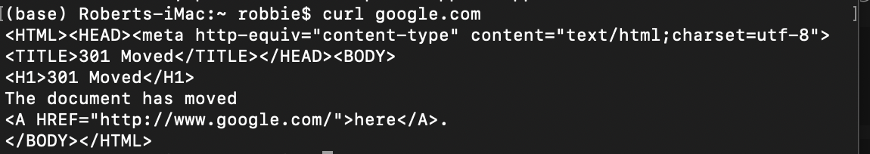

1. Check this by using the -I option

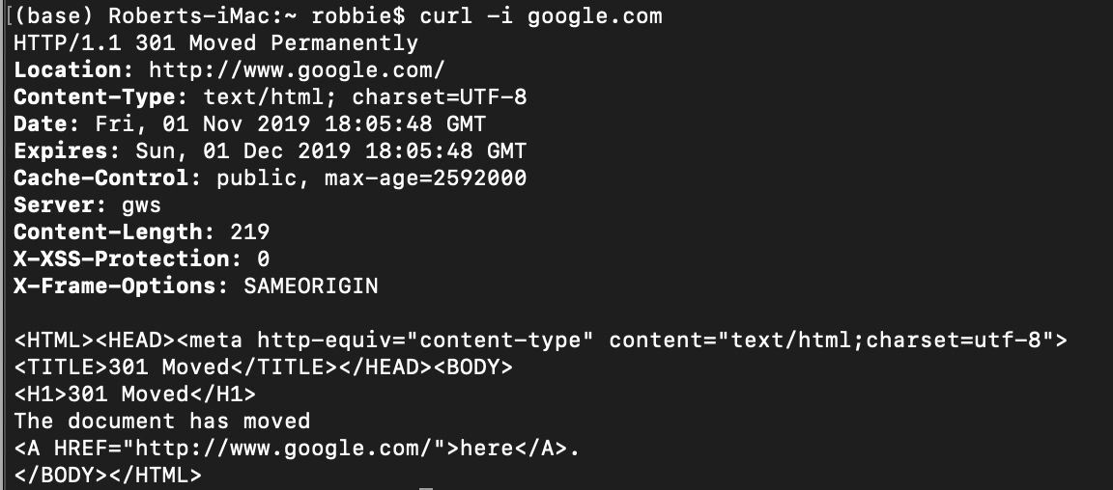

1. Look at the website <http://dummy.restapiexample.com/>
   1. What would the curl command be to view all the employees?

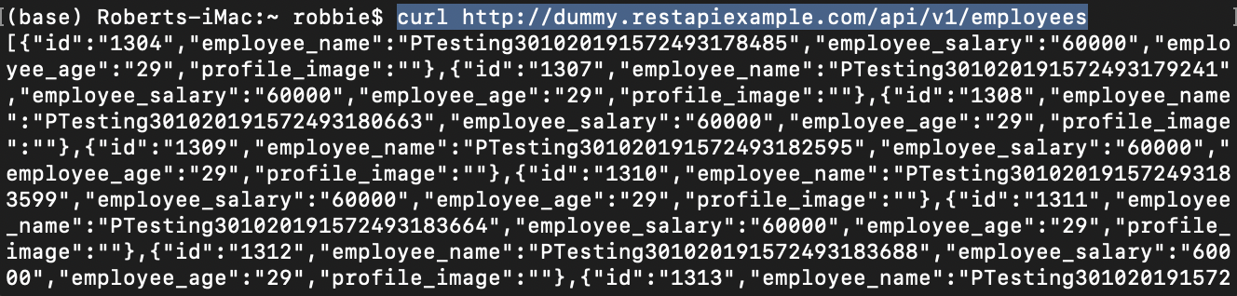

… etc …

* 1. What would the curl command be to view employee 2202?



1. For the same website how would you use curl to delete an employee



1. For the same website, how would you use curl to create an employee, you may need to make the employees name unique.
   1. Mac

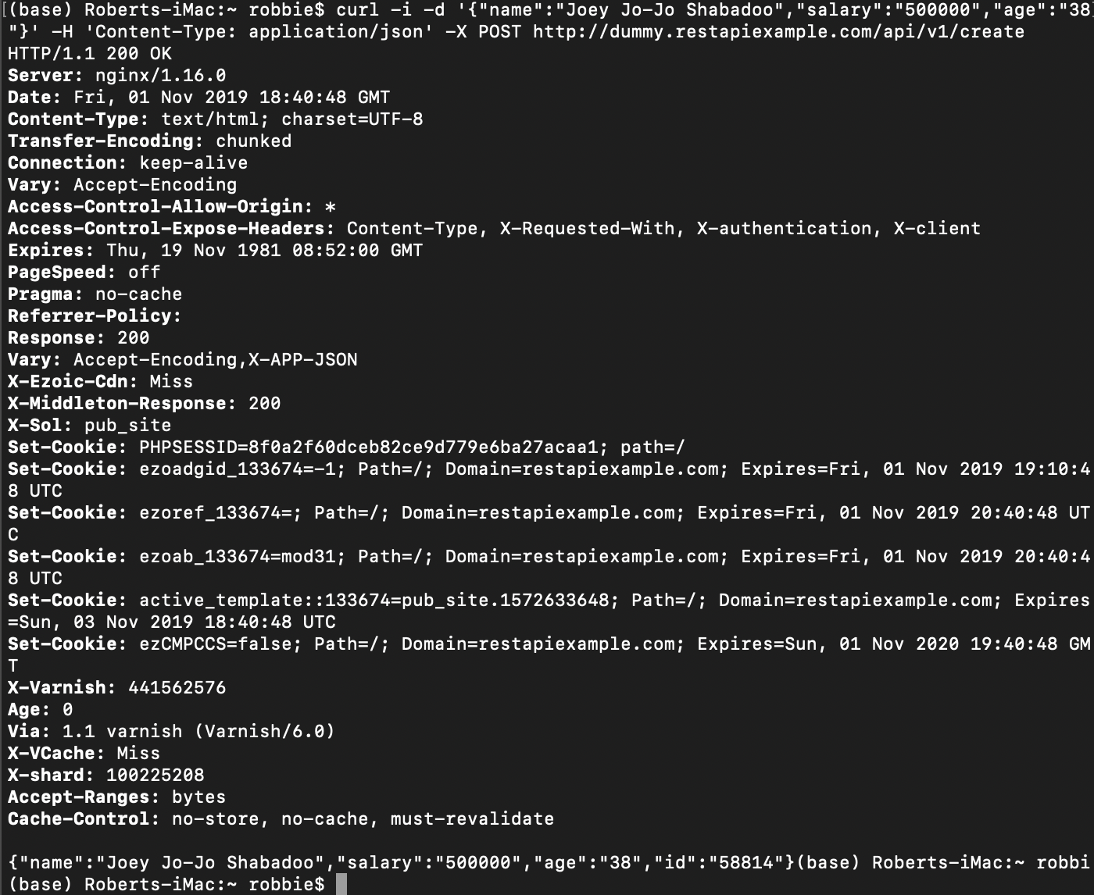

* 1. Windows (windows only has “ (not’) so the data needs to be between “ “ and all the inverted commas in the JSON need to be escaped \”.)



1. For the same website, how would you use curl to update an employee
   1. Mac

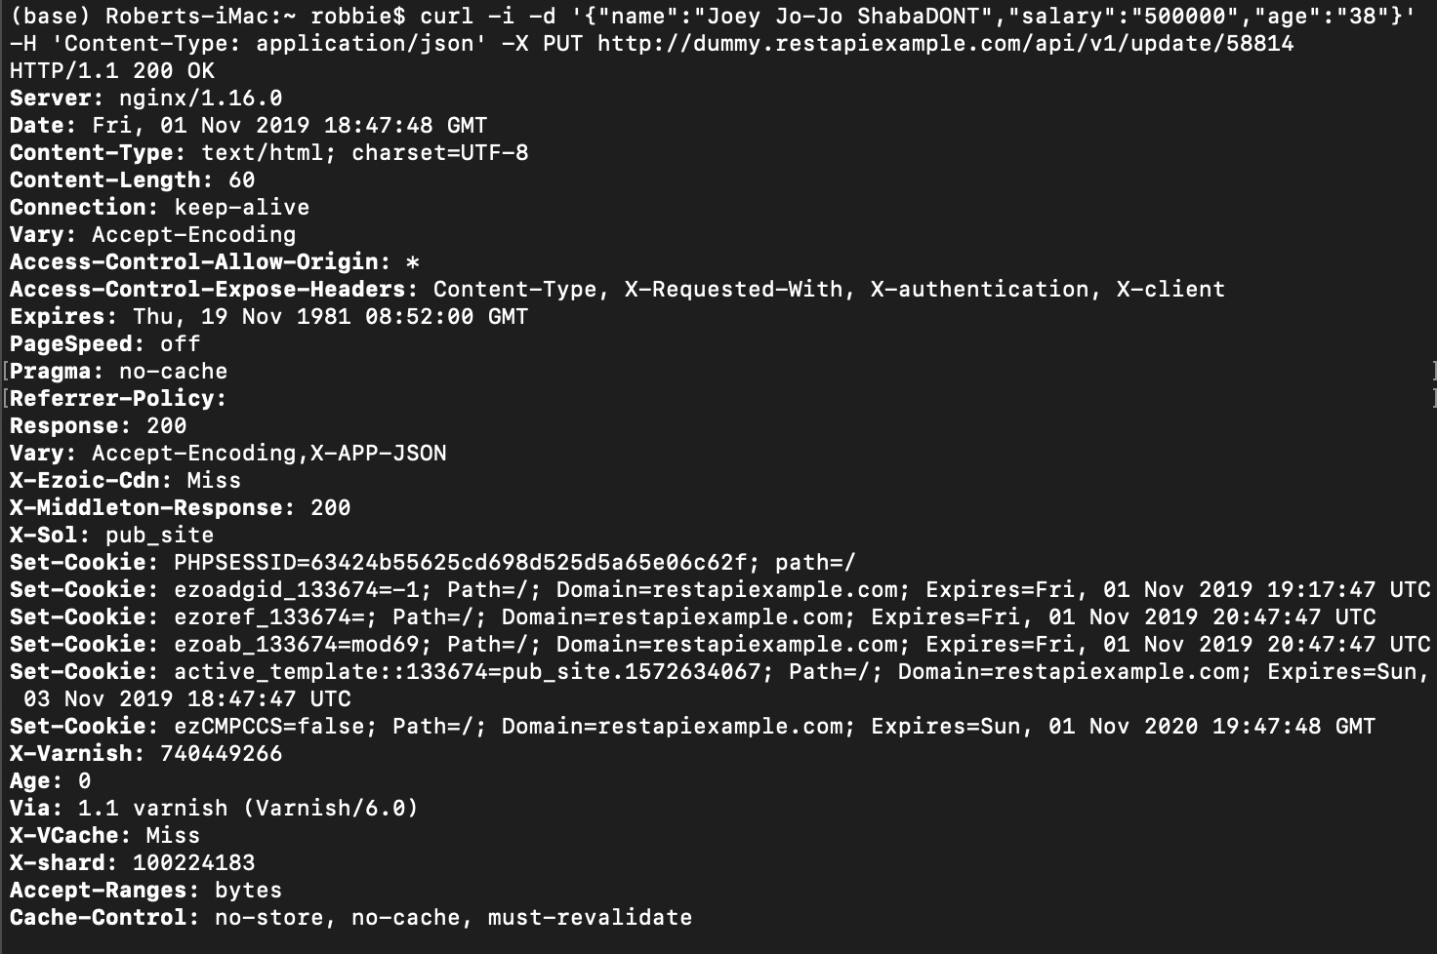

* 1. Windows

