1. Create a table in mysql called student that has three columns (id, firstname, age), id will be auto_increment
   1. Open a mysql console
   2. When you login to mysql you are not in any particular database to see the databases use the command

* 1. To create a database

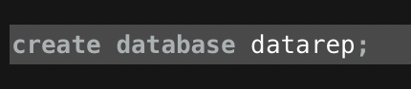



* 1. To use a database

* 1. Create the table in the database with the command

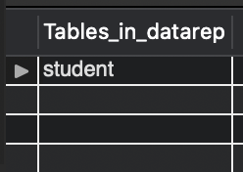

insert data

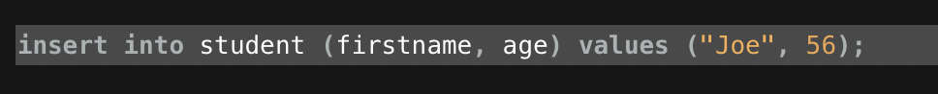





view data

Updata data

Delete





Make sure you do not forget the semi colon (;) if you are stuck in the middle of a command use ctrl-c

1. Make a table called book that has 4 columns (id, title, author, price) and insert some data into it.

1. Look at the tables in phpmyadmin.