Title: Assignment 2

PROG8850 Database Automation

Workflow and Pipline Screenshots:

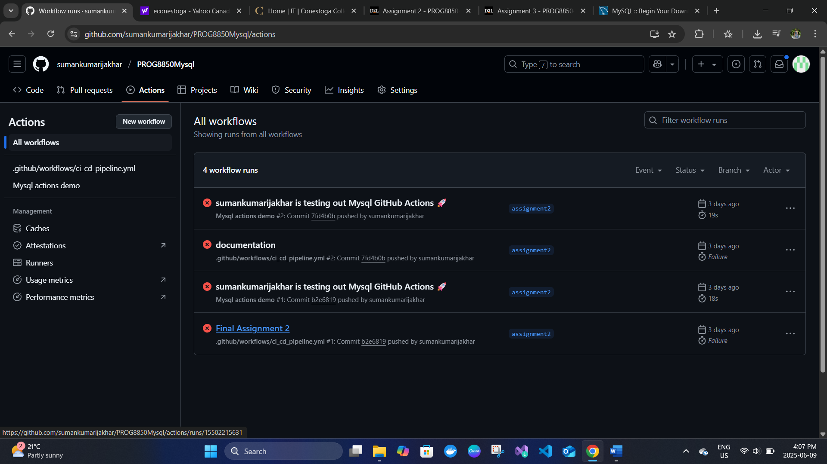
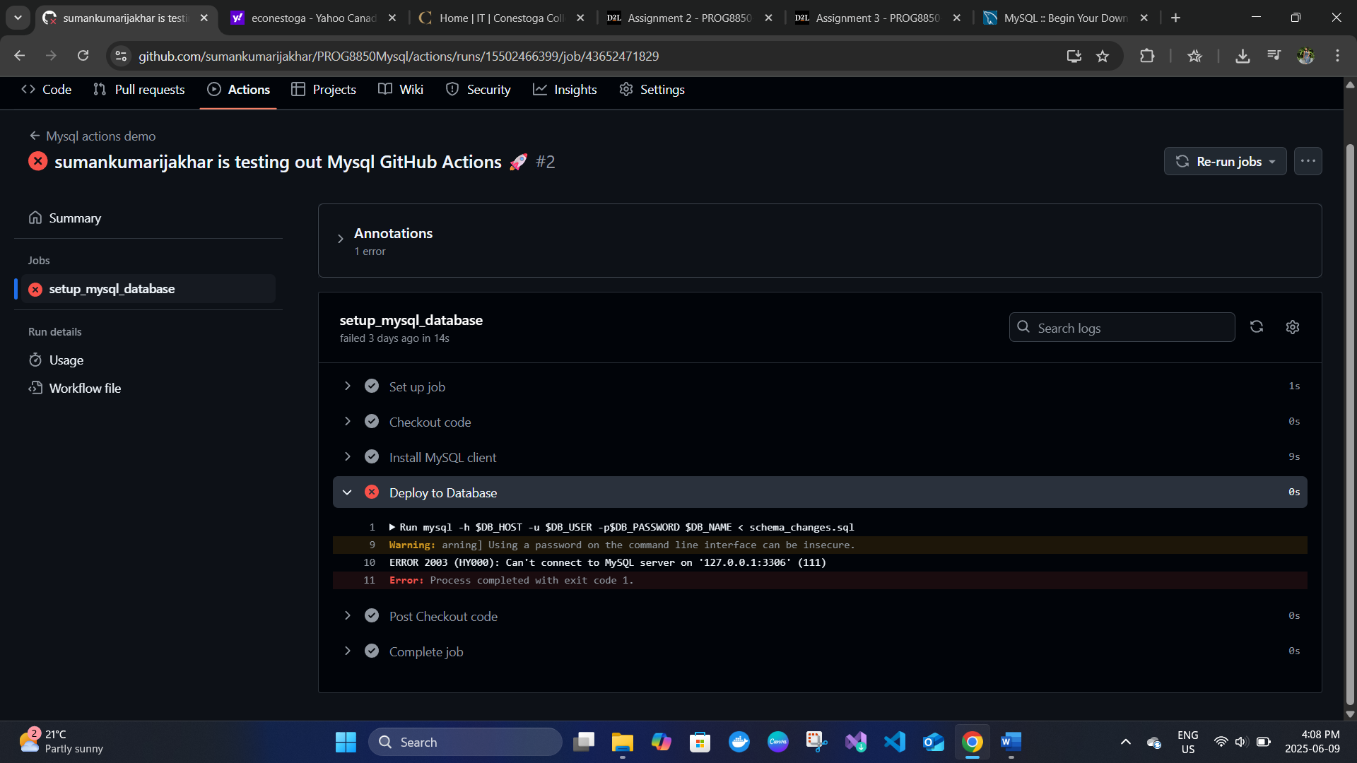
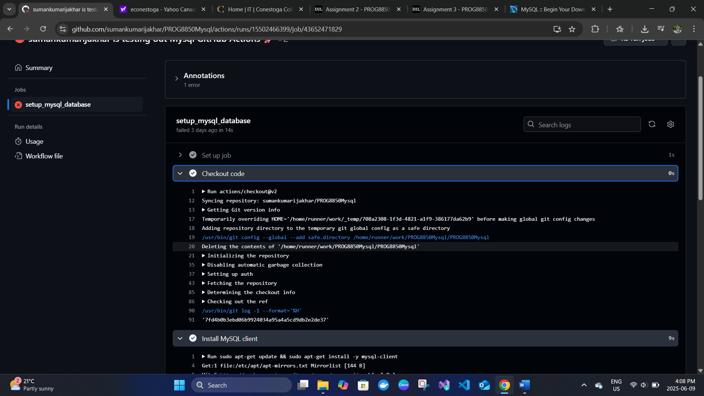
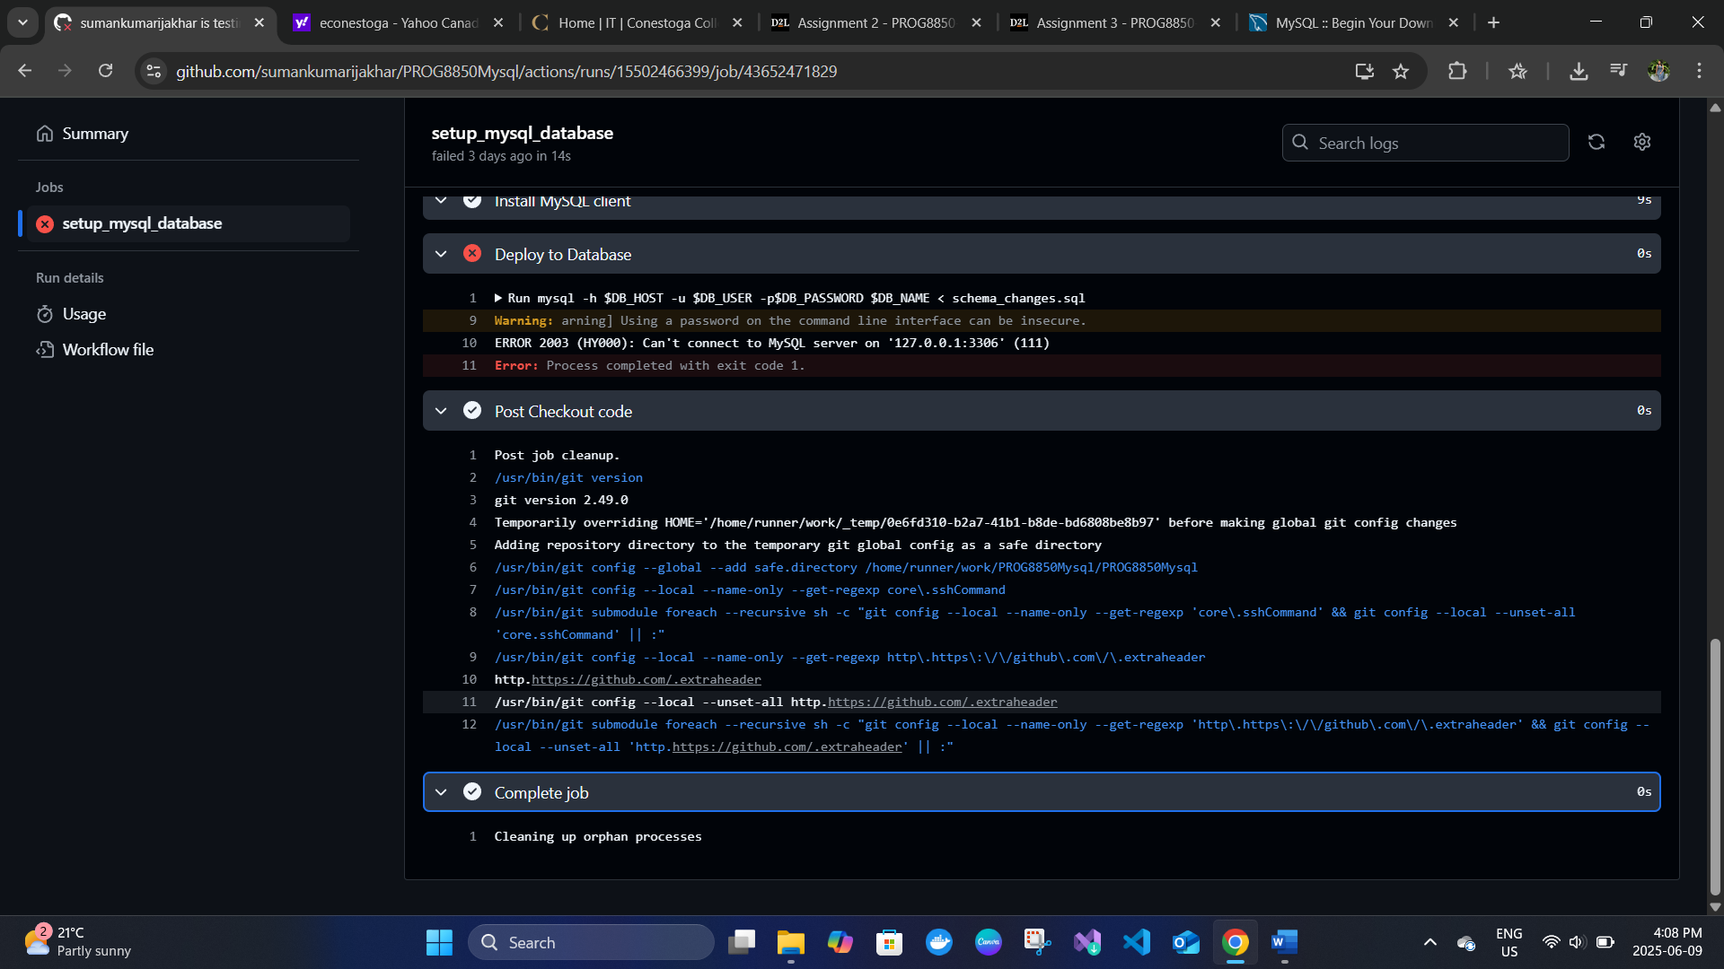

References
- GitHub Actions
- Azure MySQL
- mysql-connector-python

