Dietrich Boles

University of Oldenburg (Germany)

Droidfoot

–

Porting Greenfoot-Scenarios to Android Devices

Version 2.0 (modified slightly to work with Android Studio)

1 Introduction

Greenfoot ( www.greenfoot.org) is an interactive Java development environment that has been developed primarily for educational purposes. It allows for the easy development of two-dimensional graphical applications such as simulations and games. Programs developed with Greenfoot (called scenarios) can be run as JavaSE applications on the PC as well as in web browsers in form of java applets.X

Droidfoot (http://www.programmierkurs-java.de/droidfoot) is a project that makes it possible to run Greenfoot scenarios as Android apps on Android devices. Droidfoot consists of the Greenfoot class library that has been ported to Android, as well as a player with which the scenarios can be run on the Android device. Currently Android 4.0 and up is supported.X

1.1 Changes in version 2.0 compared with version 1.0

Compared with version 1.0 there are the following changes in version 2.0 of Droidfoot:

Greenfoot class GreenfootSound has been implemented (see chapter 2.6).

Greenfoot class UserInfo has been implemented (see chapter 2.7).

Now the rotation of actors is incorporated in the implementation of the collision detection methods.

Now it is possible to configure the Android Greenfoot Player (see chapter 5.4).

The examples have slightly been modified (see chapter 4).

Structure oft he manual

In this document the changes of the Android Greenfoot class library in contrast to the original Greenfoot class library are described in Section 2. Chapter 3 introduces the basic structure and handling of the Android Greenfoot player. Chapter 4 is devoted to the installation of Droidfoot if you want to implement your own Greenfoot scenarios as Android apps. Finally, Chapter 5 presents the basic procedure to implement already finished Greenfoot scenarios as Android apps.

2 Greenfoot class library for Android

The Greenfoot class library consists of the following classes:

Actor

Greenfoot

GreenfootImage

GreenfootSound

MouseInfo

UserInfo

World

In version 2.0 of Droidfoot all classes are supported.

The JavaSE package jawa.awt is not accessible in Android. In exchange for that package a package greenfoot.awt has been defined, which implements substitute classes Color and Font.

2.1 Greenfoot

The following methods of class Greenfoot are not supported by Droidfoot:

getMicLevel

getKey

isKeyDown

mouseMoved

mouseClicked

The method mousePressed returns true due to a touch event.

2.2 World

The methods with class java.awt.Color in their signature are adapted to class greenfoot.awt.Color.

Defining your own world class please note

that you have to implement a constructor without parameters and

that you have to call one of the setBackground methods in each constructor.

2.3 Actor

Defining an actor class please note

that you have to call one of the setImage methods in each constructor.

GreenfootImage

The following methods of class GreenfootImage are not supported by Droidfoot:

drawShape

fillShape

The methods with class java.awt.Color or class java.awt.Font in their signature are adapted to class greenfoot.awt.Color and greenfoot.awt.Font.

The return type of method getAwtImage is android.graphics.Bitmap.

2.5 MouseInfo

All methods of class MouseInfo are supported by Droidfoot. However, Droidfoot does not support double clicks. So method getClickCount will always return 1.

2.6 GreenfootSound

All methods of class GreenfootSound are supported by Droidfoot. The implementation is done using the Android media player, so all audio formats which are supported by the Android media player are supported by Droidfoot too (see http://developer.android.com/guide/appendix/media-formats.html).X

2.7 UserInfo

All methods of class UserInfo are supported by Droidfoot. The storage and management of data is not done on a server but locally on the Android device, so it behaves like executing a scenario in Greenfoot itself. The user name can be changed in the Android Greenfoot player using the menu item "settings". The method isStorageAvailable returns false if and only if the user name is empty.

2.8 Class greenfoot.awt.Color

Class greenfoot.awt.Color is a substitute of class java.awt.Color. The class defines nearly the same methods as class java.awt.Color.

In Android color information are stored in an int value (see class android.graphics.Color). The methods getColor and getRGB return that value.

2.9 Class greenfoot.awt.Font

Class greenfoot.awt.Font is a substitute of class java.awt.Font. Fonts are represented differently in Android and in JavaSE-AWT. Internally the new class represents fonts by an instance of class android.graphics.Typespace and an int value for the font size.

Please be careful if you use class greenfoot.awt.Font. If you use fonts excessively in your Greenfoot scenarios you should consider converting your implementation to class android.graphics.Typespace and use the corresponding constructor of class greenfoot.awt.Font.
3 Greenfoot player for Android

The Android Greenfoot player requires an Android device with Android 4.0 and up. Reason for that is the usage of the Android action bar (see http://developer.android.com/guide/topics/ui/actionbar.html).X

In the action bar the buttons (run, pause, reset, …) and the speed slider are placed.

The following figure shows the structure and design of the Android Greenfoot player.
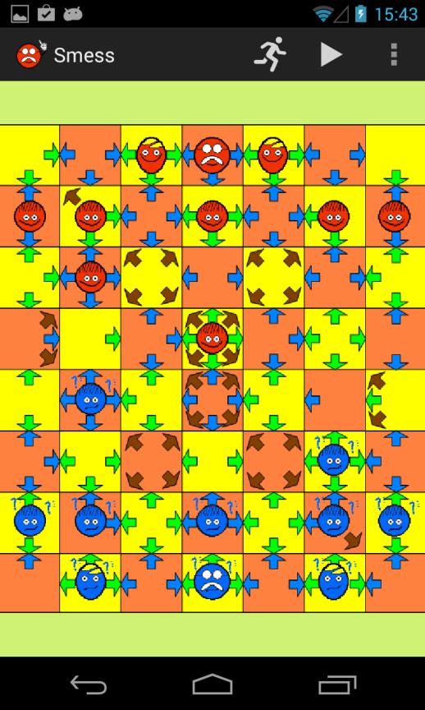

The whole screen is reserved for displaying the Greenfoot world. In the action bar above the controls are placed. In the left of the action bar you can see the app icon and the app name. In the right of the action bar or in the overflow area the action buttons and action items are located. The following actions exist if not configured otherwise (see chapter 5.4):

Speed (runner symbol): By touching the runner button a slider appears which can be used to change the speed of the Greenfoot scenario. By touching the app icon the slider disappears.

Start/Pause (start/pause symbol): By touching the start/pause button you can start or pause the Greenfoot scenario (equipollent to the Greenfoot start/pause button)

Reset (reset symbol): By touching the reset button the Greenfoot scenario is resetted (equipollent to the Greenfoot reset button).

Help: By touching the help menu item a web browser with useful information will be opened.

Settings: By touching the settings menu item a screen with the following settings will be opened:

o Scale: If the checkbox is activated the world will always cover the whole screen. If the checkbox is not activated it will be possible that the world only covers a part of the screen.

Screen orientation: The user can choose the screen orientation: always portrait modus, always landscape modus or automatic change between portrait and landscape modus due to device rotations.

Username: Clicking this item a dialogbox will be opened in which the username can be changed.

4 Installation

Prerequisite for the use of Droidfoot is the installation of Eclipse and the Android SDK. Please have a look at the Android Developer website ( http://developer.android.com/sdk/index.html) and follow the instructions given there. It is definitely an advantage if you already have developed an own Android app.X

Download the file droidfoot-2.0.zip from the Droidfoot website and unzip the file. The included directory eclipse-workspace-droidfoot can directly be used as Eclipse workspace. It contains the following projects:

Droidfoot: An Android library project that contains the Android Greenfoot class library und the Android Greenfoot player (inclusive source code und resources). That Android library has to be included in all Android Greenfot projects.

DFTemplate: An Android application project which provides a template for new Android Greenfoot scenarios.

DFBalloons: A sample project which contains an implementation of the well-known Greenfoot balloon scenario.

DFSnake: A sample project which contains an implementation of the well-known snake game (see http://www.greenfoot.org/scenarios/9260). X

DFLights: A sample project which contains an implementation of the well-known lights game (see http://www.greenfoot.org/scenarios/1380). X

DFSmess: A sample project which contains an implementation of a chess like game called smess (see http://www.greenfoot.org/scenarios/354). X

Please start Eclipse and switch to the workspace eclipse-workspace-droidfoot (> File > Switch Workspace)

5 Basic procedure

In this chapter the general procedure porting a Greenfoot scenario to Android is described. Please note the differences between the original and the Android Greenfoot class library (see Chapter 2). For example, the Android Greenfoot class library does not support keyboard input.

5.1 Default way

As an example the porting of a Greenfoot scenario called Snake is used, which implements the well-known snake game.

While still in Greenfoot, change your java world file to use setBackground("cell.jpg"); in the constructor to include its background image.
Also, still within Greenfoot, change your java actor files to use setImage("leaf.gif"); in the constructor to set the actor’s image.
Test, to make sure that the world and actor classes still have images. (This is necessary, because only the java, image and sound files are going to be used in the droidfoot Android version of the project.)
Copy-paste the eclipse android project DFTemplate to a new eclipse project called Snake (in this example).
Open Android studio and import the new eclipse project (Snake in this example) in to a new Android Studio Project.
Open the file strings.xml in folder DFTemplate/src/main/res/values and replace the name DFTemplate by the name of your scenario (e.g. Snake).
Rename the package org.droidfoot.dftemplate in folder src (e.g. org.droidfoot.snake) (> Refactor > Rename).
Rename the file/class DFTemplateActivity in folder src in the package being renamed in step 4 (bspw. SnakeActivity)
Open the file AndroidManifest.xml and rename the package-attribute (second line) corresponding to the renaming in step 4 (e.g. package=“org.droidfoot.snake“ )
Copy the java-files of your Greenfoot scenario into the package being renamed in step 4. Please note that all java-file have to define the corresponding package-statement as the first statement (package org.droidfoot.snake;).
Eliminate all errors in your java-files which can occur due to the differences between the original and the Android Greenfoot class library (see chapter 2).
Open the activity file being renamed in step 5, remove the comment in front the statement in method onCreate and assign the class object of your world class to the variable

DroidfootActivity.worldClass (DroidfootActivity.worldClass = SnakeWorld.class;
Copy the folders images and sounds which contain the images and sounds of your Greenfoot scenario into the folder DFTemplate/src/main/assets.
Run your project by clicking on the green arrow!
Make a signed apk by going to the build menu in Android Studio.
Upload the apk, using google drive, and download it on to your phone.

5.2 Customized launcher icons

By default, the launcher icons of the Android library Droidfoot are used. However, you can use customized icons for your app. You can do that by copying the corresponding icon files (png or gif) into the appropriate drawable-subfolders of the folder res. Please note that the icon files must have the name droidfoot_launcher (with the extension .png or .gif)!

5.3 Customized help file

By default, a page "no help available" appears when the user touches the help menu item in the action bar. However, you can create a customized help page for your Android Greenfoot scenario. Simply create an html-file with the name help.html and place it in the folder res/raw. Following the localization rules of Android you can also place localized help files in the corresponding subfolders of folder res. For example you could place a german help file named help.html in the folder res/raw-de.

5.4 Modifications of the Android Greenfoot players

Since version 2.0 of Droidfoot it is possible to make adjustments to the Android Greenfoot player in a simple manner. For this purpose, certain attributes must be set accordingly in the same activity file where the attribute DroidfootActivity.worldClass has to be set. If you have used the project DFTemplate as a starting point for your project, as described in section 5.1, you can find the following instructions in the activity file:

help item available in the menu (true/false)? Settings.help = true;

speed item and speed slider available in the action bar (true/false)? Settings.speed = true;

background color of the droidfoot activity view Settings.backgroundColor = Color.rgb(207, 241, 116);

scale option available in the settings (true/false)? Settings.scale = true;

if true the world will always cover the whole screen Settings.scaleDefault = true;

orientation option available in the settings (true/false)? Settings.orientation = true;

if LANDSCAPE always landscape modus
if PORTRAIT always portrait modus

if SWITCH automatic change between portrait and landscape modus due
to device rotations

Settings.orientationDefault = Settings.SWITCH; // LANDSCAPE, PORTRAIT, SWITCH

username option available in the settings (true/false)? Settings.username = true;
name for the highscore table

Settings.usernameDefault = "Default";

The following adjustments are possible:

Help: Shall a help symbol be placed into the action bar or its overflow menu (attribute

Settings.help)?

Speed: Shall a speed button respectively a speed slider be placed into the action bar (attribute Settings.speed)? If the user shall not be allowed to change the speed of the scenario, the attribute has to be set to false.

Background color: Via this attribute you can change the background color of the view which contains the Greenfoot world (attribute Settings.backgroundColor).

Scaling: Shall the item Scale be placed into the settings menu (attribute Settings.scale)?

Default value of scaling: Via this attribute you can define if the world shall always cover the whole screen (attribute Settings.scaleDefault)?

Screen orientation: Shall the item Screen orientation be placed into the settings menu (attribute Settings.orientation)?

Default value of screen orientation: Via this attribute you can define the default value of the screen orientation: always portrait modus, always landscape modus or automatic change between portrait and landscape modus due to device rotations (attribute

Settings.orientationDefault)?

Username Shall the item Username be placed into the settings menu (attribute

Settings.username)?

Default value of username: Via this attribute you can define the default value of the username (attribute Settings.usernameDefault)?

Further modifications

Further modifications are possible by performing appropriate modifications in the eclipse project Droidfoot. It should be noted that the implementation of Droidfoot in this first version 2.0 is not very “clean” in the technical sense. That will change in one of the next versions. However, Droidfoot was extensively tested and should not contain major bugs.

6 Contact

If you have questions, problems or suggestions for improvement fell free to contact me: Dietrich Boles, Universität Oldenburg, Email: boles@informatik.uni-oldenburg.deX

The version on github for Android Studio was refreshed very slightly, by Rich Hildred, Wilfrid Laurier University, Brantford, Ontario, Canada, email: rhildred@wlu.caX

Please note the copyright: The Greenfoot copyright is held by Michael Kölling and Poul Henriksen, whilst the Greenfoot system is available under the GNU General Public Licence version 2 with the Classpath Exception.

