# **The Dating Assignment: Part I**

Overview

You've been tasked with setting up a registration system for a brand new online dating website. Registration will set up a new dating profile with many details of a user. Feel free to take creative license with the text and the image. You might create a Pet Dating site or an Alien Dating Site, if you wish!

This assignment will focus on getting your basic infrastructure set up, and utilizing HTML with Bootstrap.

The Application

The user will initially be presented with a home page containing some basic information about services on the website and a clear call to action: "Create a Profile!"

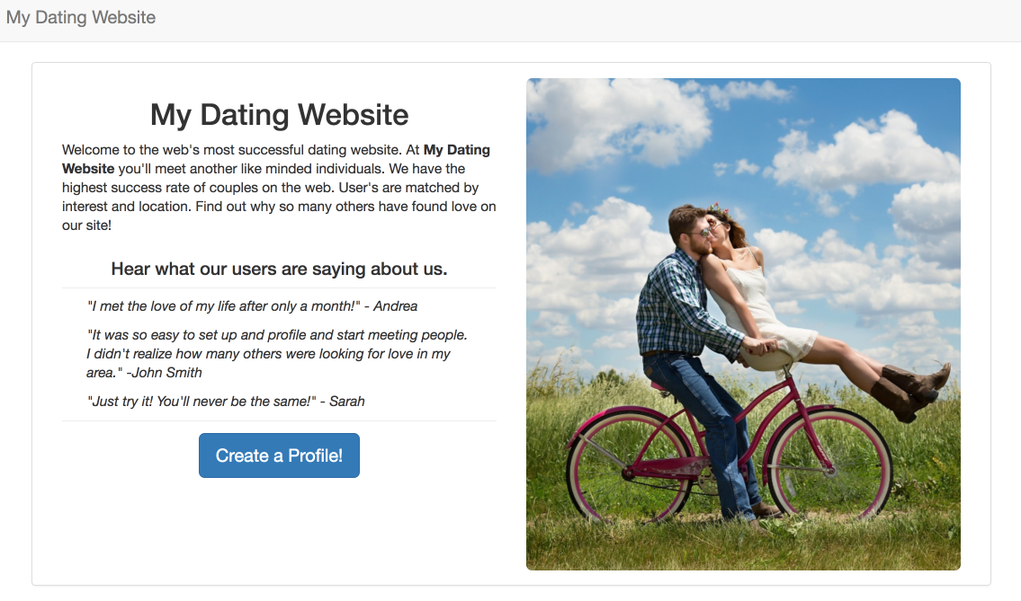

Version Control

Begin by creating a new project in GitHub called ‘dating’. Make sure your project has a readme file. Clone your project to your 328 directory on greenriverdev. Commit frequently, and make sure that your commits have a meaningful comment. You should have a minimum of 5 commits for this assignment.

Directory Structure

Create the foundational files and folders for your project.

1. Inside the dating directory, create directories called **views, images,**and **styles**
2. Upload a home page image to your images directory
3. Create a file called **home.html** in the views directory
4. Create **styles.css** in the styles directory
5. Inside the dating directory, create a **composer.json** file
6. Create an **index.php** page

The end result should look like this:

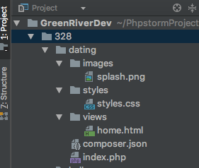

Setting up Fat Free

1. Add the appropriate content to your composer.json file
2. Install composer for your project from a terminal window
3. Define a default route that renders a view **views/home.html**

The Home Page

Utilize Bootstrap to design a home page with the layout shown above. Again, feel free to take creative license with the text and the image. But your layout should match the one shown, including rounded corners on the image and the button, a top nav bar, indented quotes, and lines above and below the quotes.

Coding Conventions

Check that your HTML is valid at <https://html5.validator.nu/>. Ensure a clear separation of HTML, CSS, and JS. Style tags should *not*be embedded in HTML tags. Make sure your page has a title.

Each PHP and HTML file should have a comment header with your name, the date, and a brief file description.

Submission

For this assignment:

1. Submit a link to the URL of your dating site.
2. Copy the URL of your GitHub repository into the comments. You should have a *minimum* of 5 commits.

Be sure to carefully review the Grading Rubric in Canvas before submitting your assignment.