Ex:No: 12

Date:

**TCL COMMANADS**

**Problem 1:**

Rollback to that state using the ROLLBACK command whenever required.

Create a following table Class and insert values into it in the order and create savepoints in between them. Try to rollback t the save point and check your output by giving select commands.

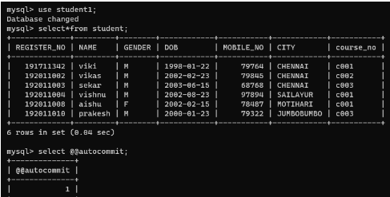

The resultant table will look like,

Now let's use the ROLLBACK command to roll back the state of data to the savepoint B.

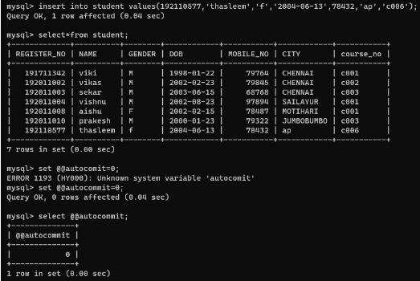

Now our class table will look like,

Now let's again use the ROLLBACK command to roll back the state of data to the savepoint A

