[**【转】80端口被NT kernel & System 占用pid 4**](http://www.cnblogs.com/fzzl/archive/2011/12/23/2298796.html)

转自：<http://www.2cto.com/os/201111/111269.html>

前段时间停止了Apache，结果在打开的时候发现无法打开，80端口被占用，于是win+r 运行cmd

输入netstat -ano

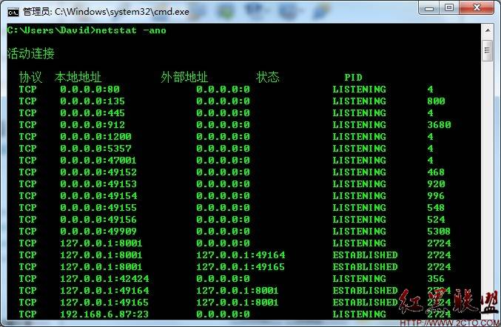

可以看到80端口被PID4占用，于是打开任务管理器-进程-查看，选择列，勾选PID

可以看到pid 4 的被NT kernel & System 占用

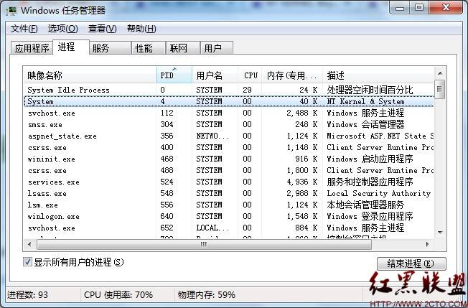

在网上找了很久找到解决方案

<http://www.cameroncooke.com/2009/01/25/windows-7-uses-port-80-and-makes-it-impossible-to-install-apache-solution/comment-page-1/#comments>

原文：

Hi Cameron,

I work on Http.sys technology at Microsoft and somebody sent me a link to this blog. I am a bit surprised by this behavior you are seeing on Windows7 Beta and with some help from you, I will like to find out the root cause of this issue so that we can take the appropriate action if needed.  
You are right, Http.sys uses port 80. It is the driver component for httpapi, the server http stack (You can find more info on this technology at [http://msdn.microsoft.com/en-us/library/aa364434(VS.85).aspx](http://msdn.microsoft.com/en-us/library/aa364434%28VS.85%29.aspx) ). In your case, some application is running which is using http.sys to listen on port 80. This is preventing Apache from using port 80. We offer a mechanism for applications to help control port sharing but I’ll need to look into the specific application that’s causing you this conflict. If you can give us the output of following command “netsh http show servicestate”, then it will allow me to find out which application is using http.sys. Since you have disabled http.sys, please follow these steps listed below before running the command:  
1. sc config http start= demand  
2. Reboot  
3. Run the command (netsh http show servicestate) as administrator

After you have run this command, you can disable http.sys as follows:  
1. net stop http  
2. Sc config http start= disabled

Please let me know if you face any issues in the process.

Thanks,  
Niranjan

翻译如下：

该进程是Http.sys。它是http API的驱动组件，Http栈服务器。如果该端口被Http.sys占用，说明一些正在使用http.sys的应用程序在运行。这就是阻止Apache运 行的原因，因为Http.sys占用着80端口。我们提供了一种应用程序的机制来帮助控制端口共享，但是我需要调查导致你遇到这种困难的是什么特殊应用程 序。如果你能提供给我们“netsh http show servicestate”这条命令的输出结果，我就能找出是哪个应用程序在使用Http.sys。在你禁用Http.sys之前，请按照下面的步骤来运 行命令：

1. sc config http stat = demand

2. reboot

3. run the command(netsh http show servicestat)as administrator

在你使用这个命令之前，你可以按照下面步骤禁用http.sys：

1. net stop http

2. Sc config http start= disabled

于是运行net stop http

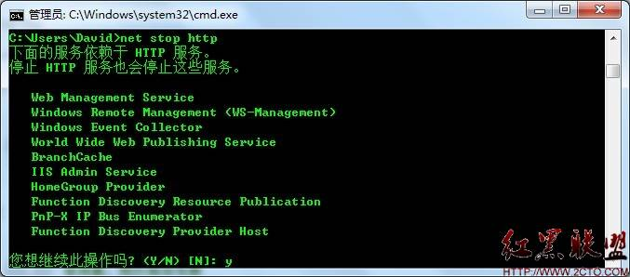

按y 确定

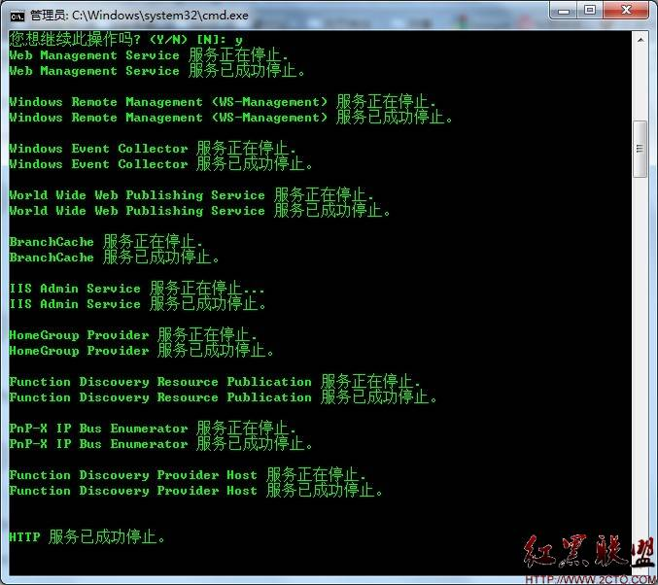

再运行 Sc config http start= disabled

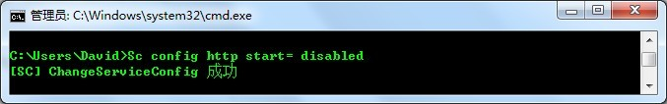

好了，现在启动Apache，可以启动了。

在查看一下netstat -ano

发现pid 4占用了445端口

反之：

先执行 net start W3SVC如果不行就先执行下面的，再执行这个

以管理员身份运行cmd,输入：  
sc config http start= demand & net start http