

Data Structures and Algorithms (23CSE203)

Lab Manual
Submitted By
NAME | Rhishiraj Thalakkat
ROLL NO. | AV.SC.U4CSE25147
YEAR/SEM/SECTION | 2nd/3rd/CSE-B
Credits | 5

Submitted to | Dr. Raj Kumar Batchu`
Designation | Asst. Professor (Sl. Grade)
Department | School of Computing

Index

S.NO | TITLE / TOPICS | DATE
1 | WEEK 1:  Recursion  - Recursive program for countdown from n to 1, followed by 'launch'.  - Recursive program to calculate P^n (compound interest growth factor P, years n).  - Recursive program to print first n terms of Fibonacci series.  - Recursive program to search for an employee ID in a list.  - Recursive program to calculate factorial (n!) for parcel arrangement. | 14-07-26
2 | WEEK 2:  Searching  - Python program to perform Linear Search on given input.  - Python program to perform Binary Search on given input (verify with sorted and unsorted lists). | 21-07-26
3 | WEEK 3:  Elementary Sorting  - Python program to implement Bubble Sort (user input).  - Python program to implement Selection Sort (user input).  - Python program to implement Insertion Sort (user input). | 01-08-26
4 | WEEK 4:  Advanced Sorting  - Python program to implement Merge Sort (user input).  - Python program to implement Quick Sort (user input). | 11-08-26
5 | WEEK 5:  Linked Lists  Implement operations for:  - Singly Linked List (SLL)  - Doubly Linked List (DLL)  - Circular Linked List (CLL)  Operations: 1. Create LL 2. Insert at Beginning 3. Insert at End 4. Insert at Index 5. Delete by Value 6. Delete Prior Node 7. Delete Last Node 8. Count Nodes 9. Display/Traverse 10. Exit | 18-08-26
6 | WEEK 6:  Stacks  - Implement Stack operations (Push, Pop, Peek, Display) using Array. | 25-08-26

 | B) Implement Stack operations (Push, Pop, Peek, Display) using Linked List.
7 | WEEK 7:  Queues  - Implement Queue using Arrays.  - Implement Queue using Linked List.  - Implement Circular Queue using Arrays.  - Implement Circular Queue using Linked List. | 22-09-26
8 | WEEK 8:  Binary Trees  - Implement Binary Tree with operations using Array.  - Implement Binary Tree with operations using Linked List. | 29-09-26
9 | WEEK 9:  Binary Search Trees  Python program to implement Binary Search Tree (BST) operations. | 06-10-26
10 | WEEK 9:  AVL Trees  Python program to implement AVL Tree with all it’s operations. | 13-10-26
11 | WEEK 11:  Hashing  Python program to implement Hashing (Separate chaining, Linear probing, and Quadratic probing). | 27-10-26

WEEK-1

1. A rocket launch system displays a countdown before launch. Instead of using loop implement the countdown using recursion. Write a recursive program to display a countdown from n to 1 followed by launch.

Program:
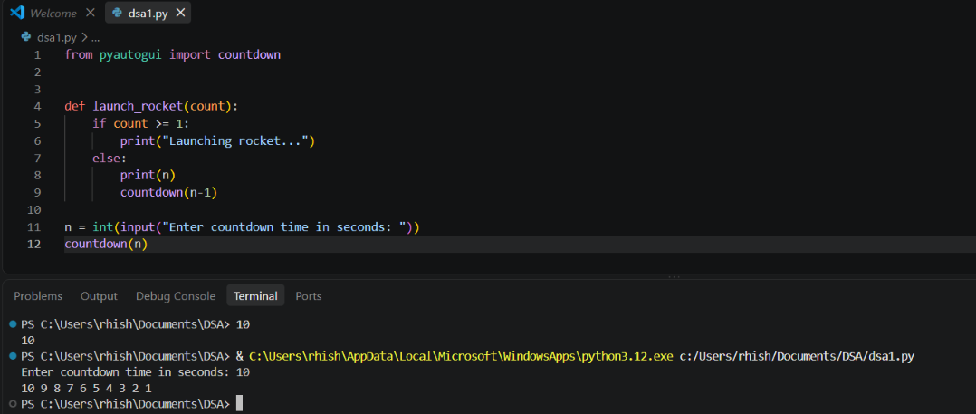

Explanation:
• It takes a number as input from the user and stores it in num.
• It creates a function named launch().
• It starts the countdown from 10 by assigning i = 10.
• It prints the value of i as long as num <= i.
• It decreases the value of i by 1 after each iteration.
• When the loop ends, it prints "Rocket launched" and executes the function using launch().
• For negative input, the function keeps decreasing instead of reaching 0, causing infinite recursion and eventually a Recursion Error.

Error Table:
Error | Rectification
1. Infinite loop  2. Calling function at wrong place | 1. Iteration at correct place  2. Placed with correct syntax

2. Banks calculate the growth of investment using compound interest. The formula requires calculating powers, which can be implemented recursively. Write a recursive program to calculate P^n where P = Principal growth factor, n = number of years.

Program:
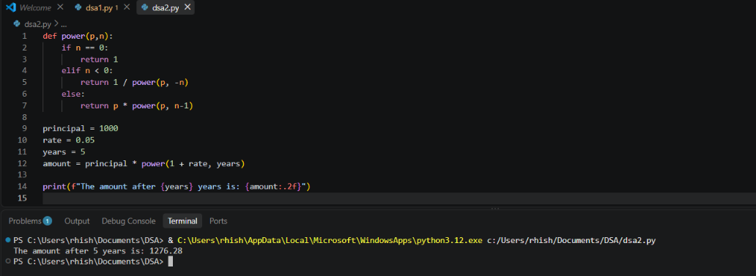

Explanation:
• The program takes the principal growth factor p and number of years n as input.
• It defines a recursive function power(p, n).
• If n is 0, the function returns 1 (base case).
• Otherwise, it returns p * power(p, n-1).
• The recursive calls continue until n becomes 0.
• The final value of pⁿ is displayed as the output. 8 | Page
• For a negative exponent, calculate the reciprocal instead of continuing recursion downward indefinitely.

Error Table:
Error | Rectification
1. Return 0  2. print | 1. Return 1  2. return

3. Write a recursive program to print the first n terms of fibanocci series.

Program:
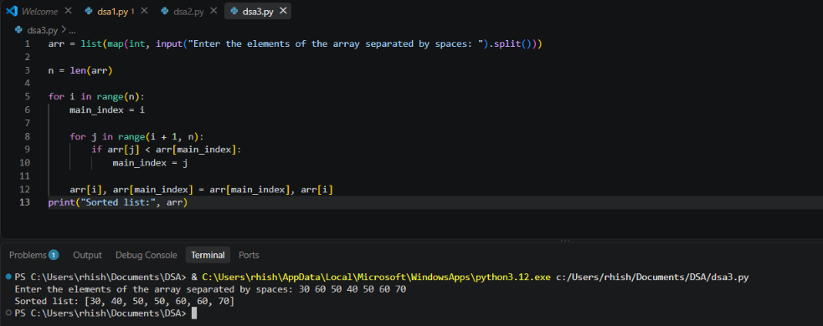
Explanation:
• For entering the number as input from user we defined as n
• We declared variable for formula.
• If input number is less than one then it return “1”
• Or it will goes under fibanocci iteration.
• If x is not present in the list, recursion reaches the end and returns False.

Error Table:
Error | Rectification
1. Forgot to declare n<=1  2. Formula mistake | 1. rectified  2. rectified

4. An hr department stores employee ids in a list develop a recursive program to search for a given employee id. Write a recursive function to search for an employee id in the list.

Program:
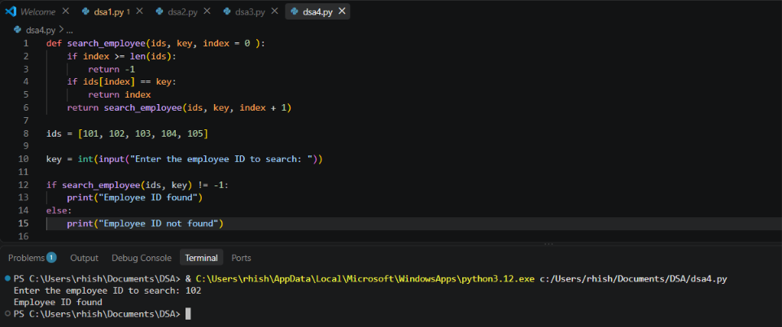
Explanation:
• The program creates a function to search for an employee ID in a list.
• It checks one employee ID at a time, starting from the first ID.
• If the entered employee ID matches the current ID, it returns True.
• If it does not match, the function moves to the next ID using recursion.
• If all employee IDs are checked and no match is found, it returns False.

Error Table:
Error | Rectification
1. Emp lst  2. print | 1. Emp_list  2. return

5. In a logistics the no.of possible ways to arrange n different parcels calculate using the factorial (n!). develop a recursive program to calculate the factorial of given number.

Program:
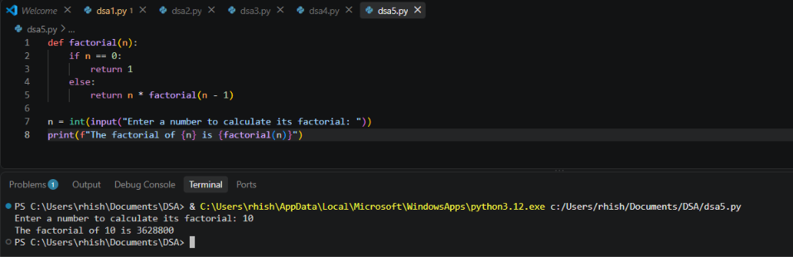
Explanation:
• The program defines a recursive function fact() to calculate the factorial of a number.
• It takes a number as input from the user.
• If the number is 1, the function returns 1 (base case).
• Otherwise, it multiplies the number by the factorial of the previous number (n-1).
• The recursive calls continue until the number becomes 1.
• Finally, the program prints the factorial of the given number.
• Negative numbers do not have a factorial, so the program should handle them separately instead of recursing forever.

Error Table:
Error | Rectification
1. n+1  2. Syntax error | 1. n-1  2. rectified

WEEK-2

1. Write a python program to perform linear search on the given input.
Program:
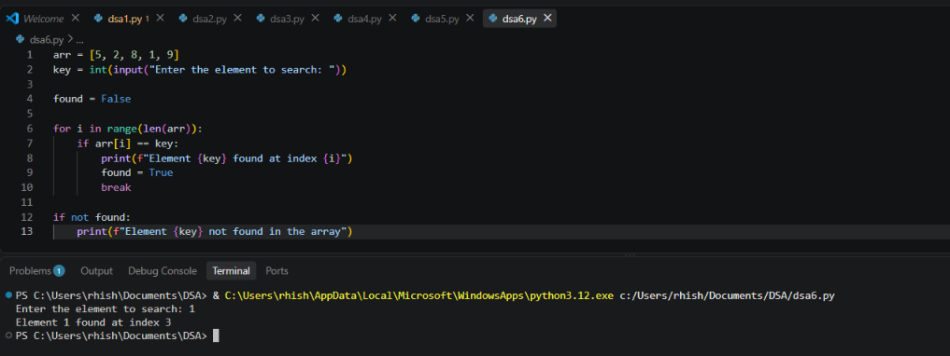
Explanation:
• In linear search we can append elements in sorted or unsorted way also.
• After placing the target we need to check the all the elements in a order.
• The time complixity is O(n).
• The target element may be found at beginning or last or at middle.
• If the key is greater than every element in the sorted array, the search reaches the end and returns -1.

Error Table:
Error | Rectification
1. Return placed in wrong place  2. Calling the function | 1. Corrected later  2. Rectified

2. Write a python program to perform binary search on the list.

Program: Unsorted
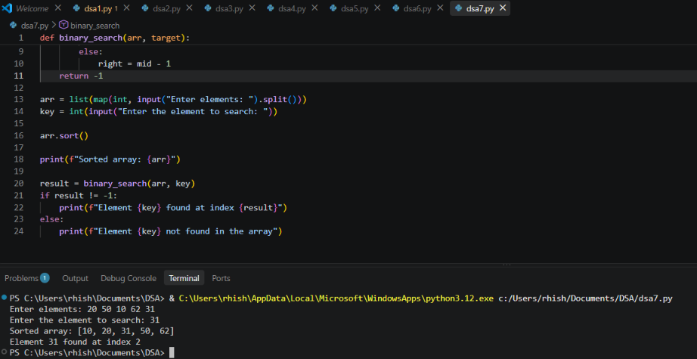
Program: Sorted
Explanation:
• The binary search should always executed in sorted order.
• Either it can be ascending or descending order.
• So the program is in unsorted order so we need to do sorting first later the binary search is executed.

Error Table:
Error | Rectification
1. Mistakes in main logic  2. Errors in conditions | 1. Rectified  2. Rectified

WEEK-3
1. write a python program to implement bubble sort, where the elements are taken from user.

Program:
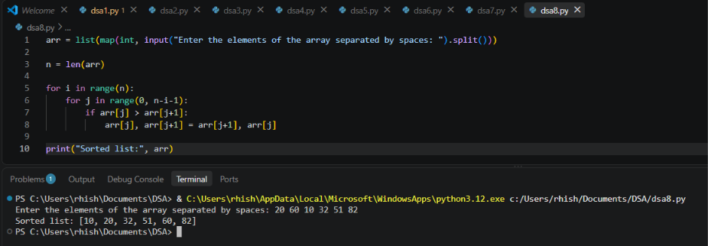
Explanation:
• Bubble sort is a sorting technique used to arrange elements in ascending or descending order.
• The program may contain elements in unsorted order, so adjacent elements are compared and swapped if they are in the wrong order.
• This process is repeated for multiple passes until the entire array is sorted.
• For n = 0, the program now prints the error message without trying to use an undefined arr.

Error Table:
Error | Rectification
1. Mistakes in main logic  2. Errors in conditions | 1. Rectified  2. Rectified

2. write a python program to implement insertion sort, where the elements are taken from user.

Program:
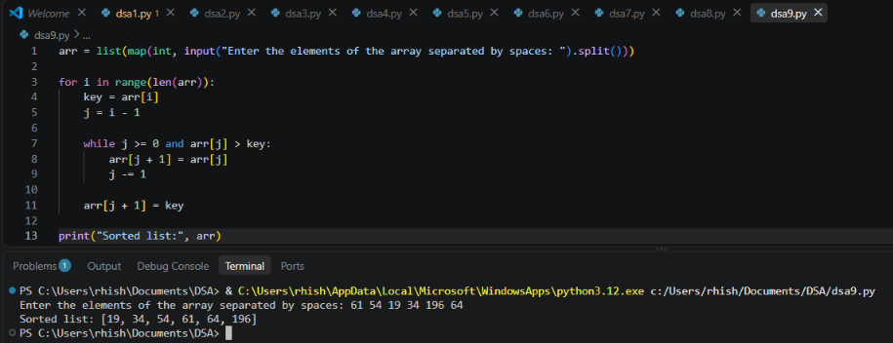
Explanation:
• Insertion sort is a sorting technique used to arrange elements in ascending or descending order.
• The program takes one element at a time and inserts it into its correct position in the already sorted part.
• This process is repeated until all elements are sorted.
• When the number of elements is zero, the array is empty and insertion sort simply performs no iterations.

Error Table:
Error | Rectification
1. Mistakes in main logic  2. Errors in conditions | 1. Rectified  2. Rectified

3. write a python program to implement selection sort, where the elements are taken from user.

Program:
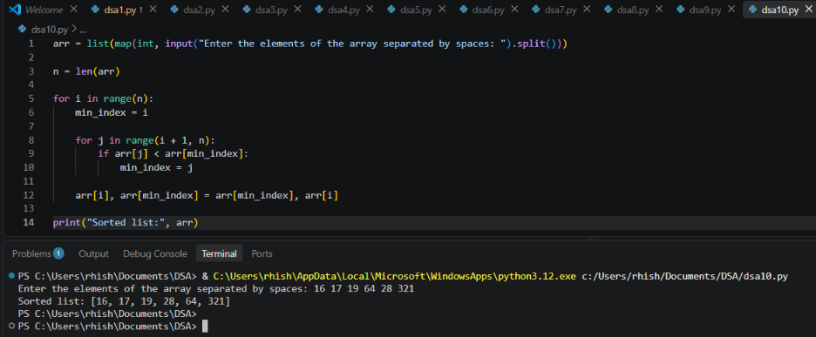
Explanation:
• Selection sort is a sorting technique used to arrange elements in ascending or descending order.
• The program finds the smallest element from the unsorted part and swaps it with the first element of that part.
• This process is repeated until the entire array is sorted.
• When n = 0, the array is empty and selection sort performs no iterations, so the program runs normally.

Error Table:
Error | Rectification
1. Mistakes in main logic  2. Errors in conditions | 1. Rectified  2. Rectified

WEEK-4
4a) Write a python program to implement merge sort where the input elements are taken from the user
Code:
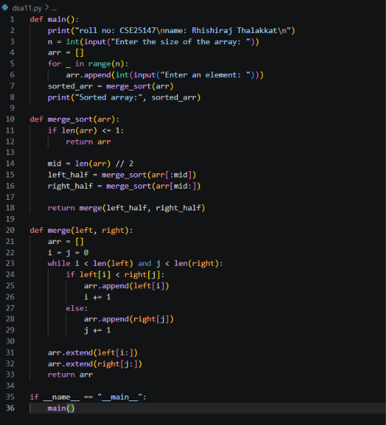

Output:
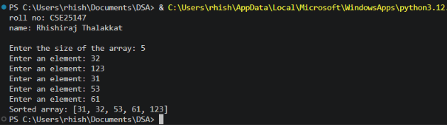

Error Table:
Error | Rectification
RecursionError: maximum recursion depth exceeded | base case in merge_sort() len(arr) <1 to len(arr) <= 1
PS C:\Users\Lab\Documents\cse25142\dsa-lab\week-4> python merge_sort.py  [2, 3, 7, 7, 8, 3, 7, 7, 8, 7, 7, 8] | kept the extend in the while loop instead of out of while loop

Description:
- The program implements the Merge Sort algorithm.
- The user enters the size of the array.
- The elements are taken from the user and stored in a list.
- The merge_sort() function recursively divides the array into two halves.
- The array is divided until each sub-array contains one or zero elements.
- The left and right portions are then sorted recursively.
- The sorted left and right arrays are compared element by element.
- The smaller element is placed into the original array.
- Remaining elements from either portion are then copied into the array.
- Finally, the completely sorted array is displayed.
- Merge Sort follows the divide-and-conquer approach.

4b) Write a python program to implement quick sort where the input elements are taken from the user.

Code:
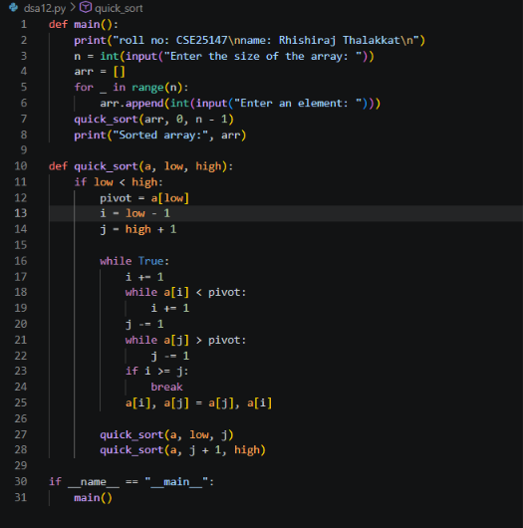

Output:
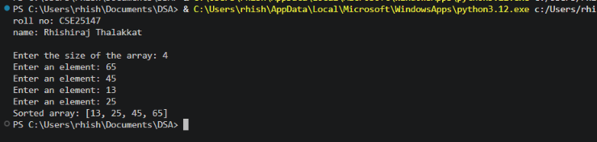

Error Table:
Error | Rectification
PS C:\Users\Lab\Documents\cse25142\dsa-lab\week-4> python quick_sort.py  rolln0 : cse25142  name : P. Bhanu Kiran  Enter size of array: 7  enter 1 element: 2  enter 2 element: 3  enter 3 element: 56  enter 4 element: 9  enter 5 element: -`  enter 6 element:  enter 7 element: 2 | Instead of inputting the integers, inputted the string added int before the input  arr.append(int(input(f”enter {i+1} element”)
PS C:\Users\Lab\Documents\cse25142\dsa-lab\week-4> python quick_sort.py  Traceback (most recent call last):  File "C:\Users\Lab\Documents\cse25142\dsa-lab\week-4\quick_sort.py", line 24, in <module>  main()  File "C:\Users\Lab\Documents\cse25142\dsa-lab\week-4\quick_sort.py", line 5, in main  quick_sort(arr)  TypeError: quick_sort() missing 2 required positional arguments: 'low' and 'high'  PS C:\Users\Lab\Documents\cse25142\dsa-lab\week-4> | added the two parameters to the function
Traceback (most recent call last):  File "C:\Users\Lab\Documents\cse25142\dsa-lab\week-4\quick_sort.py", line 29, in <module>  main()  File "C:\Users\Lab\Documents\cse25142\dsa-lab\week-4\quick_sort.py", line 9, in main  print(quick_sort(arr, 0, n-1))  ^^^^^^^^^^^^^^^^^^^^^^^  File "C:\Users\Lab\Documents\cse25142\dsa-lab\week-4\quick_sort.py", line 26, in quick_sort  quick_sort(a, j+1, high) #right part  ^^^^^^^^^^^^^^^^^^^^^^^^  File "C:\Users\Lab\Documents\cse25142\dsa-lab\week-4\quick_sort.py", line 24, in quick_sort  a[j], a[pivot] = a[pivot] = a[j] # placing the pivot in the correct position  ^^^^^^^^^^^^^^  ValueError: too many values to unpack (expected 2) | Placed a comma

Description:
- The program implements the Quick Sort algorithm.
- The user enters the size of the array.
- The elements are taken from the user and stored in a list.
- The quick_sort() function is used to sort the array recursively.
- The first element of the current portion is selected as the pivot.
- Two pointers, i and j, are used to compare elements with the pivot.
- i moves from the left side and searches for an element greater than or equal to the pivot.
- j moves from the right side and searches for an element smaller than or equal to the pivot.
- If i < j, the two elements are swapped.
- After the partitioning process, the pivot is placed in its correct position.
- The array is then divided into left and right portions.
- Quick Sort is recursively applied to both portions.

WEEK-5
5a) Write a Python program to implement a Singly Linked List (SLL) with the following operations:
1. Create LL
2. Insert at Beginning
3. Insert at End
4. Insert at Index
5. Delete by Value
6. Delete Prior Node
7. Delete Last Node
8. Count Number of Nodes
9. Display/Traverse
10. Exit

Code:
def main():
print("CSE2517 Rhishiraj Thalakkat\n")
my_LinkedList = None
while True:
print(
"1.create\n2.insert at beginning\n3.insert at end\n4.insert at certain position\n5.delete first node\n6.delete last node\n7.delete specific node\n"
"8.count\n9.display\n10.exit"
)
option = input("Enter your choice: ")
if option == "1":
my_LinkedList = LinkedList()
print("linked list successfully created")
elif my_LinkedList is None:
print("please create the linked list first (option 1)")
elif option == "2":
my_LinkedList.insert_begin(int(input("Enter the data: ")))
print("element is inserted")
elif option == "3":
my_LinkedList.insert_end(int(input("Enter the data: ")))
print("element inserted")
elif option == "4":
my_LinkedList.insert_position(
int(input("Enter the data: ")), int(input("Enter the position: "))
)
elif option == "5":
my_LinkedList.delete_begin()
elif option == "6":
my_LinkedList.delete_end()
elif option == "7":
my_LinkedList.delete_position(int(input("Enter position: ")))
elif option == "8":
count = my_LinkedList.size()
print("the size of linked list is {}".format(count))
elif option == "9":
my_LinkedList.display()
elif option == "10":
print("exiting the program")
break
else:
print("option not defined")

class LinkedList:
def __init__(self):
self.head = None

def insert_begin(self, data):
node = Node(data)
if self.head is None:
self.head = node
return
node.next = self.head
self.head = node

def insert_end(self, data):
if self.head is None:
self.insert_begin(data)
return
node = Node(data)
temp = self.head
while temp.next:
temp = temp.next
temp.next = node

def size(self):
temp = self.head
count = 0
while temp:
temp = temp.next
count += 1
return count

def insert_position(self, data, pos):
# positions are 1-indexed: pos=1 means new head
n = self.size()
if pos < 1 or pos > n + 1:
print("position not available")
return
if pos == 1:
self.insert_begin(data)
print("element inserted")
return
node = Node(data)
temp = self.head
count = 1
while count < pos - 1:
temp = temp.next
count += 1
node.next = temp.next
temp.next = node
print("element inserted")

def display(self):
if self.head is None:
print("The linked list is empty")
return
temp = self.head
while temp:
print(temp.data, end=" <-> ")
temp = temp.next
print("None")

def delete_begin(self):
if self.head is None:
print("The Linked list is empty")
return
self.head = self.head.next
print("first node deleted")

def delete_end(self):
if self.head is None:
print("The Linked list is empty")
return
if self.head.next is None:
self.head = None
print("last node deleted")
return
temp = self.head
while temp.next.next:
temp = temp.next
temp.next = None
print("last node deleted")

def delete_position(self, pos):
# positions are 1-indexed: pos=1 means head
if self.head is None:
print("Empty linked list")
return
n = self.size()
if pos < 1 or pos > n:
print("position does not exist")
return
if pos == 1:
self.head = self.head.next
print("node at position is deleted")
return
temp = self.head
count = 1
while count < pos - 1:
temp = temp.next
count += 1
temp.next = temp.next.next
print("node at position is deleted")

class Node:
def __init__(self, data):
self.data = data
self.next = None

if __name__ == "__main__":
main()

Output:
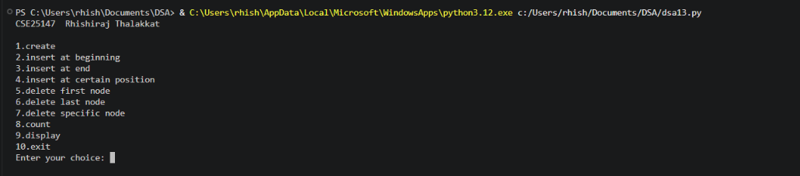

Error Table:
Error | Rectification
The program may display an incorrect message for insertion at a specific index even when the index is invalid | Check whether the index is valid before displaying the successful insertion message.
Description:
- The program implements a Singly Linked List using Python classes.
- The Node class is used to create individual nodes.
- Each node contains two parts: data and next.
- data stores the value of the node.
- next stores the reference to the next node.
- The SingleLinkedList class manages the linked list.
- The head variable stores the reference to the first node.
- The program provides an option to create a linked list.
- It supports insertion at the beginning of the list.
- It supports insertion at the end of the list.
- It supports insertion at a specific index.
- It supports deletion of a specific value.
- It supports deletion of the first node.
- It supports deletion of the last node.
- It provides a function to count the number of nodes.
- It provides a function to display/traverse all the nodes.
- A menu-driven approach is used to allow the user to select different operations.
- The program continues running until the user selects the Exit option

5b) Write a Python program to implement a Double Linked List (DLL) with the following operations:
1. Create LL
2. Insert at Beginning
3. Insert at End
4. Insert at Index
5. Delete by Value
6. Delete Prior Node
7. Delete Last Node
8. Count Number of Nodes
9. Display/Traverse
10. Exit
Code:
def main():
print("CSE25147 Rhishiraj Thalakkat\n")
dll = None
while True:
print("\n---menu---\n1.Create DLL\n2.insert begin\n3.insert end"
"\n4.insert index\n5.delete begin\n6.delete end\n7.delete value\n8.size of DLL\n9.exit")
o = input("Enter a choice: ")
match o:
case '1':
dll = DLL()
dll.create()
case '2':
if dll is None:
print("please create the DLL first")
else:
dll.insert_begin(int(input("Enter the data: ")))
case '3':
if dll is None:
print("please create the DLL first")
else:
dll.insert_end(int(input("Enter the data: ")))
case '4':
if dll is None:
print("please create the DLL first")
else:
data = int(input("Enter the data: "))
index = int(input("Enter the index: "))
dll.insert_index(data, index)
case '5':
if dll is None:
print("please create the DLL first")
else:
dll.delete_begin()
case '6':
if dll is None:
print("please create the DLL first")
else:
dll.delete_end()
case '7':
if dll is None:
print("please create the DLL first")
else:
dll.delete_value(int(input("Enter the value: ")))
case '8':
if dll is None:
print("please create the DLL first")
else:
dll.size()
case '9':
break
case _:
print("invalid choice")
print("Exiting the program........")

class Node:
def __init__(self, data):
self.data = data
self.next = None
self.prev = None

class DLL:
def __init__(self):
self.head = None

def create(self):
n = int(input("Enter the no of nodes: "))
for i in range(n):
data = int(input("Enter the data: "))
new = Node(data)
if self.head is None:
self.head = new
continue # fixed: continue, not return
temp = self.head
while temp.next:
temp = temp.next
temp.next = new
new.prev = temp
return 1

def insert_begin(self, data):
new = Node(data)
if self.head is None:
self.head = new
return
self.head.prev = new
new.next = self.head
self.head = new

def insert_end(self, data):
new = Node(data)
if self.head is None:
self.insert_begin(data)
return
temp = self.head
while temp.next:
temp = temp.next
temp.next = new
new.prev = temp

def insert_index(self, data, index):
if index < 0:
print("not possible")
return # fixed: stop execution here
new = Node(data)
if index == 0:
self.insert_begin(data)
return
temp = self.head
for i in range(index - 1):
if temp is None:
print("Not available")
return
temp = temp.next
if temp is None:
print("Not available")
returnx
if temp.next:
temp.next.prev = new
new.next = temp.next
temp.next = new
new.prev = temp

def size(self):
count = 0
if self.head is None:
print("List is Empty")
return count
temp = self.head
while temp:
count += 1
temp = temp.next
print(f"the dll contains {count} elements")
return count

def delete_begin(self):
if self.head is None:
print("Empty list")
return -1
if self.head.next is None:
self.head = None
return 1
self.head = self.head.next
self.head.prev = None
return 1

def delete_end(self):
if self.head is None:
print("Empty list") # fixed: no crash on empty list
return -1
if self.head.next is None:
self.head = None
return 1
temp = self.head
while temp.next:
temp = temp.next
temp.prev.next = None
temp.prev = None
return 1

def delete_value(self, value):
if self.head is None:
print("The list is empty")
return -1
if self.head.data == value:
self.head = self.head.next
if self.head:
self.head.prev = None # fixed: clear prev on new head
return 1
temp = self.head
while temp.next and temp.next.data != value:
temp = temp.next
if temp.next is None:
print("Value not available")
return -1
target = temp.next
temp.next = target.next # fixed: relink around target, not temp.prev
if target.next:
target.next.prev = temp
return 1

if __name__ == '__main__':
main()

Output:
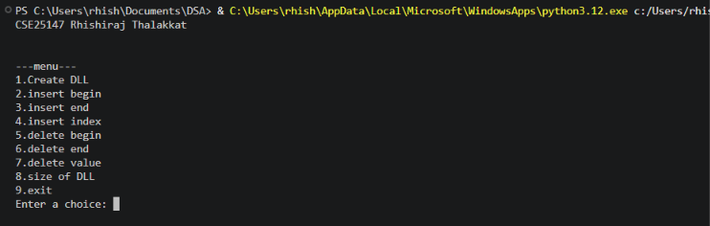

Error Table:
Error | Rectification
The prev and next links may not be updated correctly during insertion or deletion. | Update both links whenever a node is inserted or deleted.

Description:
- The program implements a Doubly Linked List using Python classes.
- The Node class is used to create individual nodes.
- Each node contains three parts: data, prev, and next.
- data stores the value of the node.
- prev stores the reference to the previous node.
- next stores the reference to the next node.
- The DoubleLinkedList class is used to manage the linked list.
- The head variable stores the reference to the first node.
- The program provides an option to create a doubly linked list.
- It supports insertion at the beginning of the list.
- It supports insertion at the end of the list.
- It supports insertion at a specific index.
- It supports deletion of a specific value.
- It supports deletion of the first node.
- It supports deletion of the last node.
- It provides a function to count the number of nodes.
- It provides a function to display/traverse the list.
- During insertion and deletion, both prev and next links are updated.
- The list is displayed using <--> to show the connection between nodes.
- A menu-driven approach is used to perform different DLL operations.
- The program continues until the user selects the Exit option.

5c) Write a Python program to implement a Circular Linked List (CLL) with the following operations:
1. Create LL
2. Insert at Beginning
3. Insert at End
4. Insert at Index
5. Delete by Value
6. Delete Prior Node
7. Delete Last Node
8. Count Number of Nodes
9. Display/Traverse
10. Exit

Code:
def main():
print("cse25147 Rhishiraj Thalakkat\n")
CLL = CircularLinkedList()

while True:
print("\n1.Create CLL")
print("2.Insert at beginning")
print("3.Insert at ending")
print("4.Insert at index")
print("5.Delete by value")
print("6.Delete first node")
print("7.Delete last node")
print("8.Count no of nodes")
print("9.Display / Traverse")
print("10.Exit")

choice = int(input("Enter your choice: "))

if choice == 1:
CLL.create()
print("CLL is created")

elif choice == 2:
data = int(input("Enter data to insert: "))
CLL.insert_begin(data)
print("Data is inserted at beginning")

elif choice == 3:
data = int(input("Enter data to insert: "))
CLL.insert_end(data)
print("Data is inserted at ending")

elif choice == 4:
data = int(input("Enter data to insert: "))
index = int(input("Enter the index: "))
CLL.insert_index(index, data)

elif choice == 5:
data = int(input("Enter data to delete: "))
CLL.delete(data)

elif choice == 6:
CLL.delete_begin()

elif choice == 7:
CLL.delete_end()

elif choice == 8:
CLL.count()

elif choice == 9:
CLL.display()

elif choice == 10:
print("Exiting the program")
break

else:
print("Invalid choice")

class Node:
def __init__(self, data):
self.data = data
self.next = None

class CircularLinkedList:
def __init__(self):
self.head = None

# Creation
def create(self):
n = int(input("Enter no of elements: "))

for i in range(n):
data = int(input("Enter the values: "))
new = Node(data)

if self.head is None:
self.head = new
new.next = self.head
else:
temp = self.head

while temp.next != self.head:
temp = temp.next

temp.next = new
new.next = self.head

# Insert begin
def insert_begin(self, data):
new = Node(data)

if self.head is None:
self.head = new
new.next = self.head
else:
temp = self.head

while temp.next != self.head:
temp = temp.next

new.next = self.head
self.head = new
temp.next = self.head

# Insert end
def insert_end(self, data):
new = Node(data)

if self.head is None:
self.head = new
new.next = self.head
else:
temp = self.head

while temp.next != self.head:
temp = temp.next

temp.next = new
new.next = self.head

# Insert at specific index
def insert_index(self, index, data):
if index < 0:
print("Invalid index")
return

if index == 0:
self.insert_begin(data)
return

if self.head is None:
print("Invalid index")
return

temp = self.head

for i in range(index - 1):
if temp.next == self.head:
print("Invalid index")
return

temp = temp.next

new = Node(data)
new.next = temp.next
temp.next = new

# Delete specific value
def delete(self, data):
if self.head is None:
print("No data")
return

# If head contains the value
if self.head.data == data:

# Only one node
if self.head.next == self.head:
self.head = None
print("Value deleted")
return

temp = self.head

while temp.next != self.head:
temp = temp.next

temp.next = self.head.next
self.head = self.head.next

print("Value deleted")
return

temp = self.head

while temp.next != self.head and temp.next.data != data:
temp = temp.next

if temp.next == self.head:
print("Value not present")
else:
temp.next = temp.next.next
print("Value deleted")

# Delete begin
def delete_begin(self):
if self.head is None:
print("No data to delete")
return

# Only one node
if self.head.next == self.head:
print("Deleted value = ", self.head.data)
self.head = None
return

temp = self.head

while temp.next != self.head:
temp = temp.next

print("Deleted value = ", self.head.data)

temp.next = self.head.next
self.head = self.head.next

# Delete end
def delete_end(self):
if self.head is None:
print("No data to delete")
return

# Only one node
if self.head.next == self.head:
print("Deleted value = ", self.head.data)
self.head = None
return

temp = self.head

while temp.next.next != self.head:
temp = temp.next

print("Deleted value = ", temp.next.data)

temp.next = self.head

# Count
def count(self):
if self.head is None:
print("No data to count")
return

count = 0
temp = self.head

while True:
count += 1
temp = temp.next

if temp == self.head:
break

print(f"Number of nodes = {count}")

# Display / Traverse
def display(self):
if self.head is None:
print("No data")
return

temp = self.head

while True:
print(temp.data, end="-->")
temp = temp.next

if temp == self.head:
break

print("HEAD")

if __name__ == '__main__':
main()

output:
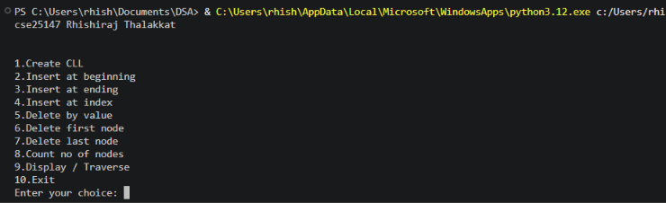

Error Table:
Error | Rectification
No errors
Description:
- The program implements a Circular Linked List using Python classes.
- The Node class is used to create individual nodes.
- Each node contains two parts: data and next.
- data stores the value of the node.
- next stores the reference to the next node.
- In a Circular Linked List, the last node points back to the first node.
- The CircularLinkedList class is used to manage the linked list.
- The head variable stores the reference to the first node.
- The program provides an option to create a circular linked list.
- It supports insertion at the beginning of the list.
- It supports insertion at the end of the list.
- It supports insertion at a specific index.
- It supports deletion of a specific value.
- It supports deletion of the first node.
- It supports deletion of the last node.
- It provides a function to count the number of nodes.
- It provides a function to display/traverse the circular linked list.
- During traversal, the program stops when it reaches the head again.
- The list is displayed using --> and ends with HEAD, showing its circular nature.
- The program handles the special case where the list contains only one node.
- A menu-driven approach is used to perform different CLL operations.
- The program continues until the user selects the Exit option.

WEEK-6
6a) write a Python program to implement stack operations such as Push, Pop, Peek, and Display using an Array.
Code:
class Stack:
def __init__(self, size):
self.size = size
self.stack = [None]*size
self.top = -1
def push(self,item):
# check for over flow condition
if self.top == self.size-1:
print("Stack over flow")
return
self.top += 1
self.stack[self.top] = item
print(f"{item} inserted into stack")
return
def peek(self):
# check if the stack is empty
if self.top == -1:
print("Stack is empty")
return
# returning the top item in the array
return self.stack[self.top]
def pop(self):
# checking for the under flow condition
if self.top == -1:
print("stack under flow")
return
item = self.stack[self.top]
self.stack[self.top] = None
self.top -= 1
print(f"{item} removed successfully")
def display(self):
if self.top == -1:
print("Empty stack")
return
for i in range(self.top+1):
print(self.stack[i], end=" ")
print("\n")

def main():
print("cse25140 P. Hemanth Ram\n")
stack = Stack(5)
stack.push(10)
stack.push(20)
stack.push(30)
stack.push(40)
stack.push(50)
stack.display()
stack.pop()
stack.pop()
stack.display()
stack.peek()
stack.pop()
stack.pop()
stack.pop()
stack.pop()

if __name__ == '__main__':
main()

Output:
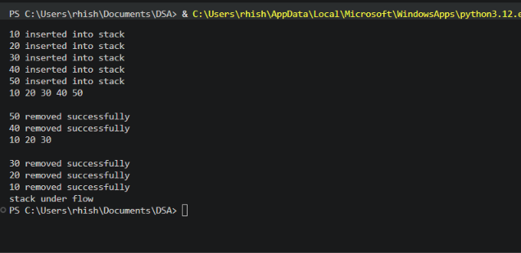

Error Table:
Error | Rectification
In peek, self.peek is taken in ‘if’ does not give correct answer for stack underflow. | Self.top is taken in ‘if’ to give correct output.
Description:
- The Stack class implements a stack using a Python list.
- size stores the maximum size of the stack.
- stack stores the stack elements.
- top keeps track of the top position. Initially, top = -1, meaning the stack is empty.
- Push adds an element to the top of the stack.
- Pop removes the top element from the stack.
- Peek displays the top element without removing it.
- Display prints all elements from top to bottom.
- Stack Overflow occurs when trying to push into a full stack.
- Stack Underflow occurs when trying to pop from an empty stack.
The program uses a menu-driven approach with options for Push, Pop, Peek, Display, and Exit.

6b)Write a Python program to implement stack operations such as Push, Pop, Peek, and Display using an Linked List
Code:
class Node:
def __init__(self, data):
self.data = data
self.next = None

class Stack:
def __init__(self):
self.top = None
def push(self,item):
# since we use linked list, there is no over flow condition
node = Node(item)
if self.top is None:
self.top = node
return
node.next = self.top
self.top = node
print(f"{item} inserted")
def pop(self):
# checking for the under flow condition
if self.top is None:
print("stack under flow")
return
#need to give the self.top to the next node
item = self.top.data
self.top = self.top.next
print(f"{item} removed")
def peek(self):
# checking if the list is empty
if self.top is None:
print("stack is none")
return
# display the top node data
print(f"{self.top.data} is the top item")
def display(self):
# checking if hte stack is empty
if self.top is None:
print("stack is empty")
return
temp = self.top
while temp:
print(f"{temp.data}", end='->')
temp = temp.next
print("None")

def main():
print("cse25147 Rhishiraj Thalakkat\n")
stack = Stack()
stack.push(10)
stack.push(20)
stack.push(30)
stack.push(40)
stack.push(50)
stack.display()
stack.pop()
stack.pop()
stack.display()
stack.peek()
stack.pop()
stack.pop()
stack.pop()
stack.pop()
if __name__ =='__main__':
main()

Output:
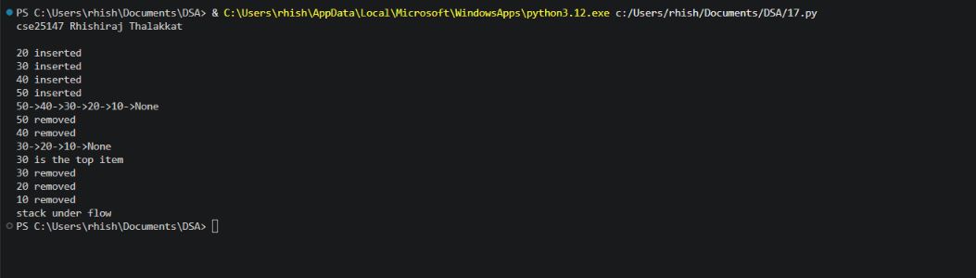

Error Table:
Error | Rectification
No errors
Description:
- The stack is implemented using a singly linked list.
- Each node contains data and a next pointer.
- top points to the top node of the stack.
- Push inserts a new node at the beginning of the linked list.
- Pop removes the node pointed to by top.
- Peek displays the data of the top node without removing it.
- Display traverses the linked list from top to the last node.
- If top is None, the stack is empty.
- Stack Overflow is not a fixed-size issue here because the stack grows dynamically, subject to available memory.

WEEK-7

7a) Write a Python program to implement queue operations such as Push, Pop, Peek, and Display using an array.
Code:
class Queue:
def __init__(self, size):
self.size = size
self.queue = [None]*size
self.front = -1
self.rear = -1
def enqueue(self, item):
if self.rear == self.size - 1:
print("Queue overflow")
return
if self.front == -1 and self.rear == -1:
self.front = self.rear = 0
self.queue[self.rear] = item
print(f"{item} is inserted into queue")
return
self.rear += 1
self.queue[self.rear] = item
print(f"{item} is inserted")
return
def dequeue(self):
if self.front == -1:
print("queue over flow")
return
item = self.queue[self.front]
self.front += 1
if self.front > self.rear:
self.front = self.rear = -1
print(f"{item} deleted from the queue")
return
def peek(self):
if self.front == -1:
print("the queue is empty")
return
item = self.queue[self.front]
print(f"the front element is {item}")
return
def display(self):
if self.front == -1:
print("th4e queue is empty")
return
for i in range(self.front, self.rear+1):
print(f"{self.queue[i]}", end=" | ")
print("")
return

def main():
print("CSE25147, Rhishiraj Thalakkat.")
queue = Queue(5)
while True:
print("1.Enqueue\n2.Dequeue\n3.Peek\n4.Display\n5.Exit")
choice = int(input("Enter Your Choice: "))
if choice == 1:
queue.enqueue(int(input("Enter the item: ")))
elif choice == 2:
queue.dequeue()
elif choice == 3:
queue.peek()
elif choice == 4:
queue.display()
elif choice == 5:
print("Exiting the program")
break
else:
print("Invalid choice")

if __name__ == '__main__':
main()

Output:
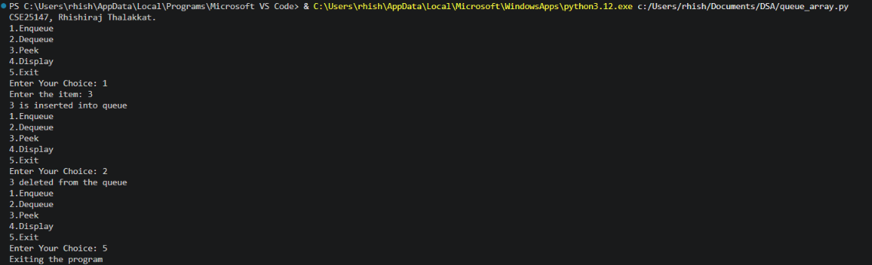

Error Table:

Error | Rectification
Unused Space Error: After several dequeues, empty positions at the beginning cannot be reused in a linear array queue. | Use a circular queue when reuse of empty positions is required.

Description:
- The queue is implemented using a fixed-size array.
- Each element is stored in a separate array position.
- front points to the first element of the queue.
- rear points to the last element of the queue.
- Enqueue inserts a new element at the rear of the queue.
- Dequeue removes the element from the front of the queue.
- Peek displays the element at the front without removing it.
- Display traverses the queue from front to rear.

- If the queue is empty, front and rear indicate the empty condition.
- Queue Overflow occurs when an element is inserted into a full array queue and Queue Underflow occurs when an element is deleted from an empty queue.

7b) Write a Python program to implement queue operations such as Push, Pop, Peek, and Display using a Linked List.

Code:
class Queue:
def init (self, size): self.size = size self.queue = [None]*size self.front = -1
self.rear = -1
def enqueue(self, item):
if self.rear == self.size - 1: print("Queue overflow") return
if self.front == -1 and self.rear == -1: self.front = self.rear = 0 self.queue[self.rear] = item print(f"{item} is inserted into queue") return
self.rear += 1 self.queue[self.rear] = item print(f"{item} is inserted") return
def dequeue(self):
if self.front == -1: print("queue over flow") return
item = self.queue[self.front] self.front += 1
if self.front > self.rear: self.front = self.rear = -1
print(f"{item} deleted from the queue") return
def peek(self):
if self.front == -1: print("the queue is empty") return
item = self.queue[self.front] print(f"the front element is {item}") return
def display(self):

if self.front == -1: print("th4e queue is empty") return
for i in range(self.front, self.rear+1): print(f"{self.queue[i]}", end=" | ")
print("") return

def main():
print("CSE25147, Rhishiraj Thalakkat.") queue = Queue(5)
while True:
print("1.Enqueue\n2.Dequeue\n3.Peek\n4.Display\n5.Exit") choice = int(input("Enter Your Choice: "))
if choice == 1:
queue.enqueue(int(input("Enter the item: "))) elif choice == 2:
queue.dequeue() elif choice == 3:
queue.peek() elif choice == 4:
queue.display() elif choice == 5:
print("Exiting the program") break
else:
print("Invalid choice")

if name == ' main ': main()

Output:

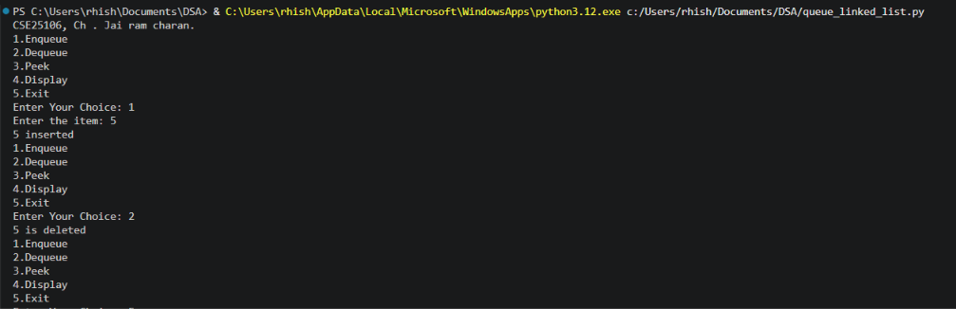

Error Table:

Error | Rectification
Incorrectly changing the next pointer can break the linked list. | Maintain the correct next links during insertion and deletion

Description:
- The queue is implemented using a singly linked list.
- Each node contains data and a next pointer.
- front points to the first node of the queue.
- rear points to the last node of the queue.
- Enqueue creates a new node and inserts it at the rear.
- Dequeue removes the node pointed to by front.
- Peek displays the data of the front node without removing it.
- Display traverses the linked list from front to rear.
- If front is None, the queue is empty.
- Queue Overflow is not a fixed-size issue because the queue grows dynamically, subject to available memory.
- Queue Underflow occurs when dequeue is attempted on an empty queue.

7c) Write a Python program to implement queue operations such as Push, Pop, Peek, and Display using an Circular Linked List.

Code:
class CircularQueue:
def __init__(self, size):
self.size = size
self.queue = [None]*size
self.front = -1
self.rear = -1
def enqueue(self, item):
if (self.rear + 1) % self.size == self.front:
print("queue over flow")
return
if self.front == -1:
self.front = self.rear = 0
self.queue[self.rear] = item
print(f"{item} inserted")
return
self.rear = (self.rear+1) % self.size
self.queue[self.rear] = item
print(f"{item} inserted")
return
def dequeue(self):
if self.front == -1:
print("queue under flow")
return
item = self.queue[self.front]
self.front = (self.front+1) % self.size
if self.front == (self.rear+1) % self.size:
self.front = self.rear = -1
print(f"{item} deleted")
return
def peek(self):
if self.front == -1:
print("the queue is empty")
return
item = self.queue[self.front]
print(f"{item} is the font element")
return
def display(self):
if self.front == -1:
print("the queue is empty")
return
i = self.front
while i != (self.rear + 1)%self.size:
print(self.queue[i], end="|")
i = (i+1) % self.size
print("")
return

def main():
print("CSE25106, Ch. Jai ram charan.")
queue = CircularQueue(5)
while True:
print("1.Enqueue\n2.Dequeue\n3.Peek\n4.Display\n5.Exit")
choice = int(input("Enter Your Choice: "))
if choice == 1:
queue.enqueue(int(input("Enter the item: ")))
elif choice == 2:
queue.dequeue()
elif choice == 3:
queue.peek()
elif choice == 4:
queue.display()
elif choice == 5:
print("Exiting the program.....")
break
else:
print("Invalid choice")

if __name__ == '__main__':
main()

Output:
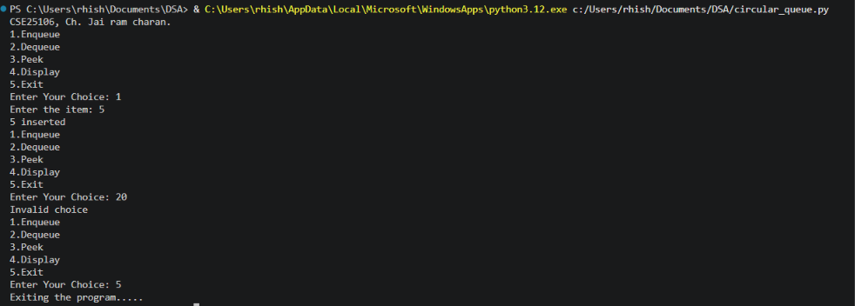

WEEK-8
8a) Write a Python program to implement Binary Tree with its operations using array.

Code:
class BinaryTreeArray:
def __init__(self,size):
self.tree = [None]*size
self.size = size
#Insert root
def set_root(self,data):
self.tree[0] = data
#Left child
def set_left(self,parent_index,data):
child_index = 2*parent_index+1
if child_index<self.size:
self.tree[child_index] = data
else:
print("Index out of range.")
#Right child
def set_right(self,parent_index,data):
child_index = 2*parent_index+2
if child_index < self.size:
self.tree[child_index] = data
else:
print("Index out of range.")
#Preorder Traversal
def preorder(self,index=0):
if index >= self.size or self.tree[index] is None:
return
print(self.tree[index],end="")
self.preorder(2*index+1)
self.preorder(2*index+2)
#Inorder Traversal
def inorder(self,index=0):
if index >= self.size or self.tree[index] is None:
return
self.inorder(2*index+1)
print(self.tree[index],end=" ")
self.inorder(2*index+2)
#Postorder Traversal
def postorder(self,index=0):
if index >= self.size or self.tree[index] is None:
return
self.postorder(2*index+1)
self.postorder(2*index+2)
print(self.tree[index],end=" ")
#Level order Traversal
def level_order(self):
for value in self.tree:
if value is not None:
print(value,end=" ")
#Display
def display(self):
print("\nArray Representation")
for i in range(self.size):
print(f"Index {i} : {self.tree[i]}")

tree = BinaryTreeArray(7)
#Create tree
tree.set_root('A')
# Children of A
tree.set_left(0, 'B')
tree.set_right(0, 'C')
# Children of B
tree.set_left(1, 'D')
tree.set_right(1, 'E')
# Right child of C
tree.set_right(2, 'F')
tree.display()
print("\nPreorder: ", end="")
tree.preorder()
print("\nInorder: ", end="")
tree.inorder()
print("\nPostorder: ", end="")
tree.postorder()
print("\nLevel-order: ", end="")
tree.level_order()

Output:
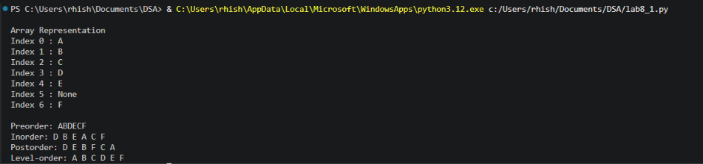

Error Table:

Error | Rectification
Accessing an index outside the array size can cause Index Error. | Check the array boundaries before accessing an index.

Description:
- The binary tree is represented using an array, where each position stores a node of the tree.
- The first element of the array represents the root node.
- For a node at index i, its left child is stored at 2*i + 1.
- For a node at index i, its right child is stored at 2*i + 2.
- The binary tree can be traversed using preorder, inorder, and postorder methods.
- New elements are inserted into the appropriate array positions while maintaining the binary-tree structure.
- Empty positions in the array indicate that the corresponding node does not exist.

8b) Write a Python program to implement Binary Tree with its operations using Linked list.

Code:
class Node:
def __init__(self,data):
self.left = None
self.right = None
self.data = data

class BinaryTree:
def __init__(self):
self.root = None
def create_tree(self):
self.root = Node('A')
# Left and right children of A
self.root.left = Node('B')
self.root.right = Node('C')
# Children of B
self.root.left.left = Node('D')
self.root.left.right = Node('E')
# Right child of C
self.root.right.right = Node('F')
# Preorder Traversal
def preorder(self, node):
if node is None:
return
print(node.data, end=" ")
self.preorder(node.left)
self.preorder(node.right)
# Inorder Traversal
def inorder(self, node):
if node is None:
return
self.inorder(node.left)
print(node.data, end=" ")
self.inorder(node.right)
# Postorder Traversal
def postorder(self, node):
if node is None:
return
self.postorder(node.left)
self.postorder(node.right)
print(node.data, end=" ")
# Level-order Traversal
def level_order(self):
if self.root is None:
return
queue = [self.root]
while queue:
node = queue.pop(0) # Remove first node
print(node.data, end=" ")
# Add left child
if node.left is not None:
queue.append(node.left)
# Add right child
if node.right is not None:
queue.append(node.right)

tree = BinaryTree()
tree.create_tree()

print("Preorder: ", end="")
tree.preorder(tree.root)

print("\nInorder: ", end="")
tree.inorder(tree.root)

print("\nPostorder: ", end="")
tree.postorder(tree.root)

print("\nLevel-order: ", end="")
tree.level_order()

Output:

Error Table:

Error | Rectification
Accessing a None node may cause an Attribute Error. | Check whether the node is None before accessing its data or pointers.

Description:
- Each tree node contains data, left pointer, and right pointer.
- The root pointer stores the address of the first node of the binary tree.
- The left pointer stores the address of the left child.
- The right pointer stores the address of the right child.
- New nodes are dynamically created and connected to the appropriate parent node.
- Memory is allocated dynamically as new nodes are created.
- The tree can be traversed using preorder, inorder, and postorder methods.
- A node with both left and right pointers as None is called a leaf node.
- Linked-list representation allows the tree to grow dynamically without a fixed size.
- Each node is connected to its children using pointers, providing a flexible representation of a binary tree

WEEK-9
Write a Python program to implement Binary Search Tree with its operations
Code:
# Binary Search Tree
#CSE25147, Rhishiraj Thalakkat.
class Node:
def __init__(self, data):
self.data = data
self.left = None
self.right = None

class BinarySearchTree:

# Insert a node
def insert(self, root, data):
if root is None:
return Node(data)

if data < root.data:
root.left = self.insert(root.left, data)
elif data > root.data:
root.right = self.insert(root.right, data)

return root

# Search for a node
def search(self, root, data):
if root is None:
return False

if root.data == data:
return True
elif data < root.data:
return self.search(root.left, data)
else:
return self.search(root.right, data)

# Find minimum value node
def find_min(self, root):
current = root

while current.left is not None:
current = current.left

return current

# Delete a node
def delete(self, root, data):
if root is None:
return root

if data < root.data:
root.left = self.delete(root.left, data)

elif data > root.data:
root.right = self.delete(root.right, data)

else:
# Case 1: No child
if root.left is None and root.right is None:
return None

# Case 2: Only right child
elif root.left is None:
return root.right

# Case 3: Only left child
elif root.right is None:
return root.left

# Case 4: Two children
else:
temp = self.find_min(root.right)
root.data = temp.data
root.right = self.delete(root.right, temp.data)

return root

# Inorder: Left -> Root -> Right
def inorder(self, root):
if root is not None:
self.inorder(root.left)
print(root.data, end=" ")
self.inorder(root.right)

# Preorder: Root -> Left -> Right
def preorder(self, root):
if root is not None:
print(root.data, end=" ")
self.preorder(root.left)
self.preorder(root.right)

# Postorder: Left -> Right -> Root
def postorder(self, root):
if root is not None:
self.postorder(root.left)
self.postorder(root.right)
print(root.data, end=" ")

# Main program
bst = BinarySearchTree()
root = None

while True:
print("\n\n--- BINARY SEARCH TREE ---")
print("1. Insert")
print("2. Search")
print("3. Delete")
print("4. Inorder Traversal")
print("5. Preorder Traversal")
print("6. Postorder Traversal")
print("7. Exit")

choice = int(input("Enter your choice: "))

if choice == 1:
data = int(input("Enter value to insert: "))
root = bst.insert(root, data)
print("Node inserted successfully.")

elif choice == 2:
data = int(input("Enter value to search: "))

if bst.search(root, data):
print("Element found.")
else:
print("Element not found.")

elif choice == 3:
data = int(input("Enter value to delete: "))
root = bst.delete(root, data)
print("Node deleted successfully.")

elif choice == 4:
print("Inorder Traversal:")
bst.inorder(root)

elif choice == 5:
print("Preorder Traversal:")
bst.preorder(root)

elif choice == 6:
print("Postorder Traversal:")
bst.postorder(root)

elif choice == 7:
print("Program terminated.")
break

else:
print("Invalid choice.")

Error Table:

Error | Rectification
Accessing a None node may cause an Attribute Error. | Check whether the node is None before accessing its data or pointers.

Description:
- The program implements a Binary Search Tree (BST) using Python classes and objects.
- Each node stores a data value and references to its left and right child nodes.
- The insertion operation places each new value in its correct position according to BST rules.
- The search operation checks whether a specified value exists in the tree.
- The deletion operation removes a node and adjusts the tree structure based on the number of children.
- The minimum value is found by traversing the left child nodes until the leftmost node is reached.
The traversal operations display the tree elements using inorder, preorder, and postorder methods

WEEK-10
Python program to implement AVL Tree with all its operations.

Code:
#CSE25147, Rhishiraj Thalakkat.
class Node:
def __init__(self, data):
self.data = data
self.left = None
self.right = None
self.height = 1
class AVLTree:
def height(self, root):
if root is None:
return 0
return root.height
def balance(self, root):
if root is None:
return 0
return self.height(root.left) - self.height(root.right)
def right_rotate(self, y):
x = y.left
t = x.right
x.right = y
y.left = t
y.height = 1 + max(self.height(y.left), self.height(y.right))
x.height = 1 + max(self.height(x.left), self.height(x.right))
return x
def left_rotate(self, x):
y = x.right
t = y.left
y.left = x
x.right = t
x.height = 1 + max(self.height(x.left), self.height(x.right))
y.height = 1 + max(self.height(y.left), self.height(y.right))
return y
def insert(self, root, data):
if root is None:
return Node(data)
if data < root.data:
root.left = self.insert(root.left, data)
elif data > root.data:
root.right = self.insert(root.right, data)
else:
return root
root.height = 1 + max(self.height(root.left), self.height(root.right))
b = self.balance(root)
if b > 1 and data < root.left.data:
return self.right_rotate(root)
if b < -1 and data > root.right.data:
return self.left_rotate(root)
if b > 1 and data > root.left.data:
root.left = self.left_rotate(root.left)
return self.right_rotate(root)
if b < -1 and data < root.right.data:
root.right = self.right_rotate(root.right)
return self.left_rotate(root)
return root
def search(self, root, data):
if root is None:
return False
if root.data == data:
return True
elif data < root.data:
return self.search(root.left, data)
else:
return self.search(root.right, data)
def find_min(self, root):
current = root
while current.left is not None:
current = current.left
return current
def delete(self, root, data):
if root is None:
return root
if data < root.data:
root.left = self.delete(root.left, data)
elif data > root.data:
root.right = self.delete(root.right, data)
else:
if root.left is None:
return root.right
elif root.right is None:
return root.left
else:
temp = self.find_min(root.right)
root.data = temp.data
root.right = self.delete(root.right, temp.data)
root.height = 1 + max(self.height(root.left), self.height(root.right))
b = self.balance(root)
if b > 1 and self.balance(root.left) >= 0:
return self.right_rotate(root)
if b > 1 and self.balance(root.left) < 0:
root.left = self.left_rotate(root.left)
return self.right_rotate(root)
if b < -1 and self.balance(root.right) <= 0:
return self.left_rotate(root)
if b < -1 and self.balance(root.right) > 0:
root.right = self.right_rotate(root.right)
return self.left_rotate(root)
return root
def inorder(self, root):
if root:
self.inorder(root.left)
print(root.data, end=" ")
self.inorder(root.right)
def preorder(self, root):
if root:
print(root.data, end=" ")
self.preorder(root.left)
self.preorder(root.right)
def postorder(self, root):
if root:
self.postorder(root.left)
self.postorder(root.right)
print(root.data, end=" ")
def level_order(self, root):
if root is None:
return
queue = [root]
while queue:
node = queue.pop(0)
print(node.data, end=" ")
if node.left:
queue.append(node.left)
if node.right:
queue.append(node.right)

avl = AVLTree()
root = None

while True:
print("\n\n--- AVL TREE ---")
print("1. Insert")
print("2. Search")
print("3. Delete")
print("4. Inorder Traversal")
print("5. Preorder Traversal")
print("6. Postorder Traversal")
print("7. Level Order Traversal")
print("8. Exit")

choice = int(input("Enter your choice: "))

if choice == 1:
data = int(input("Enter value to insert: "))
root = avl.insert(root, data)
print("Node inserted successfully.")
elif choice == 2:
data = int(input("Enter value to search: "))
if avl.search(root, data):
print("Element found.")
else:
print("Element not found.")
elif choice == 3:
data = int(input("Enter value to delete: "))
root = avl.delete(root, data)
print("Node deleted successfully.")
elif choice == 4:
print("Inorder Traversal:")
avl.inorder(root)
elif choice == 5:
print("Preorder Traversal:")
avl.preorder(root)
elif choice == 6:
print("Postorder Traversal:")
avl.postorder(root)
elif choice == 7:
print("Level Order Traversal:")
avl.level_order(root)
elif choice == 8:
print("Program terminated.")
break
else:
print("Invalid choice.")

Output:
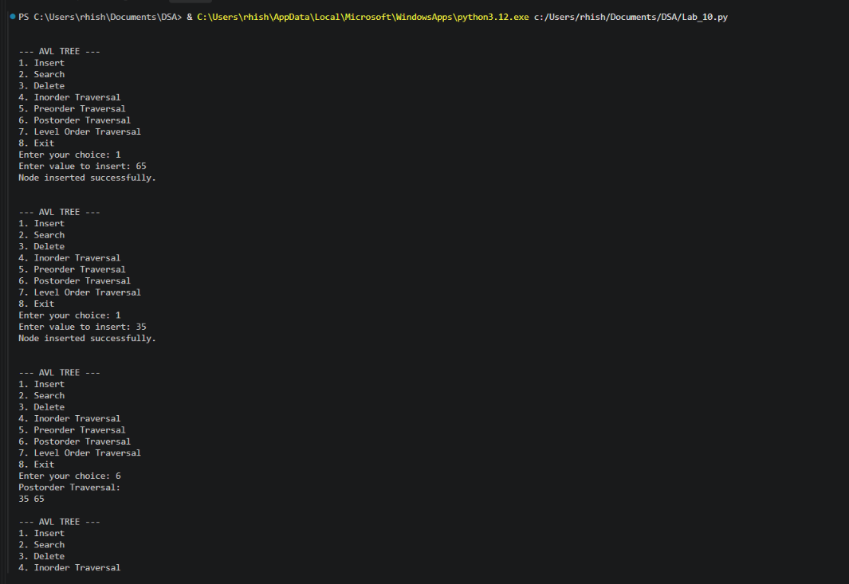

Error Table:

Error | Rectification
Invalid Input | Occurs when non-integer values are entered.

Description:

- AVL Tree is a self-balancing Binary Search Tree.
- Each node contains data, left child, right child and height.
- It maintains a balance factor of -1, 0 or +1 for every node.
- Insertion adds new nodes while maintaining the balance of the tree.
- Searching is used to find a particular element in the tree.
- Deletion removes a node and rebalances the tree using rotations.
- AVL Tree uses four rotations: LL, RR, LR and RL.
- It provides efficient searching, insertion and deletion operations.

WEEK-11
Python program to implement Hashing (Separate chaining, Linear probing, and Quadratic probing).

Code:
#CSE25147, Rhishiraj Thalakkat.
size = 10
chain = [[] for i in range(size)]
def separate_chaining(key):
index = key % size
chain[index].append(key)

linear = [None] * size

def linear_probing(key):
index = key % size
while linear[index] is not None:
index = (index + 1) % size
linear[index] = key

quadratic = [None] * size

def quadratic_probing(key):
index = key % size
i = 0
while i < size:
new_index = (index + i * i) % size
if quadratic[new_index] is None:
quadratic[new_index] = key
return
i += 1
print("Hash table is full")

n = int(input("Enter number of elements: "))
keys = []

for i in range(n):
key = int(input("Enter key: "))
keys.append(key)
separate_chaining(key)
linear_probing(key)
quadratic_probing(key)

print("\nSeparate Chaining:")
for i in range(size):
print(i, ":", chain[i])
print("\nLinear Probing:")
print(linear)
print("\nQuadratic Probing:")
print(quadratic)

Output:
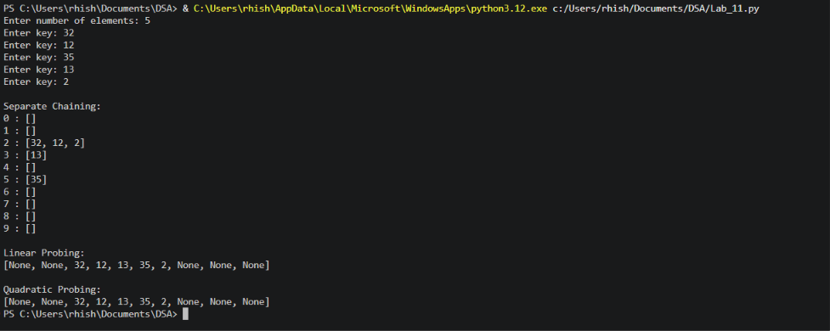

Error Table:

Error | Rectification
Index Out of Range | Occurs when an invalid index is accessed.

Description:

- Hashing is a technique used to store and retrieve data efficiently using a hash function.
- A hash function calculates the index of a key in a hash table.
- Separate Chaining handles collisions by storing multiple elements at the same index using a list.
- Linear Probing resolves collisions by checking the next available position in the hash table.
- Quadratic Probing resolves collisions by checking positions using quadratic intervals.
- These three techniques help manage collisions and improve data storage and searching efficiency.

