Andrea Chen, Jacob Olinger

R_004

15th November 2021

CSSE220-04

Dr. Wilkin

Experiment Report

1. An explanation of the experiment (including parameters used)

|  |  |
| --- | --- |
| population size: | 100 |
| mutation rate: | 1 |
| crossover method: | no |
| chromosome length: | 100 |
| selection method: | Truncation |
| max generations: | 500 |

The maximum of fitness an organism can get is 100, and the process terminated once an individual reaches this limit.

1. A hypothesis (might just be a guess)

The population should be able to produce a 100-fitness individual within 500 terms. It might not be able to happen within the first 100 trails.

1. Description of the results including plots (or a table of results)

An organism with 100 fitness was evolved at the 235th evolving process.

|  |  |  |  |  |  |  |  |  |  |  |
| --- | --- | --- | --- | --- | --- | --- | --- | --- | --- | --- |
| run # | 1 | 2 | 3 | 4 | 5 | 6 | 7 | 8 | 9 | 10 |
| gens | 280 | 235 | 235 | 250 | 285 | 230 | 225 | 380 | 147 | 165 |

1. What if anything you can conclude and anything you learned or affirmed by doing so?

About 200-300 generations were token before reaching 100. It can vary from 150 to nearly 400 generations. We were expecting the variation to be a big range because there is only one source of randomness and it’s not that easy to get a solution out of such little randomness. When we were testing mutation-related implementations, the generation we set to be 100 and it never gave a solution out of this small range. Therefore, the data we collected is reasonable to us.

a. An explanation of the experiment (including parameters used)

|  |  |
| --- | --- |
| population size: | 100 |
| mutation rate: | 1 |
| crossover method: | Single point crossover |
| chromosome length: | 100 |
| selection method: | Truncation |
| max generations: | 500 |

The maximum of fitness an organism can get is 100, and the process terminated once an individual reaches this limit.

1. A hypothesis (might just be a guess)

The population should be able to produce a 100-fitness individual within 500 terms. It might be able to happen within the first 100 trails.

1. Description of the results including plots (or a table of results)

An organism with 100 fitness was evolved at the 60th evolving process.

|  |  |  |  |  |  |  |  |  |  |  |
| --- | --- | --- | --- | --- | --- | --- | --- | --- | --- | --- |
| run # | 1 | 2 | 3 | 4 | 5 | 6 | 7 | 8 | 9 | 10 |
| gens | 60 | 55 | 55 | 48 | 48 | 40 | 55 | 60 | 57 | 45 |

1. What if anything you can conclude and anything you learned or affirmed by doing so?

It took much less generations, about 40-60, for a final solution. The total number of generations decreased dramatically as well as the variation. Since crossover introduced one more source for randomness, every individual had more chance to have higher fitness and pass on their genes. As a result, the solution came out much quicker than only mutation was involved.

a. An explanation of the experiment (including parameters used)

|  |  |
| --- | --- |
| population size: | 100 |
| mutation rate: | 0 |
| crossover method: | Single point crossover |
| chromosome length: | 100 |
| selection method: | Truncation |
| max generations: | 500 |

The maximum of fitness an organism can get is 100, and the process terminated once an individual reaches this limit.

1. A hypothesis (might just be a guess)

The population might not be able to evolve a solution even after 500 trials.

1. Description of the results including plots (or a table of results)

No solution were produced.

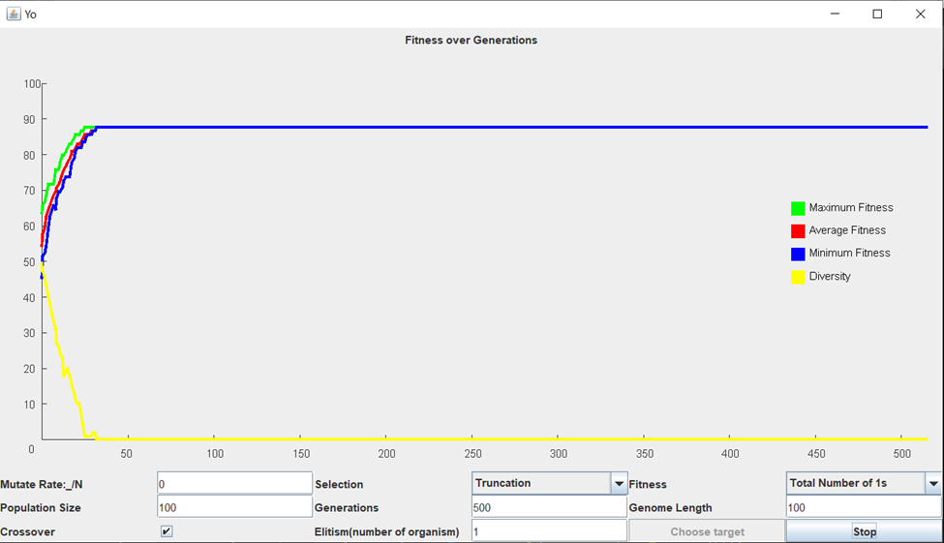

1. What if anything you can conclude and anything you learned or affirmed by doing so?

Since there is no single point of genes that’s get mutated, every segment of genes that gets copied to each other during crossover never changes. As the least fit genes segments are eliminated by the selection of parents, the segments that have the most 1s in them get passed on throughout the evolution. The straight line for fitness and diversity means all genes are identical now, which means now all the organisms are composed of the fittest segments and that gene sequence is the most possible solution to have under no mutation.

a. An explanation of the experiment (including parameters used)

|  |  |
| --- | --- |
| population size: | 100 |
| mutation rate: | 1 |
| crossover method: | no |
| chromosome length: | 100 |
| selection method: | Routtele Wheel Selection / Rank Selection |
| max generations: | 500 |

The maximum of fitness an organism can get is 100, and the process terminated once an individual reaches this limit.

1. A hypothesis (might just be a guess)

The generation should be able to produce a 100-fitness individual within 500 terms. It might not be able to happen within the first 100 trails.

1. Description of the results including plots (or a table of results)

No solution was produced for Routtele Wheel Selection.

An organism with 100 fitness was evolved at the 165th evolving process by Rank Selection.

1. What if anything you can conclude and anything you learned or affirmed by doing so?

We tested only mutation with both Rank selection and Routtele Wheel selection, and were surprised. Both selections used similar method to select the parent, the only difference is the assigned probability of individuals to be chosen as a parent. However, Routtele Wheel selection cannot evolve a solution even after 500 trials. The reason we came out was that the probability of the fittest organism to be chosen is different for these two selections. In Routtele Wheel selection, due to the large size of population, the percentage of one organism’s fitness over total fitness is so small that there is no big difference between fitter ones and less fit ones, which means the parents were chosen without directing to the final solution.

**Designed Experiment**

What would happen if the fitness function changed part way through the evolutionary process? Would such a change be biologically realistic? Devise and produce an experiment to explore this. Is there a relationship to diversity and your results?

a. An explanation of the experiment (including parameters used)

|  |  |
| --- | --- |
| population size: | 100 |
| mutation rate: | 1 |
| crossover method: | no |
| chromosome length: | 100 |
| selection method: | Truncation/Target Chromosome/Consecutive 1s |
| max generations: | 300 |

The maximum of fitness an organism can get is 100, and the process terminated once an individual reaches this limit. The fitness function will be changed every 100 generations and continue to graph.

1. A hypothesis (might just be a guess)

The fitness will change dramatically suddenly, which we think is not biological realistic, but we are not sure about what will happen to the diversity curve.

1. Description of the results including plots (or a table of results)

1. What if anything you can conclude and anything you learned or affirmed by doing so?

The fitness changes too suddenly to be consider biological realistic because evolution is a gradual process and should not have such fitness curve. The diversity curve doesn’t change significantly like fitness curves, and it is similar to the graph when there is only one fitness function involved. Therefore, we think diversity is not affected by the change of fitness function.

**Reproduce result from a classic paper**

We’ve tried to write code to produce graph with magic dance fitness function. Unfortunately, due to unknown bugs that we haven’t figured out, we cannot produce the desired graph. As we tested, the method to get different genes works, so we think there is some problem with “Life” class which controls the 1000 days of living for the population. The while loop seems not functional but we don’t know why.