How to get the starting code for a Pair Programming project
- When you arrive in class, find a partner with whom you would like to pair program. Your instructor will help you as needed.
Do NOT continue until your instructor tells you to do so.
- When your instructor tells you to proceed (and NOT BEFORE THEN), your pair (or triple) should select a name that you think will be unique to your team, that begins with your section number, like this example for a team in Section 2:
2-bob-jill
Use that name in the following.
- Decide which of the pair will be Person 1 and which Person 2 (and which will be Person 3 if working in a team of three).
- Person 1 (and ONLY Person 1):
  - Follow the link to the Starting Code for Pair Programming for the session, for example this link for Session 3.
  - At the link you will see something like this:
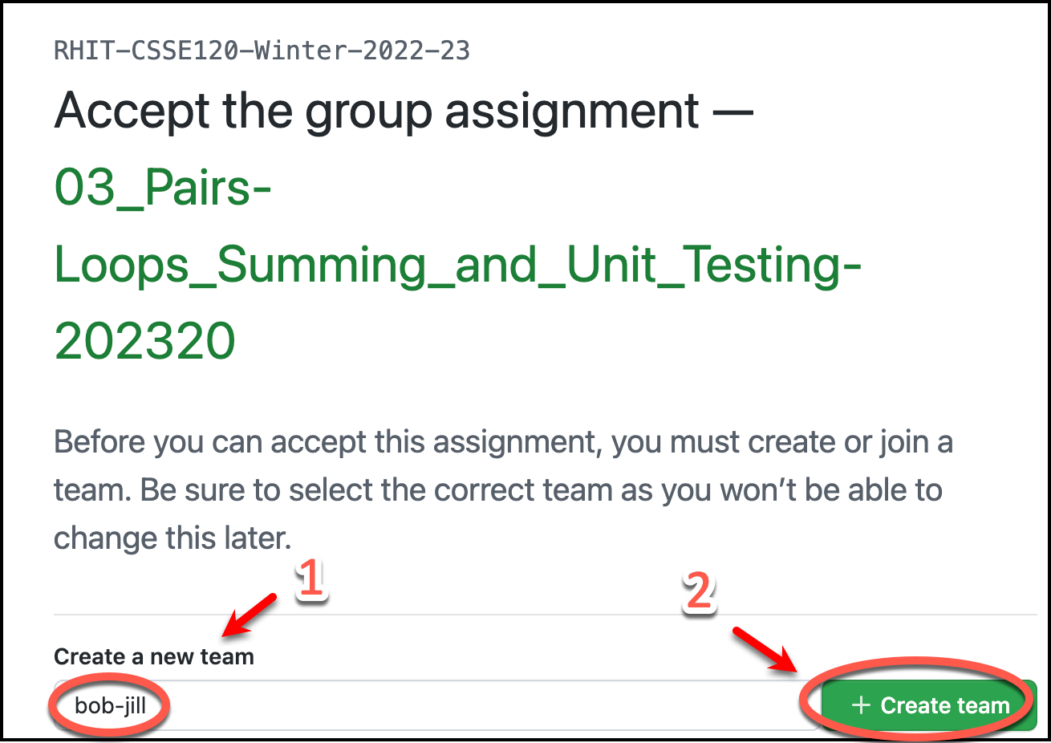
Person 1 (and ONLY Person 1) should then type your UNIQUE team name and then press the Create Team button, as shown above.
  - Person 1 will then see the usual “Accept the [group] assignment…” message and should continue in the usual way to clone the project into PyCharm.

- Now Person 2 (and Person 3 if applicable) should:
  - Follow the link to the Starting Code for Pair Programming for the session, for example this link for Session 3
  - At the link you will see something like this:
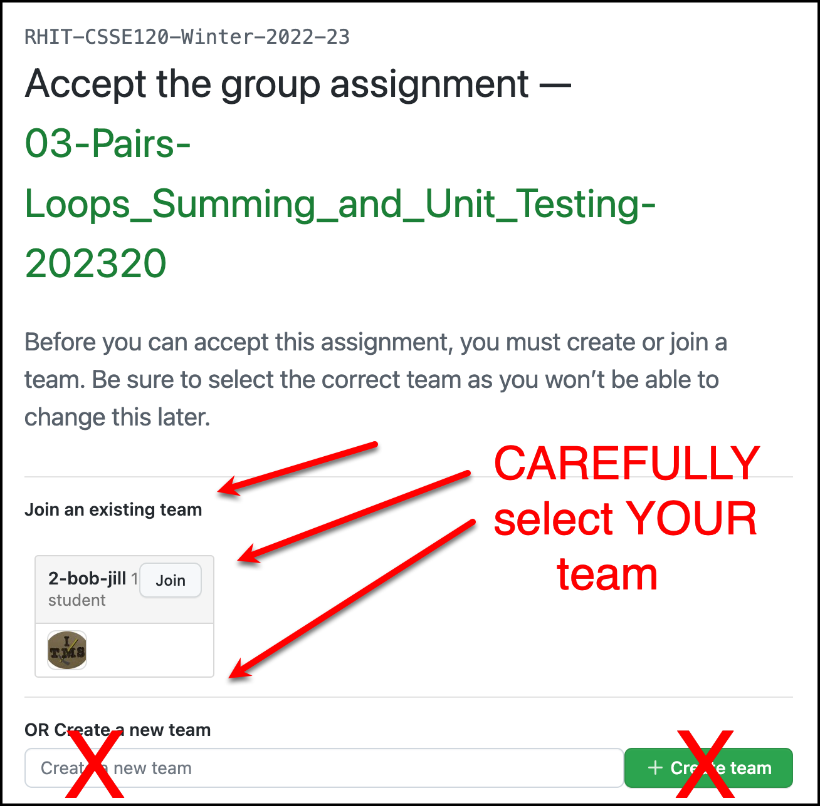
Person 2 (and Person 3 if applicable) should find their team name and then press its Join button, as indicated above. BE CAREFUL – select YOUR team name. THERE IS NO “UNDO” option!
  - Person 2 (and Person 3 if applicable) will then see the usual “Accept this [group] assignment…” message and should continue in the usual way to clone the project into PyCharm.
- The group then pair-programs, using ONE computer at any instant in time. Each time you switch Driver/Navigator, the old Driver does a Git ~ Commit-and-push to send the current version to the repository and the new Navigator does a Git ~ Pull to obtain the updated version of the project. (Use Microsoft Teams and Share screen if you want to use two computers to see the code or if you are physically distant.)
- When done, commit-and-push and/or pull your work. Then each team member manually copies the work from their shared repository to their individual repository for that session, and turns in their individual repository as usual (by commit-and-push and also via the Moodle quiz/dropbox).

