The goal of this assignment is to continue using general purpose IO (GPIO) and use i2c. **Keep all your work in a github repository.** The grayed parts are optional.

## TMP101

In your kit are two TI, TMP101 i2c temperature sensors. Go to <http://ti.com> and look up its datasheet. On its pinout you’ll see the clock (SCL) and data (SDA) for the i2c interface. There is also an address line (ADD0). It can appear at one of 3 i2c addresses on the i2c bus and the ADD0 line decides which address. What are those addresses? (Hint: check the datasheet.) There is also an ALERT pin which can be programmed to transition when the temperature is above THIGH or below TLOW.

1. Wire up your two TMP101 on the i2c bus so each has a different address.
2. Use **/sys/class/i2c-adapter/i2c-2/new_device** as shown in 02-3 I2C.pptx starting at slide 25. Use **echo tmp101 0x48 > new_device** for each of the sensors and then read the current temperature from the command line.
3. Write a python program to read the temperature of each.

## Etch-a-sketch

Modify your etch-a-sketch program to use the bicolor LED matrix in your kit. The matrix will work off 3.3V.

1. Wire the matrix up to the same bus as your TMP101’s.
2. Use the programs in **exercises/displays/matrix8x8** to set the matrix before modifying your Etch-a-sketch program.
3. Once working, interface the LED matrix to your Etch-a-sketch.

## Rotary Encoders

Modify your Etch-a-Sketch to use two rotary encoders. <https://elinux.org/EBC_Reading_a_Rotary_Encoder_via_eQEP> is an example of how to read an encoder. Create a **setup.sh file** for configuring the pins.

Here’s how to wire it. 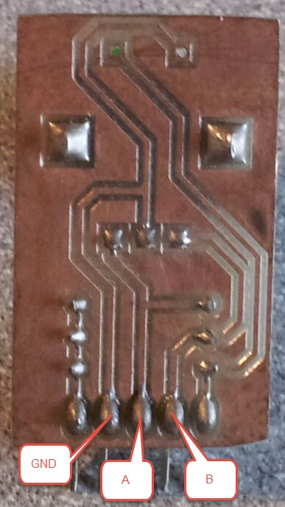

## Extras

Here are some other things you can do to make the project more interesting. Feel free to think of your own ideas.

* Use a couple of potentiometers and the analog in lines to be the knobs controlling your Etch-a-sketch.
* Make your Etch-a-sketch get brighter as the temperature rises
* Make your Etch-a-sketch erase when it gets too hot.

## What to turn in

1. Make a subdirectory in your github repository called **hw03**.
2. Put all your files in the directory, include a **README.md** that explains what your homework does and how to use it. Also include **setup.sh** if it’s needed.
3. Document your code.