Memo-ECE425-LAB4

Date: 1/30/2022

To: Professor Berry

Team: Leonardo - Nathan Lee, Shantao Cao

The purpose of this Lab was to implement Braitenberg Vehicles using photosensors and build on top of last lab to use a hybrid controller for beacon docking. For this Lab, we used LEONARDO’s four IR sensors and added two photo resistive sensors. For Braitenberg Vehicles, we were able to execute the four vehicles by reacting to light. LEO was also able to execute a hybrid controller, and dock towards a beacon of light from wall following and return to its original location before docking.

**Prelab: Hybrid Controller**

Before working with LEO, we designed a hybrid controller (Appendix A) for executing beacon docking with all previous behaviors in last lab (wall following, wandering, etc.). All the behaviors from last lab was set to be in the reactive layer of the hybrid controller because it is simple states and functions to execute based on the environment. There is no though processing or recalling that LEO would need in any of the behavior states. The planning and middle layer is set when LEO detects a beacon of light and execute his docking control. This is in the planning and middle layer because once LEO has approached the light, he would need to think and plan out his return pathing to where he initially found the light.

**Photoresistor Testing**

After setting up a hybrid controller for LEO, we set up and tested the photo-resistive sensors. Since the sensors were photo-resistive, we set up a voltage divider and have the Arduino read the voltage drop across the sensor. This means that there will be a larger voltage drop when less light is present. The photo sensors were attach to the front of LEO and both sensors pointed directly ahead of it. Table 1 shows our initial calibrations of the photosensors. The photosensors data was much more constant than any other sensors on LEO. Further testing and calibration of the photosensors were done to calibrate distances to the readings (Appendix B). Upon both calibrating both left and right sensors to the environment, there shows little differences between the left and right sensors. When light is detected, the small difference between the left and right sensors (about 50 mV difference) is negligible compared to the difference between environment and the light beacon (about 250 mV difference). This lets LEO easily find which direction the beacon of light is coming from and could detect the angle of attack from where the beacon is coming from with little turning movements.

|  |  |  |
| --- | --- | --- |
|  | **Left (mV)** | **Right(mV)** |
| Ambient on table | 496 | 417 |
| Ambient under table | 220 | 209 |
| Sensor covered | <40 | <40 |
| In front of a light | >750 | >770 |

**Table 1:** Ambient and flashlight readings of the environment.

**Braitenberg Vehicles**

To test the photosensors in action, we set up the four reactive Braitenberg Vehicles. Figure 1 shows the four types of vehicles: Love, Fear, Exploration and Aggression. For the vehicles, the left or right sensor is coupled to their corresponding or opposite wheel based on the type of vehicle. For example, the Braitenberg Vehicle for Love would have the left sensor attached to the left wheel. And when light is present on the left side, the left wheel should decrease speed (pointing the robot towards the light). LEO was able to execute all four vehicles with some minor issues over looked. Since our light sensors were both facing directly ahead of LEO, if the light was centered or too far from LEO, it had difficulty differentiating which side the light source would be coming from and executed an unusual behavior. Putting the light source much closer and in front of one side of the photosensor demonstrated the four vehicle behaviors more clearly.

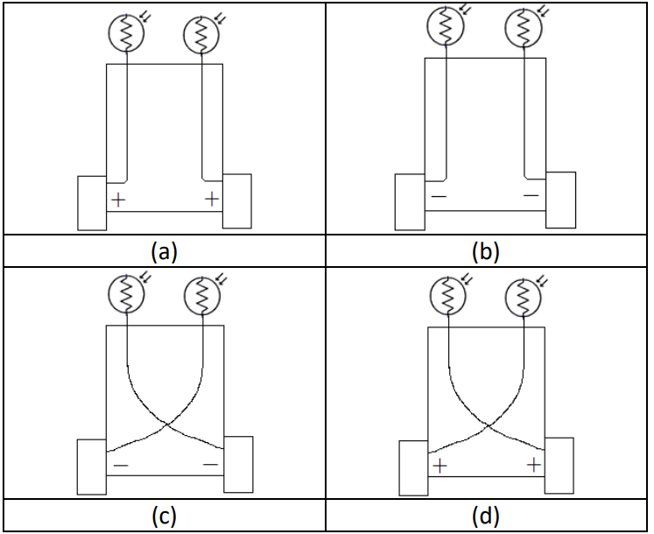

**Figure 1**: Braitenberg Vehicles uses sensors to react to their environment. The four types of vehicles are fear (a), love (b), exploration (c), and aggression (d)

**Appendix A: PreLab Hybrid Control Diagrams**

*The State Machine Diagram for light detection*

*The Hybrid Control Diagram implementing Docking*

**Appendix B: Additional Photo-resistive Sensor Calibration**

|  |  |  |  |  |  |  |  |
| --- | --- | --- | --- | --- | --- | --- | --- |
|  |  | Left (mV) | | | Right (mV) | | |
| Environment | Distance(in) | -45 degrees | 0 degree | 45 degrees | -45 degrees | 0 degree | 45 degrees |
| On the table | 3 | 634 | 570 | 551 | 508 | 569 | 777 |
| On the table | 6 | 761 | 599 | 523 | 463 | 696 | 762 |
| On the table | 9 | 700 | 554 | 514 | 487 | 631 | 730 |
| On the table | 12 | 627 | 544 | 508 | 460 | 620 | 695 |
| On the table | 15 | 607 | 550 | 500 | 480 | 590 | 640 |
| Under the table | 3 | 686 | 390 | 239 | 184 | 425 | 678 |
| Under the table | 6 | 542 | 378 | 281 | 250 | 416 | 651 |
| Under the table | 9 | 500 | 369 | 262 | 274 | 434 | 570 |
| Under the table | 12 | 479 | 328 | 231 | 258 | 322 | 523 |
| Under the table | 15 | 468 | 317 | 236 | 218 | 319 | 435 |

How does the robot behave when (a) the light source is directly in front of the robot, (b) the light source is to one side of the robot? Is there anything about the robot’s behavior that surprises you? Answer this question in the lab memo

1. **Directly in front: hard to find which direction light to turn to. One side, easy to work with bratingehr**

Braitenberg called these four light sensing behaviors, fear, aggression, love, and explorer. These are the emergent behaviors that you did not explicitly program. Can you identify which of the four behaviors (fear, aggression, love, explorer) is exhibited for each of the prior motor/sensor connections? Answer this question in the lab memo.

3. How did you integrate the light sensors into the obstacle avoidance behavior?

**Light sensor would suppress wander, but avoid suppress everything else**

4. How reliable was the photoresistor at detecting the light at various angles and distances? Compare and contrast sensor data.

**Different angles was very unreialble, but sensors are much more constent than any other sensors used**

5. How significant was the difference in sensor data based upon distance from the source? How did you use this difference to extract distance information to move the robot toward the beacon?

**Head on, not much difference, once angled is a huge difference. Because of angled causes large diff, able to detect becon**

6. What does the hybrid control architecture for your design look like? What was on the planning layer? Middle layer? Reactive layer?

**prelab**

7. What was your general strategy for planning the path back to the wall from the beacon?

**We detected becon location from wall location, tries for the most linear path to the becon and turns around to return using same linear path**

8. How did the architecture respond to differences in robot start position or beacon location?

**Since simplie location and preplanning a lot of the path to the beacon, not much to change. Just have difficulty detecting becone**

9. How did the robot’s hybrid controller respond to dynamic changes in the environment (i.e., other robots and people) and compare this to purely deliberative control?

10. Were there any challenges in implementing the homing routine?

**Identifying the light**

11. What could you do to improve the robot homing?

**Better light sensor mounting would allow for a larger range to detect becon**

12. How did docking the robot modify the control architecture or algorithm?

**The docking changes a lot of the control architecture in the avoid obstacle**