Assignment #HW4 Artificial Neural Network

CSSE490: Bio-Inspired Artificial Intelligence

Prepared and submitted by:

________________________

Collaboration and resources:

I worked (alone / with other student(s) including _________)

Resources I used to complete this assignment (websites, textbook, friends, etc.):

________________________

________________________

________________________

To pass this assignment you must provide the requested data as listed in this document. You do need to provide at least some minimal evidence of reflection on the results of the plots. If you want to use a different plotting tool that is completely OK, but you should be sure to watch what happens to the accuracy in particularly, although observing the weights can be insightful as well.

Checkpoint #1: Provide a screenshot of your code running a perceptron and outputting the correct output values for the four possible inputs values (00, 01, 10, 11). Also provide the two weights for you perceptron and the weight for bias for in each case. *(This was done by hand in class)*

|  |  |
| --- | --- |
| OR values | |
| w1 | ? |
| w2 | ? |
| b | ? |

logical OR

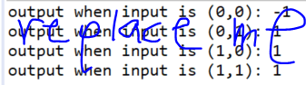

_______________________________________________________________

|  |  |
| --- | --- |
| AND values | |
| w1 | ? |
| w2 | ? |
| b | ? |

and logical AND



_______________________________________________________________

Checkpoint #2: Confirm training works on a well-defined example.

A. Provide a screenshot (or list them) of the weights of your “OR perceptron” ***before*** and ***after*** being trained with a single incorrect output. You can do this by providing a training set that has x=0, y=0 and answer is 1. (This is an incorrect answer according to logical OR). This should INCREASE your bias weight ONLY, since the input for x and y are 0.

______________REPLACE IMAGE BELOW OR LIST WEIGHTS____________________________

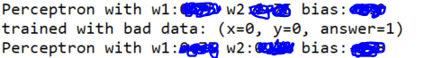

B. Try to train with a CORRECT example (x=0, y=0 and answer is -1), there should be NO change in the weights.

______________REPLACE IMAGE BELOW OR LIST WEIGHTS____________________________

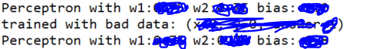

C. Train using another bad example: x=1, y=1 and answer is -1. (This is an incorrect answer according to logical OR). This should change ALL your weights since the input for x and y are 1.

______________REPLACE IMAGE BELOW OR LIST WEIGHTS____________________________



Checkpoint #3: Provide plots and note observations for each of the experiments as listed below:

**Experiment 1:  high learning rate - Repeat experiment #1, but with a learning rate of 0.1**

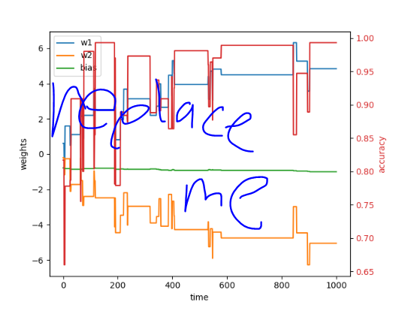

Note any observations that surprise you or confirm things you feel you understand.

**Experiment 2:  low learning rate - repeat experiment #1, but with a learning rate of 0.001**



Note any observations that surprise you or confirm things you feel you understand.

**Experiment 3:  different activation function - Try to use the tanh function instead of step function**



Note any observations that surprise you or confirm things you feel you understand.

**Experiment 4:  XOR repeat experiment #1, but let’s give our poor perceptron an impossible task. Let’s ask it to solve XOR and see what happens.**



Note any observations that surprise you or confirm things you feel you understand.