Vapor Sales Implementation Report
  - CSSE 220, Luke Mowery, Will Gebelein

Section 1: GenAI Part Preparation
- What context do you think you should provide to the GenAI tool when you ask it to implement each task? Explain your answer.
We need to give what we currently have in our code, so that it does not make entirely new variables to store and know what we already had to complete the task. We even gave context of the task, to better explain what we were trying to complete.
- For each of the three tasks, sketch out an idea of what you think will be the best way to implement the feature. (This could be on a whiteboard, or with comments forming an outline/pseudocode in the method.)
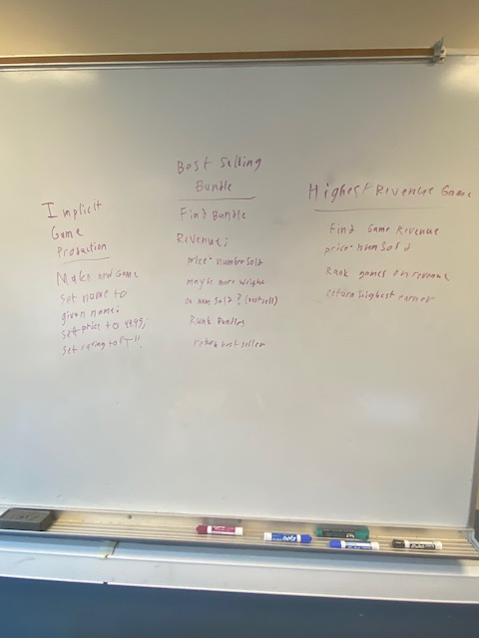

- Which GenAI tool did your team select, and why?
We used ChatGTP and Copilot, because they were able to take what we have and mostly complete the task we were trying to finish when making new chunks of code.

Section 2: GenAI Part Reflection
- Did the GenAI tool tend to produce code that was:
  - worse than,
  - better than, or
  - about as good
as you expected? Explain.
About as good because it was able to maintain the variables we were currently using, but it did not pass the AI tests and can be hard to decode in order to solve the problem within the code.
- Include link(s) to your one or more GenAI tool conversations. (Copy/paste links from the tools’ built-in “Share” features.)
 | Link | Notes
Conversation #1: | https://chatgpt.com/share/6abec245-7ef8-83ea-8da4-bd82d893e8e7 | Used to attempt to complete all GenAI tasks
Conversation #2: | https://m365.cloud.microsoft/hwav2/chat/conversation/36b34617-215f-4c5e-afde-e5384ba784c8?version=19.2609.52011.0&capabilities=interopPromise%2CsuspendOnClose%2CautoStart&client-request-id=81ada577-fa14-1940-a120-79d384414c68&appstate=suspended&SSRDesktopTest=2 | Used to determine issues with GenAI tasks

- Summarize (in 1-2 paragraphs with complete sentences) what you learned from this assignment about GenAI-assisted software development. Consider your target audience to be next quarter’s CSSE 220 students.
GenAi-assisted software development is bit of a double-edge sword. It’s capable of creating code that gets the job done and done correctly. It can also save time and energy without needing to think on how to write the code line by line. However, sometimes it can misread the question and put out code that does not complete the task at hand. It can also write the code in strange ways that makes the coder unable to understand, making it harder to explain and fix the program. Overall, when it comes to using GenAi-assisted software for coding, it’s important to give it as much information as possible to get it correctly the first time around and be prepared to fix any issues within the code. It is probably best to avoid using too much AI as possible to better write and understand code by yourself.

