**Basic Experiment 1.**

Try evolving a solution using just mutation (no crossover) 10 (or more) times. How many generations does it appear to take to evolve a solution? How much variation is there from run to run? Is this more or less than you expected (both generations and variation)?

* *population size: 100*
* *mutation rate: 1%*
* *crossover method: False*
* *chromosome length: 100*
* *selection method: Truncation (We had not implemented Ranked sorting so we had to choose between Roulette Wheel or Truncation. Roulette Wheel seemed to be a less efficient method and very rarely reached solution despite our inputs, so to make this experiment show the actual changes from our independent variables, we thought Truncation was a better fit).*
* *max generations: 500*
* *termination condition: 100*
* *Fitness function: check for 1’s*

**Hypothesis**

We expect to see the curves go up, but not reach the max fitness because we are only mutating the chromosomes, which is a random process.

**Description of the results including plots**

When crossover is off, our solution is never reached because mutation is random and the chance that the inactive genes are the only genes mutated perfectly to reach the solution is extremely unlikely. While eventually it may reach a solution, this will be through trial and error rather than efficiency.

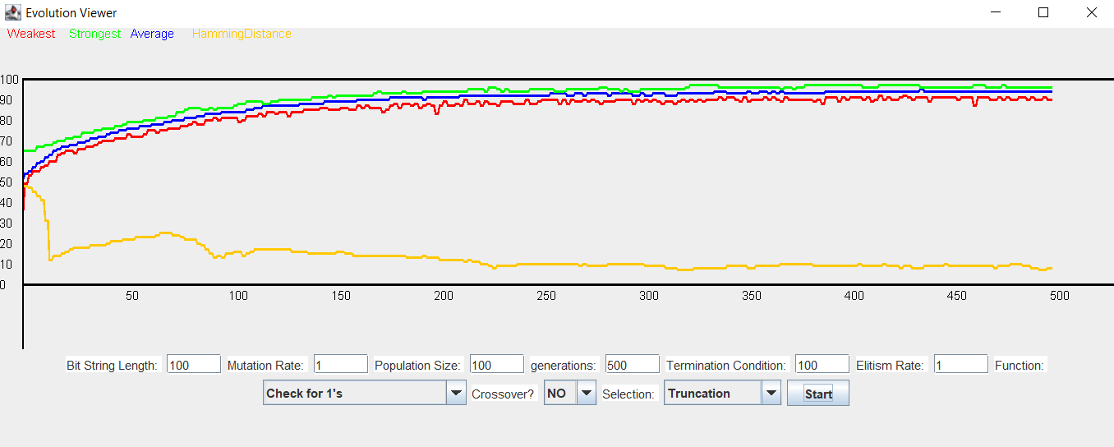

**What if anything you can conclude and anything you learned or affirmed by doing so?**

When we are only mutating chromosomes, it takes a lot of generations before we reach our maximum fitness value. There is almost no variation from run to run, which is what we expected. We conclude that because mutation is a random process, there is a lot of trial and error before we reach maximum fitness. This shows that crossover is important because it keeps good genes, which helps increase fitness faster than just mutating all chromosomes every time.

**Basic Experiment 2.**

Repeat experiment #1, but use crossover (single crossover point) and mutation. How many generations does it appear to take to evolve a solution? What can you conclude from this?

* *population size: 100*
* *mutation rate: 1%*
* *crossover method: True*
* *chromosome length: 100*
* *selection method: Truncation*
* *max generations: 500*
* *termination condition: 100*
* *Fitness function: check for 1’s*

**Hypothesis**

*We expect to see all the curves go up at a decreasing rate while never crossing one another. Crossover will make finding the solution more efficient by allowing more variety and changes and hamming distance will continue to drop as a solution is found.*

**Description of the results including plots**

It appears that the solution is found much quicker and more consistently than it was without crossover. All curves other than hamming distance also continue to increase at what seems to be a logarithmic rate and decreases the higher it gets.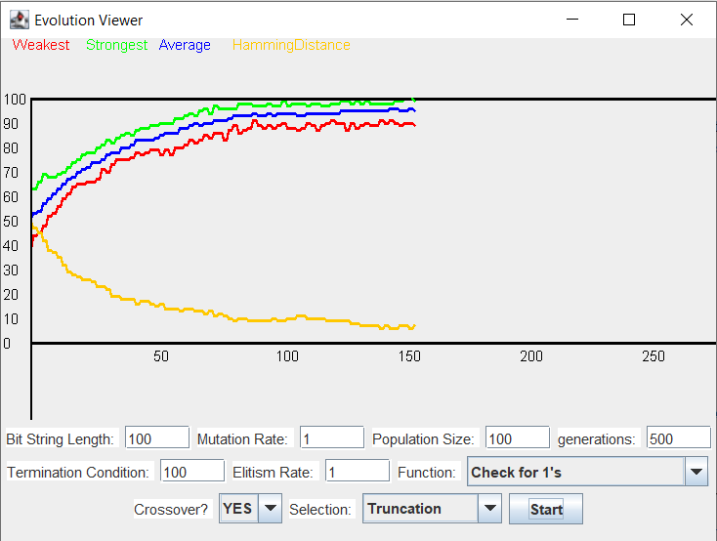

**What if anything you can conclude and anything you learned or affirmed by doing so?**

We find that each generation will still have a pretty similar difference between the average, maximum, and minimum, even as the overall values seem to increase. This shows that the distribution between them will remain relatively the same. We also see that the values, while generally increasing, have some fluctuation meaning that it is still random, but with a bias towards higher values. The main takeaway is that crossover makes it more efficient to reach a solution as it consistently took less generations to reach a solution in comparison to the previous experiment.

**Basic Experiment 3.**

Repeat experiment #1, but with ONLY crossover (single crossover point) set the mutation rate to 0. What do you think will happen? Run the experiment and report on your findings. Write down your best explanation of the results.

* *population size: 100*
* *mutation rate: 0%*
* *crossover method: True*
* *chromosome length: 100*
* *selection method: Truncation*
* *max generations: 500*
* *termination condition: 100*
* *Fitness function: check for 1’s*

**Hypothesis**

*We expect to see all the curves go up at a decreasing rate while never crossing one another. Crossover will make finding the solution more efficient by allowing more variety and changes, however, with a lack of mutation we believe that it will be less likely as no real changes are being made to the initial group. Hamming distance will continue to decrease as the least fit are being removed and the most fit are being ‘recreated’ in a sense.*

**Description of the results including plots**

It appears that the solution is almost never found and all of the chromosomes eventually become exactly the same and converge to a single value. Due to this, the max, average, and minimum become the same value. Also due to this, the hamming distance becomes 0.

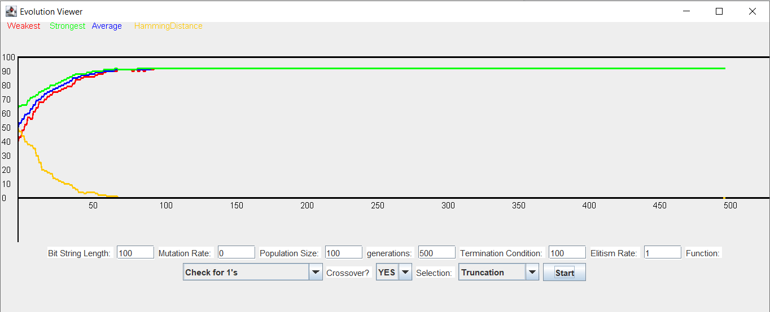

**What if anything you can conclude and anything you learned or affirmed by doing so?**

It is the same general take away from the last experiment, however, we also find that mutation is also a necessity to reach an optimal fitness. Like stated in our hypothesis, without these mutations there are no real changes being made to our starting sample other than them mixing with one another, while it is possible that this will reach the optimal fitness, it is more likely that more and more values just become closer to one another until they are exactly the same and no more changes can be made to their fitness values.

**Basic Experiment 4.**

Try different variations of parameters and turn mutation and crossover on and off in conjunction with different selection methods. Do you find anything surprising?

* *population size: 100*
* *mutation rate:20*
* *crossover method: alternating during experiment*
* *chromosome length: 100*
* *selection method: alternating during experiment*
* *max generations:500*
* *termination condition: 100*
* *Fitness function: check for 1’s*

**Hypothesis**

We expect Truncation to be a better selection method than Roulette Wheel, so Truncation will cause the population to reach maximum fitness before Roulette Wheel. Crossover is known to be helpful in reaching maximum fitness, so roulette wheel with crossover might be better than truncation without crossover.

**Description of the results including plots**

Roulette Wheel with crossover

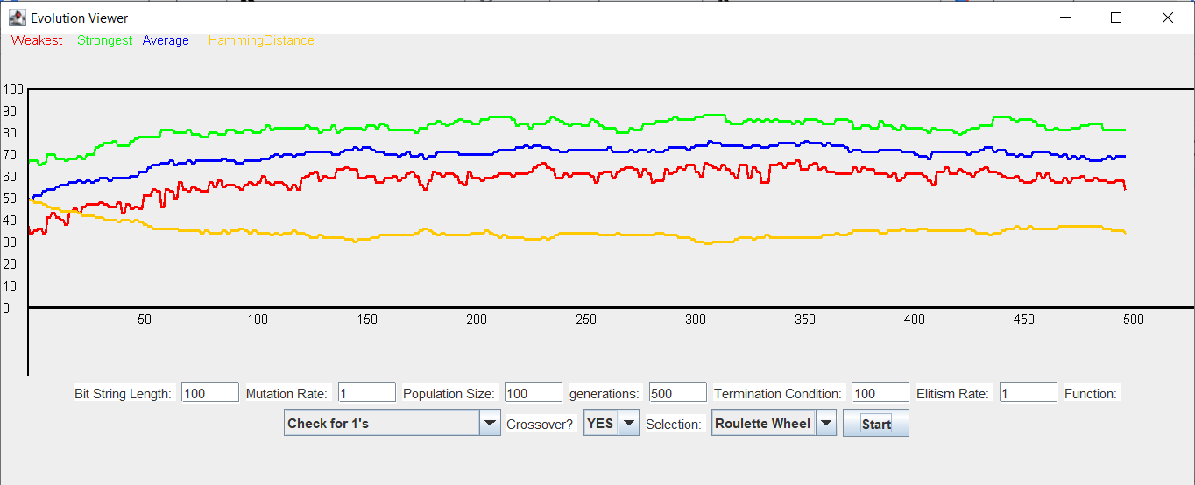

Roulette Wheel without crossover

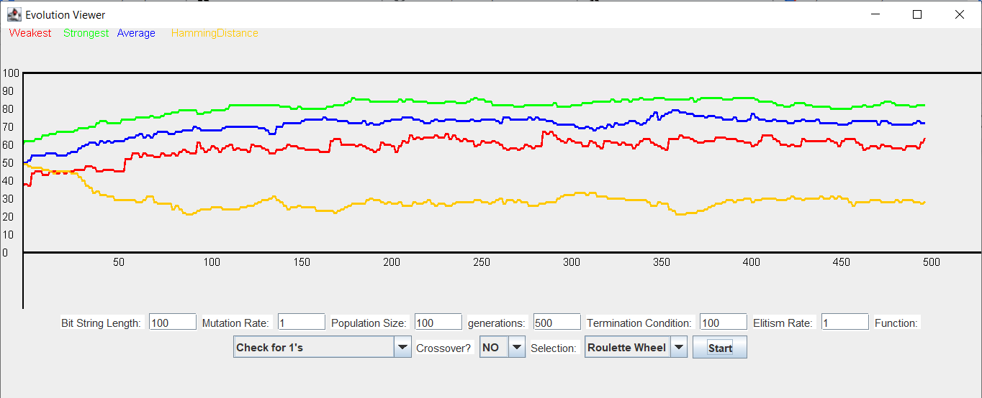

Truncation with crossover

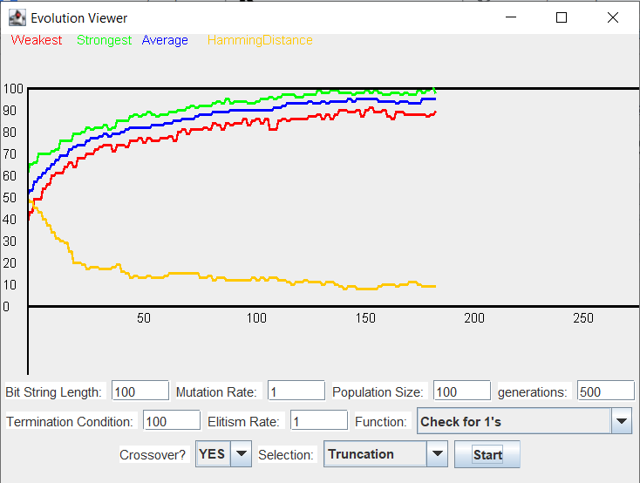

Truncation without crossover

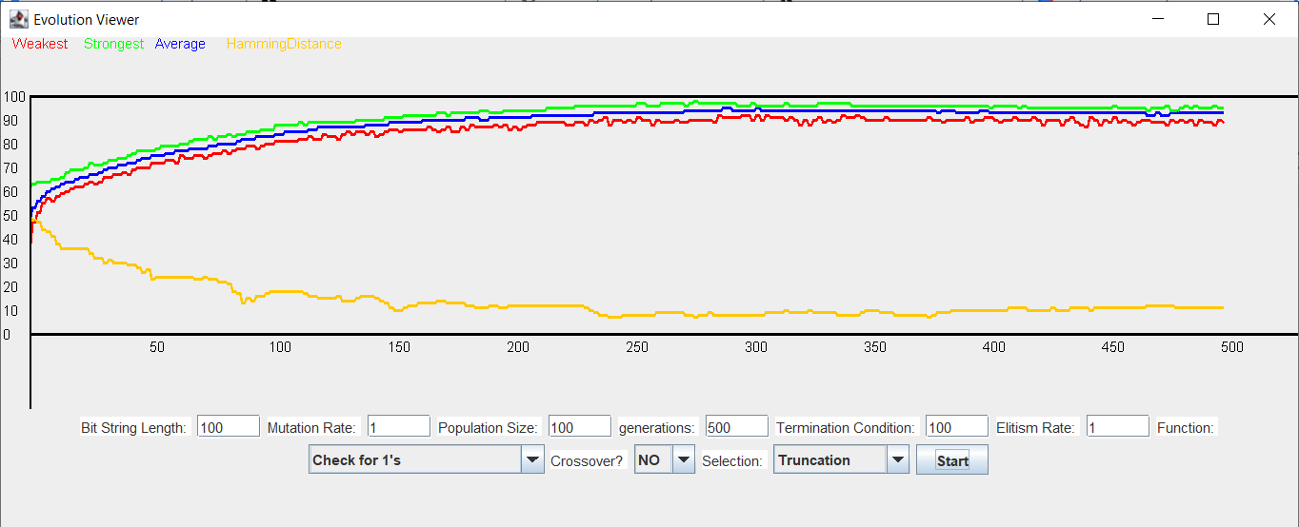

We found that from best to worst, we have truncation with crossover, truncation without crossover, Roulette Wheel with crossover, and Roulette wheel without crossover. This shows the power of crossover with the right selection method. Even with Roulette Wheel, we can see that there is less diversity with crossover than without.

**What if anything you can conclude and anything you learned or affirmed by doing so?**

We can conclude that crossover is extremely helpful in evolving a population to reach a certain maximum fitness. This is how it works in nature as well. We get our genes based on our parent’s chromosomes swapping with each other. We also have some mutation, or else we would reach a certain fitness but not the maximum we want. If we only had mutation and no crossover, then our parent’s fitness doesn’t pass on to us. We can also conclude that truncation is a much better selection method than roulette wheel.

**Experiment 5 - What we chose.**

What would happen if the fitness function changed part way through the evolutionary process? Would such a change be biologically realistic? Devise and produce an experiment to explore this. Is there a relationship to diversity and your results?

We decided to model this experiment by changing the fitness function in the middle of EvolutionMain running. The answers to the questions posed above are located in the conclusion.

* *population size: 100*
* *mutation rate: 1*
* *crossover method: True*
* *chromosome length: 100*
* *selection method: Truncation*
* *max generations:500*
* *termination condition: 100*
* *fitness function: changed between check for 1’s and check for consecutive 0’s*

**Hypothesis**

We expect the general fitness values to increase over time and they will never cross and same as before, they should increase at a decreasing rate as it gets closer to the ideal fitness. When we change the fitness function, there will be a huge drop in the fitness value as the entire definition of fitness was changed. At this point, the fitness will begin to increase again as it adapts. We believe the diversity should increase slightly as the definition of fitness was changed so the previous ideal will be broken apart and increases the hamming distance before it grows closer to the the new ideal and will once again decrease.

**Description of the results including plots**

We see that the fitness value does take a large drop when the fitness function changes, we also see that after this change the hamming distance does increase slightly, however, after the fitness value begins to recover, the hamming distance seems to settle down and start decreasing again. The weakest chromosomes seem to never recover and continue to fluctuate, while the fittest and average chromosomes grow closer and begin to increase again albeit at a slower rate than previously, however, this may be due to the specific fitness function.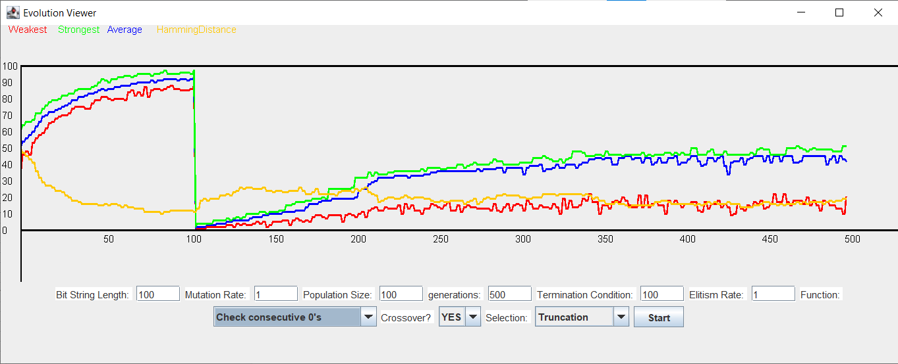

**What if anything you can conclude and anything you learned or affirmed by doing so?**

First, this is an experiment that is biologically realistic. While it does not occur very often, there are events that can change entire ecosystems and redefine what is necessary to survive. For example, humans, with deforestation due to logging and forest fires caused by campers or hunters, in certain areas, the forests have been reduced to nothing, the previous animals that had the features necessary to survive in a forest now have lost their advantage, it might even make them more vulnerable decreasing their ‘fitness value.’ Previous mutations that may have seemed disadvantageous may be equivalent to winning the lottery in this new world. The hamming distance seems to increase slightly when the fitness function is changed. While afterwards, it does seem to follow it’s previous trend and continue to decrease, but it seems that the diversity of the chromosomes will increase when fitness value changes.

**Experiment 6 - What we chose.**

What would happen if the fitness function changed part way through the evolutionary process? Would such a change be biologically realistic? Devise and produce an experiment to explore this. Is there a relationship to diversity and your results?

We decided to model this experiment by changing the fitness function in the middle of EvolutionMain running. The answers to the questions posed above are located in the conclusion.

* *population size: 100 for first run, 1000 for last three*
* *mutation rate: 0*
* *crossover method: True*
* *chromosome length: 10 for first, 15 for last three*
* *selection method: Truncation for first, Roulette Wheel for last three*
* *max generations:50 for first, 100 for second, 200 for third, 300 for last*
* *termination condition: Unnessecary*
* *fitness function: Experiment from Paper*

**Hypothesis**

We expect the number of one’s to increase quickly while the number of zero’s decrease quickly after a few seconds in the run. The question marks should vary and then become constant. Our fittest chromosome should start small and then increase to 100 fitness. Our average chromosome should converge with the fittest.

**Description of the results including plots**

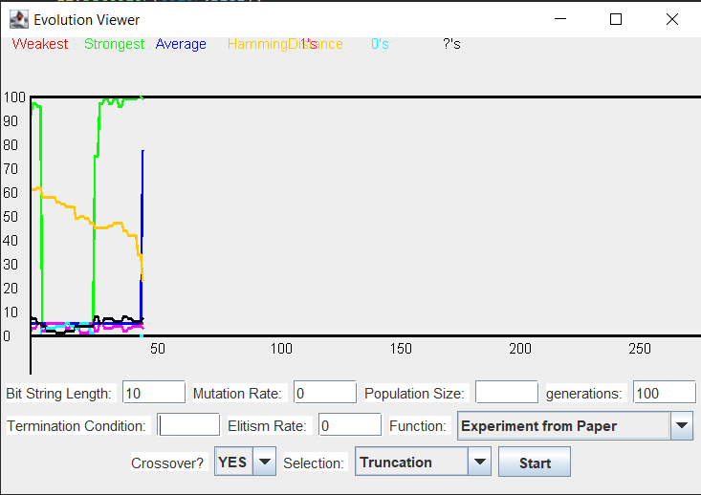

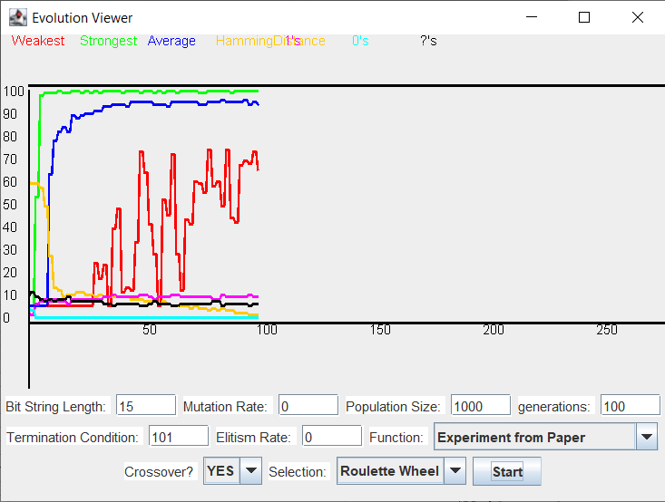

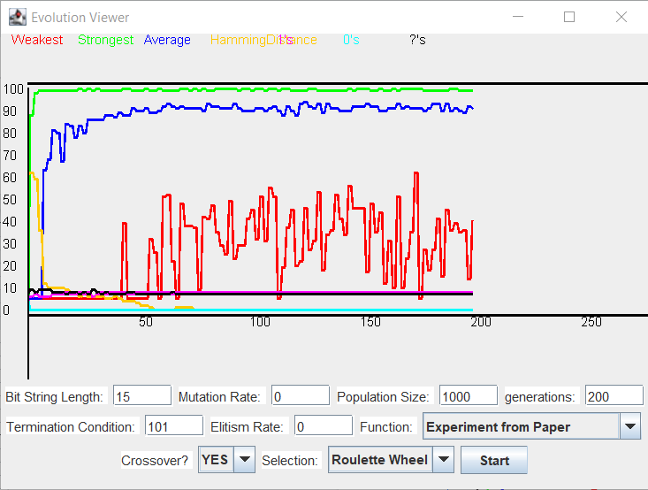

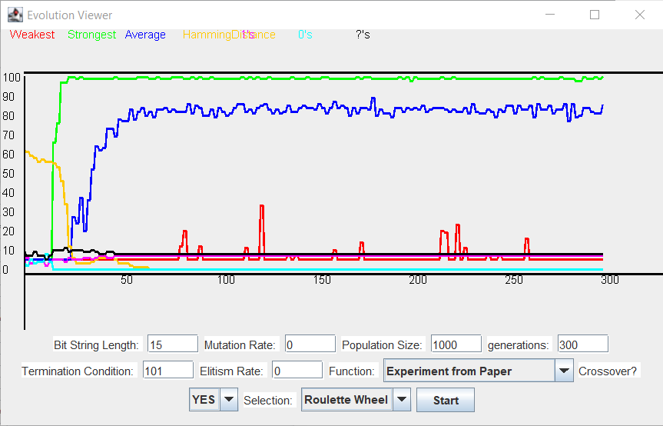

We see that almost every time we run, our fittest rises to maximum fitness, the average starts to converge with the fittest, the weakest has a lot of variation, the 0’s and 1’s start at the same amount and at the beginning spike to all one’s and all zeroes with the questions rising at first and then lowering to a constant value.

**What if anything you can conclude and anything you learned or affirmed by doing so?**

We can see that we reproduced similar results from the paper. We learned that when we take into account learning, the population can either reach the fittest very quickly, or just drop to the lowest fitness level. At large bit string lengths, this method does not work as much as with smaller bit string lengths. Occasionally we see a large dip in the fittest’s fitness. This is because the fitness function is probabilistic.