Car Racing Game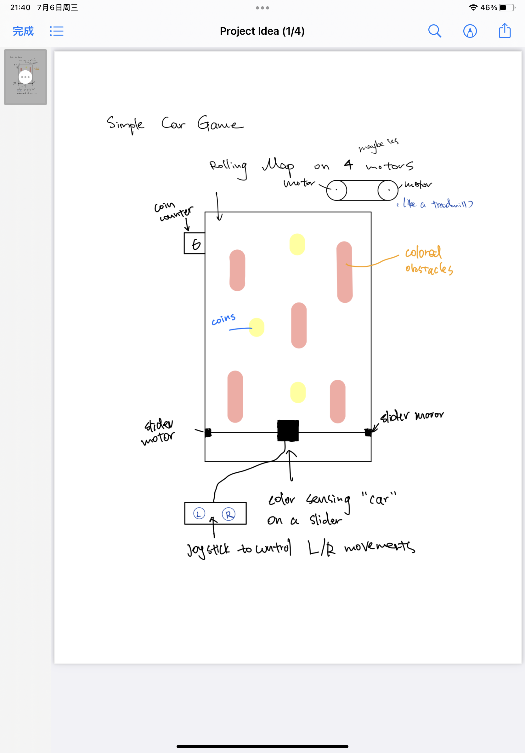

Inputs: Buttons controlling left & right movement; Color sensor in the middle

Outputs: digital number on the top left corner

Parts List:

* RGB color sensor
* Additional GearHead Motors