ROBOGAMES 2016

EVENT NAME: - IRGT

*DATE: -*

Team info

Team name:- Rhitvik

Team leader’s name:- Rhitvik

Contact details of team leader:- 9799755477

Number of members in the team (max 7):

*MEMBERS INFO:-*

|  |  |  |  |
| --- | --- | --- | --- |
| S No | NAME | EMAIL ID | PHONE NO. |
| 1 | Rhitvik | rhitvik17@Gmail.com | 9799755477 |
| 2 |  |  |  |
| 3 |  |  |  |
| 4 |  |  |  |
| 5 |  |  |  |
| 6 |  |  |  |
| 7 |  |  |  |

IMPORTANT NOTES AND GUIDELINES:-

* Filling of this form should be taken **seriously** as the selections would be based on the evaluation of this form.
* All the Information and facts provided by you must be **correct**.
* Any information and content which are taken from elsewhere must be given proper reference.
* Your content should be Brief and addition of unnecessary content should be avoided.
* Images should be used wherever you feel appropriate in a sense that it gives a better vision of your content.
* You can attach CAD diagrams, Electronic simulations provide links etc. ., related to your robot.
* **Any form of plagiarism shall lead to disqualification.**
* Attach the list of components used.

***DEADLINE FOR ABSTRACT SUBMISSION : - 30 December 2015.***

***ABSTRACT SHOULD BE MAILED TO : - robogames@techkriti.org***

***SUBJECT OF MAIL SHOULD BE : - “Robogames: <Team Name> Event Name”.***

**Try sending a single abstract. In-case of multiple abstracts the latest shall be considered**

**Please check our website** [**www.techkriti.org**](http://www.techkriti.org) **for further updates .**

**FOR ANY QUERIES CONTACT:**

**SASIKANT SAINI JAISHRI JAIN ANIRBAN MANNA MOHIT PANDEY**

**7752894595 8127183931 7275797315 8090621345**

INTRODUCTION:-

In many fields robots are used to carry loads from one place to another. If the robots made are to carry heavy load and have to take turns, complex steering and handling systems must be used. These powerful drivers and actuators can cause the cost of the robots rendered high. Since the pathways on which the robot has to take turns, the proper turning will be requiring optimum power delivered to the wheels for which electronic differential drives are employed. But these drives are applicable on the rear wheel set or the front wheels, accompanied by a pair of Omni directional wheels. Thus for more power the motor installed has to be more powerful. This will solve the power problem but will not improve the traction of the robot and hence the controllability of the system reduces down.

So to solve this type of problem the robot can be fitted with a four wheel drive that will be controlled by a microcontroller programmed with a knowledge based algorithm that will not only improve the traction offered but also will give a better control over the robot and also will solve the problem of skidding of the wheels during the turning as each wheel will be given a controlled power on the basis of calculation and radius of turns.

Also the robot is provided with a regenerative mechanism which will recharge its batteries during the braking mechanism. The idea is to optimize the power by implementing KERS (Kinetic Energy Recovery System).

The robot can also be controlled with the tilt action of the accelerometer fixed on the transmitter.

CONSTRUCTION:-

Electronic components used:

FOR ROBOT AND TRANSMITTER: Microcontrollers, relays , motor drivers, Darlington arrays, RF-receiver and transmission module, relays, printed circuit board, batteries, LEDs, resistors, capacitors, inductors, potentiometers, crystal oscillators, motors (DC motors), voltage regulators, joystick buttons, wires, accelerometer, servos.

Mechanical components used:

Aluminum frame, supporting stand, mounting brackets, centre shaft economy motor wheels, nut-bolts, wrist band for accelerometer mounting, cover case.

ANATOMY:

The four wheels of the robot will be mounted on the shaft of the motors. The front wheel will be coupled to servos and will let the robot to take turns on a variable turning radii basis which will be controlled by the user with the help of joy stick switch or the accelerometer fitted on the wrist band itself. A variable PWM will be fed to the motors independently and accordingly on the basis of the movement and acceleration required on an analog basis.

The ADC controller will continuously sample the analog position of the joystick switch and then transmit the 10 bit sampled value to the receiver of the robot which will then control the speed and direction of the robot. This can also be done by the position of the accelerometer once the switch is pressed on the remote.

During the braking of the robot relays will actuate and drive the operation of the motor in the fourth quadrant also well known as the recovery mode or the regenerative mode. If the voltage generated falls below a given threshold, the relays will actuate again and cause the braking by driving the motor in the third quadrant. The generated voltage can be fed back to the battery to recharge it. Kinetic energy recovery system is employed in the robot to regenerate electricity by harnessing the momentum of the robot itself.

WORKING PRINCIPLE:-

INNOVATION:

1. KERS – Kinetic Energy Recovery System is used in the robot that will recharge the batteries of the robot while its braking time. This technology integrated with the cadence braking mechanism can also be employed in the hybrid electric or pure electric vehicles instead of flywheels that are not only costlier arrangement but also increases the aggregate mass of the vehicle.

2. four wheel differential drive is employed that will result in a better traction on the surface of the operation, more controllability factor on the robot and will make the system more modular in which 4 low power motors can be used instead of two heavy duty motors which are costlier during replacement.

3. Cascaded serial communication is employed to solve the problem of pin count deficiency instead of multiplexer circuits in 8-bit microcontrollers that will provide a better level of controllability on the whole system. Hence no heavy duty microcontroller need be installed and also the requirement of multiple channels of communication is eliminated.

WORKING PRINCIPLE OF THE ROBOT:

The whole system can be divided into three parts: COMMUNICATION SYSTEM, KINETIC ENERGY RECOVERY SYSTEM, LOGIC FEEDBACK and CONTROL SYSTEM.

1. Communication system: the remote will continuously send the data to the receiving microcontroller which will then drive the microcontroller accordingly. The remote can change the sampling of the analog values generated by the joystick to the accelerometer that can be mounted on the wrist and then can be used to control the robot by gesture action.

2. Kinetic Energy Recovery System will be activated in the robot during the braking of it. This will recharge the batteries in it and will improve its efficiency.

3. The control system is majorly open looped except for one part where the braking if required is not achieved by the virtue of back EMF, which will stop the KERS and will cause braking deliberately. The rest of the system will actuate the motor drivers according to the signal received by the microcontroller and will independently generate PWM signals for each motor individually. Here state cycle implementation can also be used but it will just render the controllability of the system low.

The internal circuitry will also cause the steering mechanism of the robot by controlling servos in accordance to the signal received by the microcontroller. To overcome the problem of skidding each motor will be fed different amount of power to drive the robot with the calculations done on the basis of the turning radius which will again be determined by the sampled voltage in the joystick switch by the microcontroller in the remote transmitter.

REFERENCES:-

The robot is currently under development due to which images and simulations have not been uploaded yet.

Coding is done on Atmel studio 6 in C++ on AVR platform

The circuit design is made on Proteus.

The image provided is of the basic control system made for the robot.

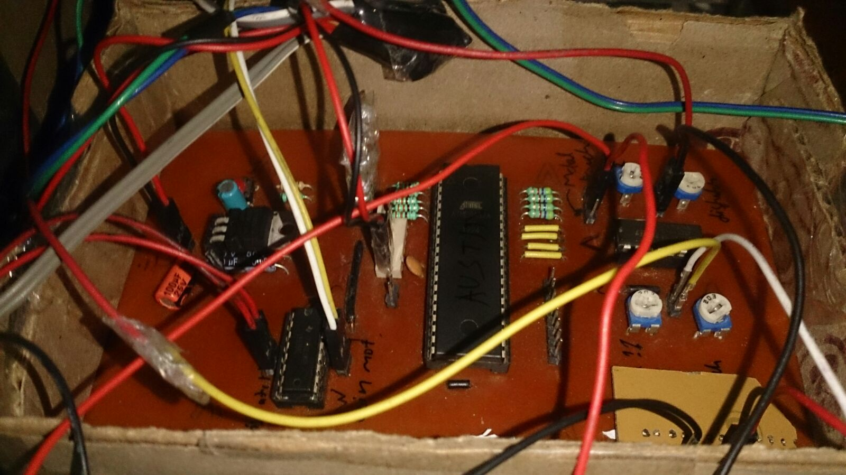

LIST OF ATTACHMENTS: -

(List of components is attached to the mail)

ANY INFORMATION YOU WOULD LIKE TO SHARE

Robot is currently under development as a result of which pictures and videos have not been uploaded on the internet yet.