GLOBAL INSTITUTE OF TECHNOLOGY

DEPARTMENT OF ELECTRICAL ENGINEERING

SYPOPSIS OF PROJECT

PROJECT:

KINETIC ENERGY RECOVERY SYSTEM

TITLE OF PROJECT: KINETIC ENERGY RECOVERY SYSTEM

CIRCUIT DIAGRAM:

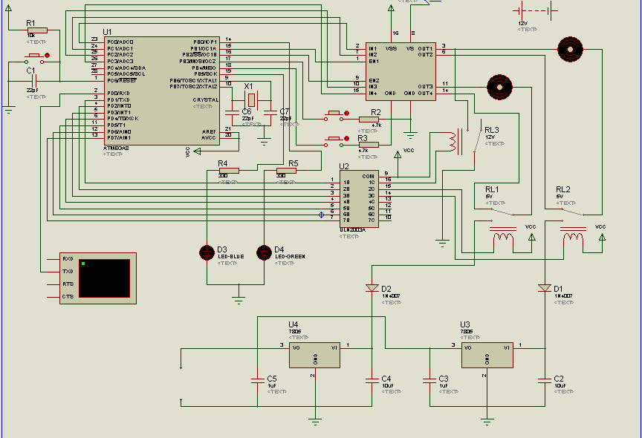

WORKING PRINCIPLE:

Kinetic energy recovery system is the method of using the driving mechanism to operate in regenerative mode in order to produce power along with braking which in turn can be fed back into the battery for charging purposes hence incrementing and optimizing the performance of the system by extending the battery life.

As all the electric vehicles operate with either DC motors or 3ph synchronous motors (commonly known as BLDCs), in the period of braking if these motors are operated in generative mode, not only the regenerated energy can be used to recharge the battery but also the back EMF generated by the action can improve the braking dynamics of the car.

The principle used is that the operated car with motors (here DC motor) will be subjected to a switching circuitry by an EMS (engine management system), for this a microcontroller is employed here to alter the logics at its programmed pins which in turn will actuate the relays that will be forming the connections in operative or regenerative mode.

COMPONENT LIST

1. DC motors

2. Gear box

3. Microcontroller

4. Voltage regulators

5. Relays

6. Crystal oscillators

7. Wires, cables and buses

8. Resistors, capacitors and inductors

9. Encoders

10. Motor drivers

11. Darlington and resistance arrays

12. Chassis mount and tires

13. Transmitter and receiver unit

14. Batteries and charger

15. Bearings

16. Programming platform (USBASP)

17. Leds, potentiometers and operational amplifiers

FUTURE SCOPES

With the increased concern in the world about the pollution and incremented fuel needs, there is a technological paradigm shift from internal combustion engines to hybrid electric or pure electric cars where the current technological needs demands to incur low production costing in manufacturing for increased power rating, it might prove to be a good alternative for battery replacement which will promise to run for more time.

Also battery with higher power are costlier and heavier will result in increased investments and parasitic effect on the assembly as well as the power train if used so.

Hence to conclude this method of regenerative mechanism will result in a better operated and incremented battery performance of the electric/hybrid vehicle which will not only make the whole assembly lighter but also fetch a better value for money.