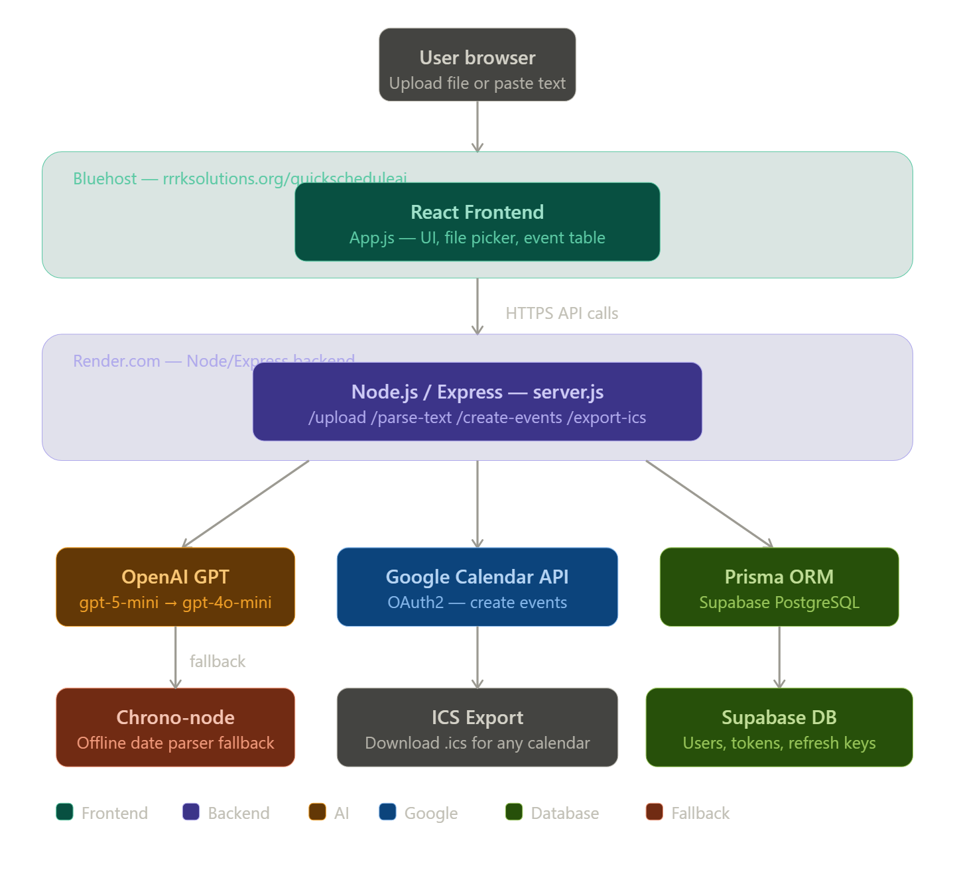
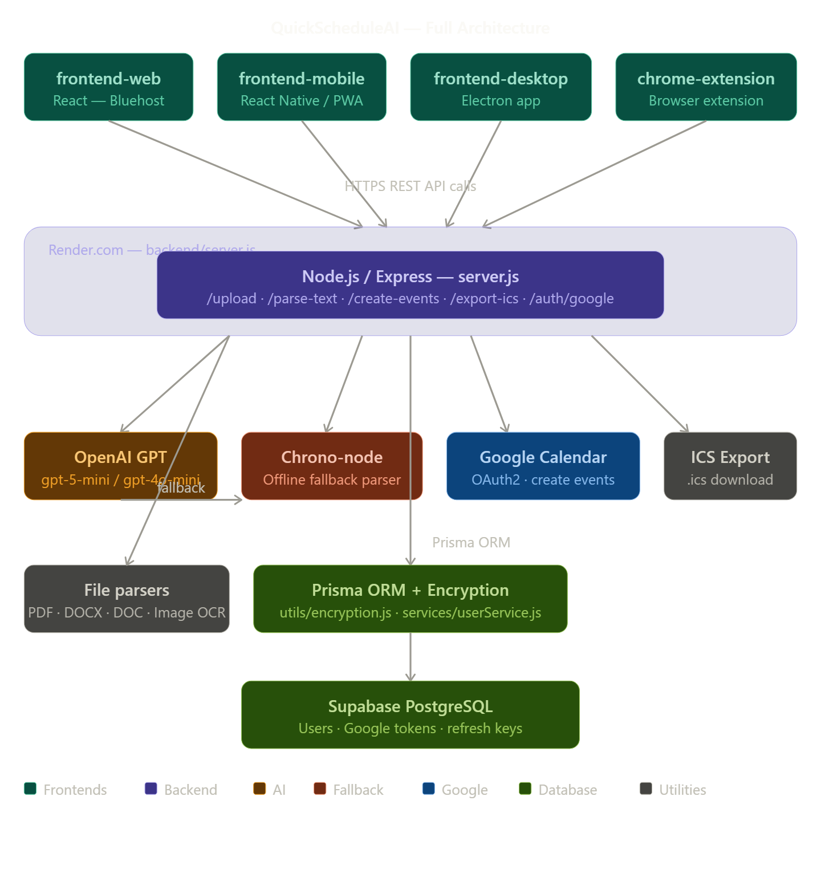

Your project is more complete than a typical hobby app! Here's your full tech stack based on what I can see:
4 Client Apps — all talk to one shared backend:
- frontend-web → React → deploy to Bluehost
- frontend-mobile → likely React Native or PWA
- frontend-desktop → likely Electron
- chrome-extension → browser extension
1 Shared Backend (backend/server.js):
- Node.js + Express
- OpenAI GPT-5-mini (with gpt-4o-mini fallback, then chrono-node offline fallback)
- Google Calendar OAuth2
- Prisma ORM with encryption
- PDF / DOCX / OCR file parsing
1 Database:
- Supabase PostgreSQL (to replace your local one)

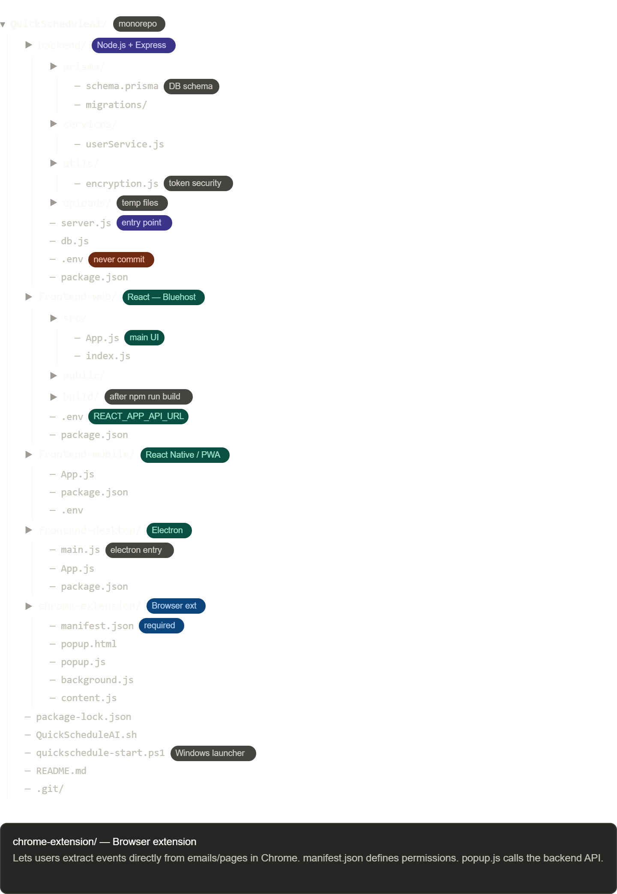

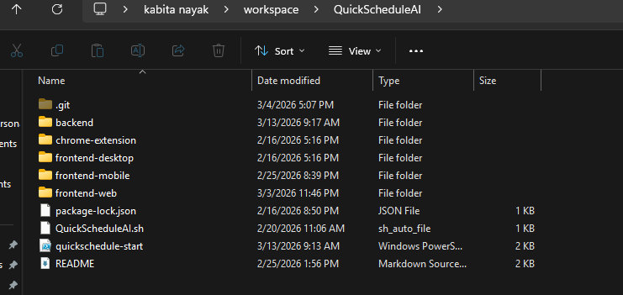
Click any box to ask about that component! Here's a quick summary of the flow:
- User uploads a file or pastes text in the browser
- React frontend (Bluehost) sends it to the backend via HTTPS
- Express backend (Render) extracts text, calls GPT-5-mini to parse events
- If GPT fails → falls back to chrono-node (offline, no API needed)
- User reviews events → either pushes to Google Calendar (OAuth2) or downloads .ics
- Prisma + Supabase stores user tokens securely for Google re-auth
The key deployment split is Bluehost (frontend only) + Render (backend + all the heavy lifting).
Your QuickScheduleAI.sh and quickschedule-start.ps1 are launcher scripts — great for starting all services locally at once. Make sure your .env files are in .gitignore across all folders before pushing to GitHub, since you have API keys in there.

