Software construction

Lab5

Raaiha Humayun

BESE 6B

TASK 4

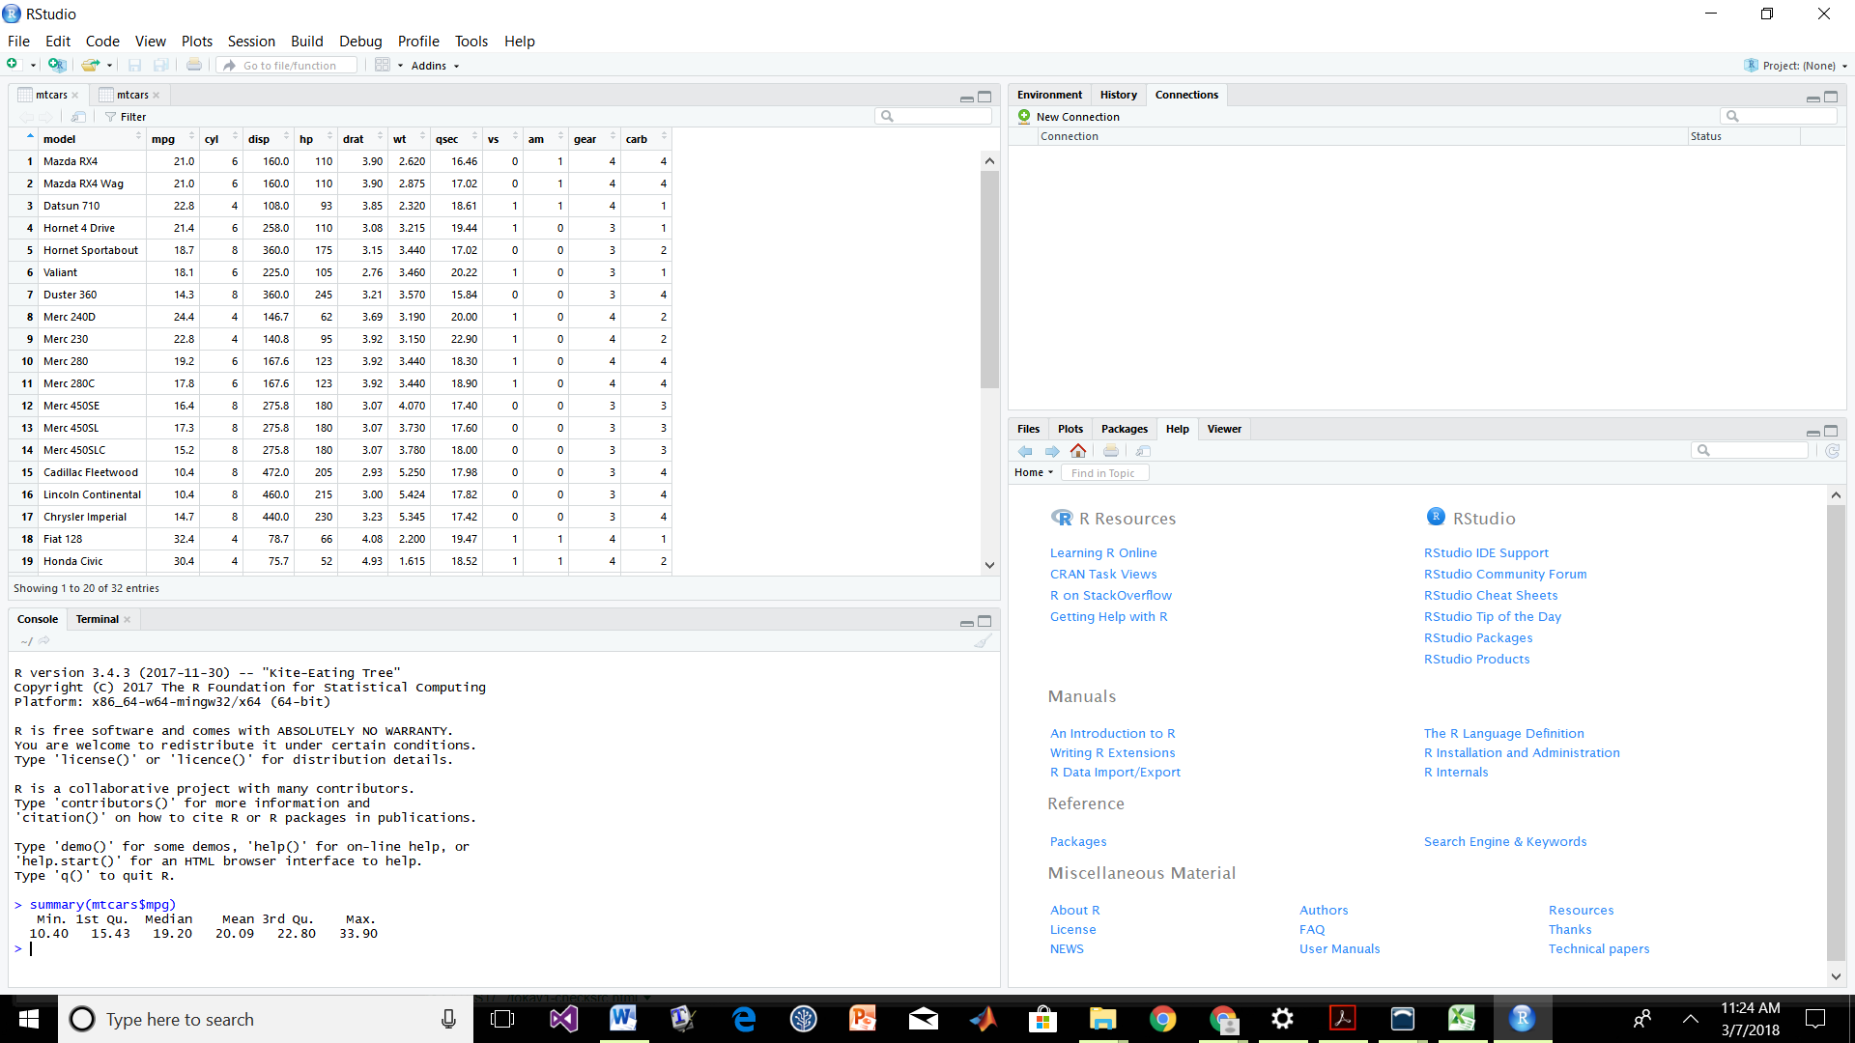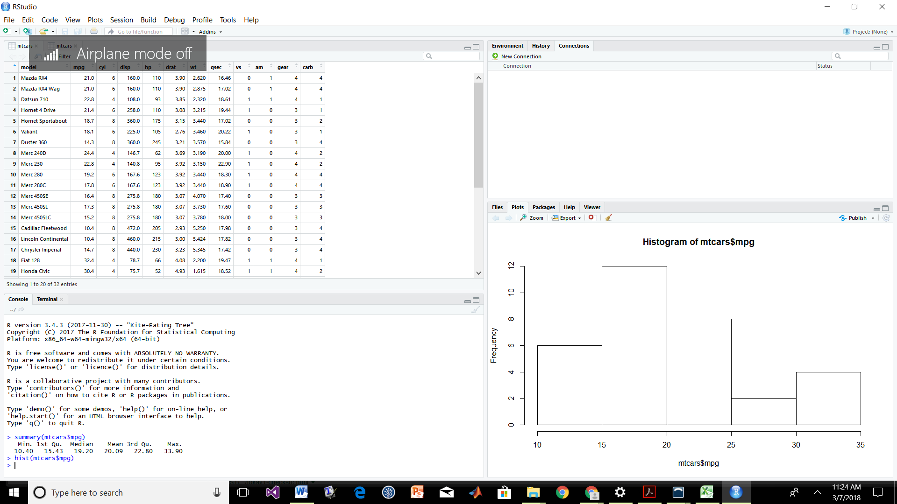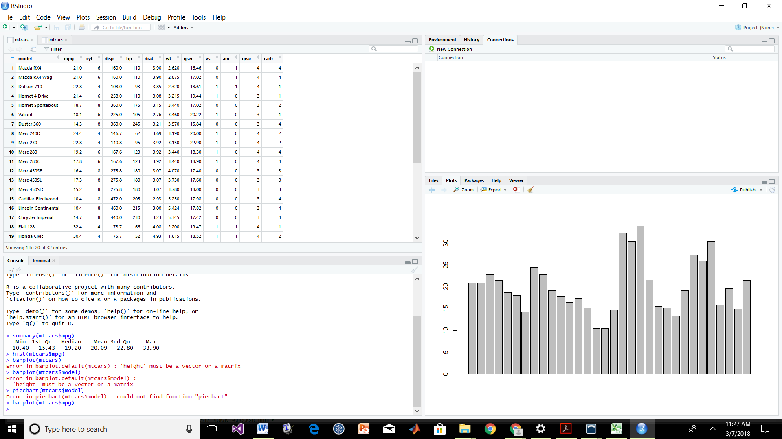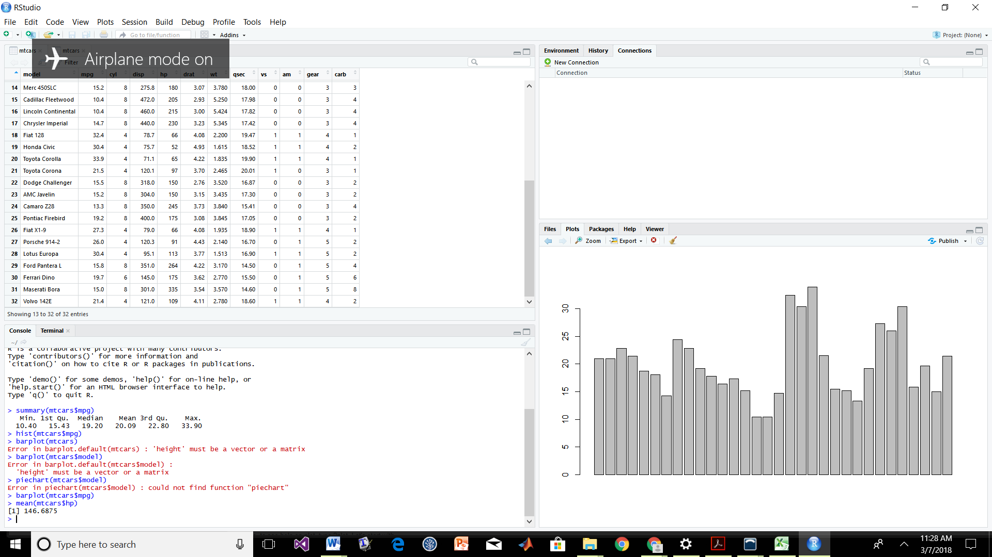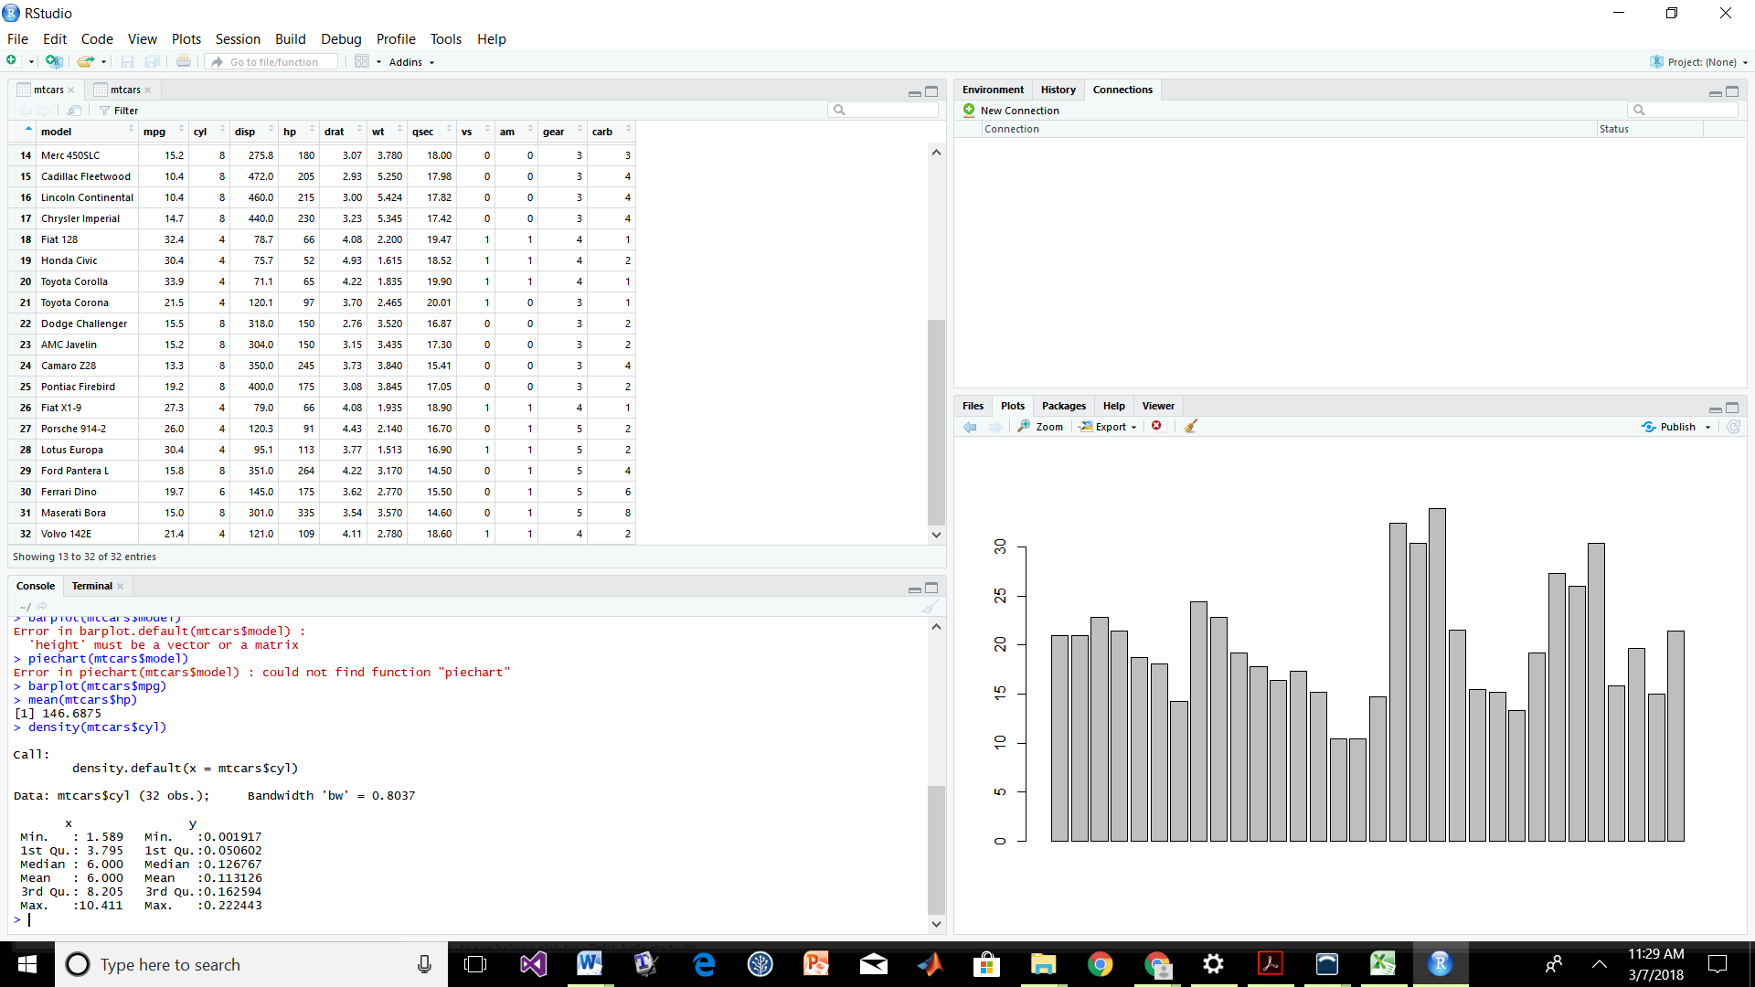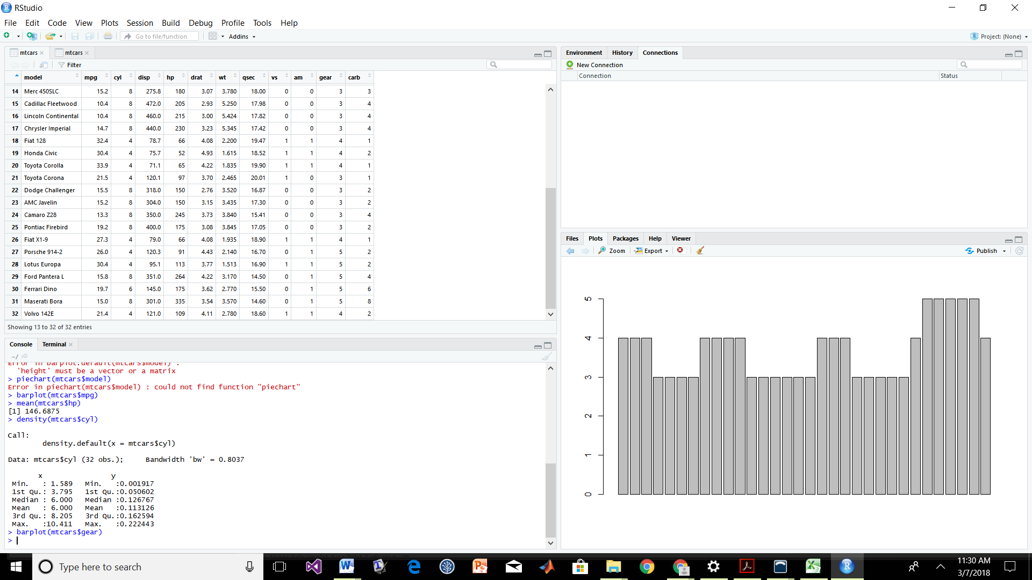

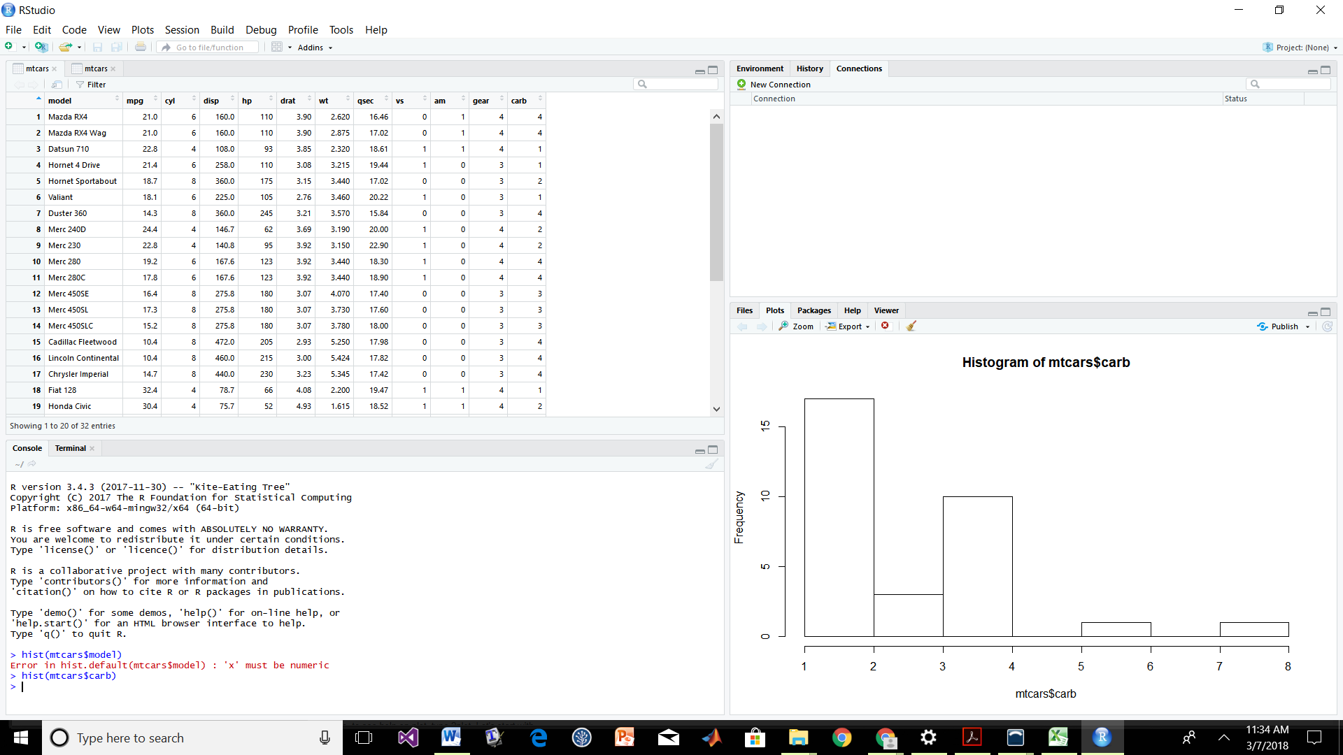

LAB 5 PART 2

Q6)

Highest profitable month is: July

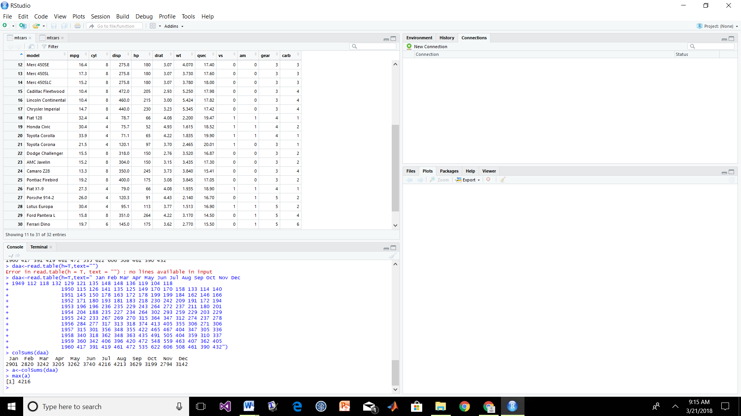

Highest profitable year is: 1960

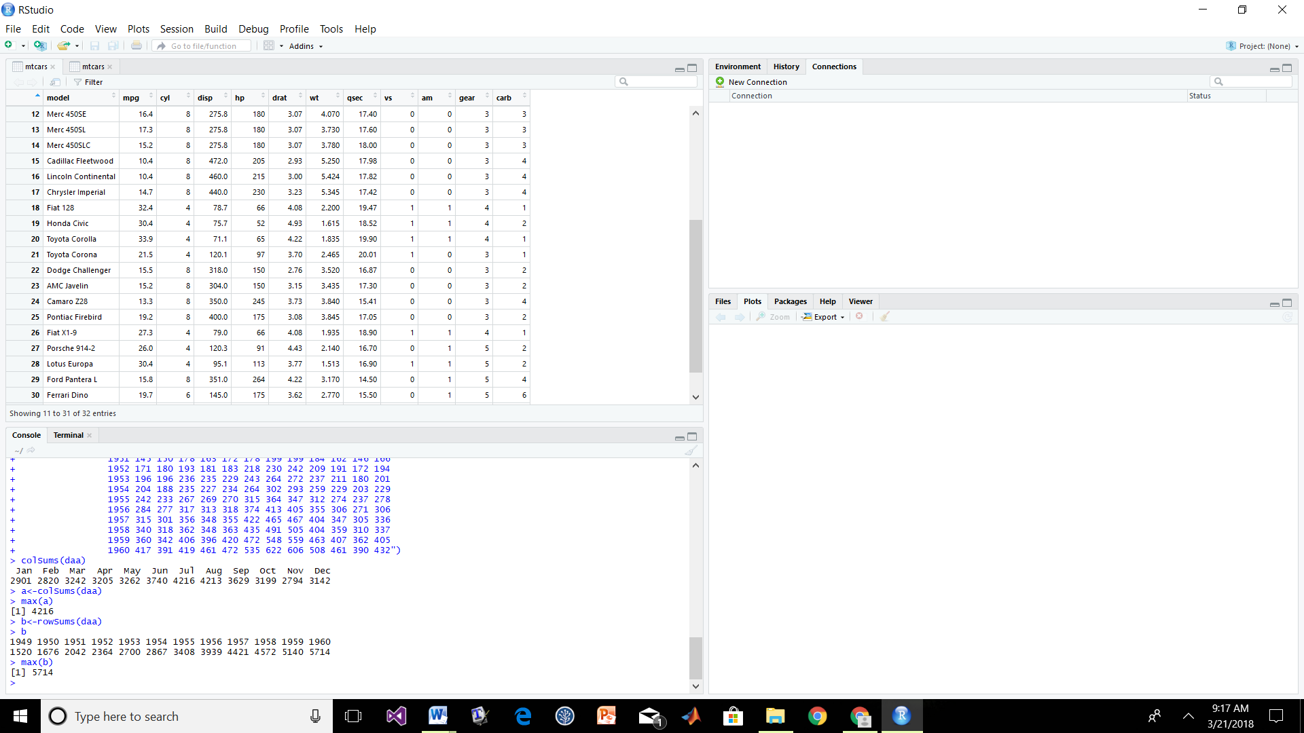

Plot:

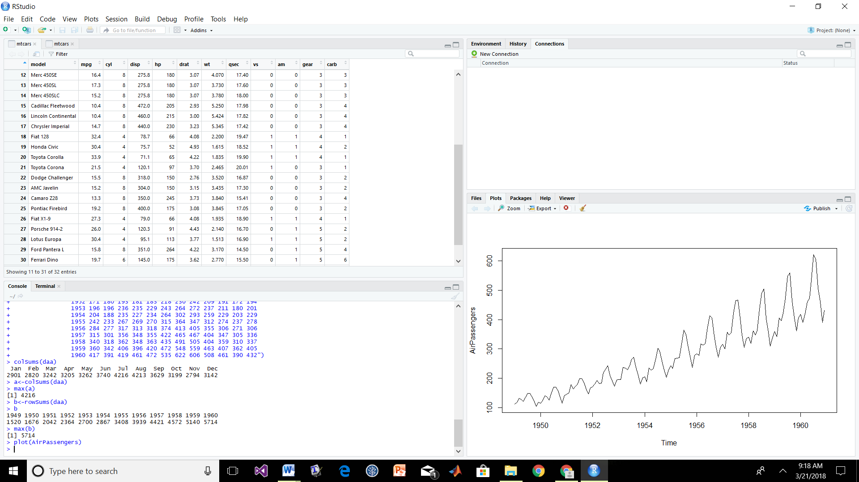

Q7

z = c(8000,8800,9680,10648,11712.8,12884.08,14172.5,15589.75,17148.73,18863.6,18863.6,20749.96)

> ny<-z\*daa

a) colSums(ny)

Jan Feb Mar Apr May Jun Jul Aug Sep Oct Nov Dec

45172806 43484887 49879318 49662324 50814744 58425293 66115803 66029562 56377851 49765770 43386599 48586485

> max(colSums(ny))

[1] 66115803

SO the most profitable month is July out of 12 years data with a value of 66115803

b) Most profitable year in 12 years is 1960 with a value of 11856271

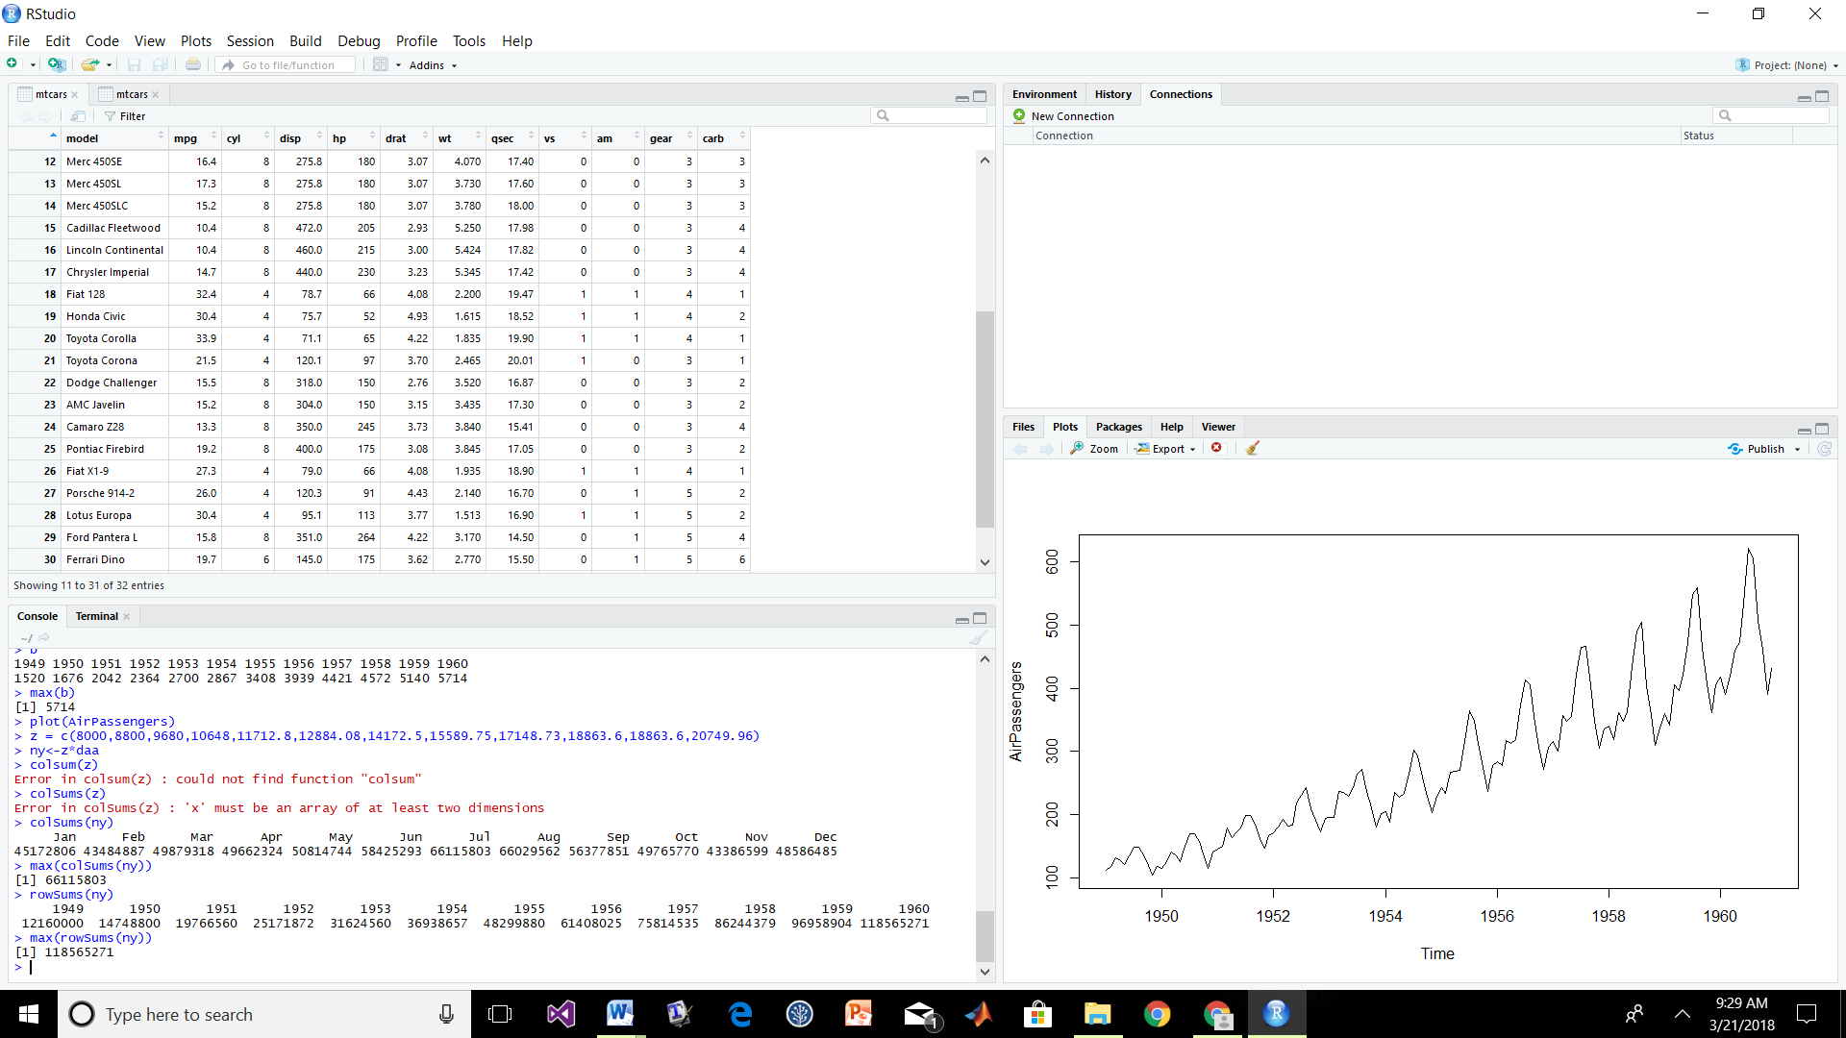

c) The total revenue is: 627701445

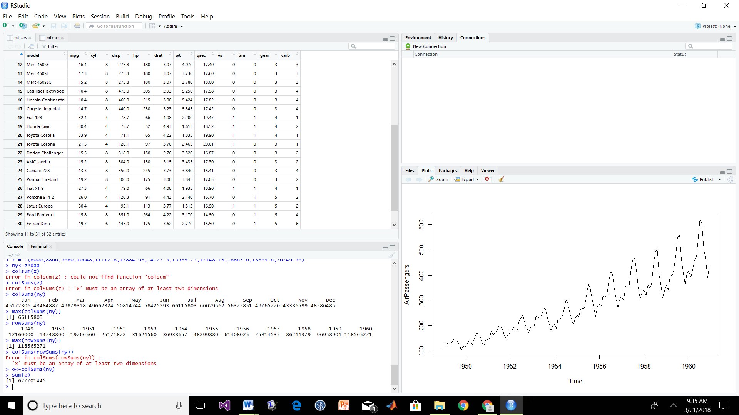

8)

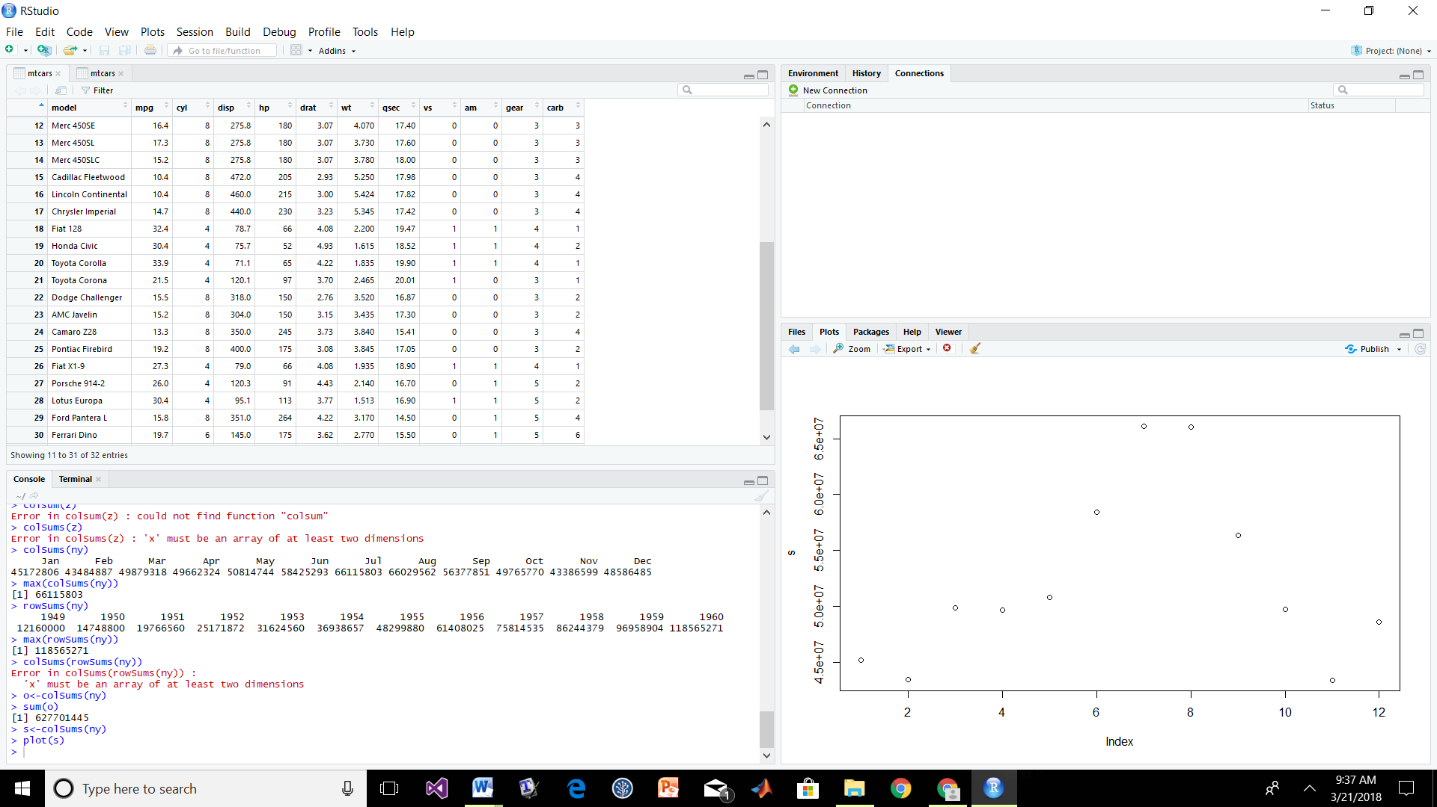

So we can see that july is the most travelled month