Software construction

Raaiha Humayun Kabir

Lab 8

BESE 6B

122995

Statement autocommit false time 3 sec

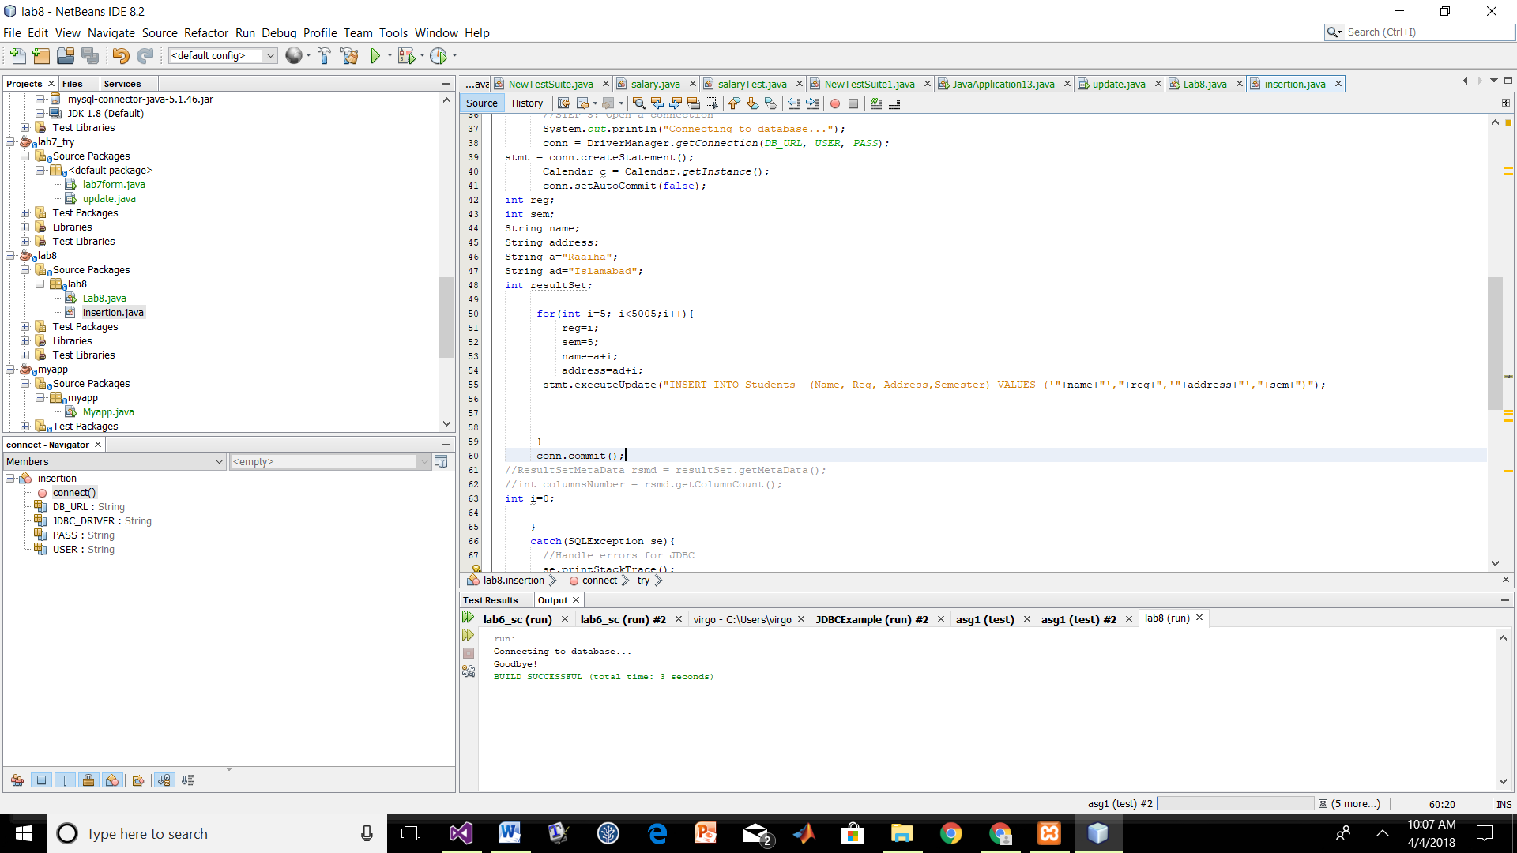

With Statement and autocommit true time 3 min 0 sec

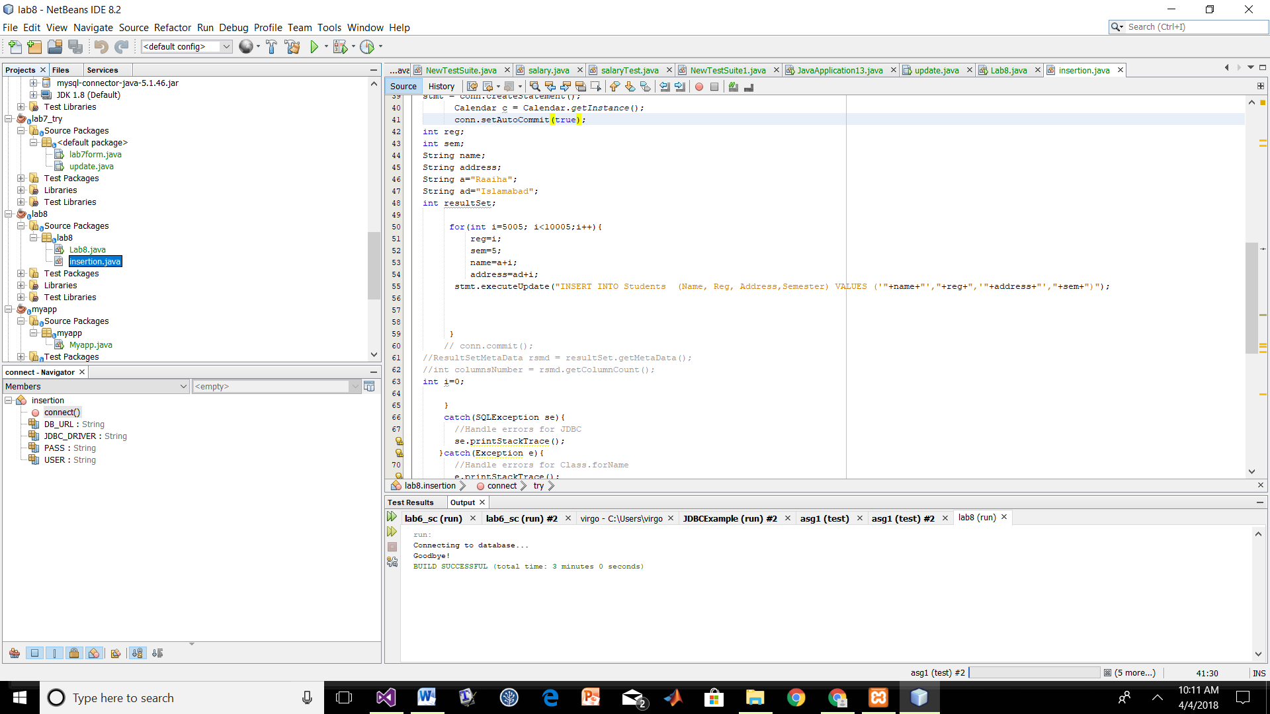

With Prepared Statement and autocommit true time 3 min 10 sec

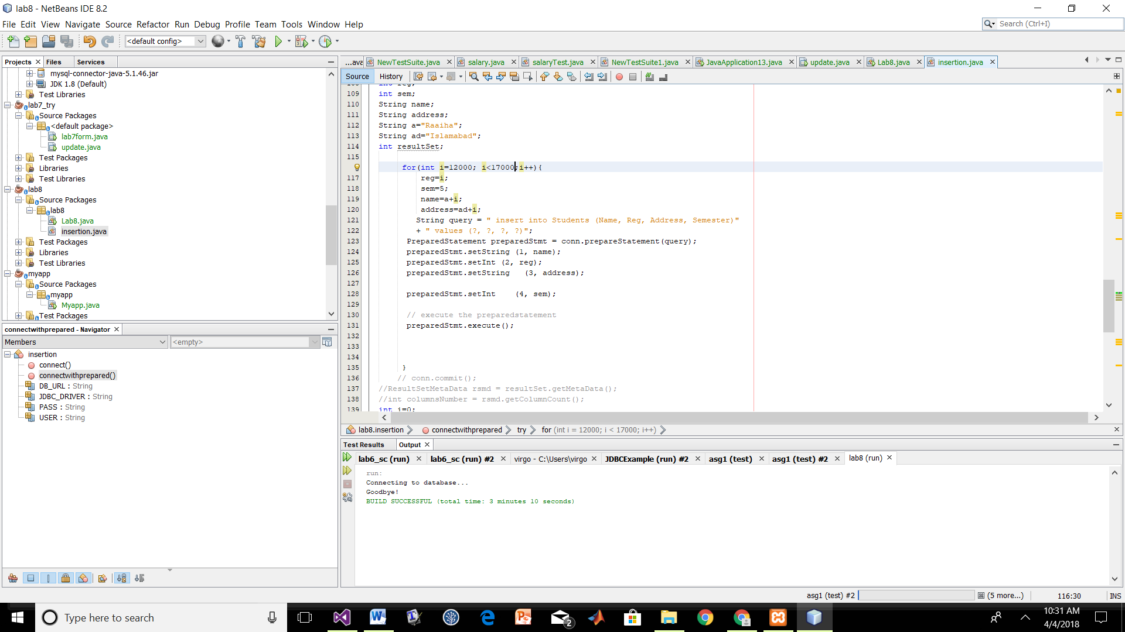

With Prepared Statement and autocommit false time 2sec

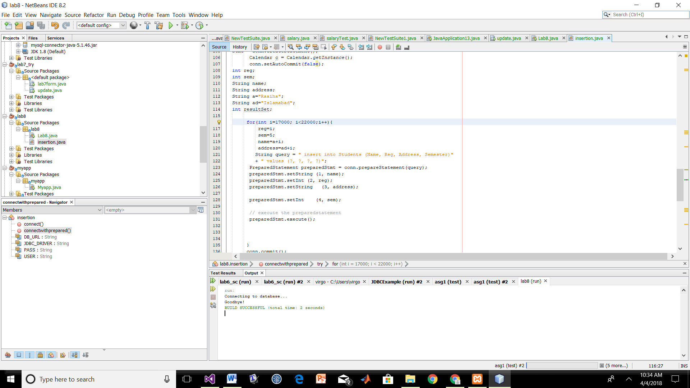

With batch update and autocommit false time 3sec

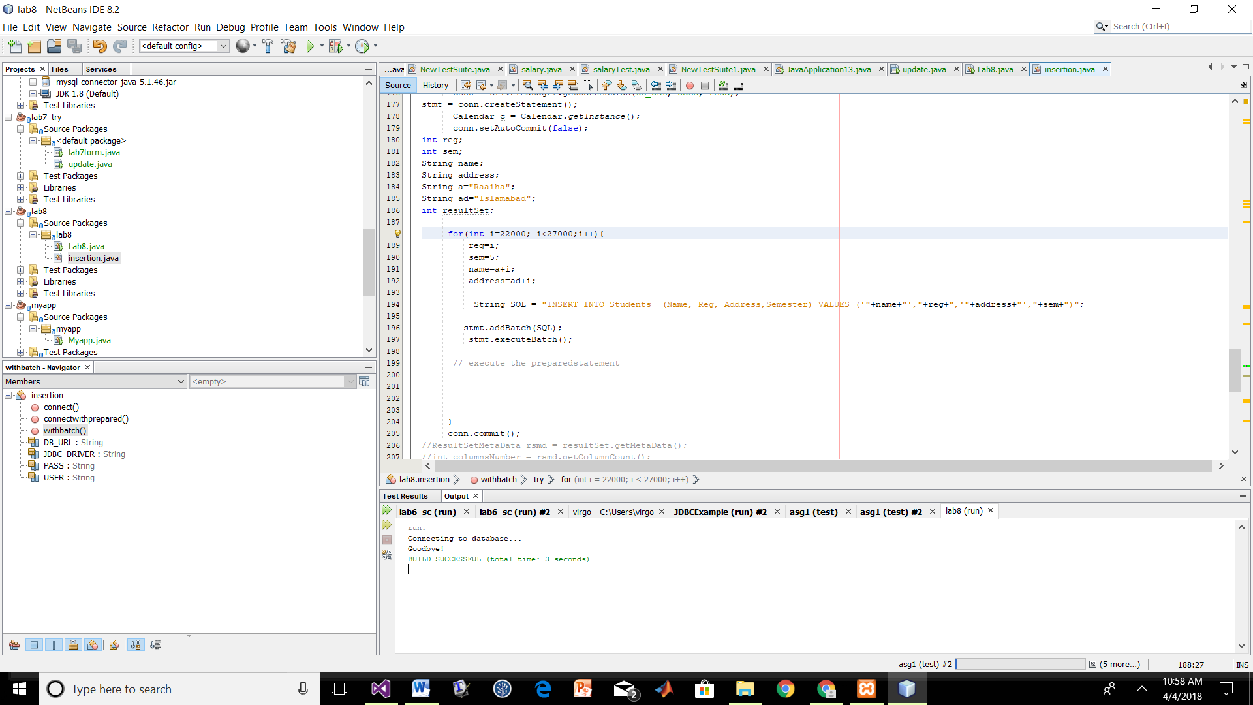

With batch update and autocommit true time 3min 37

