**Install Angular CLI**

Angular CLI is command line interface used to build angular apps using nodejs modules. It already follows best practices.

To install angular CLI, use below steps:

* Check nodejs and npm are installed or not by getting their versions
  + Node –v and npm –version.
* If nodejs is available, **use below command to install angular cli**
  + **npm install -g @angular/cli**
  + Here –g represents available globally.
* After successful installation of angular CLI, **check version using below command in command prompt:**
  + **ng –version**
* Below result will be available

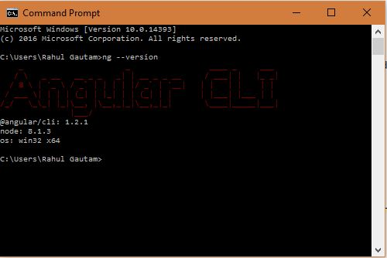

* After successful installation of angular CLI, create new project using below command in command prompt:
* **ng new Project_Name e.g. ng new FirstAngularDemo**
* **After creation below result will be available in command prompt:**

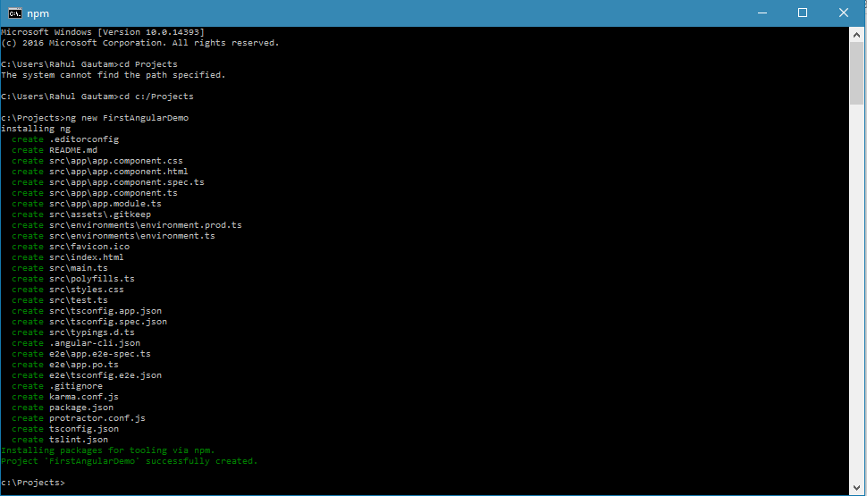

**To run the project, use below command:**

* First go to the location where project is available. E.g. in our case, project is available in C:/Projects/FirstAngularDemo  
  **cd c:/Projects/FirstAngularDemo**
* After this, run **ng serve** to run the angular cli server. See Below Snapshot:

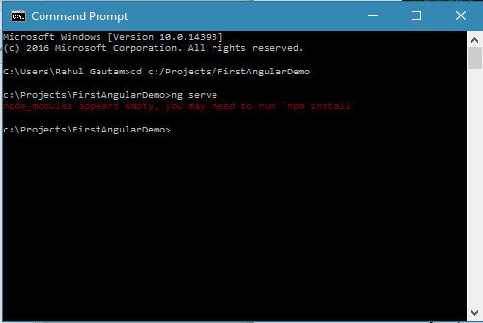

* One might get a message ‘node_modules appear empty, you may need to run npm-install’. It mostly happens for windows 10 OS machine. In this case, just run ‘npm-install’ once.
* Now run, **ng serve** command. See below snapshot:

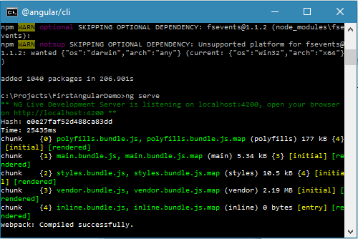

* Open browser and try to run url: <http://localhost:4200>

