Introduction
The movement of organisms, materials, energy, and information across landscapes is essential for maintaining ecosystem health and functionality, biodiversity, and ecosystem services (Crooks and Sanjayan, 2006). Numerous species, especially those that are mobile, need access to a variety of habitats during their life cycles in order to locate food, reproduce, and find a place to live. Connected ecosystems allow for the natural migration and movement of species, which promotes genetic exchange, the settlement of new areas, and the population's general resilience. The movement of energy, nutrients, and species interactions between various ecosystems is also made possible by connected habitats. The ecosystem can respond to and adapt to environmental changes, such as climate change, natural disasters, or human disruptions, due to its interconnection
Two major established concepts in habitat connectivity are structural and functional connectivity. Without taking into account any prospective creatures of interest, structural connectivity is a broad measure of connectivity associated to the physical features of the landscape (Tischendorf and Fahrig, 2000). There are numerous techniques to measure this, but the most popular ones are the distance between habitat patches (Moilanen and Nieminen 2002), linear corridors (Haddad et al. 2003) or stepping stones (Baum et al. 2004) between target habitats. Habitat patch refers to isolated pockets of suitable habitats in a landscape which can vary in size, shape and quality. The spatial arrangement and distribution of these patches influence the dispersal of populations and typically, larger and more contiguous patches provide better habitat conditions and support a greater diversity of species. The linear features that connect different habitat patches and allows for the easy movement of species are known as corridors. They might be man-made structures like wildlife corridors or green infrastructure, or they can be natural elements like rivers, streams, or woodland corridors. Stepping stones are smaller habitat patches or isolated areas that act as intermediate stopover sites between larger patches. Structural connectivity is ultimately based on the human perception of a landscape and may not always be an accurate gauge of how ecological populations and communities use their physical environment (Fischer and Lindenmayer, 2007). However, functional connectivity, which describes how animals react to different landscape features (Tischendorf and Fahrig 2000), is largely influenced by the organisms and study setting. Thus, the ecological notion of habitat connectedness emphasizes the significance of preserving or reestablishing functional links between habitats for the survival of species and ecosystems.
In the past, Scotland's woodlands and those of the rest of Britain were home to numerous pine martens (Martes martes). However, during the 19th and 20th centuries, their population rapidly decreased as a result of widespread deforestation and persecution (Lockie, 1964). Pine martens were only found in isolated regions of the Scottish Highlands and Islands by the middle of the 20th century. In Scotland, efforts have been made recently to promote habitat connectivity and restore forest habitats. More ideal habitats for pine martens have been developed as a result of extensive reforestation efforts and the extension of native woods. Pine marten populations have recovered and grown as a result of the habitat recovery, legislative protection, and conservation activities. This project aims to carry out an assessment of habitat connectivity between two areas of Scottish national parkland from the perspective of Pine Marten conservation.

Methodology
Study Area
The study area comprises of Cairngorms National Park and Loch Lomond National Park which are both located in Scotland and are noted for their unique landscapes, complex ecosystems, and vital conservation initiatives. With a land area of 4,528 square kilometers, Cairngorms National Park is the largest national park in the United Kingdom. It is located in Scotland's northeastern region (Stockdale and Barker, 2009). The park hosts a wide range of habitats, including ancient Caledonian pine forests, moorlands, rivers, and lochs (Watt and Jones, 1948.). The Caledonian pine forests present in Cairngorms National Park provide a perfect habitat for pine martens (Davies and Legg, 2008). The martens can find suitable den locations, plenty of prey, and dense cover in these forests. The park's expansive and relatively undisturbed nature allows the pine martens to thrive. The 1,865 square kilometer Loch Lomond National Park is found in the southernmost region of the Scottish Highlands. The park contains a range of habitats, including wetlands, grasslands, heathlands, and woodlands (Carver et.al, 2012). The woodlands inside Loch Lomond National Park provide vital refuge and foraging grounds for pine martens. For these secretive creatures, the combination of deciduous and coniferous trees provides a varied prey base and adequate denning alternatives. The study area map is shown in Fig 1.
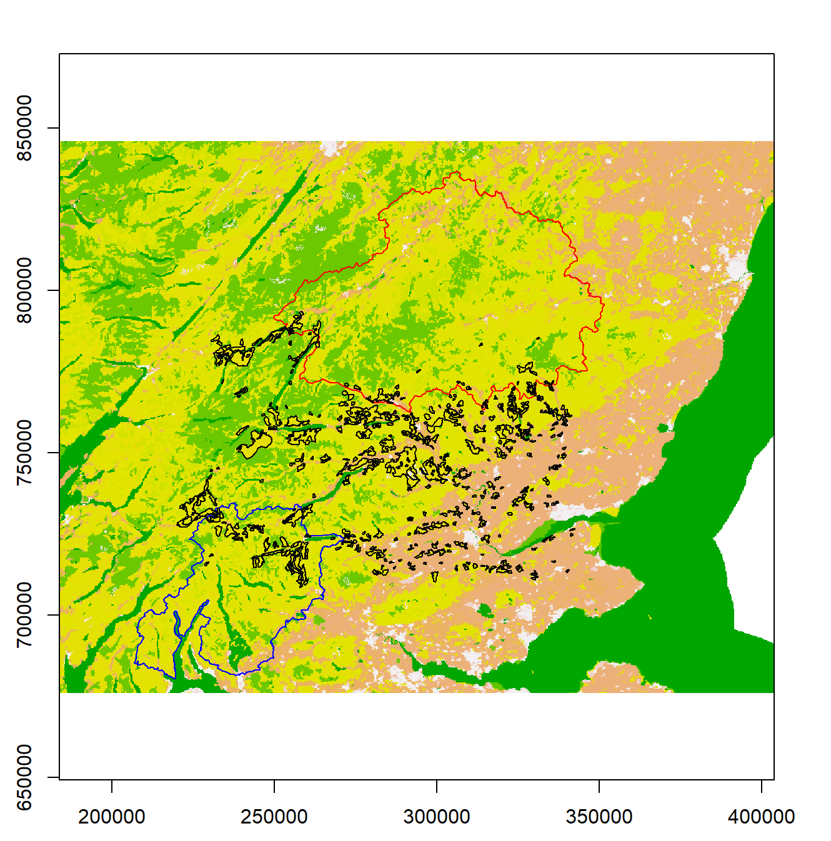

Fig 1: Map of the study area showing Cairngorms National Park in red and Loch Lomond National Park in blue with the conifer patches in between them.

The methodology adopted in this study to assess the habitat connectivity of pine martens between the two areas of Scottish national parkland are:
a) parameterizing a cost (resistance) layer between the Cairngorms and Loch Lomond National Parks,
b) plotting a potential wildlife corridor based on known habitat preference and
c) highlighting the relative importance of habitat patches as stepping stones between the two protected areas.
Parameterizing a Cost Layer
A resistance or cost map was created from the Corine Landcover 2018 (Fig 2) dataset which shows the resistance offered by the different landcover types to the movement of the pine martens between the two national parks. Although formerly expert opinion and literature reviews were more extensively depended upon, landscape resistance, or how difficult it is for a study species to travel across a specific pixel, is now regularly assessed using resource selection functions (Beier, Majka, and Spencer, 2008). In this study, the 34 landcover classes were identified from the raster layer and the resistance values obtained from Stringer et al. (2018) was then used to create a cost layer.
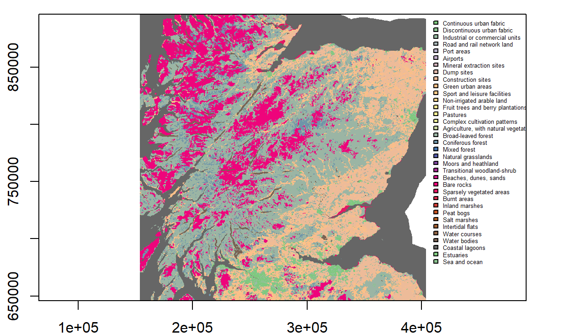

Fig 2: The Corine Landcover dataset clipped to the study extent.

Plotting a Wildlife Corridor
A cumulative cost layer was created for each of the national parks originating from their centroids by using the accCost function which uses Dijkstra's algorithm. The function uses a transition matrix created from the cost layer which has conductance values derived from an 8 neighbor mean rule to create a least cost surface originating from the centroids of the parks. These cumulative cost layers were then overlayed to create a raster from which the lowest 7 percent cost of the layer was then used to create a corridor.
Highlighting the Relative Importance of Habitat Patches
There are 330 conifer patches in the study extent and in order to assess their relative importance, Betweenness Centrality and Probability of Connectivity was used.
On the basis of a negative exponential function, an adjacency matrix was created. This transition matrix, which is undirected and weighted, uses the inverse of the typical pine marten dispersal distance of 8 km (Stringer et al., 2018).
Betweenness Centrality
On the basis of the adjacency matrix, a node's significance as a stepping stone between other nodes within a network was determined by calculating the betweenness centrality based on the shortest paths between them (Albert et.al, 2017). A patch with a high betweenness centrality serves as a crucial link between protected areas, allowing the movement of pine martens throughout the landscape.
Probability of Connectivity
In order to determine the likelihood that two randomly chosen points within an ecosystem are in habitat areas that are reachable from one another given a network graph consisting of habitat patches and links, the Probability of Connectivity Index takes into account both the habitat area within the patches and the area that can be reached through the links between patches (Saura and Pascual-Hortal, 2007). In this study the difference in the probability of connectivity when each node is removed is found (dPC) which is then used to assess the relative importance od that node
The methodology summarized into a flow chart is given in figure below.

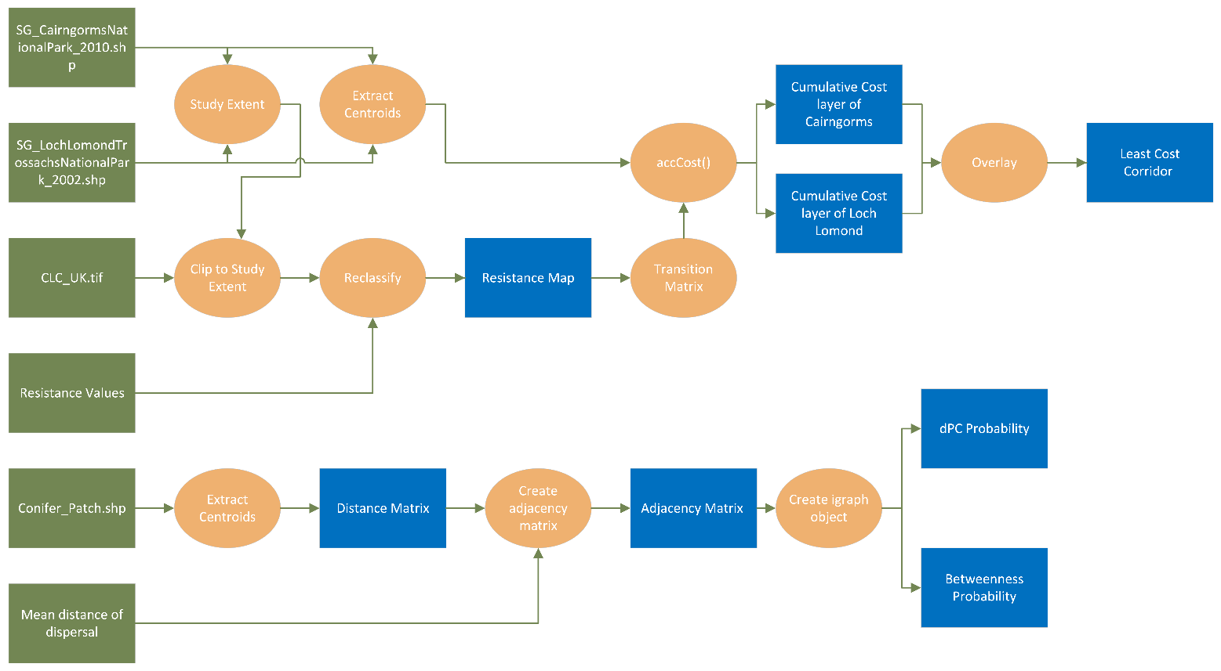
Fig 3: Flowchart summarizing the methodology used in this assessment.

Results and Discussion
The resistance layer created is shown in Fig 4 which shows the resistance offered by the different land cover classes to the movement of pine martens between the two national parks. By comparing this resistance map with location of the national parks, it can be seen that the area between the two parks offer moderate to low levels of resistance to pine marten movement. The area between the two parks mainly constitutes forests, bushes, grasslands and crops which do not offer high resistance and thus can help in pine marten movement. This resistance map gives an idea about the potential connectivity offered by the different land cover classes in the area between the two parks. The resistance values obtained from Stringer et.al in creating the layer is also added in the legend which shows the resistance values assigned to various land cover classes based on which the connectivity offered by these land types were identified.

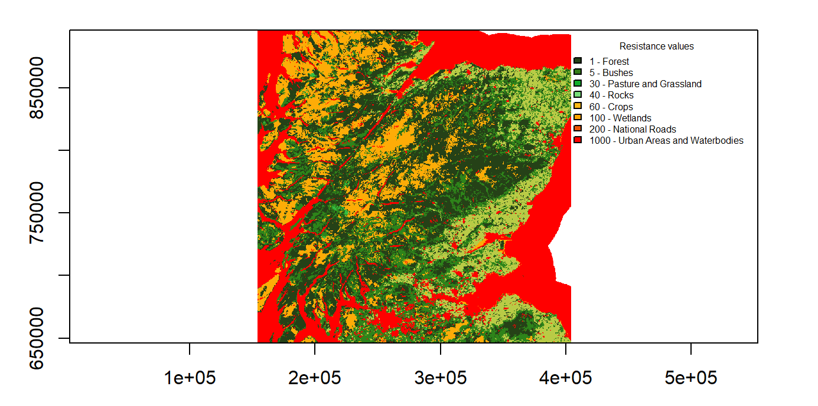
Fig 4: The resistance layer created from the Corine Landcover dataset.

The resistance map can be used to get an idea about the least cost corridor which the pine martens could use to move between the two parks. The least cost corridor created from overlaying the cumulative cost layers is shown in Fig 5.
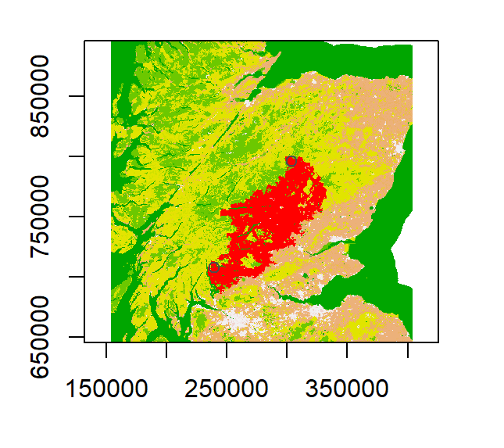

Fig 5: The least cost corridor that facilitates pine marten movement.

The betweenness centrality values were calculated for each of the conifer patch and the map output showing the relative importance of these habitat patches as stepping stone is shown in Fig 6. The size of the nodes indicates their relative betweenness values where bigger nodes mean higher betweenness values. It can be seen from the plot that the nodes closer to the least cost corridor has higher betweenness values and these nodes are also in regions which offer low resistance to the pine marten movement.
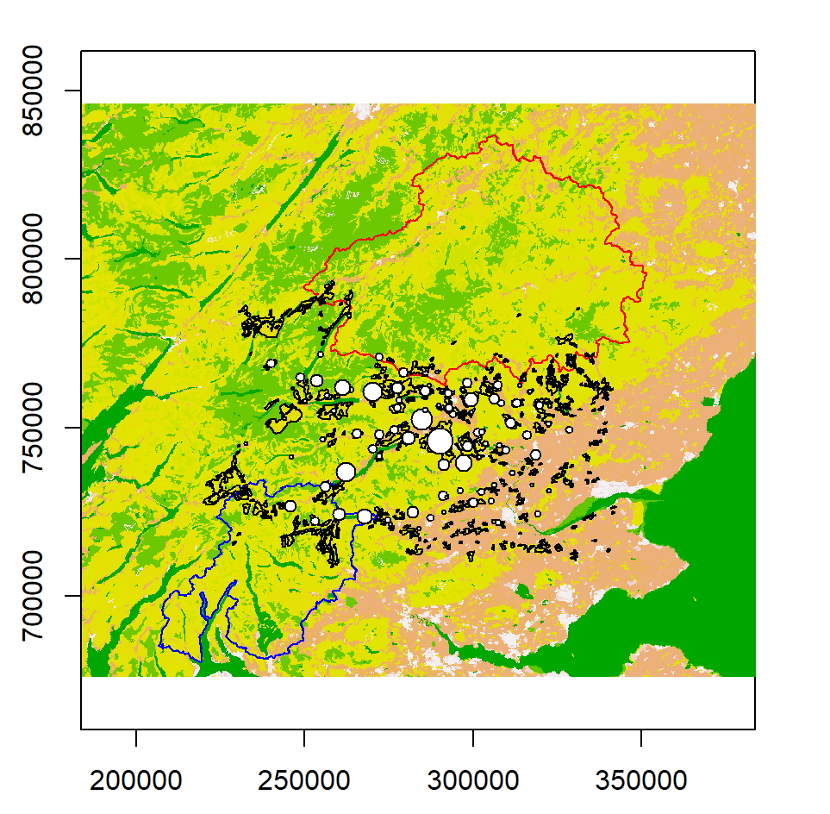

Fig 6: Plot showing the betweenness probability values of the conifer patches.

The dPC centrality values of the conifer patches were calculated and this is shown in Fig 7. It can be seen that unlike betweenness values fewer nodes show higher dPC values suggesting that only these nodes are important in maintaining the connectivity between the two national parks.

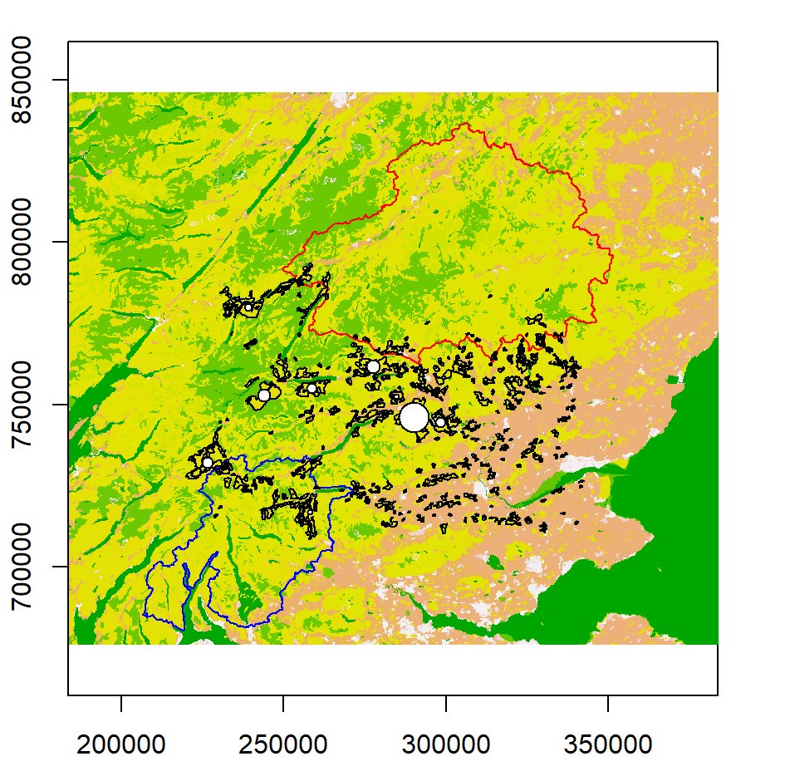

Fig 7: Plot showing the dPC centrality values of the conifer patches.

A shortcoming of this analysis is that observed movement data of pine martens were not used in the assessment. The use observed data would give better results which would help us identify connectivity which might better represent the real world. This analysis also has used simplified assumptions which does not take into account factors like competition, predators and other ecological interactions which can impact pine martens movement. Future analyses should employ observed data to ensure results which model real life connectivity of pine martens. This would aid in developing conservation measures which would be better suited to the actual scenarios present in the ecological space involving pine martens. The method adopted in this study to identify the least cost corridor was to create a cumulative cost layer originating from the centroids of each of the national parks which were then overlayed to find the corridor. This method has given a corridor with some low and moderate resistance land cover types. However, there could be other approaches which could give a better corridor or a reasonable one with low resistance land cover types which could be better for the pine martens.

References
Albert, C.H., Rayfield, B., Dumitru, M. and Gonzalez, A., 2017. Applying network theory to prioritize multispecies habitat networks that are robust to climate and land‐use change. Conservation Biology, 31(6), pp.1383-1396.
Baum, K.A., K.J. Haynes, F.P. Dillemuth, and J.T. Cronin. 2004. The matrix enhances the effectiveness of corridors and stepping stones. Ecology 85: 2671–2676.
Beier, P., Majka, D.R. and Spencer, W.D., 2008. Forks in the road: choices in procedures for designing wildland linkages. Conservation Biology, 22(4), pp.836-851.
Carver, S., Comber, A., McMorran, R. and Nutter, S., 2012. A GIS model for mapping spatial patterns and distribution of wild land in Scotland. Landscape and urban planning, 104(3-4), pp.395-409.
Crooks, K.R. and Sanjayan, M. eds., 2006. Connectivity conservation (Vol. 14). Cambridge University Press.
Davies, G.M. and Legg, C.J., 2008. The effect of traditional management burning on lichen diversity. Applied Vegetation Science, 11(4), pp.529-538.
Fischer, J., and D.B. Lindenmayer. 2007. Landscape modification and habitat fragmentation: A synthesis. Global Ecology and Biogeography 16: 265–280.
Haddad, N.M., D.R. Bowne, A. Cunningham, B.J. Danielson, D.J. Levey, S. Sargent, and T. Spira. 2003. Corridor use by diverse taxa. Ecology 84: 609–615.
Lockie, J.D., 1964. Distribution and fluctuations of the pine marten, Martes martes (L.), in Scotland. The Journal of Animal Ecology, pp.349-356.
Moilanen, A., and M. Nieminen. 2002. Simple connectivity measures in spatial ecology. Ecology 83: 1131–1145.
Saura, S. and Pascual-Hortal, L., 2007. A new habitat availability index to integrate connectivity in landscape conservation planning: comparison with existing indices and application to a case study. Landscape and urban planning, 83(2-3), pp.91-103.
Stockdale, A. and Barker, A., 2009. Sustainability and the multifunctional landscape: An assessment of approaches to planning and management in the Cairngorms National Park. Land Use Policy, 26(2), pp.479-492.
Stringer et al. 2018. The Feasibility of reintroducing pine martens to the Forest of Dean and Lower Wye Valley. Gloucestershire Wildlife Trust.
Tischendorf, L. and Fahrig, L., 2000. On the usage and measurement of landscape connectivity. Oikos, 90(1), pp.7-19.
Watt, A.S. and Jones, E.W., 1948. The ecology of the Cairngorms: Part 1. The environment and the altitudinal zonation of the vegetation. Journal of Ecology, 36(2), pp.283-304.

