




SOFTWARE ENGINEERING LAB MANUAL
5th SEMESTER
COMPUTER ENGINEERING DEPARTMENT

Subject: - Software Engineering (5th Sem)



CERTIFICATE
This is to certify that Mr. Enroll. No. Branch B. Tech C.E. Semester V has satisfactorily completed his term work in the Subject of Software Engineering within the four walls of the institute.
Date of Submission:

Sign – in – Charge Head of Department

Subject: - Software Engineering (5th Sem)

Sr.  No. | List of Experiments | Page No. | Date of  Submission | Sign & Grade
1 | Identify and define a real-world problem with a clear problem statement and objectives.
2 | Study the complete Software Development Life Cycle (SDLC) and analyze various activities conducted as a part  of various phases. For each SDLC phase, identify the objectives and summaries outcomes.
3 | To perform the system analysis: Functional and Non-Functional requirements as a part of Requirement analysis.
4 | To perform the user’s view analysis: Use case diagram for your Project.
5 | To draw the structural view diagram: Class diagram for your Project.
6 | To draw the behavioral view diagram: Activity diagram for your Project.
7 | To perform the function-oriented diagram: Data Flow Diagram for your Project.
8 | Consider any project to be developed in any technology  as a Project Manager. Construct Software Requirement Specification (SRS) document for the project.
9 | To study various testing tools.
10 | To design test cases and to apply them using various testing tools.
11 | To study cost estimation and preparation of timeline charts.
12 | Capability Maturity Model (CMM) & its Levels in Software Engineering
13 | Calculate cyclomatic complexity for given Code. Identify number of independent paths require for testing
14 | Generate a test suite using the white box testing  strategies.
15 | Apply basic and intermediate COCOMO technique.

Aim: Identify and define a real-world problem with a clear problem statement and objectives.
Topic
Smart Crowdsourced Disaster Management & Relief Platform
Requirement
1. Background
India is one of the most disaster-prone countries in the world. Floods, cyclones, earthquakes and landslides affect millions of people every year. In the first few hours after a disaster, the biggest challenge is not always a shortage of relief material but the lack of coordinated information: who needs help, where they are, what they need, and who is nearest to help them.
2. Problem Statement
During natural disasters such as floods and earthquakes, there is a serious communication gap between victims, local volunteers and official relief agencies. Victims send help requests through scattered phone calls, social media posts and messaging groups; volunteers do not know where help is needed most; and relief agencies lack a real-time picture of the ground situation. As a result, rescue is delayed, the same area receives duplicate relief while other areas receive none, and valuable resources such as food, water, medicines and boats are mismanaged.
There is a need for a single, reliable, real-time platform that collects help requests from the crowd, verifies them, and allocates the nearest available volunteers and resources to the people who need them most.
3. Objectives
- To provide a one-tap SOS alert that shares the victim's live GPS location with the relief network.
- To allow citizens to crowdsource incident reports with photos, videos and severity details.
- To maintain a live disaster map showing incidents, shelters, relief centres and volunteers.
- To automatically match each verified request with the nearest available volunteer and relief centre.
- To manage relief inventory (food, water, medicines, rescue equipment) and avoid duplicate or wasted distribution.
- To send mass emergency alerts by SMS and push notification to people in affected zones.
- To generate reports and analytics that help agencies plan and improve future responses.
- To keep working in low-network conditions by queuing requests offline and syncing when connectivity returns.
4. Scope of the Project
The platform is a web-based Progressive Web Application (PWA) usable on mobile phones and computers. It serves three main user roles: Victims/Citizens who request help, Volunteers who deliver help on the ground, and Admins/Relief Coordinators who verify requests, manage resources and supervise operations. Physical rescue operations, drone integration and payment/donation handling are outside the scope of the current version.
5. Requirement Gathering and Analysis
Requirements were gathered by studying news reports of recent floods and earthquakes, reviewing existing government and NGO disaster apps, and holding informal discussions with NCC/NSS student volunteers and local NGO members. The main issues identified were: absence of a single channel for help requests, no location accuracy, no verification of fake or duplicate reports, no visibility of volunteer availability, and poor tracking of relief stock.
6. Functional Requirements
- User registration and OTP-based login for victims, volunteers and admins.
- SOS alert with automatic live location sharing.
- Incident reporting with photo/video upload and severity level.
- Relief request submission and live status tracking.
- Admin verification of incidents and management of relief inventory.
- Automatic allocation of the nearest volunteer and relief centre.
- Volunteer task acceptance, navigation and status update.
- Emergency alert broadcasting and report generation.
7. Non-Functional Requirements
- High availability – the system must stay online during disaster peaks.
- Fast response – SOS alerts must reach the control dashboard within a few seconds.
- Security & privacy – location and personal data must be protected.
- Scalability – must handle sudden spikes of thousands of simultaneous users.
- Usability – simple, large buttons usable by stressed or low-literacy users, with multi-language support.
8. Technical Requirements
- Frontend: React.js (Progressive Web App), HTML5, CSS3, JavaScript
- Backend: Node.js with Express.js (REST APIs)
- Real-time Communication: Socket.IO (WebSockets)
- Database: MongoDB with geospatial (2dsphere) indexing
- Maps: Leaflet.js with OpenStreetMap
- Notifications: Firebase Cloud Messaging (push) and SMS Gateway API
- Tools: Visual Studio Code, Git & GitHub, Postman, MongoDB Compass
9. Sources of Information
- NDMA (National Disaster Management Authority) guidelines and public reports.
- Local NGOs and NCC/NSS student volunteers.
- News coverage and case studies of recent floods and earthquakes.
- Existing disaster and emergency response applications.
- Online technical references and documentation.
10. Expected Outcome
The Smart Crowdsourced Disaster Management & Relief Platform will reduce the time between a victim's call for help and the arrival of relief. It will give relief agencies a real-time, verified picture of the disaster, prevent duplicate and wasted distribution of resources, and allow volunteers to be used where they are needed most.
Conclusion
A clear problem statement and well-defined objectives form the foundation of the project. By identifying the communication gap between victims, volunteers and relief agencies, this practical establishes why the platform is needed and what it must achieve.

Aim: To study the Software Development Life Cycle (SDLC) and understand the activities, objectives, and outcomes of each phase for the Smart Crowdsourced Disaster Management & Relief Platform.
Topic
Software Development Life Cycle (SDLC) for Smart Crowdsourced Disaster Management & Relief Platform
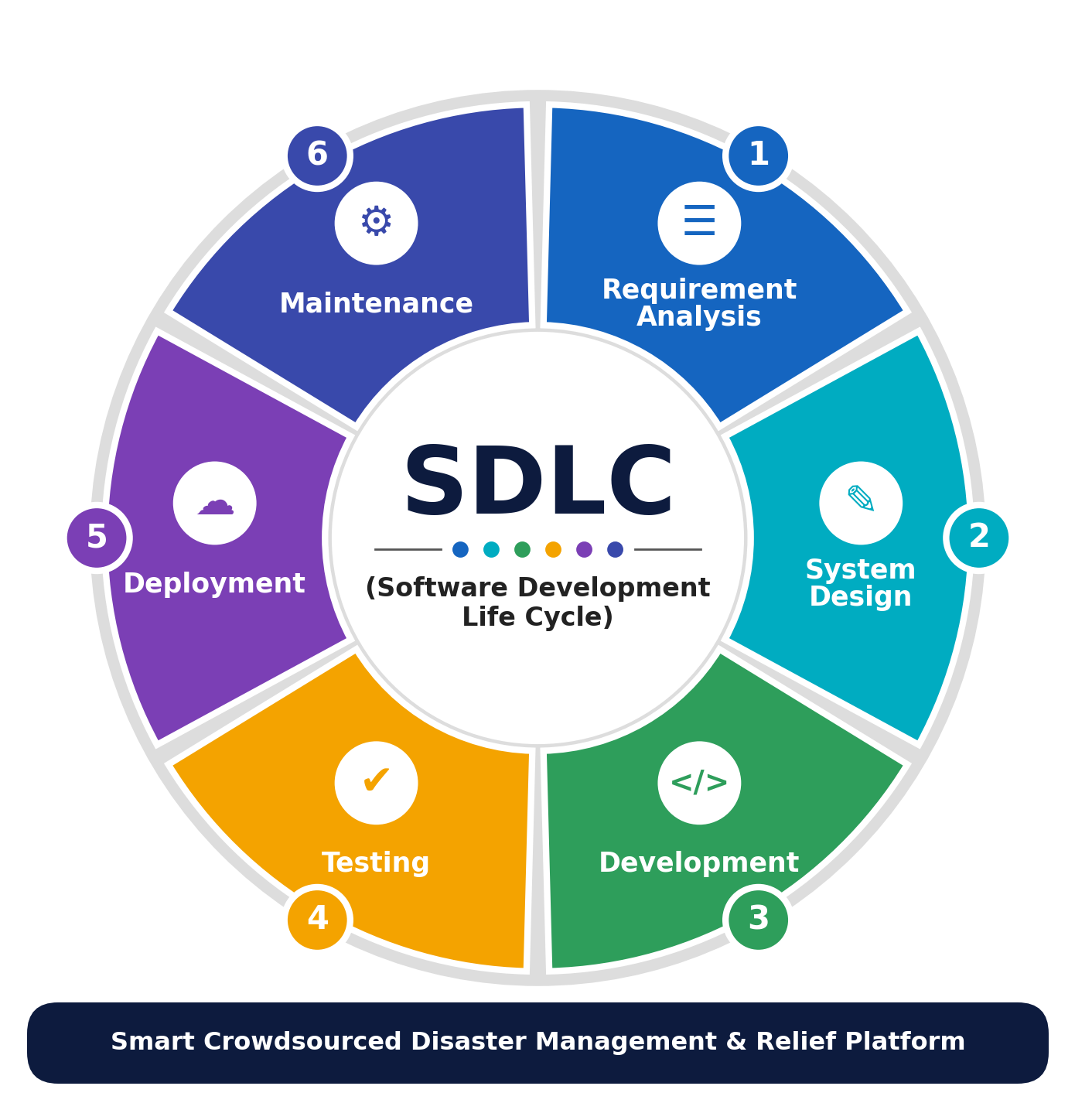
Figure 2.1: Phases of the Software Development Life Cycle
Introduction
The Software Development Life Cycle (SDLC) is a structured, step-by-step process for building software in a planned and systematic way. It ensures that the final product meets user requirements, is reliable, and is delivered within the planned time and budget. For the disaster management platform, where failure can directly affect human lives, following the SDLC carefully is especially important.
SDLC Model Selected: Iterative (Incremental) Model
The Iterative / Incremental model is selected for this project. The core life-saving features (login, SOS alert, live map) are built and tested first as a working increment, and further features (resource allocation, volunteer matching, analytics) are added in later iterations. This allows early feedback from volunteers and coordinators and reduces the risk of building features that do not work well in real disaster conditions.
1. Requirement Analysis Phase
Objective
To understand the problems faced by victims, volunteers and relief agencies during disasters and to collect complete system requirements.
Activities
- Discuss needs with NGO members, NCC/NSS volunteers and local authorities.
- Study existing disaster-response apps and their limitations.
- Identify user roles: Victim, Volunteer and Admin (Relief Coordinator).
- Define functional and non-functional requirements.
- Prepare the Software Requirement Specification (SRS).
Outcome
A clear and approved SRS document containing all functional, non-functional and technical requirements.
2. System Design Phase
Objective
To design the overall architecture, database and user interfaces of the platform.
Activities
- Design the three-tier architecture (React PWA, Node.js API, MongoDB).
- Create UML diagrams – Use Case, Class, Activity and Data Flow Diagrams.
- Design the MongoDB collections with geospatial indexes.
- Design simple, large-button UI screens for stressful situations.
- Design the volunteer-matching and priority algorithm.
Outcome
A complete design document and diagrams that act as the blueprint for development.
3. Development Phase
Objective
To build the platform module by module according to the design.
Activities
- Develop authentication with OTP verification.
- Implement SOS alert, incident reporting and live GPS sharing.
- Build the real-time disaster map using Leaflet and Socket.IO.
- Implement inventory management, resource allocation and volunteer task modules.
- Integrate SMS and push notification services.
Outcome
A working version of the platform with all essential features implemented.
4. Testing Phase
Objective
To make sure the platform works correctly, securely and reliably under heavy load.
Activities
- Unit testing of each module and integration testing of APIs.
- Functional testing of SOS, reporting, allocation and notification flows.
- Load testing to simulate thousands of simultaneous SOS requests.
- Security testing for authentication, data privacy and injection attacks.
- Field testing with a small group of volunteers in a mock drill.
Outcome
A stable, secure and reliable application that is ready for deployment.
5. Deployment Phase
Objective
To make the platform available to real users.
Activities
- Deploy the backend on a cloud server with auto-scaling.
- Configure the production database, backups and SSL certificates.
- Publish the PWA and create admin and coordinator accounts.
- Train NGO staff and volunteers to use the platform.
Outcome
The platform is live and accessible to victims, volunteers and relief agencies.
6. Maintenance Phase
Objective
To keep the system updated, secure and ready for the next disaster.
Activities
- Fix bugs reported after deployment.
- Monitor server performance and uptime, especially during disaster seasons.
- Add features based on feedback (e.g., new languages, offline improvements).
- Update security patches and review data-privacy compliance.
Outcome
An improved, secure and well-maintained platform that continues to meet user needs.
Summary of SDLC Phases
Table 2.1: Summary of SDLC phases
Phase | Main Objective | Key Deliverable
Requirement Analysis | Collect needs of victims, volunteers and agencies | SRS document
System Design | Plan architecture, database and UI | UML diagrams, DB schema, UI design
Development | Build all modules | Working platform (source code)
Testing | Verify correctness, security and load handling | Test report, bug list
Deployment | Release to real users | Live system, user training
Maintenance | Keep system updated and reliable | Updates, patches, new versions

Conclusion
The SDLC provides a structured approach for developing the Smart Crowdsourced Disaster Management & Relief Platform. By following each phase carefully, and by using an iterative approach that delivers life-saving features first, the platform becomes easier to develop, test and maintain, and is reliable enough to support victims, volunteers and relief agencies during emergencies.

Aim: To perform system analysis by identifying and documenting the functional and non-functional requirements of the Smart Crowdsourced Disaster Management & Relief Platform as a part of requirement analysis.
Topic
System Analysis: Functional and Non-Functional Requirements of Smart Crowdsourced Disaster Management & Relief Platform
Requirement
Introduction
System analysis is the process of understanding what users expect from a software system before development begins. It identifies the required features (functional requirements) and the quality expectations such as speed, reliability and security (non-functional requirements). For a disaster platform, these requirements must be analysed carefully because the system is used under extreme pressure, poor network conditions and very high load.
1. Functional Requirements
Functional requirements describe what the system should do.
Victim / Citizen Module
- Register and log in using mobile number with OTP verification.
- Send a one-tap SOS alert with automatic live GPS location.
- Report a disaster incident with type, severity, description and photos/videos.
- Submit relief requests for food, water, medicine, shelter or rescue.
- Track the status of requests in real time (Pending, Assigned, On the Way, Completed).
- View nearby shelters, relief centres and safe zones on the map.
- Receive emergency alerts and safety instructions.
Volunteer Module
- Register with skills (first aid, swimming, driving, medical), vehicle details and service area.
- Set availability status (Available / Busy / Off-duty).
- View assigned tasks with victim location and priority.
- Accept or reject assigned tasks.
- Navigate to the victim's location using the built-in map route.
- Update task status and upload proof of delivery or rescue.
Admin (Relief Coordinator) Module
- Secure admin login with role-based access.
- Verify, merge or reject incident reports (fake / duplicate).
- Monitor the live disaster map with incidents, volunteers and relief centres.
- Manage relief inventory and relief centres/shelters.
- Allocate resources and approve volunteer assignments.
- Manage volunteer accounts (verify, block, rate).
- Broadcast emergency alerts to users in a selected area.
- Generate reports and analytics.
System Functions (Automatic)
- Automatically assign priority to each request based on medical emergency, severity and number of people affected.
- Find the nearest available volunteer and relief centre using geospatial queries.
- Detect and merge duplicate reports from the same location within a short time.
- Re-assign tasks automatically if a volunteer does not respond within a time limit.
- Queue requests offline and sync them when the network is restored.
- Maintain a complete log of all actions for audit.
2. Non-Functional Requirements
Non-functional requirements describe how well the system should perform.
Performance
- SOS alerts shall reach the admin dashboard within 3 seconds.
- Map and dashboard pages shall load within 3 seconds on a 4G network.
Availability and Reliability
- The system shall be available 99.9% of the time, especially during disaster events.
- No SOS alert or relief request shall ever be lost; all critical writes shall be saved reliably.
Scalability
- The system shall handle sudden spikes of at least 5,000 concurrent users.
- Servers shall scale horizontally when load increases.
Security and Privacy
- Passwords shall be stored using bcrypt hashing; all traffic shall use HTTPS.
- A victim's exact location shall be visible only to the assigned volunteer and admins.
- Role-based access control shall restrict each user to authorised features only.
Usability and Accessibility
- The SOS button shall be large and reachable within one tap from the home screen.
- The interface shall support English, Hindi and Gujarati.
- The app shall be usable by people with limited technical knowledge.
Maintainability and Portability
- The code shall be modular so that new disaster types and features can be added easily.
- The PWA shall run on Android, iOS and desktop browsers without separate installation.
Table 3.1: Summary of measurable non-functional requirements
Category | Requirement | Measurable Target
Performance | SOS delivery time | ≤ 3 seconds
Performance | Page load time | ≤ 3 seconds on 4G
Availability | System uptime | 99.9%
Scalability | Concurrent users | ≥ 5,000
Security | Password storage | bcrypt hashing
Usability | Steps to send SOS | 1 tap
Offline Support | Request queuing | Auto-sync on reconnect

Conclusion
Proper system analysis helps in understanding the exact requirements before development starts. Identifying functional and non-functional requirements ensures that the platform is fast, reliable, secure and easy to use, and that it truly supports victims, volunteers and relief agencies during emergencies.

Aim: To perform the user's view analysis and design a Use Case Diagram showing the functional requirements of the Smart Crowdsourced Disaster Management & Relief Platform.
Definition of a Use Case Diagram
A Use Case Diagram is a UML (Unified Modeling Language) behavioural diagram that represents the functional requirements of a system from the user's point of view. It shows the actors (users or external systems), the use cases (functions the system provides), and the relationships between them.
Table 4.1: Use case diagram notations
Notation | Name | Purpose | Example
 | Actor | Represents a person, organisation or external system that interacts with the system. An actor is always outside the system. | Victim, Volunteer, Admin
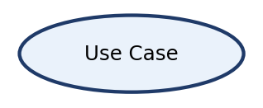 | Use Case | Represents a function or service the system performs for an actor. It describes what the system does, not how. | Send SOS Alert, Login
 | Association | Connects an actor to a use case in which it participates. | Victim — Send SOS Alert
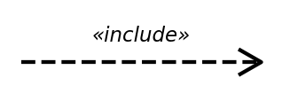 | Include (<<include>>) | Shows mandatory behaviour that is always executed as part of the base use case. | Send SOS Alert includes Share Live GPS Location
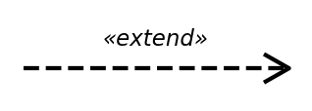 | Extend (<<extend>>) | Shows optional or conditional behaviour that extends a base use case. | Upload Photo extends Report Incident
 | Generalization | Shows that a child actor/use case inherits the behaviour of a parent. | Volunteer is a type of User
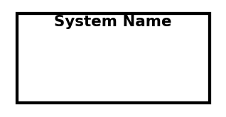 | System Boundary | A rectangle that separates the system's use cases from the external actors. | Disaster Relief Platform

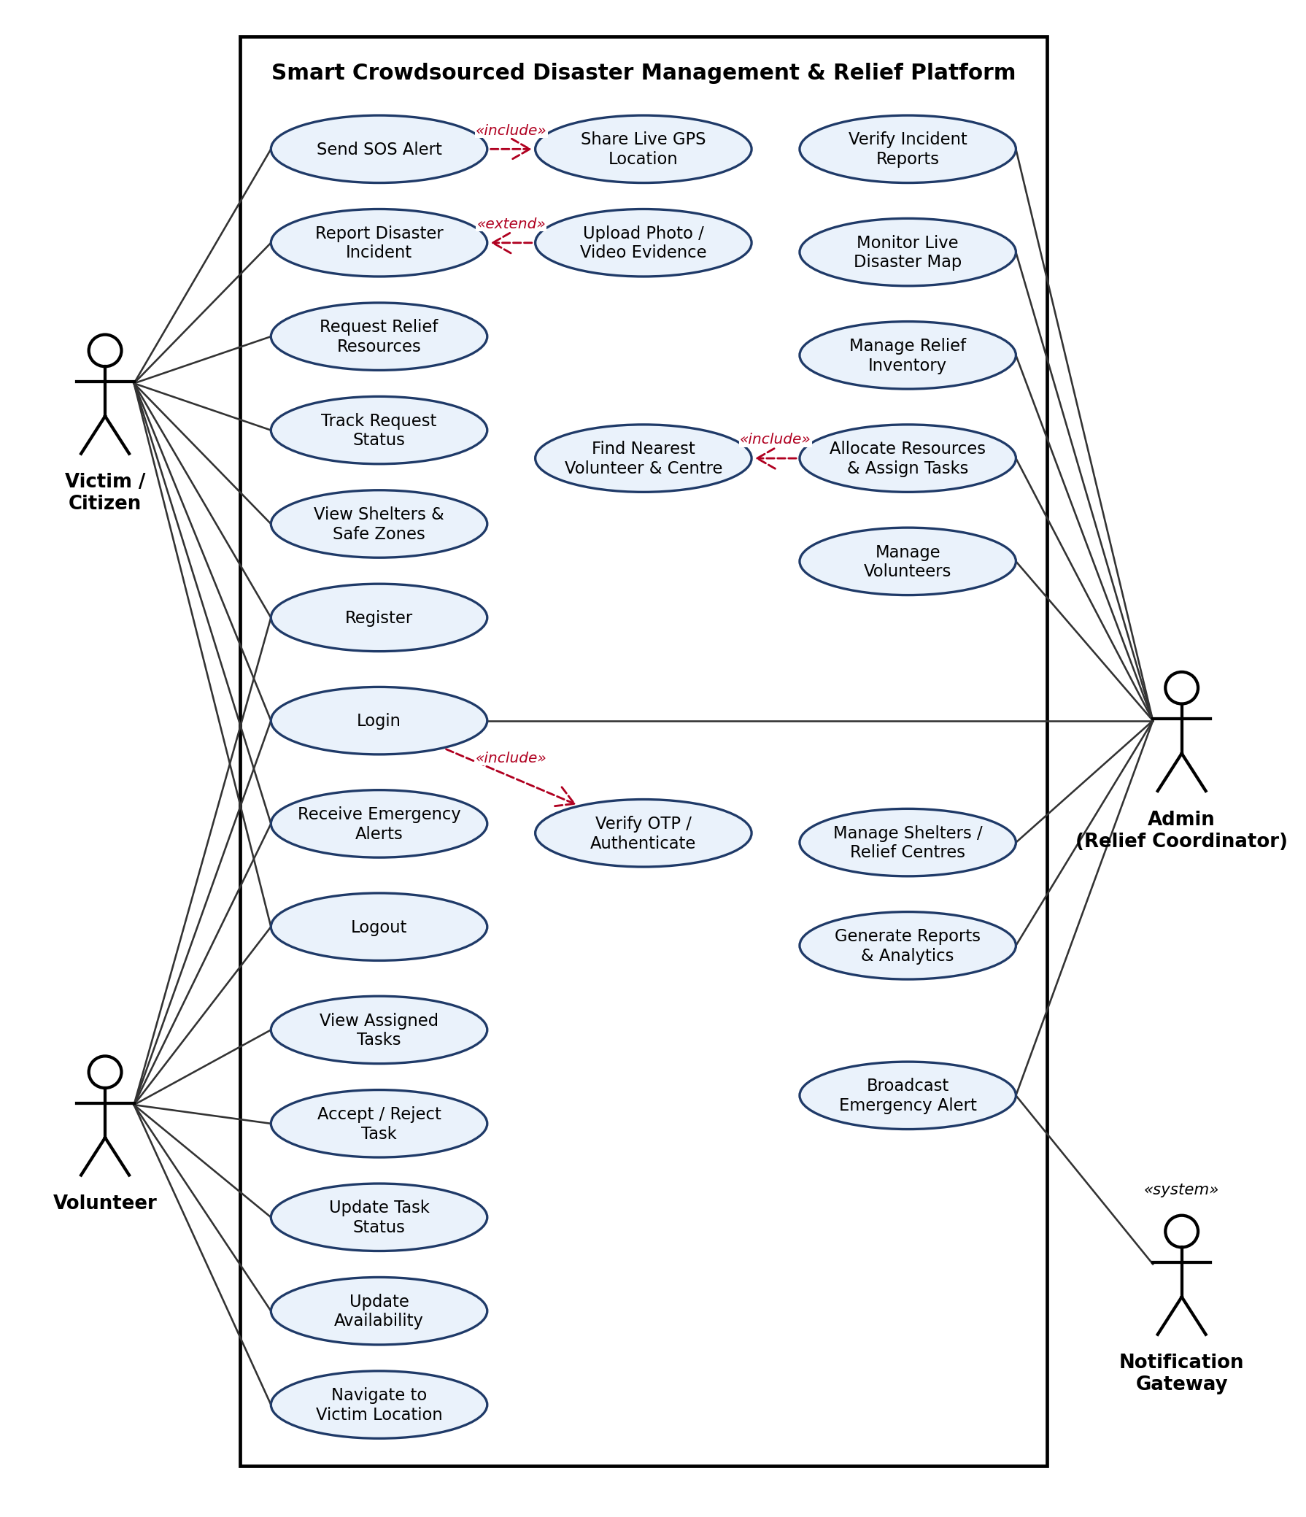
Figure 4.1: Use Case Diagram of the Smart Crowdsourced Disaster Management & Relief Platform
Actor Details
1. Victim / Citizen
Description:
A person affected by the disaster, or a citizen reporting on behalf of others. The victim is the primary user who raises help requests.
Role:
- Register and Login
- Send SOS Alert (includes Share Live GPS Location)
- Report Disaster Incident (extended by Upload Photo/Video)
- Request Relief Resources and Track Request Status
- View Shelters & Safe Zones
- Receive Emergency Alerts and Logout
Goal:
To get quick, reliable help and information during an emergency.
2. Volunteer
Description:
A registered and verified person (NSS/NCC student, NGO member, local rescuer) who delivers help on the ground.
Role:
- Register and Login
- View Assigned Tasks and Accept / Reject Task
- Navigate to Victim Location
- Update Task Status and Update Availability
- Receive Emergency Alerts and Logout
Goal:
To reach victims quickly and deliver relief where it is needed most.
3. Admin (Relief Coordinator)
Description:
An official from the relief agency, NGO or district control room who controls and supervises all operations.
Role:
- Login
- Verify Incident Reports and Monitor Live Disaster Map
- Manage Relief Inventory, Volunteers and Shelters / Relief Centres
- Allocate Resources & Assign Tasks (includes Find Nearest Volunteer & Centre)
- Broadcast Emergency Alert and Generate Reports & Analytics
Goal:
To coordinate the response efficiently and make sure no request is missed.
4. Notification Gateway (System Actor)
Description:
An external SMS / push notification service used by the platform to deliver messages.
Role:
- Deliver broadcast emergency alerts by SMS and push notification
- Deliver OTP and status-update messages
Goal:
To make sure critical messages reach users even on basic phones.
Use Case Specification: Send SOS Alert
Table 4.2: Use case specification for Send SOS Alert
Field | Description
Use Case Name | Send SOS Alert
Primary Actor | Victim / Citizen
Secondary Actors | Admin, Volunteer, Notification Gateway
Pre-condition | Victim is logged in (or uses guest SOS) and location permission is available.
Main Flow | 1. Victim presses the SOS button.  2. System captures the live GPS location (include).  3. System creates an SOS alert with a priority level.  4. Alert appears instantly on the admin dashboard map.  5. System finds and notifies the nearest available volunteer.
Alternate Flow | If GPS is unavailable, the victim enters a landmark manually. If there is no network, the alert is queued and sent when the connection returns.
Post-condition | SOS alert is stored and its status is visible to the victim.

Conclusion
The use case diagram clearly shows how victims, volunteers, admins and the notification gateway interact with the platform. It captures all major functional requirements from the user's point of view and serves as a base for the class, activity and data flow diagrams.

Aim: To draw the structural view diagram: Class diagram for your Project.
Definition of a Class Diagram
A Class Diagram is a UML structural diagram that represents the classes of a system, their attributes, methods, and the relationships between the classes. It shows the static structure of the system and is used as a blueprint for object-oriented programming and database design.
Table 5.1: UML class relationships
UML Relationship | Symbol | Can be used with | Easy Example | Meaning
Association |  | 1 : 1, 1 : Many, Many : Many | Victim 1 —— 0..* SOSAlert | One victim can raise many SOS alerts
Directed Association |  | 1 : Many | Admin —→ Notification | Admin sends notifications (one-way navigation)
Aggregation |  | 1 : Many (weak 'has-a') | Team ◇—— Volunteer | A team has volunteers; volunteers can exist without the team
Composition |  | 1 : Many (strong 'part-of') | ReliefCenter ◆—— Resource | Resources (stock) exist only inside a relief centre
Generalization |  | Inheritance (is-a) | Victim ——▷ User | Victim is a type of User
Realization |  | Class implements interface | SMSService - - ▷ Notifier | SMSService implements the Notifier interface
Dependency |  | Temporary use | Report - - → Incident | Report generation uses incident data

Table 5.2: Multiplicity notations
Multiplicity | Meaning
1 | Exactly one
0..1 | Zero or one
0..* (or *) | Zero or many
1..* | One or many

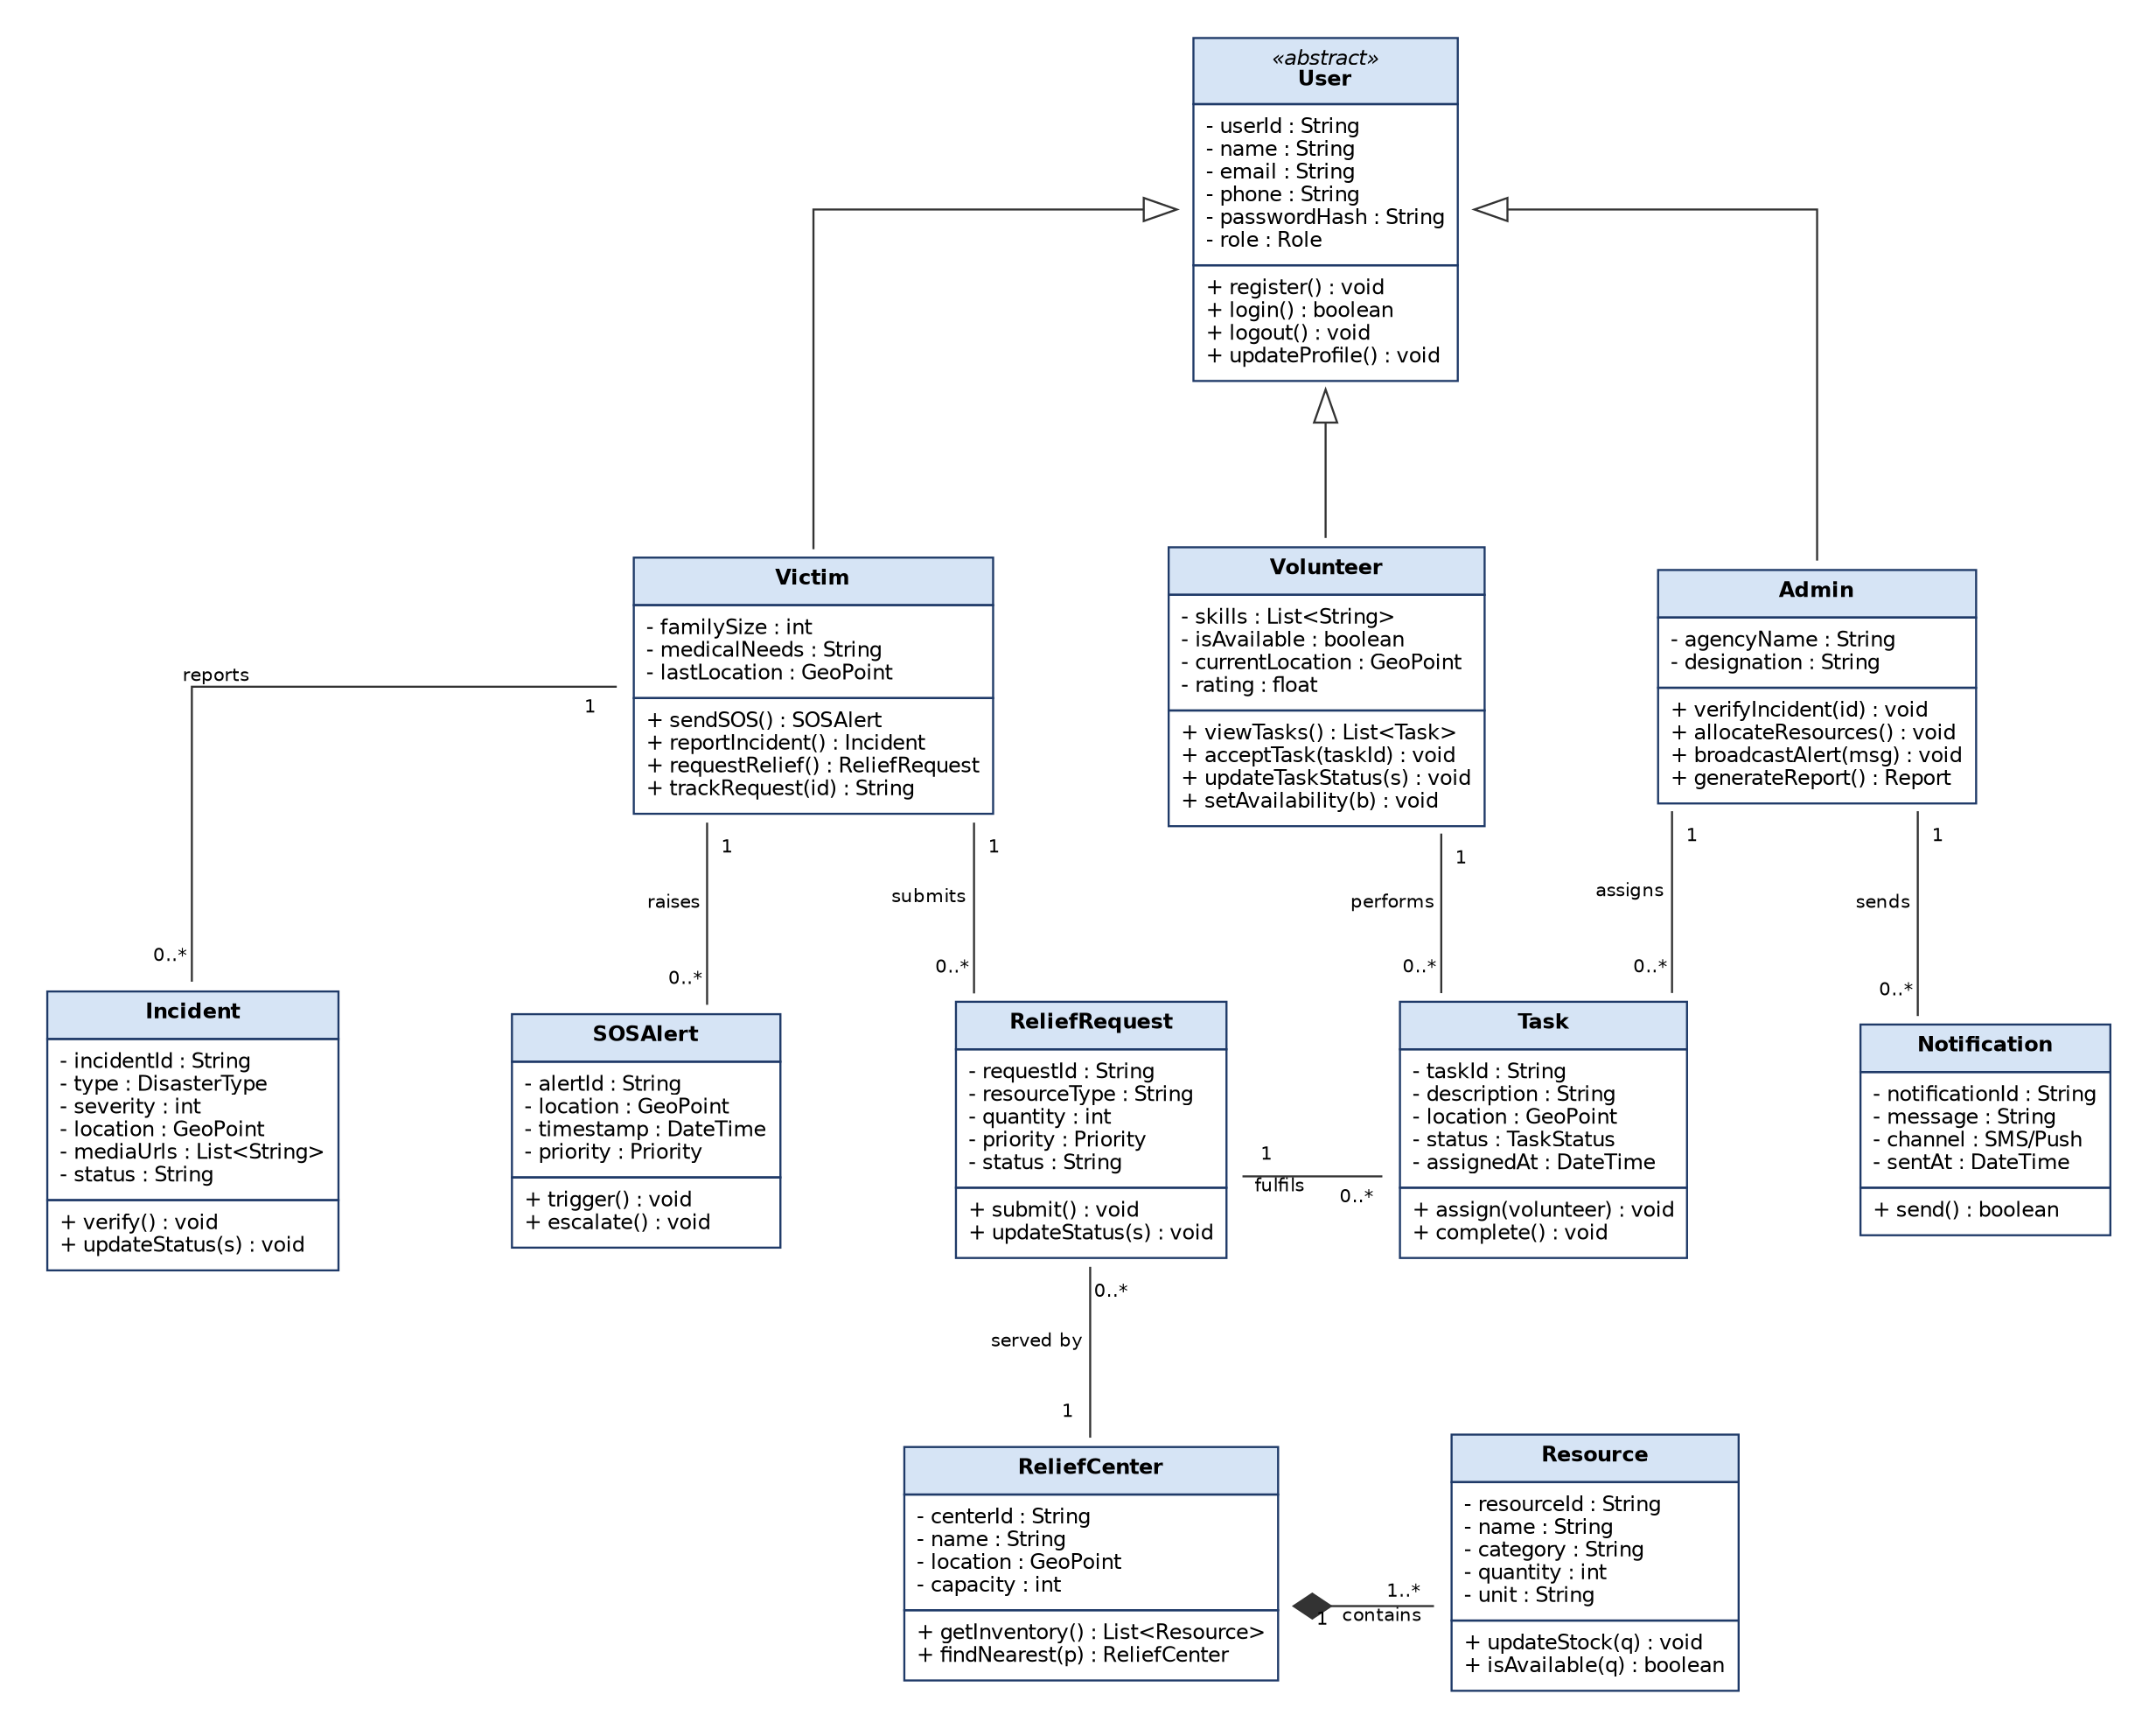
Figure 5.1: Class Diagram of the Smart Crowdsourced Disaster Management & Relief Platform
Description of Classes
Table 5.3: Class responsibilities
Class | Responsibility
User (abstract) | Common details and behaviour of all users – registration, login, logout and profile update.
Victim | Sends SOS alerts, reports incidents, requests relief and tracks request status.
Volunteer | Stores skills, availability and location; accepts tasks and updates task status.
Admin | Verifies incidents, allocates resources, broadcasts alerts and generates reports.
Incident | Represents a crowdsourced disaster report with type, severity, location and media.
SOSAlert | Represents an emergency alert with live location, time and priority.
ReliefRequest | Represents a request for specific relief resources and its current status.
Task | Work assigned to a volunteer to fulfil a relief request.
ReliefCenter | A relief camp / warehouse / shelter with location and capacity.
Resource | A relief item (food, water, medicine, equipment) with quantity stored in a relief centre.
Notification | An SMS or push message sent to users.

Relationships Used
- Generalization: Victim, Volunteer and Admin inherit from the abstract User class.
- Association (1 to 0..*): A Victim raises SOS alerts, reports incidents and submits relief requests.
- Association: A Volunteer performs Tasks and an Admin assigns Tasks; each Task fulfils one ReliefRequest.
- Association: Many ReliefRequests are served by one ReliefCenter; an Admin sends many Notifications.
- Composition: A ReliefCenter contains one or more Resources; stock records cannot exist without the centre.
Conclusion
The class diagram shows the static structure of the platform – its main classes, their attributes and methods, and how they are related. It directly guides the design of the MongoDB collections and the backend code.

Aim: To draw the behavioral view diagram: Activity diagram for your Project.
Definition of an Activity Diagram
An Activity Diagram is a behavioural UML diagram that shows the flow of activities or actions in a system from start to finish. It is similar to a flowchart but also supports parallel activities using fork and join nodes.
Table 6.1: Activity diagram notations
Symbol | Name | Easy Definition | Simple Example
 | Initial Node | Shows the starting point of the activity flow. | Start of login
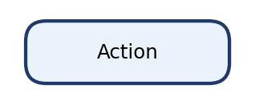 | Action / Activity | Shows a task or action performed by the user or system. | Send SOS Alert
 | Decision / Merge | Decision splits the flow based on a condition; merge combines alternative flows. | Valid credentials?
 | Control Flow | Shows the direction of flow from one action to the next. | Login → Verify
 | Fork | Splits one flow into multiple activities that run at the same time. | Capture GPS + Attach Photo
 | Join | Combines parallel flows into one after all of them finish. | → Submit Relief Request
 | Final Node | Shows the end of the activity flow. | After Logout

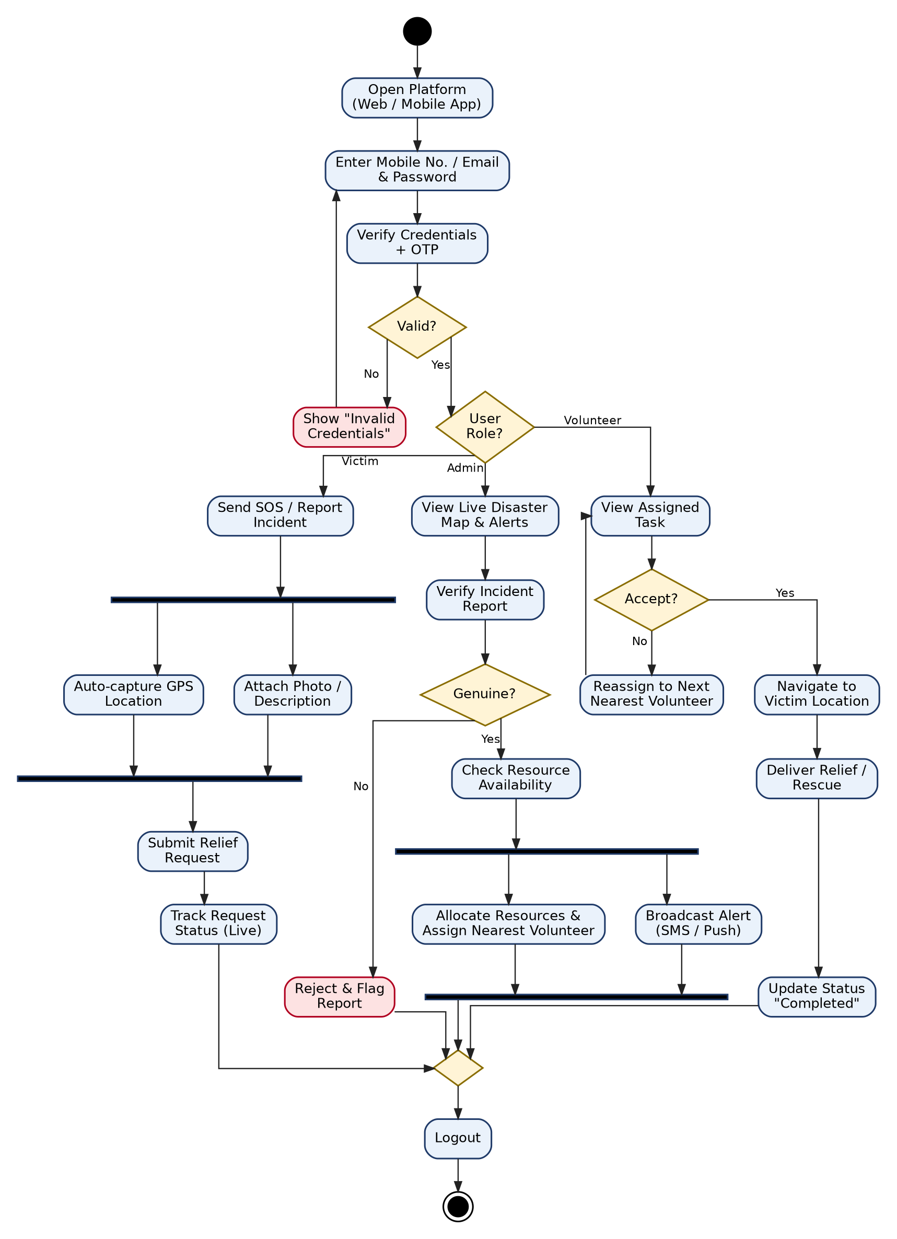
Figure 6.1: Activity Diagram of the Smart Crowdsourced Disaster Management & Relief Platform
Explanation of the Activity Flow
1. Login and Verification
The user opens the platform and enters a mobile number/email and password. The system verifies the credentials and OTP. If they are invalid, an error is shown and the user returns to the login screen; otherwise the flow branches by user role.
2. Victim Flow
The victim sends an SOS or reports an incident. A fork runs two actions in parallel – automatic GPS capture and attaching photos/description. After both finish (join), the relief request is submitted and the victim can track its status live.
3. Admin Flow
The admin views the live disaster map and verifies the incident. If it is fake, the report is rejected and flagged. If it is genuine, resource availability is checked and a fork runs allocation of resources/assignment of the nearest volunteer and broadcasting of alerts in parallel.
4. Volunteer Flow
The volunteer views the assigned task. If the task is rejected, the system reassigns it to the next nearest volunteer. If accepted, the volunteer navigates to the victim, delivers relief or rescue, and updates the status to 'Completed'.
All branches meet at a merge node, after which the user logs out and the activity ends.
Conclusion
The activity diagram shows the dynamic behaviour of the platform, including decisions, parallel activities and the complete flow from a victim's request to its resolution by a volunteer. It helps developers and testers understand the exact sequence of operations.

Aim: To perform the function oriented diagram: Data Flow Diagram for your Project.
Data Flow Diagram (DFD) – Symbols
Table 7.1: DFD symbols
Symbol | Name | Easy Definition | Simple Example
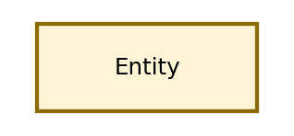 | External Entity | A person, organisation or system outside the software that sends or receives data. | Victim, Volunteer, Admin
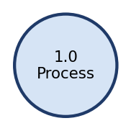 | Process | Transforms input data into output data. Numbered as 1.0, 2.0 … | 2.0 SOS & Incident Reporting
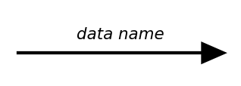 | Data Flow | Shows the movement of data and its direction between components. | SOS alert, GPS location
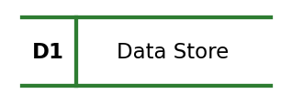 | Data Store | A place where data is stored for later use (database / file). | D2 Incidents DB

Data Flow Diagram (DFD) Level 0 – Definition
A Level 0 Data Flow Diagram (DFD), also called a Context Diagram, is the highest-level view of a system. It shows the entire system as a single process and how external entities interact with it through data flows.
Characteristics:
- Represents the whole system as one process (0.0).
- Shows only external entities and the data flowing between them and the system.
- Does not show internal processes or data stores.
- Gives a general overview of the system boundary.
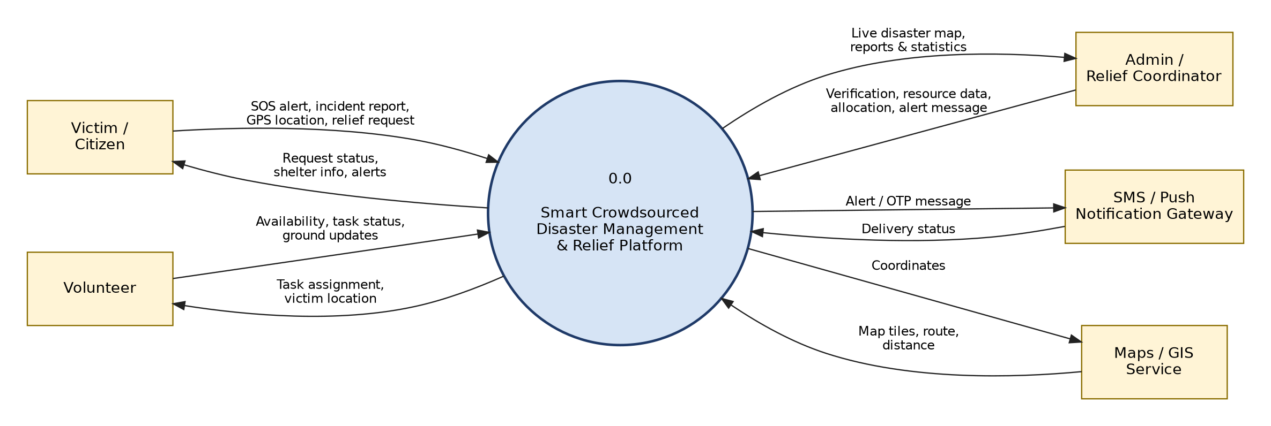
Figure 7.1: DFD Level 0 (Context Diagram)
In the context diagram, the Victim sends SOS alerts, incident reports and relief requests and receives status updates and alerts. The Volunteer sends availability and task updates and receives task assignments. The Admin sends verification and allocation decisions and receives the live map and reports. The Notification Gateway and Maps/GIS Service are external systems used for messaging and location services.
Data Flow Diagram (DFD) Level 1 – Definition
A Level 1 Data Flow Diagram (DFD) is a more detailed version of Level 0. It breaks the single process into major sub-processes and shows how data moves between these processes, data stores and external entities.
Characteristics:
- Breaks the main process into several sub-processes.
- Shows internal data flows between processes.
- Includes data stores (databases/files).
- Gives a detailed understanding of the system's functionality.
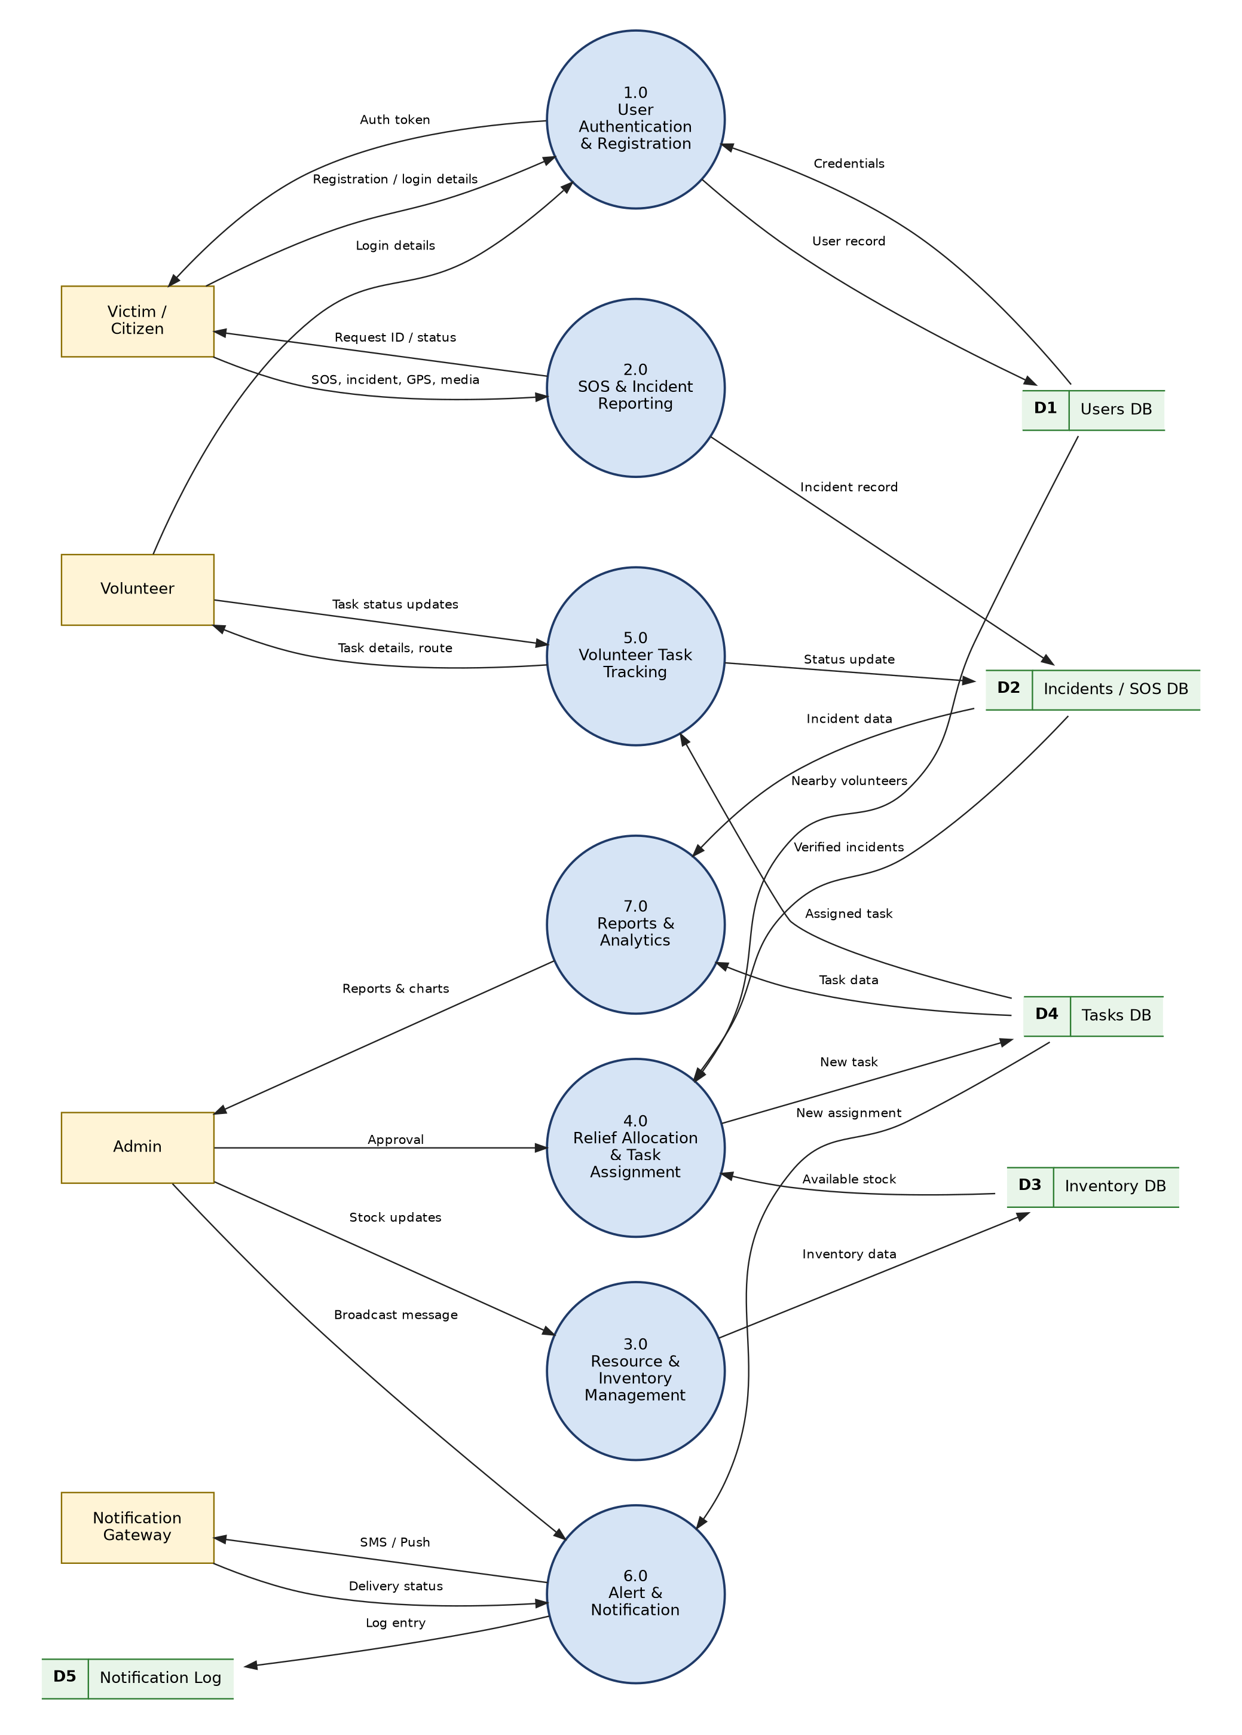
Figure 7.2: DFD Level 1 of the Smart Crowdsourced Disaster Management & Relief Platform
Table 7.2: Level 1 process description
Process | Input | Output | Data Store Used
1.0 User Authentication & Registration | Registration / login details | Auth token | D1 Users DB
2.0 SOS & Incident Reporting | SOS, incident details, GPS, media | Incident record, request ID | D2 Incidents / SOS DB
3.0 Resource & Inventory Management | Stock updates from admin | Updated inventory | D3 Inventory DB
4.0 Relief Allocation & Task Assignment | Verified incidents, stock, nearby volunteers | New task | D1, D2, D3, D4
5.0 Volunteer Task Tracking | Assigned task, status updates | Task details, route | D2, D4 Tasks DB
6.0 Alert & Notification | Broadcast message, new assignment | SMS / push, log entry | D4, D5 Notification Log
7.0 Reports & Analytics | Incident and task data | Reports & charts | D2, D4

Table 7.3: Comparison of DFD Level 0 and Level 1
Feature | DFD Level 0 | DFD Level 1
Purpose | Gives an overview of the entire system | Shows detailed internal processes
Processes | One main process | Multiple sub-processes (1.0 – 7.0)
Data Stores | Not shown | Shown (D1 – D5)
Detail Level | High-level | More detailed
External Entities | Shown | Shown

Conclusion
The Data Flow Diagrams show how information moves through the platform – from victims' SOS alerts to verified incidents, allocated tasks and delivered notifications. Level 0 defines the system boundary, while Level 1 exposes the internal processes and data stores needed for design and implementation.

Aim: Consider any project to be developed in any technology as a Project Manager. Construct Software Requirement Specification (SRS) document for the project.
SRS = Software Requirements Specification
An SRS is a document that describes what a software system should do, how it should behave, which rules it must follow, and what requirements it must satisfy. It acts as the blueprint of the software and as an agreement between the customer, developers and testers.
Why do we need SRS?
The main purpose is to make sure everyone understands the project in the same way.
Without SRS: Relief agency: "We needed volunteers to be auto-assigned." Developer: "I thought the admin assigns them manually." Tester: "Nobody told me about auto-assignment." → Confusion is created.
With SRS: Customer → SRS → Developer → Tester → No confusion is created.
Easy way to remember
Table 8.1: Structure of an SRS
SRS Section | Question it Answers
Introduction | Why are we building it?
Overall Description | What are we building, who will use it, where will it work?
Functional Requirements | What should it do? What rules should it follow?
Non-Functional Requirements | How well should it work?
External Interfaces | How does it connect with users, hardware and other software?
Data Requirements | What data is needed and how is it stored?
System Constraints | What are the limitations?
Performance Characteristics | How fast and how reliably should it work?
Acceptance Criteria | How do we know it is correct?
References | Where did the information come from?

SOFTWARE REQUIREMENTS SPECIFICATION – SMART CROWDSOURCED DISASTER MANAGEMENT & RELIEF PLATFORM
1. Introduction
1.1 Purpose
The purpose of this SRS is to define the functional and non-functional requirements of the Smart Crowdsourced Disaster Management & Relief Platform – a web-based Progressive Web Application that connects disaster victims, volunteers and relief agencies on a single real-time platform. It is intended for the project team, the faculty guide, testers and relief-agency stakeholders.
1.2 Scope
The platform will provide the following major capabilities:
- Role-based registration and OTP login for Victims, Volunteers and Admins.
- One-tap SOS alert with live GPS location sharing.
- Crowdsourced incident reporting with photos/videos and severity.
- Relief request submission and real-time status tracking.
- Live disaster map with incidents, shelters, relief centres and volunteers.
- Relief inventory and relief-centre management.
- Automatic priority calculation and nearest-volunteer matching.
- Volunteer task assignment, acceptance, navigation and completion.
- Mass emergency alerts through SMS and push notifications.
- Reports and analytics dashboards, and offline request queuing.
1.3 Definitions and Abbreviations
Term | Definition
SRS | Software Requirements Specification
SOS | Emergency distress signal sent by a victim
PWA | Progressive Web Application
GPS | Global Positioning System
OTP | One-Time Password
NDMA | National Disaster Management Authority
NGO | Non-Governmental Organisation
API | Application Programming Interface
JWT | JSON Web Token (authentication mechanism)
RBAC | Role-Based Access Control
FCM | Firebase Cloud Messaging
GIS | Geographic Information System

1.4 References
- Project problem statement, requirement analysis and UML diagrams (Practicals 1–7).
- IEEE Std 830-1998 – Recommended Practice for Software Requirements Specifications.
- NDMA National Disaster Management Guidelines.
- Node.js, Express.js, React.js, MongoDB and Socket.IO documentation.
- OWASP Top Ten – web application security reference.
1.5 Overview
The rest of this document describes the general and overall description, functional requirements, non-functional requirements, external interfaces, data requirements, constraints, performance characteristics, acceptance criteria and references.
2. Specific Requirements
The system shall provide facilities for authentication, SOS alerts, incident reporting, relief requests, live mapping, inventory management, automatic resource allocation, volunteer task management, notifications and reporting. These are divided into functional, non-functional, external interface, data, constraint and performance requirements.
3. General Description
3.1 Product Perspective
The platform is a new, self-contained system with a three-tier architecture: a React PWA frontend for all users, a Node.js/Express backend with Socket.IO for real-time updates, and a MongoDB database with geospatial indexing. It integrates with external SMS/push services and map services.
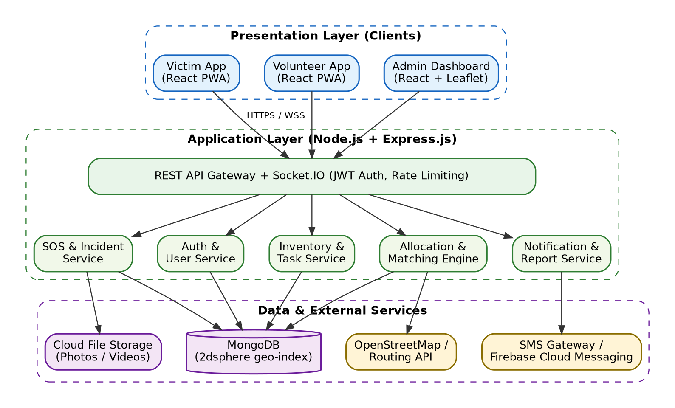
Figure 8.1: System architecture of the platform
3.2 Software Interface
- React.js (PWA) – frontend for victims, volunteers and admins.
- Node.js with Express.js – backend REST APIs.
- Socket.IO – real-time updates of SOS alerts, map markers and task status.
- MongoDB – database with 2dsphere geospatial indexes.
- Leaflet.js with OpenStreetMap – maps and routing.
- Firebase Cloud Messaging and SMS Gateway API – notifications and OTP.
4. Overall Description
4.1 Product Functions
- User registration and login with OTP verification.
- SOS alert and incident reporting with location and media.
- Relief request submission and live tracking.
- Incident verification, merging and rejection by admin.
- Inventory and relief-centre management.
- Priority calculation and nearest volunteer/relief-centre matching.
- Task assignment, acceptance, navigation and completion.
- Emergency alert broadcasting and report generation.
4.2 User Types
- Victim / Citizen – sends SOS, reports incidents, requests relief and tracks status.
- Volunteer – receives tasks, reaches victims, delivers relief and updates status.
- Admin (Relief Coordinator) – verifies reports, manages inventory and volunteers, allocates resources and broadcasts alerts.
4.3 Operating Environment
- Any modern browser (Chrome, Firefox, Edge, Safari) on Android, iOS or desktop.
- Cloud server running Linux with Node.js 20 LTS.
- MongoDB 7.x (cloud-hosted with replica set).
- Internet connection (2G/3G/4G supported with offline queuing).
4.4 Constraints
- A user can raise only one active SOS at a time; repeated SOS within 60 seconds is merged.
- Only verified volunteers can receive tasks.
- Photo uploads are limited to JPG/PNG and videos to MP4, maximum 10 MB each.
- Admin actions require admin-role authentication.
4.5 Assumptions and Dependencies
- Users have a smartphone or basic phone (for SMS alerts).
- Victims allow location permission on their device.
- SMS gateway and map services are available.
- Relief agencies provide initial inventory and relief-centre data.
5. Functional Requirements
FR-1: User Authentication
FR-1.1 Registration
The system shall allow victims and volunteers to register using name, mobile number and password. Volunteers shall also provide skills and service area. Admin accounts are created by the super admin.
FR-1.2 Login with OTP
The system shall authenticate users by password and OTP sent to the registered mobile number. Invalid credentials shall show an error and return to the login screen.
FR-1.3 Role-Based Redirection
After login, the system shall redirect users to the Victim, Volunteer or Admin dashboard.
FR-1.4 Guest SOS
The system shall allow an unregistered user to send an SOS using only a mobile number.
FR-2: SOS Alert and Incident Reporting
FR-2.1 Send SOS
The system shall send an SOS alert with the victim's live GPS location in a single tap.
FR-2.2 Report Incident
The system shall allow reporting of an incident with type (flood, earthquake, fire, landslide), severity (1–5), description and media.
FR-2.3 Duplicate Detection
The system shall merge reports from the same location (within 200 m) and same type within 30 minutes.
FR-3: Relief Request Management
FR-3.1 Submit Request
The victim shall request resources such as food, water, medicine, shelter or rescue, with quantity.
FR-3.2 Track Status
The victim shall view live status: Pending, Verified, Assigned, On the Way, Completed.
FR-4: Incident Verification (Admin)
FR-4.1 Verify / Reject
The admin shall verify genuine incidents and reject or flag fake reports.
FR-4.2 Live Map
The admin shall view all incidents, volunteers and relief centres on a live map.
FR-5: Resource and Inventory Management
FR-5.1 Manage Stock
The admin shall add, update and view relief stock at each relief centre.
FR-5.2 Stock Validation
The system shall not allocate more quantity than is available.
FR-6: Resource Allocation and Volunteer Matching
FR-6.1 Priority
The system shall assign priority: Critical (medical emergency), High (severity ≥ 4), Medium (> 50 people affected), Low (others).
FR-6.2 Nearest Match
The system shall find the nearest available volunteer and relief centre with sufficient stock within a 10 km radius, widening the radius if none is found.
FR-6.3 Auto Reassignment
If a volunteer does not accept a task within 5 minutes, the system shall reassign it to the next nearest volunteer.
FR-7: Volunteer Task Management
FR-7.1 Accept / Reject
The volunteer shall accept or reject assigned tasks.
FR-7.2 Navigate and Update
The volunteer shall view the route to the victim and update status with optional photo proof.
FR-8: Notifications
FR-8.1 Broadcast
The admin shall broadcast alerts to all users within a selected geographic area via SMS and push notification.
FR-8.2 Status Alerts
The system shall notify victims whenever their request status changes.
FR-9: Reports and Analytics
FR-9.1 Reports
The admin shall generate reports of incidents, requests fulfilled, response time and resource usage, exportable as PDF/CSV.
FR-9.2 Charts
Reports shall be shown with bar/pie charts and area heatmaps.
6. Non-Functional Requirements
6.1 Performance
- SOS alerts shall reach the admin dashboard within 3 seconds.
- Pages shall load within 3 seconds on a 4G connection.
6.2 Security
- Passwords shall be hashed using bcrypt; all communication shall use HTTPS/WSS.
- JWT-based authentication with role-based access control.
- Protection against NoSQL injection, XSS and CSRF attacks.
- Victim location shall be shared only with the assigned volunteer and admins.
6.3 Reliability and Availability
- System availability of 99.9% with database replication and daily backups.
- No SOS or request shall be lost; offline requests shall be queued and synced.
6.4 Scalability
- The system shall support at least 5,000 concurrent users and scale horizontally.
6.5 Usability
- Large SOS button, simple icons and support for English, Hindi and Gujarati.
- Responsive design for mobiles, tablets and desktops.
6.6 Maintainability
- Modular code (controllers, services, models) with version control on GitHub.
7. External Interface Requirements
7.1 User Interface
- Login / registration screens with OTP entry.
- Victim dashboard: SOS button, Report Incident, Request Relief, Track Status, Shelters Map.
- Volunteer dashboard: Task list, Accept/Reject, Navigation map, Status update.
- Admin dashboard: Live map, Verification queue, Inventory, Volunteers, Alerts, Reports.
7.2 Hardware Interfaces
The system uses the device's GPS sensor for location and its camera for photos. No other special hardware is required.
7.3 Software Interfaces
Software | Purpose
React.js (PWA) | Frontend user interface
Node.js 20 + Express.js | Backend REST APIs
Socket.IO | Real-time communication
MongoDB 7.x | Database with geospatial queries
Leaflet + OpenStreetMap | Maps and routing
FCM / SMS Gateway | Push notifications, SMS and OTP

7.4 Communication Interfaces
- RESTful HTTPS APIs using JSON.
- WebSocket (WSS) connections for real-time updates.
- Media uploads using multipart/form-data over HTTPS.
8. Data Requirements
8.1 Data Entities
Table 8.2: Data entities
Entity | Key Attributes
User | userId, name, phone, email, passwordHash, role, status
Volunteer Profile | userId, skills, isAvailable, currentLocation, rating
Incident / SOS | incidentId, type, severity, location (GeoJSON), mediaUrls, status, reportedBy, time
Relief Request | requestId, resourceType, quantity, priority, status, victimId
Relief Centre | centreId, name, location, capacity, contact
Resource | resourceId, centreId, name, category, quantity, unit
Task | taskId, requestId, volunteerId, status, assignedAt, completedAt
Notification | notificationId, userId, message, channel, sentAt

8.2 Data Validation
- Mobile number must be 10 digits and unique.
- Severity must be between 1 and 5; quantity must be greater than 0.
- Only valid latitude/longitude values are accepted.
- Media type and size are checked before upload.
8.3 Data Retention
- Incident and relief records are kept for at least 3 years for audit and planning.
- Daily automatic backups are taken during active disaster periods.
9. System Constraints
- Technology: MERN stack (MongoDB, Express, React, Node.js) with Socket.IO.
- Hardware: Server with at least 4 vCPU and 8 GB RAM for production.
- Legal: Compliance with the Digital Personal Data Protection Act, 2023; personal data used only for relief purposes.
- Limitation: Accuracy depends on the GPS signal and network availability of users.
10. Performance Characteristics
Table 8.3: Performance characteristics
Parameter | Requirement
SOS delivery to dashboard | ≤ 3 seconds
Page load time | ≤ 3 seconds (4G)
Nearest volunteer search | ≤ 1 second
Concurrent users | ≥ 5,000
Availability | 99.9%
Media upload limit | 10 MB per file
Backup frequency | Daily

11. Acceptance Criteria
1. A victim can register, log in with OTP and reach the victim dashboard.
2. A victim can send an SOS with live location in one tap and it appears on the admin map within 3 seconds.
3. Incident reports with photos are saved and duplicate reports are merged.
4. The admin can verify or reject incidents.
5. The system assigns the nearest available volunteer and reassigns if the task is rejected.
6. The volunteer can accept, navigate and complete a task, and the victim sees the updated status.
7. Stock cannot be allocated beyond availability.
8. Broadcast alerts are delivered by SMS/push to users in the selected area.
9. Reports can be generated and exported as PDF/CSV.
10. Security (hashing, HTTPS, RBAC) and performance targets are verified.
12. References
- IEEE Std 830-1998 – IEEE Recommended Practice for Software Requirements Specifications.
- NDMA – National Disaster Management Guidelines, Government of India.
- Node.js – https://nodejs.org/docs
- MongoDB Geospatial Queries – https://www.mongodb.com/docs/manual/geospatial-queries
- Socket.IO – https://socket.io/docs
- Leaflet – https://leafletjs.com
- OWASP Top Ten – https://owasp.org/www-project-top-ten

Aim: To study various testing tools.
1. Selenium
- Tool Name: Selenium
- Tool Description: Selenium is an open-source framework for automating web browsers and testing web applications.
- Tool Purpose: Used to automate testing of the platform's web pages such as registration, login, SOS button, incident report form and admin dashboard across Chrome, Firefox and Edge.
- Tool Method: Automated
- Tool Language: Java, Python, C#, JavaScript, Ruby
2. Apache JMeter
- Tool Name: Apache JMeter
- Tool Description: JMeter is an open-source tool for performance and load testing of web applications and APIs.
- Tool Purpose: Used to simulate thousands of victims sending SOS alerts at the same moment during a disaster to check that the server stays fast and does not crash.
- Tool Method: Automated
- Tool Language: Java
3. Postman
- Tool Name: Postman
- Tool Description: Postman is a platform for building, testing and documenting APIs.
- Tool Purpose: Used to test the REST APIs of the platform (login, send SOS, create relief request, allocate resources) and to verify status codes, JSON responses and role-based access.
- Tool Method: Manual and Automated
- Tool Language: JavaScript
4. Jest
- Tool Name: Jest
- Tool Description: Jest is a JavaScript testing framework for unit testing Node.js and React code.
- Tool Purpose: Used to write unit tests for backend logic such as the priority calculation, nearest-volunteer matching and stock validation functions, and for React components.
- Tool Method: Automated
- Tool Language: JavaScript, TypeScript
5. Cypress
- Tool Name: Cypress
- Tool Description: Cypress is a modern end-to-end testing framework for web applications that runs inside the browser.
- Tool Purpose: Used to test complete user journeys, e.g., victim sends SOS → admin verifies → volunteer accepts → victim sees 'Completed'.
- Tool Method: Automated
- Tool Language: JavaScript, TypeScript
6. Appium
- Tool Name: Appium
- Tool Description: Appium is an open-source tool for automating mobile applications on Android and iOS.
- Tool Purpose: Used to test the PWA on real Android and iOS devices, including GPS permission, camera upload and offline behaviour.
- Tool Method: Automated
- Tool Language: Java, Python, JavaScript
7. OWASP ZAP
- Tool Name: OWASP ZAP
- Tool Description: OWASP ZAP (Zed Attack Proxy) is an open-source security testing tool for web applications.
- Tool Purpose: Used to find security weaknesses such as injection, XSS, broken authentication and exposure of victims' location data.
- Tool Method: Manual and Automated
- Tool Language: Java
8. Artillery
- Tool Name: Artillery
- Tool Description: Artillery is a Node.js-based load testing tool that supports HTTP and WebSocket/Socket.IO.
- Tool Purpose: Used to test real-time Socket.IO connections so that thousands of live map updates can be pushed without delay.
- Tool Method: Automated
- Tool Language: JavaScript (YAML scripts)
9. Google Lighthouse
- Tool Name: Google Lighthouse
- Tool Description: Lighthouse is an open-source tool for auditing performance, accessibility, best practices and PWA quality.
- Tool Purpose: Used to check page load speed on slow networks, accessibility of the SOS screen and offline (PWA) readiness.
- Tool Method: Automated
- Tool Language: JavaScript
10. SonarQube
- Tool Name: SonarQube
- Tool Description: SonarQube is a static code analysis tool that checks code quality and security.
- Tool Purpose: Used to detect bugs, code smells, duplicated code and security hotspots in the platform's source code before release.
- Tool Method: Automated
- Tool Language: Java (analyses JavaScript and many others)
Summary of Testing Tools
Table 9.1: Summary of testing tools
Tool | Testing Type | Method | Used For
Selenium | Functional / UI | Automated | Web page testing
Apache JMeter | Performance / Load | Automated | SOS spike simulation
Postman | API | Manual & Automated | REST API testing
Jest | Unit | Automated | Backend logic functions
Cypress | End-to-End | Automated | Complete user journeys
Appium | Mobile | Automated | Android / iOS testing
OWASP ZAP | Security | Manual & Automated | Vulnerability scanning
Artillery | Real-time Load | Automated | Socket.IO connections
Lighthouse | Performance / PWA | Automated | Speed & offline audit
SonarQube | Static Analysis | Automated | Code quality

Conclusion
Different testing tools are needed to test different aspects of the platform. Using a combination of functional, API, unit, end-to-end, mobile, performance, security and code-quality tools makes the disaster platform reliable enough for real emergencies.

Aim: To design test cases and to apply them using various testing tools.
Test Scenario ID | Test Scenario Description | Test Case ID | Test Case Description | Test Steps | Pre-conditions | Test Data | Post Conditions | Expected Result | Comments (Type & Tool)
TS_DM_01 | Application Launch | TC_DM_01 | Verify application opens successfully | 1. Open the platform URL.  2. Observe the home screen. | Application deployed | None | Application running | Home page loads without errors. | Positive (Selenium)
TS_DM_01 | Application Launch | TC_DM_02 | Verify PWA loads on mobile device | 1. Open the platform on an Android phone.  2. Tap 'Add to Home Screen'. | Mobile browser available | Android device | PWA installed | App installs and opens in full-screen mode. | Positive (Appium)
TS_DM_01 | Application Launch | TC_DM_03 | Verify app handles missing DB connection | 1. Stop the database.  2. Open the application. | Application deployed | DB unavailable | Error page shown | A friendly error message is shown; app does not crash. | Negative (Selenium)
TS_DM_02 | User Registration | TC_DM_04 | Verify valid victim registration | 1. Open Register page.  2. Enter valid details.  3. Click Register. | App running | Name, 10-digit mobile, password | Account created | Account is created and OTP is sent. | Positive (Selenium)
TS_DM_02 | User Registration | TC_DM_05 | Verify volunteer registration with skills | 1. Select 'Volunteer'.  2. Enter details and skills.  3. Submit. | App running | Skills: First Aid, Swimming | Volunteer pending verification | Volunteer account created with status 'Pending Verification'. | Positive (Selenium)
TS_DM_02 | User Registration | TC_DM_06 | Verify empty / invalid fields are rejected | 1. Leave fields empty or enter 8-digit mobile.  2. Click Register. | App running | Empty / invalid input | Account not created | Validation errors shown next to fields. | Negative (Selenium)
TS_DM_02 | User Registration | TC_DM_07 | Verify duplicate mobile number is rejected | 1. Register with an existing mobile number. | Account already exists | Existing mobile no. | Registration blocked | Message 'Mobile number already registered' is shown. | Negative (Postman)
TS_DM_03 | Login & OTP | TC_DM_08 | Verify login with valid credentials and OTP | 1. Enter mobile & password.  2. Enter OTP.  3. Click Login. | Registered user | Valid credentials, valid OTP | User logged in | User logged in and redirected to correct dashboard. | Positive (Cypress)
TS_DM_03 | Login & OTP | TC_DM_09 | Verify login with wrong password | 1. Enter valid mobile and wrong password.  2. Click Login. | Registered user | Wrong password | Login rejected | 'Invalid credentials' message is shown. | Negative (Selenium)
TS_DM_03 | Login & OTP | TC_DM_10 | Verify expired / wrong OTP is rejected | 1. Enter credentials.  2. Enter OTP after 5 minutes. | OTP sent | Expired OTP | Login rejected | 'OTP expired' shown with Resend option. | Negative (Postman)
TS_DM_03 | Login & OTP | TC_DM_11 | Verify role-based access to admin APIs | 1. Login as victim.  2. Call admin API. | Victim logged in | Victim JWT token | Access denied | API returns 403 Forbidden. | Negative (Postman)
TS_DM_04 | SOS Alert | TC_DM_12 | Verify SOS alert with live GPS | 1. Login as victim.  2. Tap SOS button. | Location permission on | GPS coordinates | SOS stored | Alert appears on admin map within 3 seconds. | Positive (Cypress)
TS_DM_04 | SOS Alert | TC_DM_13 | Verify SOS when GPS is denied | 1. Deny location permission.  2. Tap SOS. | Location permission off | No GPS | Manual location prompt | User is asked to enter a landmark; SOS is still sent. | Negative (Appium)
TS_DM_04 | SOS Alert | TC_DM_14 | Verify SOS is queued when offline | 1. Turn off internet.  2. Tap SOS.  3. Turn internet on. | Victim logged in | No network | SOS synced | SOS is queued offline and sent automatically on reconnect. | Positive (Appium)
TS_DM_04 | SOS Alert | TC_DM_15 | Verify repeated SOS is merged | 1. Tap SOS.  2. Tap SOS again within 60 s. | Active SOS exists | Same location | Single SOS kept | Duplicate SOS is merged; only one alert shown. | Negative (Jest)
TS_DM_05 | Incident Reporting | TC_DM_16 | Verify incident report with photo | 1. Open Report Incident.  2. Fill type, severity, description.  3. Upload photo and submit. | Victim logged in | JPG 2 MB, severity 4 | Incident created | Incident saved with photo and shown as 'Pending Verification'. | Positive (Selenium)
TS_DM_05 | Incident Reporting | TC_DM_17 | Verify unsupported file is rejected | 1. Upload a .exe file as evidence. | Victim logged in | report.exe | Upload rejected | 'Unsupported file type' message is shown. | Negative (Selenium)
TS_DM_05 | Incident Reporting | TC_DM_18 | Verify oversized video is rejected | 1. Upload a 25 MB video. | Victim logged in | 25 MB MP4 | Upload rejected | 'File exceeds 10 MB' message; app does not crash. | Negative (Selenium)
TS_DM_06 | Relief Request | TC_DM_19 | Verify relief request submission | 1. Open Request Relief.  2. Select Water, qty 20.  3. Submit. | Victim logged in | Water, 20 litres | Request created | Request ID generated with status 'Pending'. | Positive (Postman)
TS_DM_06 | Relief Request | TC_DM_20 | Verify zero / negative quantity rejected | 1. Enter quantity 0 or -5.  2. Submit. | Victim logged in | Qty = 0, -5 | Request not created | Validation error 'Quantity must be greater than 0'. | Negative (Jest)
TS_DM_06 | Relief Request | TC_DM_21 | Verify live status tracking | 1. Admin assigns request.  2. Victim opens Track Status. | Request exists | Status change | Status updated | Victim sees 'Assigned' instantly without refreshing. | Positive (Cypress)
TS_DM_07 | Incident Verification | TC_DM_22 | Verify admin verifies genuine incident | 1. Login as admin.  2. Open verification queue.  3. Click Verify. | Pending incident | Incident ID | Incident verified | Incident shown as verified marker on live map. | Positive (Selenium)
TS_DM_07 | Incident Verification | TC_DM_23 | Verify fake report is rejected and flagged | 1. Select a fake report.  2. Click Reject. | Pending incident | Fake report | Report flagged | Report removed from map; reporter flagged. | Positive (Selenium)
TS_DM_08 | Inventory | TC_DM_24 | Verify admin can add relief stock | 1. Open Inventory.  2. Add 500 food packets. | Admin logged in | Food packets, 500 | Stock updated | Stock quantity increases by 500. | Positive (Postman)
TS_DM_08 | Inventory | TC_DM_25 | Verify over-allocation is blocked | 1. Allocate 300 blankets when only 100 exist. | Stock = 100 | Qty = 300 | Allocation blocked | 'Insufficient stock' message is shown. | Negative (Jest)
TS_DM_09 | Allocation & Matching | TC_DM_26 | Verify nearest available volunteer is assigned | 1. Verify an incident.  2. Trigger auto-allocation. | Volunteers at 2 km & 6 km | Incident location | Task created | Volunteer at 2 km is assigned. | Positive (Jest)
TS_DM_09 | Allocation & Matching | TC_DM_27 | Verify no volunteer within radius | 1. Trigger allocation where no volunteer is within 10 km. | No nearby volunteer | Remote location | Radius widened | Search radius widens and admin is alerted. | Negative (Jest)
TS_DM_09 | Allocation & Matching | TC_DM_28 | Verify critical requests are handled first | 1. Create Low and Critical requests.  2. Run allocation. | Two pending requests | Medical emergency | Critical assigned first | Critical request is assigned before Low. | Positive (Jest)
TS_DM_10 | Volunteer Tasks | TC_DM_29 | Verify volunteer accepts task | 1. Login as volunteer.  2. Open task.  3. Click Accept. | Task assigned | Task ID | Task accepted | Status becomes 'On the Way'; route shown. | Positive (Cypress)
TS_DM_10 | Volunteer Tasks | TC_DM_30 | Verify rejected task is reassigned | 1. Click Reject on task. | Task assigned | Task ID | Task reassigned | Task goes to next nearest volunteer. | Positive (Cypress)
TS_DM_10 | Volunteer Tasks | TC_DM_31 | Verify task completion updates victim | 1. Click 'Mark Completed'.  2. Upload proof. | Task accepted | Photo proof | Task completed | Victim's request shows 'Completed'. | Positive (Cypress)
TS_DM_11 | Notifications | TC_DM_32 | Verify area-based broadcast alert | 1. Admin selects area on map.  2. Sends alert. | Users in area | Alert message | Alert delivered | Users in area receive SMS and push alert. | Positive (Postman)
TS_DM_11 | Notifications | TC_DM_33 | Verify SMS gateway failure handling | 1. Disable SMS gateway.  2. Send alert. | Gateway down | Alert message | Retry logged | System retries 3 times and logs failure. | Negative (Jest)
TS_DM_12 | Live Map | TC_DM_34 | Verify real-time marker update | 1. Open admin map.  2. Victim sends SOS. | Admin map open | New SOS | Marker added | New marker appears within 3 seconds. | Positive (Artillery)
TS_DM_12 | Live Map | TC_DM_35 | Verify map with 1,000 markers | 1. Load map with 1,000 incidents. | Bulk data | 1,000 incidents | Map rendered | Map loads within 3 seconds using clustering. | Positive (Lighthouse)
TS_DM_13 | Reports | TC_DM_36 | Verify PDF report generation | 1. Open Reports.  2. Click Export PDF. | Data available | Date range | PDF created | PDF with correct statistics and charts is downloaded. | Positive (Selenium)
TS_DM_13 | Reports | TC_DM_37 | Verify report with no data | 1. Select date range with no incidents. | No data | Empty range | Report handled | 'No data available' shown without error. | Negative (Selenium)
TS_DM_14 | Security | TC_DM_38 | Verify injection attack is blocked | 1. Enter {"$gt":""} in login field. | App running | Injection payload | Login rejected | Input sanitised; login denied. | Negative (OWASP ZAP)
TS_DM_14 | Security | TC_DM_39 | Verify location privacy | 1. Login as another victim.  2. Request someone else's SOS location. | Victim logged in | Other SOS ID | Access denied | API returns 403; location not exposed. | Negative (Postman)
TS_DM_15 | Performance | TC_DM_40 | Verify 5,000 concurrent SOS requests | 1. Run JMeter test with 5,000 users. | Load test setup | 5,000 virtual users | All SOS stored | Avg response ≤ 3 s; no request lost. | Positive (JMeter)
TS_DM_15 | Performance | TC_DM_41 | Verify 2,000 live socket connections | 1. Run Artillery Socket.IO script. | Server running | 2,000 connections | Connections stable | All clients receive updates without drop. | Positive (Artillery)
TS_DM_16 | Error Handling | TC_DM_42 | Verify server downtime handling | 1. Stop API server.  2. Try to send request. | App running | No server | Request queued | Message shown; request queued for retry. | Negative (Cypress)
TS_DM_16 | Error Handling | TC_DM_43 | Verify app stability on invalid inputs | 1. Enter random invalid inputs across forms. | App running | Mixed invalid data | App stable | Application shows errors but never crashes. | Negative (Selenium)

Summary of Test Execution
Total Test Cases | Positive Tests | Negative Tests | Test Scenarios
43 | 24 | 19 | 16

The test cases cover all major modules of the platform – launch, registration, login, SOS alerts, incident reporting, relief requests, verification, inventory, allocation, volunteer tasks, notifications, live map, reports, security, performance and error handling – and are applied using Selenium, Cypress, Appium, Postman, Jest, JMeter, Artillery, Lighthouse and OWASP ZAP.

Aim: To study cost estimation and preparation of timeline charts.
1. Cost Estimation Table
The development cost is estimated using the effort (in hours) required for each task and a standard rate of ₹400 per hour.
Table 11.1: Development (labour) cost estimation
Sr. | Task | Hours | Price (₹)
1 | Requirement Analysis & Feasibility Study | 20 | 8,000
2 | System Design (UML, DFD, DB Schema) | 25 | 10,000
3 | Project Setup & Environment Configuration | 10 | 4,000
4 | UI / UX Design (Victim, Volunteer, Admin) | 25 | 10,000
5 | User Authentication & OTP Verification | 20 | 8,000
6 | SOS Alert & Incident Reporting Module | 35 | 14,000
7 | Live Disaster Map (Leaflet + Socket.IO) | 30 | 12,000
8 | Resource & Inventory Management | 25 | 10,000
9 | Relief Allocation & Volunteer Matching | 40 | 16,000
10 | Volunteer Task Management | 25 | 10,000
11 | Alerts & Notifications (SMS / Push) | 20 | 8,000
12 | Reports & Analytics Dashboard | 20 | 8,000
13 | Offline / Low-Network Support (PWA) | 15 | 6,000
14 | Testing & Debugging | 40 | 16,000
15 | Documentation & Deployment | 15 | 6,000
 | Total | 365 | ₹1,46,000

2. Other Project Costs
Table 11.2: Infrastructure and service costs
Item | Details | Cost (₹)
Cloud Hosting | Server for 12 months | 6,000
Domain & SSL | 1 year | 1,200
SMS Gateway Credits | ≈10,000 SMS for OTP & alerts | 2,500
Maps & Push Notifications | OpenStreetMap & Firebase (free tier) | 0
Total Other Costs |  | 9,700

Calculation
Development Cost = Total Hours × Rate per hour
Development Cost = 365 × ₹400 = ₹1,46,000
Total Project Cost = Development Cost + Other Costs = ₹1,46,000 + ₹9,700
Total Project Cost = ₹1,55,700
3. Project Schedule
Table 11.3: Project schedule (06-07-2026 to 06-11-2026)
Sr. | Task | Start Date | End Date | Days
1 | Requirement Analysis & Feasibility Study | 06-07-2026 | 15-07-2026 | 10
2 | System Design (UML, DFD, DB Schema) | 13-07-2026 | 26-07-2026 | 14
3 | Project Setup & Environment Configuration | 27-07-2026 | 31-07-2026 | 5
4 | UI / UX Design (Victim, Volunteer, Admin) | 27-07-2026 | 09-08-2026 | 14
5 | User Authentication & OTP Verification | 03-08-2026 | 12-08-2026 | 10
6 | SOS Alert & Incident Reporting Module | 10-08-2026 | 28-08-2026 | 19
7 | Live Disaster Map (Leaflet + Socket.IO) | 20-08-2026 | 05-09-2026 | 17
8 | Resource & Inventory Management | 31-08-2026 | 12-09-2026 | 13
9 | Relief Allocation & Volunteer Matching | 07-09-2026 | 28-09-2026 | 22
10 | Volunteer Task Management | 14-09-2026 | 30-09-2026 | 17
11 | Alerts & Notifications (SMS / Push) | 21-09-2026 | 03-10-2026 | 13
12 | Reports & Analytics Dashboard | 28-09-2026 | 09-10-2026 | 12
13 | Offline / Low-Network Support (PWA) | 05-10-2026 | 14-10-2026 | 10
14 | Testing & Debugging | 05-10-2026 | 28-10-2026 | 24
15 | Documentation & Deployment | 26-10-2026 | 06-11-2026 | 12

4. Timeline Chart (Gantt Chart)
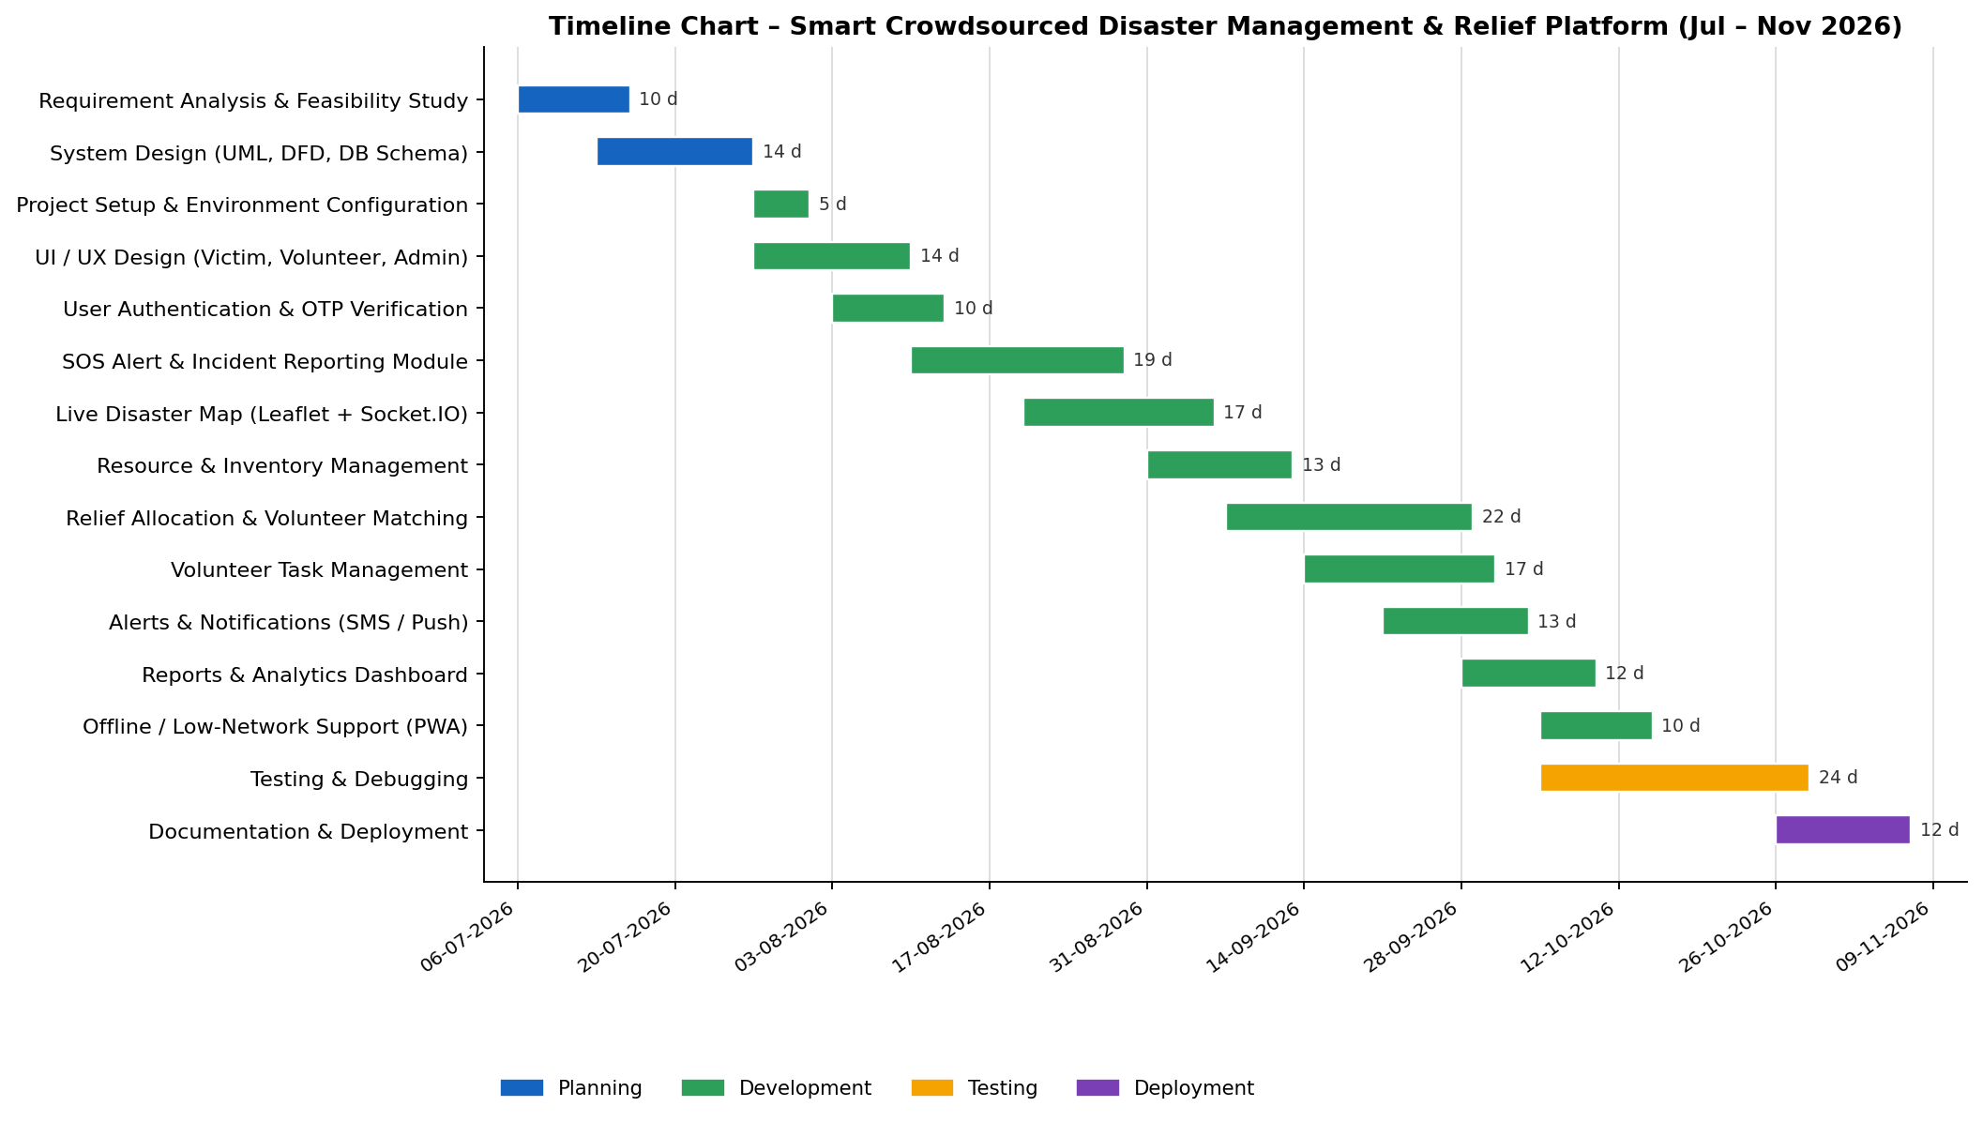
Figure 11.1: Timeline (Gantt) chart of the project
The Gantt chart shows that the project runs for about 18 weeks (06-07-2026 to 06-11-2026). Several development tasks overlap because different modules can be built in parallel, and testing starts before development is fully complete so that bugs are found early.
Conclusion
Cost estimation and timeline charts help in planning the budget and schedule of the project. The estimated effort is 365 hours with a total project cost of ₹1,55,700, completed in about 18 weeks.

Aim: Capability Maturity Model (CMM) & its Levels in Software Engineering
Capability Maturity Model (CMM)
The Capability Maturity Model (CMM), developed by the Software Engineering Institute (SEI) at Carnegie Mellon University, is a framework used to evaluate and improve the maturity of software development processes in an organisation. It helps an organisation identify its current process level and gives a path for improving software quality, productivity and project management. CMM consists of five maturity levels.
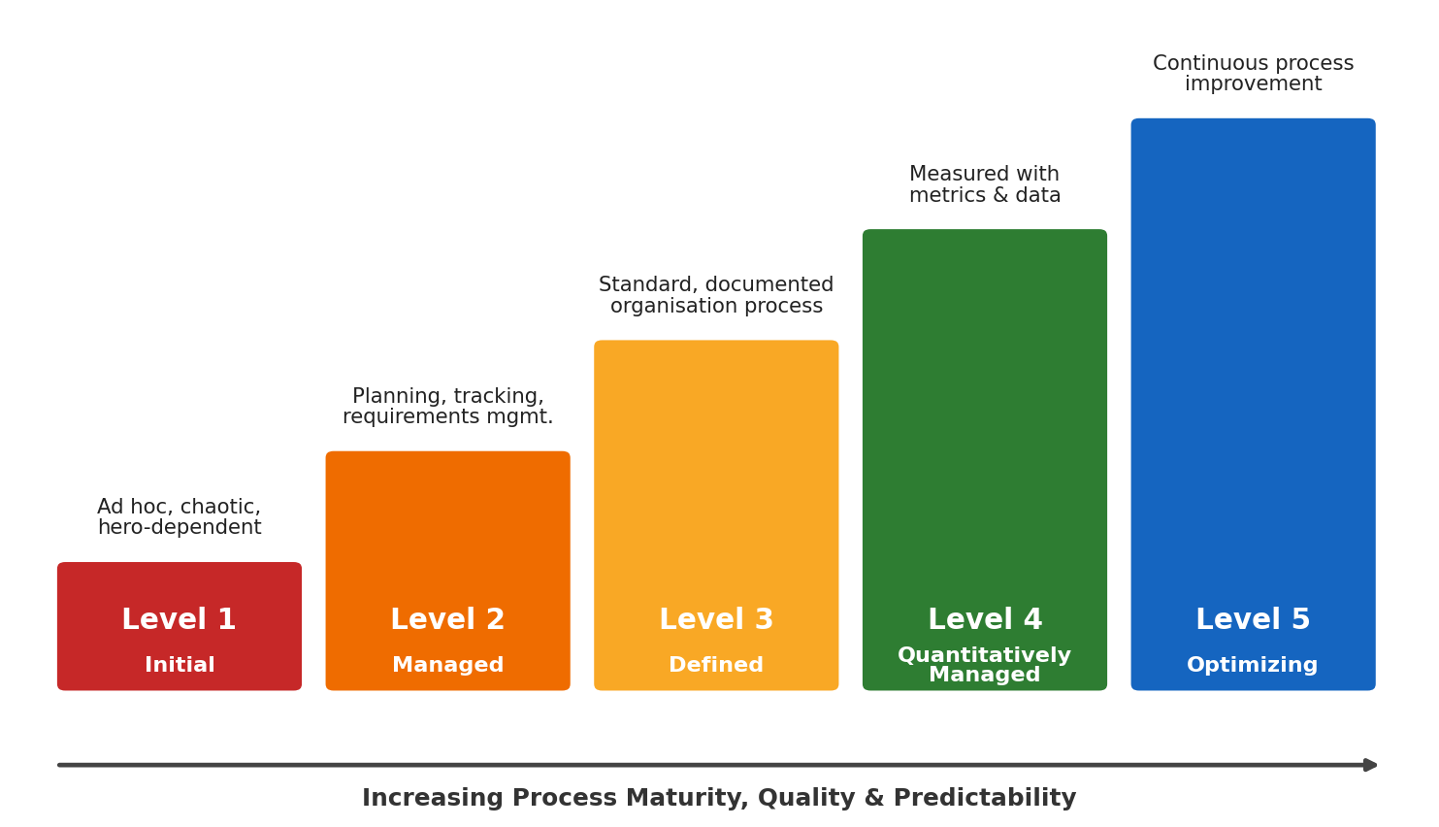
Figure 12.1: Five maturity levels of CMM
Levels of CMM
1. Level 1 – Initial
At this level, the development process is unpredictable and poorly controlled. Success depends on individual effort. There are few defined processes and schedules and costs are often exceeded.
Project example: A first prototype of the disaster platform built quickly during a hackathon, without documented requirements or testing, would be at this level.
2. Level 2 – Managed (Repeatable)
Basic project management processes are established. Requirements, schedules, costs and development activities are planned and tracked, so earlier successes can be repeated.
Project example: For the disaster platform, this corresponds to having a documented requirement analysis, a cost estimate of 365 hours and a Gantt timeline (Practical 11) that are tracked against actual progress.
3. Level 3 – Defined
Processes are documented, standardised and followed throughout the organisation. Engineering and management activities follow a common process.
Project example: For the platform, the SDLC, SRS and UML diagrams (Use Case, Class, Activity, DFD) prepared in earlier practicals are followed consistently as the standard process for every release.
4. Level 4 – Quantitatively Managed
Processes are measured and controlled using quantitative data and statistical techniques.
Project example: For the platform, metrics such as SOS delivery time (target ≤ 3 s), defect density, test coverage, average response time of volunteers and effort variance against the estimate would be collected and controlled.
5. Level 5 – Optimizing
The organisation continuously improves its processes using measurements, feedback, new technologies and lessons learned.
Project example: For the platform, feedback and data from each disaster response and mock drill would be used to improve the matching algorithm, the process and estimates for the next release.
Key Process Areas (KPAs) at Each Level
Table 12.1: Key process areas of CMM
Level | Focus | Key Process Areas
1 – Initial | Competent people | No KPAs
2 – Managed | Project management | Requirements Management, Project Planning, Project Tracking & Oversight, Subcontract Management, Software Quality Assurance, Configuration Management
3 – Defined | Engineering process | Organisation Process Focus & Definition, Training Program, Integrated Software Management, Software Product Engineering, Inter-group Coordination, Peer Reviews
4 – Quantitatively Managed | Product & process quality | Quantitative Process Management, Software Quality Management
5 – Optimizing | Continuous improvement | Defect Prevention, Technology Change Management, Process Change Management

Maturity Assessment of Our Project
Our project team currently works at Level 2 (Managed) moving towards Level 3 (Defined): requirements, cost and schedule are documented and tracked, the SRS and design diagrams are prepared, code is version-controlled on GitHub, and test cases are defined. Collecting metrics during testing and after deployment would help the team move towards Level 4.
Conclusion
CMM provides a clear roadmap for improving software processes. For a life-critical system like a disaster management platform, moving to higher maturity levels gives more predictable schedules, fewer defects and more reliable software.

Aim: Calculate cyclomatic complexity for given Code. Identify the number of Independent paths required for testing.
The following C program is taken from the priority module of the disaster platform. It decides the priority of a relief request based on the medical emergency flag, the severity of the disaster and the number of people affected.
Program
#include <stdio.h>

int main() {
int severity, people, hasMedical;

printf("Enter Severity, People, Medical(1/0): ");
scanf("%d %d %d", &severity, &people, &hasMedical);

if (hasMedical == 1)
printf("Priority: CRITICAL - Dispatch Medical Team\n");
else if (severity >= 4)
printf("Priority: HIGH - Dispatch Rescue Team\n");
else if (people > 50)
printf("Priority: MEDIUM - Dispatch Relief Supplies\n");
else
printf("Priority: LOW - Add to Relief Queue\n");

return 0;
}

Output:
Enter Severity, People, Medical(1/0): 4 30 0
Priority: HIGH - Dispatch Rescue Team

Flowchart
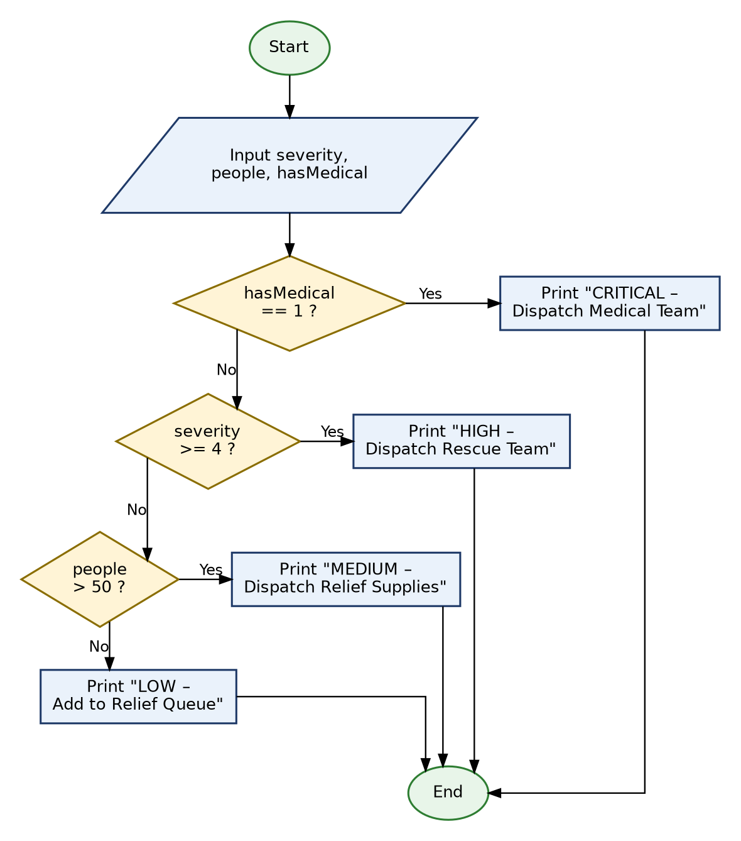
Figure 13.1: Flowchart of the priority program
Control Flow Graph (CFG)
Table 13.1: Mapping of code to CFG nodes
Node | Statement(s)
1 | Declarations, printf() and scanf() – read input
2 | if (hasMedical == 1)
3 | printf("CRITICAL …")
4 | else if (severity >= 4)
5 | printf("HIGH …")
6 | else if (people > 50)
7 | printf("MEDIUM …")
8 | else printf("LOW …")
9 | return 0; – End

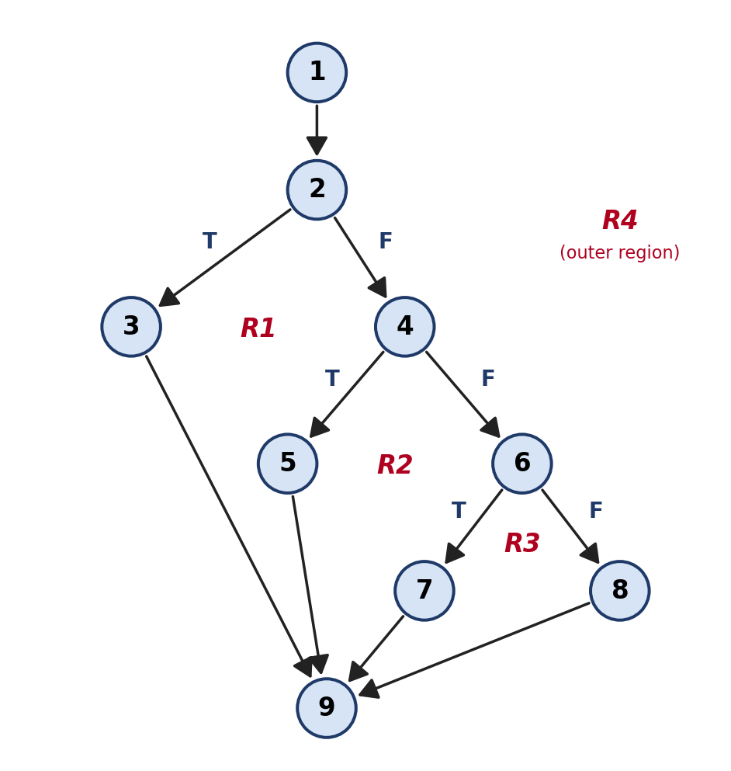
Figure 13.2: Control flow graph with regions
Calculation of Cyclomatic Complexity
From the control flow graph: Number of edges E = 11, Number of nodes N = 9, Number of predicate (decision) nodes P = 3 (nodes 2, 4 and 6), Number of regions R = 4.
Method 1: Using edges and nodes
V(G) = E − N + 2 = 11 − 9 + 2 = 4
Method 2: Using predicate nodes
V(G) = P + 1 = 3 + 1 = 4
Method 3: Using regions
V(G) = Number of regions = R1 + R2 + R3 + R4 = 4
All three methods give the same result. The number of independent paths required for testing is equal to the cyclomatic complexity.
Cyclomatic Complexity V(G) = 4, therefore Number of Independent Paths = 4.
Independent Paths
Table 13.2: Independent paths and test inputs
Path | Nodes Traversed | Test Input (severity, people, hasMedical) | Expected Output
Path 1 | 1 → 2 → 3 → 9 | (2, 10, 1) | CRITICAL – Dispatch Medical Team
Path 2 | 1 → 2 → 4 → 5 → 9 | (4, 30, 0) | HIGH – Dispatch Rescue Team
Path 3 | 1 → 2 → 4 → 6 → 7 → 9 | (2, 80, 0) | MEDIUM – Dispatch Relief Supplies
Path 4 | 1 → 2 → 4 → 6 → 8 → 9 | (2, 20, 0) | LOW – Add to Relief Queue

Result
Cyclomatic Complexity = 4
Independent Paths Required for Testing = 4
A complexity of 4 (less than 10) means the priority module is simple, easy to understand and easy to test.

Aim: Generate a test suite using the white box testing strategies.
White box testing examines the internal structure and logic of the code. The test suite below is designed for two modules of the disaster platform: Module A – the request priority program (Practical 13), and Module B – the function that finds the nearest relief centre with sufficient stock, shown below.
Module B: Program Under Test
#define MAX_CENTERS 50

/* Returns index of the nearest relief centre that has enough stock,
or -1 if no centre can serve the request */
int findNearestCenter(int stock[], int distance[], int n, int required) {
int best = -1, minDist = 9999;
for (int i = 0; i < n; i++) {
if (stock[i] >= required && distance[i] < minDist) {
minDist = distance[i];
best = i;
}
}
return best;
}

1. Statement Coverage
Statement coverage ensures that every executable statement in the program is executed at least once.
1. It checks whether all statements of the program are executed.
2. It helps find statements (dead code) that are never executed.
3. For the platform, input-reading, priority-deciding and message-printing statements are tested.
4. Test cases are designed so that each print statement runs at least once.
5. Higher statement coverage increases confidence that the priority logic has been exercised.
Table 14.1: Statement coverage test cases (Module A) – 100% coverage
Test Case | Input (severity, people, hasMedical) | Statements Executed | Expected Result
TC-01 | (2, 10, 1) | Input, if-1, CRITICAL print, return | CRITICAL – Dispatch Medical Team
TC-02 | (5, 10, 0) | Input, if-1, if-2, HIGH print, return | HIGH – Dispatch Rescue Team
TC-03 | (2, 80, 0) | Input, if-1, if-2, if-3, MEDIUM print, return | MEDIUM – Dispatch Relief Supplies
TC-04 | (1, 5, 0) | Input, if-1, if-2, if-3, LOW print, return | LOW – Add to Relief Queue

2. Branch Coverage
Branch (decision) coverage tests every possible outcome – True and False – of each decision.
1. It verifies both True and False branches of each decision.
2. It is stronger than statement coverage.
3. Each if / else-if in the priority module must be evaluated both ways.
4. It helps detect wrong comparison operators (e.g., > instead of >=).
5. For the platform, medical flag, severity and people-affected thresholds are tested.
Table 14.2: Branch coverage test cases (Module A)
Test Case | Decision | Branch | Input | Expected Result
TC-05 | hasMedical == 1 | True | (3, 10, 1) | CRITICAL
TC-06 | hasMedical == 1 | False | (4, 10, 0) | Go to next decision → HIGH
TC-07 | severity >= 4 | True | (4, 10, 0) | HIGH
TC-08 | severity >= 4 | False | (3, 60, 0) | Go to next decision → MEDIUM
TC-09 | people > 50 | True | (3, 51, 0) | MEDIUM
TC-10 | people > 50 | False | (3, 50, 0) | LOW

3. Condition Coverage
Condition coverage checks that each individual Boolean condition inside a compound decision evaluates to both True and False. Module B contains the compound decision:
if (stock[i] >= required && distance[i] < minDist) where C1 = stock[i] >= required and C2 = distance[i] < minDist.
1. It focuses on individual conditions used inside decisions.
2. Each condition must be tested with True and False values.
3. It is more detailed than branch coverage.
4. It helps identify wrong logical operators (&& vs ||).
5. For the platform, stock sufficiency and distance comparison are tested separately.
Table 14.3: Condition coverage test cases (Module B)
Test Case | C1: stock ≥ required | C2: distance < minDist | Decision Result | Expected Result
TC-11 | True (stock 100, req 50) | True (dist 5 < 9999) | True | Centre selected as best
TC-12 | True (stock 100, req 50) | False (dist 12 > minDist 5) | False | Not selected – farther than current best
TC-13 | False (stock 20, req 50) | True (dist 2 < minDist) | False | Not selected – insufficient stock
TC-14 | False (stock 10, req 50) | False (dist 20 > minDist) | False | Not selected

4. Path Coverage
Path coverage ensures that all independent execution paths of the program are tested. From Practical 13, Module A has V(G) = 4 independent paths.
1. It tests complete paths from the beginning to the end of the program.
2. It verifies the flow of execution through different decisions.
3. The number of basis paths equals the cyclomatic complexity.
4. It detects errors that occur only on particular paths.
5. For the platform, every priority outcome path is tested.
Table 14.4: Path coverage test cases (Module A)
Path | hasMedical == 1 | severity >= 4 | people > 50 | Input | Result
P1 | Yes | – | – | (2, 10, 1) | CRITICAL
P2 | No | Yes | – | (4, 30, 0) | HIGH
P3 | No | No | Yes | (2, 80, 0) | MEDIUM
P4 | No | No | No | (2, 20, 0) | LOW

5. Loop Testing
Loop testing checks the validity of loop constructs. The for loop in Module B iterates over n relief centres (maximum MAX_CENTERS = 50).
1. It tests the loop when it executes zero times (skip the loop).
2. It tests the loop for exactly one iteration.
3. It tests the loop for two iterations and a typical number of iterations.
4. It tests the loop at maximum − 1 and maximum iterations.
5. It checks that the loop terminates correctly without becoming infinite.
Table 14.5: Loop testing test cases (Module B)
Test Case | Number of Centres (n) | Loop Iterations | Expected Result
TC-15 | 0 | Loop skipped | Returns −1 ('No relief centre available')
TC-16 | 1 (stock sufficient) | 1 | Returns 0 (the only centre)
TC-17 | 2 | 2 | Returns index of the nearer centre with enough stock
TC-18 | 10 (typical) | 10 | Returns nearest centre with enough stock
TC-19 | 49 (max − 1) | 49 | Correct nearest centre returned
TC-20 | 50 (max) | 50 | Correct nearest centre returned; loop ends
TC-21 | 10 (all stock insufficient) | 10 | Returns −1; request escalated to admin

Final White Box Test Suite Summary
Table 14.6: White box test suite summary
Strategy | Module | Test Cases | Coverage Achieved
Statement Coverage | A | TC-01 to TC-04 | 100% statements
Branch Coverage | A | TC-05 to TC-10 | 100% branches
Condition Coverage | B | TC-11 to TC-14 | All condition combinations
Path Coverage | A | P1 to P4 | All 4 basis paths
Loop Testing | B | TC-15 to TC-21 | 0, 1, 2, typical, max−1, max

Conclusion
Using statement, branch, condition, path and loop coverage, a complete white box test suite of 21 test cases and 4 basis paths is generated for the priority and relief-centre selection modules. This ensures that the internal logic that decides who gets help first, and from where, is thoroughly tested.

Aim: Apply basic and intermediate COCOMO technique to estimate the effort and development time based on given project details.
Project Details
COCOMO (Constructive Cost Model), proposed by Barry Boehm, estimates the effort, development time and staff required for a software project based on its size in KLOC (Thousand Lines of Code).
Table 15.1: Module-wise size estimation
Module | Estimated LOC
User Authentication & Profile Management | 1,000
SOS Alert & Incident Reporting | 1,400
Live Disaster Map & Real-time Updates | 1,300
Resource & Inventory Management | 1,000
Relief Allocation & Volunteer Matching Engine | 1,500
Volunteer Task Management | 900
Alerts & Notifications | 700
Reports & Analytics | 800
Admin Dashboard & Common UI Components | 1,000
Offline / PWA Support | 400
Total | 10,000 LOC = 10 KLOC

Project Mode Selection
The project is classified as Semi-Detached Mode because it is of medium size and includes real-time communication, geospatial processing and high-reliability requirements, while being developed by a team with mixed experience. (A simple, familiar project would be Organic; a project with tight hardware/real-time constraints would be Embedded.)
Table 15.2: Basic COCOMO coefficients
Mode | a | b | c | d
Organic | 2.4 | 1.05 | 2.5 | 0.38
Semi-Detached | 3.0 | 1.12 | 2.5 | 0.35
Embedded | 3.6 | 1.20 | 2.5 | 0.32

Part A: Basic COCOMO Model
Formula
Effort (E) = a × (KLOC)ᵇ Person-Months
Development Time (T) = c × (E)ᵈ Months
Average Staff (S) = E / T Persons
1. Calculate Effort
E = 3.0 × (10)¹·¹² = 3.0 × 13.18
Effort (E) ≈ 39.55 Person-Months
2. Calculate Development Time
T = 2.5 × (39.55)⁰·³⁵ = 2.5 × 3.62
Development Time (T) ≈ 9.06 Months
3. Calculate Average Team Size
S = 39.55 / 9.06 ≈ 4.37
Team Size ≈ 4 to 5 Persons
4. Productivity
Productivity = KLOC / E = 10,000 / 39.55 ≈ 253 LOC per Person-Month
Table 15.3: Basic COCOMO results for 10 KLOC in all three modes
Mode | Effort (PM) | Time (Months) | Staff (Persons)
Organic | 26.93 | 8.74 | 3.08
Semi-Detached (selected) | 39.55 | 9.06 | 4.37
Embedded | 57.06 | 9.12 | 6.26

Part B: Intermediate COCOMO Model
Intermediate COCOMO improves the basic estimate by considering 15 cost drivers grouped into product, hardware (computer), personnel and project attributes. Each driver is rated from Very Low to Extra High, and the product of all multipliers gives the Effort Adjustment Factor (EAF).
Formula
Effort (E) = a × (KLOC)ᵇ × EAF (for Semi-Detached: a = 3.0, b = 1.12)
Development Time (T) = 2.5 × (E)⁰·³⁵
Cost Driver Ratings for the Project
Table 15.4: Intermediate COCOMO cost drivers
Category | Cost Driver | Rating | Multiplier | Reason
Product | RELY – Required Reliability | High | 1.15 | Failures can delay life-saving help
Product | DATA – Database Size | High | 1.08 | Large volume of incidents, media and locations
Product | CPLX – Product Complexity | High | 1.15 | Geospatial matching and real-time updates
Computer | TIME – Execution Time Constraint | High | 1.11 | SOS must be processed within 3 seconds
Computer | STOR – Main Storage Constraint | Nominal | 1.00 | Cloud storage is scalable
Computer | VIRT – Virtual Machine Volatility | Nominal | 1.00 | Stable platform (Node.js, MongoDB)
Computer | TURN – Computer Turnaround Time | Low | 0.87 | Interactive development environment
Personnel | ACAP – Analyst Capability | Nominal | 1.00 | Average analyst capability
Personnel | AEXP – Application Experience | Low | 1.13 | Team is new to disaster management domain
Personnel | PCAP – Programmer Capability | Nominal | 1.00 | Average programmer capability
Personnel | VEXP – Virtual Machine Experience | Nominal | 1.00 | Normal experience with the platform
Personnel | LEXP – Language Experience | Nominal | 1.00 | Normal JavaScript experience
Project | MODP – Modern Programming Practices | High | 0.91 | Git, code reviews, modular code
Project | TOOL – Use of Software Tools | High | 0.91 | VS Code, Postman, automated testing tools
Project | SCED – Required Schedule | Nominal | 1.00 | Normal schedule

1. Calculate EAF
EAF = 1.15 × 1.08 × 1.15 × 1.11 × 1.00 × 1.00 × 0.87 × 1.00 × 1.13 × 1.00 × 1.00 × 1.00 × 0.91 × 0.91 × 1.00
EAF ≈ 1.29
2. Calculate Effort
E = 3.0 × (10)¹·¹² × 1.29 = 39.55 × 1.29
Effort (E) ≈ 51.04 Person-Months
3. Calculate Development Time
T = 2.5 × (51.04)⁰·³⁵
Development Time (T) ≈ 9.90 Months
4. Calculate Average Team Size
S = 51.04 / 9.90 ≈ 5.15
Team Size ≈ 5 Persons
Result
Table 15.5: Comparison of Basic and Intermediate COCOMO
Parameter | Basic COCOMO | Intermediate COCOMO
Size | 10 KLOC | 10 KLOC
Mode | Semi-Detached | Semi-Detached
EAF | – (1.00) | 1.29
Effort | 39.55 Person-Months | 51.04 Person-Months
Development Time | 9.06 Months | 9.90 Months
Average Team Size | ≈ 4 Persons | ≈ 5 Persons

According to Basic COCOMO, the platform requires about 39.55 person-months of effort and 9.06 months with about 4 people. Intermediate COCOMO, which considers the high reliability, complexity and real-time constraints of a disaster management system, gives a more realistic estimate of 51.04 person-months, 9.90 months and about 5 people.
Note: COCOMO estimates effort for an industry-grade product including full documentation, reviews and quality processes; therefore it is higher than the student-team estimate of Practical 11, which covers only the development of the academic version.
Conclusion
Basic COCOMO gives a quick estimate based only on size, while Intermediate COCOMO refines the estimate using cost drivers that reflect the nature of the project. For a critical, real-time system like the disaster management platform, the intermediate model provides a more accurate basis for planning effort, schedule and team size.

