Results
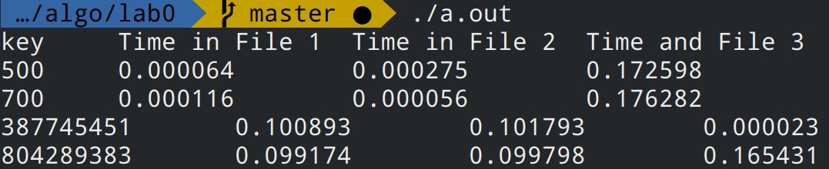
Key | Time in file 1 | Time in file 2 | Time in file 3
500 | 0.000064 | 0.000275 | 0.172598
700 | 0.000116 | 0.000056 | 0.176282
387745451 | 0.100893 | 0.101793 | 0.000023
804289383 | 0.099174 | 0.099798 | 0.165431

Code

generate.c
#include <stdio.h>
#include <stdlib.h>

#define N 1e6

#define ll unsigned long long
// Generate n random numbers between x and y and save in file_name
int generate(ll n, ll x, ll y, char file_name[256], int randomize){

// Open File
FILE* fp;
fp = fopen(file_name, "w");

if(randomize == 0){
for(ll i = x; i <= y; i++)
for(ll j = 0; j < N/1000; j++)
fprintf(fp, "%llu\n", j);
}
else{
for(ll i = 0; i < n; i++){
fprintf(fp, "%llu\n", x + (rand() % (y-x)));
}
}

printf("Generated file %s\n", file_name);
return 0;
}

int main(){

generate(N, 1,1000,"first.txt", 0);
generate(N, 1,1000,"second.txt", 1);
generate(N, 1e6,1e9,"third.txt", 1);
}

linear_search.c
#include <stdio.h>
#include <stdlib.h>
#include <time.h>

#define N 1e6L

#define ll unsigned long long

int linear_search(char file_name[256], ll key){
FILE* fp;
fp = fopen(file_name, "r");
ll num;
while(!feof(fp)){
fscanf(fp, "%llu\n", &num);
if (num == key){
return 1;
}
}
return -1;
}

void find_and_time(ll key){

double t1, t2, t3;

clock_t t;
t = clock();
linear_search("first.txt", key);
t = clock() - t;
t1 = ((double)t)/CLOCKS_PER_SEC;
t = clock();
linear_search("second.txt", key);
t = clock() - t;
t2 = ((double)t)/CLOCKS_PER_SEC;
t = clock();
linear_search("third.txt", key);
t = clock() - t;
t3 = ((double)t)/CLOCKS_PER_SEC;
printf("%llu\t%f\t%f\t%f\n", key, t1, t2, t3);
}

int main(){
printf("key\tTime in File 1\tTime in File 2\tTime and File 3\n");
find_and_time(500);
find_and_time(700);
find_and_time(387745451);
find_and_time(rand()%1000000000);
}

