Graded Lab 4

Rohan Verma

1510110508

Test.java

package gr4;

import javax.swing.*;
import java.awt.*;
import java.awt.event.*;

@SuppressWarnings("serial")
public class Test extends JFrame{

MyPanel panel = new MyPanel();
public Test(){
add(panel);
}

class MyPanel extends JPanel{

int x = 50;
int size = 10;

public MyPanel() {
addKeyListener(new KeyAdapter() {
public void keyPressed(KeyEvent e) {
switch (e.getKeyCode()) {
case KeyEvent.VK_RIGHT: x += 10;
break;
case KeyEvent.VK_LEFT: x -= 10;
break;
case KeyEvent.VK_UP: size+=10;
break;
case KeyEvent.VK_DOWN: size-=10;
}
repaint();
}});
setFocusable(true);
}

protected void paintComponent(Graphics g) {
super.paintComponent(g);

Font f = new Font(Font.MONOSPACED, 0, size);

g.setFont(f);

g.drawString("Rohan Verma",x,150);

}
}

public static void main(String[] args) {
Test frame = new Test();
frame.setTitle("Rohan Verma GR4");
frame.setSize(400,400);
frame.setLocationRelativeTo(null);
frame.setDefaultCloseOperation(JFrame.EXIT_ON_CLOSE);
frame.setVisible(true);
}
}
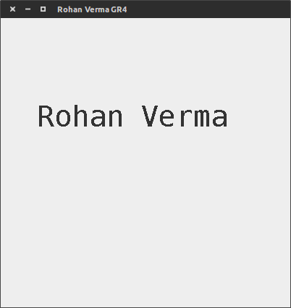

Screenshots
