Graded Lab 1
CSD 207
Shiv Nadar University
Professor Sulabh Bansal

Submitted By:

Rohan Verma
1510110508
Btech CSE, II Year

/*
Q1. Prime number generator

Author: Rohan Verma (hello@rohanverma.net)

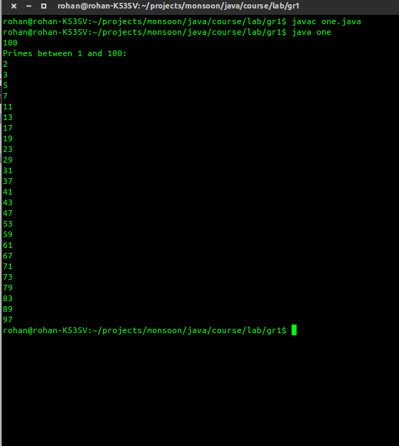

*/
import java.util.Scanner;

public class one {

public static int isPrime(int x){
for(int i = 2; i * i <= x; i++){
if(x % i == 0) return 0;
}
return 1;
}

public static void main( String [] args )
{

int num;

Scanner s = new Scanner(System.in);

num = s.nextInt();

System.out.println("Primes between 1 and " + num + ": ");

for(int i = 2; i <= num; i++){
if(isPrime(i) == 1){
System.out.println(i);
}
}
}
}

/*

Q2. Pyriamid

Author: Rohan Verma (hello@rohanverma.net)

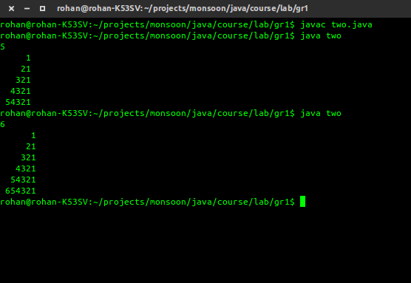

*/
import java.util.Scanner;

public class two {

public static void main( String [] args )
{

int num;

Scanner s = new Scanner(System.in);

num = s.nextInt();

for(int i = 0; i < num; i++){
for(int j = i; j < num; j++){
System.out.print(" ");
}
for(int j = num - i - 1; j < num; j++){
System.out.print(num - j);
}
System.out.print('\n');
}
}
/*
Q3. Leap years between 1901 and 2000

Author: Rohan Verma (hello@rohanverma.net)
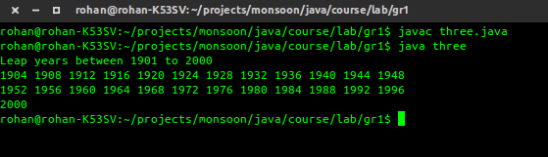
*/
import java.util.Scanner;
public class three {
public static int isPrime(int x){
for(int i = 2; i * i <= x; i++){
if(x % i == 0) return 0;
}
return 1;
}

public static void main( String [] args )
{

int BEGIN = 1901, END = 2000, printed = 0;

Scanner s = new Scanner(System.in);

System.out.println("Leap years between 1901 to 2000 ");

for(int i = BEGIN; i <= END; i++)
{

if ( i%400 == 0)
{
System.out.print(i + " ");
printed++;
}
else if ( i%100 == 0)
;
else if ( i%4 == 0 )
{
System.out.print(i + " ");
printed++;
}

if(printed%12== 0 && printed != 0) {
System.out.println();
printed = 0;
}
}

System.out.println();
}
}

