Assignment 1
CSD 207
Shiv Nadar University
Professor Sulabh Bansal

Contents:
- eighteen.java
- eight.java
- eleven.java
- fifteen.java
- five.java
- four.java
- fourteenpointa.java
- fourteenpointb.java
- fourteenpointc.java
- nine.java
- nineteen.java
- one.java
- seven.java
- seventeen.java
- six.java
- sixteen.java
- ten.java
- thirteen.java
- three.java
- twelve.java
- twenty.java
- twentyone.java
- two.java
Github Repository: https://github.com/rhnvrm/java_learn (Update after deadline of Assignment 1)
/*

1
232
34543
4567654
567898765
67890109876
7890123210987
890123454321098
90123456765432109
0123456789876543210

Done

Author: Rohan Verma (hello@rohanverma.net)
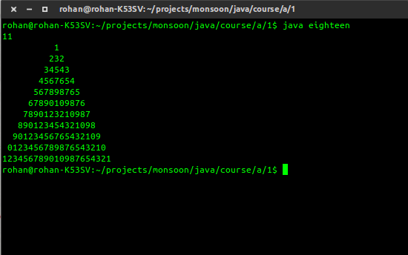
*/
import java.util.Scanner;

public class eighteen {

public static void main( String [] args )
{

int n, c, d, num = 1, space;

Scanner s = new Scanner(System.in);

n = s.nextInt();

space = n - 1;
for ( d = 1 ; d <= n ; d++ )
{
num = d;
for ( c = 1 ; c <= space ; c++ )
System.out.printf(" ");
space--;
for ( c = 1 ; c <= d ; c++ )
{
System.out.printf("%d", num%10);
num++;
}
num--;
num--;
for ( c = 1 ; c < d ; c++)
{
System.out.printf("%d", num%10);
num--;
}
System.out.printf("\n");
}

}
}

/*

Write a program that simulates flipping a
coin one million times and displays the number of
heads and tails.

Author: Rohan Verma (hello@rohanverma.net)
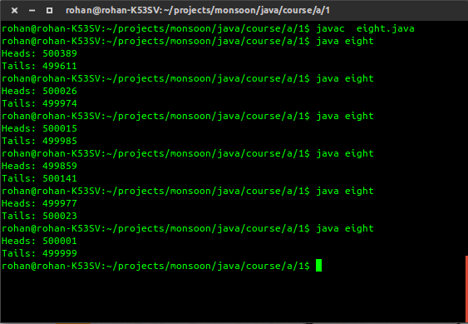
*/
import java.util.Scanner;

public class eight {

public static void main( String [] args )
{

int FLIPS = 1000000;

int heads = 0, tails = 0, coin;

for(int i = 0; i < FLIPS; i++){
coin = (int)((Math.random() > 0.5)?1:0);

if(coin == 0) heads++;
else tails++;
}

System.out.println("Heads: " + heads);
System.out.println("Tails: " + tails);

}
}
/*

A solution to find the greatest common divisor of two integers n1 and n2 is as follows: First
find d to be the minimum of n1 and n2, then check whether d, d-1, d-2, 2, or 1 is a divisor for
both n1 and n2 in this order. The first such common divisor is the greatest common divisor
for n1 and n2. Write a program that prompts the user to enter two positive integers and
displays the gcd.

Author: Rohan Verma (hello@rohanverma.net)
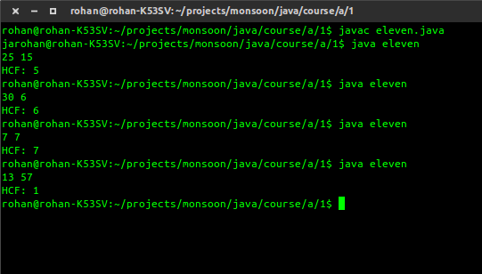
*/
import java.util.Scanner;

public class eleven {

public static int hcf(int a, int b){

int min = (a>b)?b:a;

for(int i = min; i >= 1; i--){
if(a % i == 0 && b % i == 0){
return i;
}
}

return -1;

}

public static void main( String [] args )
{
int a, b;

//Scanner
Scanner s = new Scanner(System.in);

a = s.nextInt();
b = s.nextInt();

System.out.println("HCF: " + hcf(a,b));

}
}

/*

Write a program to read an integer and reverse it.

Author: Rohan Verma (hello@rohanverma.net)
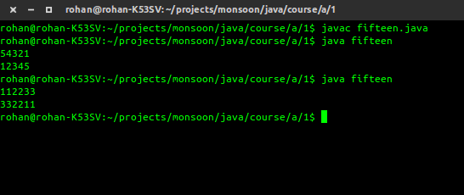
*/
import java.util.Scanner;

public class fifteen {

public static void main( String [] args )
{

int num;

Scanner s = new Scanner(System.in);

num = s.nextInt();

int rev = 0;

while(num != 0){
rev *= 10;
rev += num % 10;

num /= 10;
}

System.out.println(rev);
}
}

/*

Write a program that prompts the user to enter
a decimal integer and displays its
corresponding binary value.
Don’t use Java’s Integer.toBinaryString(int)
in this program.

Author: Rohan Verma (hello@rohanverma.net)
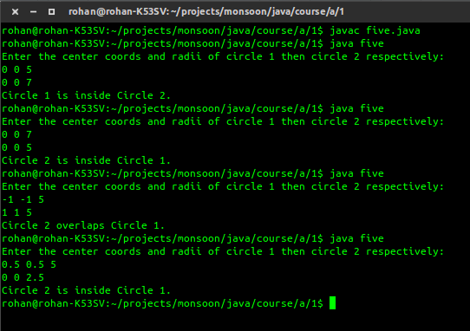
*/
import java.util.Scanner;

public class five {

public static void main( String [] args )
{
double x1, y1, r1, x2, y2, r2;

//Scanner
Scanner s = new Scanner(System.in);

System.out.println("Enter the center coords and radii of circle 1 then circle 2 respectively: ");

x1 = s.nextDouble();
y1 = s.nextDouble();
r1 = s.nextDouble();
x2 = s.nextDouble();
y2 = s.nextDouble();
r2 = s.nextDouble();

double distance = Math.pow((x1 - x2) * (x1 - x2) + (y1 - y2) * (y1 - y2), 0.5);

if (r2 >= r1 && distance <= (r2 - r1)){
System.out.println("Circle 1 is inside Circle 2.");
}
else if (r1 >= r2 && distance <= (r1 - r2) ) {
System.out.println("Circle 2 is inside Circle 1.");
}
else if (distance > (r1 + r2)){
System.out.println("Circle 2 does not overlap Circle 1.");
}
else {
System.out.println("Circle 2 overlaps Circle 1.");
}

}
}

/*

Write a program to find out the L.C.M. and H.C.F. of two numbers.

Author: Rohan Verma (hello@rohanverma.net)
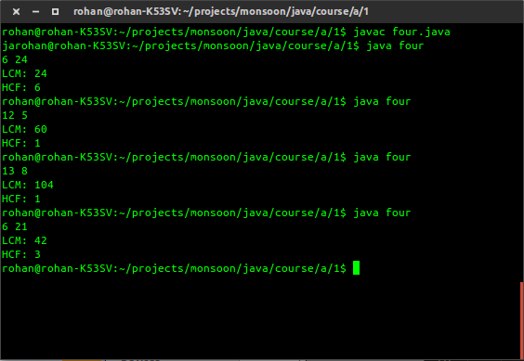
*/
import java.util.Scanner;

public class four {

public static int hcf(int a, int b){
if (b == 0) {
return a;
}
else {
return hcf(b, a % b);
}
//return -1;
}

public static int lcm(int a, int b){

return (a*b)/hcf(a,b);
}

public static void main( String [] args )
{
int a, b;

//Scanner
Scanner s = new Scanner(System.in);

a = s.nextInt();
b = s.nextInt();

System.out.println("LCM: " + lcm(a,b));
System.out.println("HCF: " + hcf(a,b));

}
}

/*

* * * * *
* * * * *
* * * * *
* * * * *
* * * * *

Author: Rohan Verma (hello@rohanverma.net)
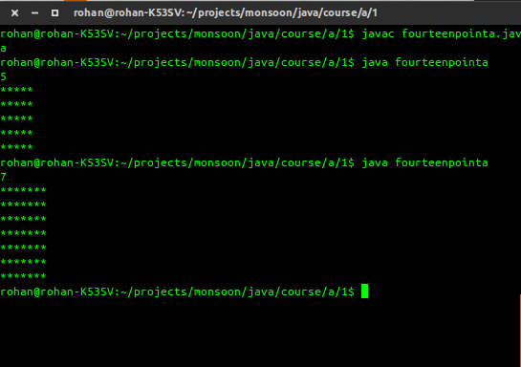
*/
import java.util.Scanner;

public class fourteenpointa {

public static void main( String [] args )
{

int num;

Scanner s = new Scanner(System.in);

num = s.nextInt();

for(int i = 0; i < num; i++){
for(int j = 0; j < num; j++){
System.out.print('*');
}
System.out.print('\n');
}
}
}

/*

*
* *
* *
* * *
* * * *

Author: Rohan Verma (hello@rohanverma.net)
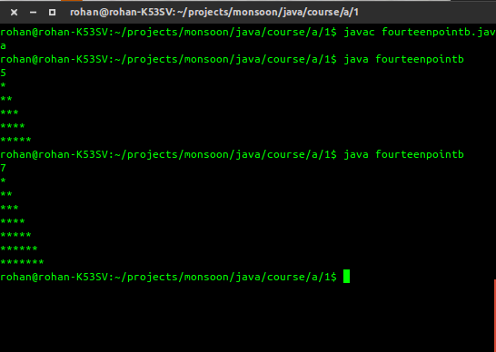
*/
import java.util.Scanner;

public class fourteenpointb {

public static void main( String [] args )
{

int num;

Scanner s = new Scanner(System.in);

num = s.nextInt();

for(int i = 0; i < num; i++){
for(int j = num - i - 1; j < num; j++){
System.out.print('*');
}
System.out.print('\n');
}
}
}

/*

* * * * *
* * * * *
* * * * *
* * * * *
* * * * *

Author: Rohan Verma (hello@rohanverma.net)
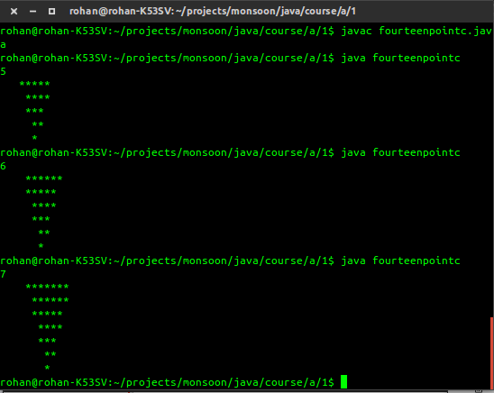
*/
import java.util.Scanner;

public class fourteenpointc {

public static void main( String [] args )
{

int num;

Scanner s = new Scanner(System.in);

num = s.nextInt();

for(int i = 0; i < num; i++){
for(int j = (num - i - 1)/2; j < num; j++){
System.out.print(' ');
}
for(int j = i; j < num; j++){
System.out.print('*');
}

System.out.print('\n');
}
}
}

/*

Write a program that prompts the user to
enter the number of seconds, displays a message at
every second, and terminates when the time expires.

Author: Rohan Verma (hello@rohanverma.net)

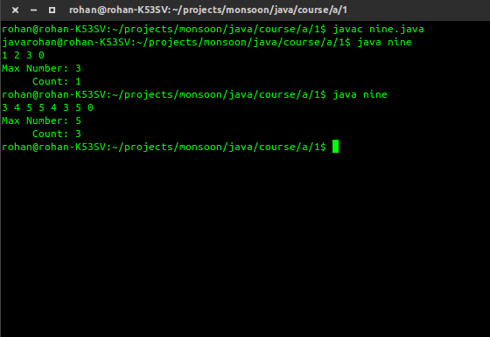
*/
import java.util.Scanner;

public class nine {

public static void main( String [] args )
{

int num, max = Integer.MIN_VALUE, count = 0;

Scanner s = new Scanner(System.in);

do{

num = s.nextInt();

if(max == num){
count += 1;
}
else if(max < num){
count = 1;
max = num;
}
else{

}

}while(num != 0);

System.out.println("Max Number: " + max);
System.out.println(" Count: " + count);

}
}

/*

In a strong number, the sum of the factorials of digits of a number is equal to the original
number. Write a program to check given number is strong number or not.

Author: Rohan Verma (hello@rohanverma.net)
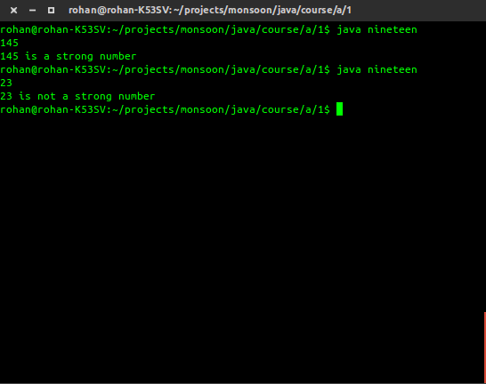
*/
import java.util.Scanner;

public class nineteen {

public static void main( String [] args )
{

int num;

Scanner s = new Scanner(System.in);

num = s.nextInt();

int temp = num,i,f,r,sum=0;
while(num!=0){
i=1;f=1;
r=num%10;

while(i<=r){
f=f*i;
i++;
}
sum=sum+f;
num=num/10;
}
if(sum==temp)
System.out.printf("%d is a strong number\n",temp);
else
System.out.printf("%d is not a strong number\n",temp);

}
}

/*

Write a program that reads three edges for a triangle and determines whether the input is
valid. The input is valid if the sum of any two edges is greater than the third edge.

Author: Rohan Verma (hello@rohanverma.net)
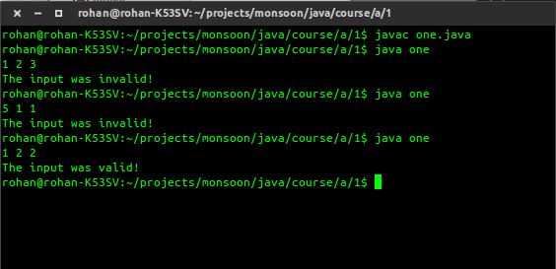
*/
import java.util.Scanner;

public class one {

public static void main( String [] args )
{
// Input edge lengths of a b c
int a,b,c;

//Scanner
Scanner s = new Scanner(System.in);

a = s.nextInt();
b = s.nextInt();
c = s.nextInt();

//Calculate sums
int x = a + b;
int y = b + c;
int z = c + a;

if(x > c && y > a && z > b){
System.out.println("The input was valid!");
}
else{
System.out.println("The input was invalid!");
}
}
}

/*

Write a program that prompts the user to enter a
decimal integer and displays its
corresponding hexadecimal value.
Don’t use Java’s Integer.toHexString(int) in this
program.

Author: Rohan Verma (hello@rohanverma.net)
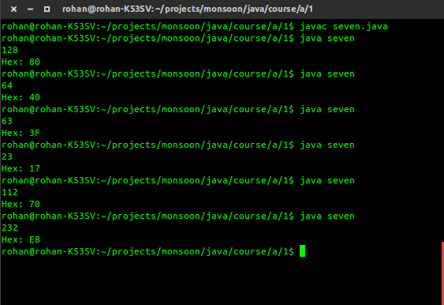
*/
import java.util.Scanner;

public class seven {

public static String reverse(String source){
if(source == null || source.isEmpty()){
return source;
}
String reverse = "";
for(int i = source.length() -1; i>=0; i--){
reverse = reverse + source.charAt(i);
}

return reverse;
}

public static String convert(int dec)
{
String hex = "";

while(dec != 0){

int remainder = dec % 16;
if(remainder > 9){
char x='e';
remainder -= 10;
switch(remainder){
case 0:
x = 'A';
break;
case 1:
x = 'B';
break;
case 2:
x = 'C';
break;
case 3:
x = 'D';
break;
case 4:
x = 'E';
break;
case 5:
x = 'F';
break;
}

hex += x;

}
else{
hex += (char)(remainder + 48);
}
dec /= 16;
}
return reverse(hex);
}

public static void main( String [] args )
{
int num;

Scanner s = new Scanner(System.in);

num = s.nextInt();

System.out.println("Hex: " + convert(num));

}
}

/*

An Armstrong number is one in which the sum of the cubes of digits of a number is equal to
the original number. Write a program to check given number is Armstrong number or not.
For example: n=153 => 1 3 + 5 3 +3 3 = 1+125+27= 153, so 153 is an Armstrong number.

Author: Rohan Verma (hello@rohanverma.net)
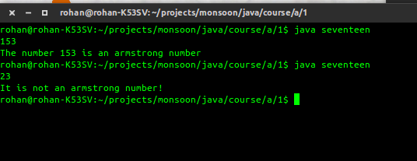
*/
import java.util.Scanner;

public class seventeen {

public static void main( String [] args )
{

int num;

Scanner s = new Scanner(System.in);

num = s.nextInt();

int sum = 0;
int temp = num;
while(num != 0){
sum += Math.pow((num%10),3);
num/=10;
}
if(sum == temp){
System.out.println("The number "+ temp + " is an armstrong number");
}
else
System.out.println("It is not an armstrong number!");

}
}

/*

Write a program that prompts the user to enter
a decimal integer and displays its
corresponding binary value.
Don’t use Java’s Integer.toBinaryString(int)
in this program.

Author: Rohan Verma (hello@rohanverma.net)
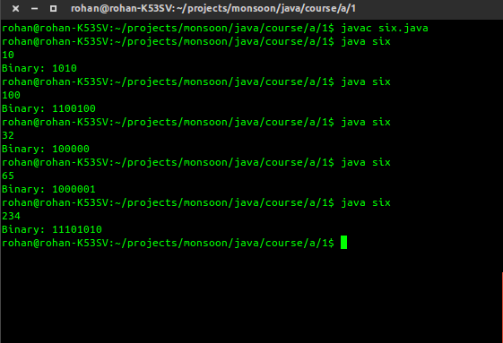
*/
import java.util.Scanner;

public class six {

public static int convert(int dec)
{
if (dec == 0)
{
return 0;
}
else
{
return (dec % 2 + 10 * convert(dec / 2));
}
}

public static void main( String [] args )
{
int num;

Scanner s = new Scanner(System.in);

num = s.nextInt();

System.out.println("Binary: " + convert(num));

}
}

/*

Write an interactive program that will convert a positive integer
quantity to a roman numeral
(e.g., 12 will be converted to XII, 14 will be converted to XIV,
and so on). Design the
program so that it will execute repeatedly, until a value of zero
is read in from the keyboard.

Author: Rohan Verma (hello@rohanverma.net)
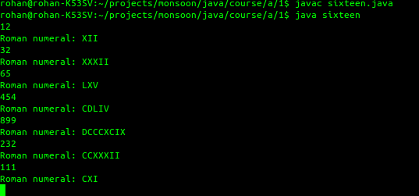
*/
import java.util.Scanner;

public class sixteen {

public static String IntegerToRomanNumeral(int input) {
if (input < 1 || input > 3999)
return "Invalid Roman Number Value";
String s = "";
while (input >= 1000) {
s += "M";
input -= 1000; }
while (input >= 900) {
s += "CM";
input -= 900;
}
while (input >= 500) {
s += "D";
input -= 500;
}
while (input >= 400) {
s += "CD";
input -= 400;
}
while (input >= 100) {
s += "C";
input -= 100;
}
while (input >= 90) {
s += "XC";
input -= 90;
}
while (input >= 50) {
s += "L";
input -= 50;
}
while (input >= 40) {
s += "XL";
input -= 40;
}
while (input >= 10) {
s += "X";
input -= 10;
}
while (input >= 9) {
s += "IX";
input -= 9;
}
while (input >= 5) {
s += "V";
input -= 5;
}
while (input >= 4) {
s += "IV";
input -= 4;
}
while (input >= 1) {
s += "I";
input -= 1;
}
return s;
}

public static void main( String [] args )
{

int num;

Scanner s = new Scanner(System.in);

do{

num = s.nextInt();

if(num!=0){
System.out.println("Roman numeral: " + IntegerToRomanNumeral(num));
}

}while(num != 0);

}
}

/*

Write a program that prompts the user to
enter the number of seconds, displays a message at
every second, and terminates when the time expires.

Author: Rohan Verma (hello@rohanverma.net)
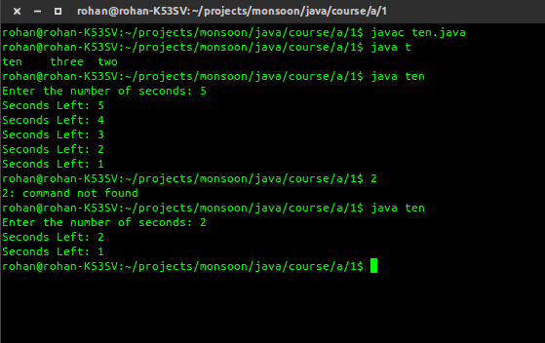
*/
import java.util.*;

public class ten {

public static void main( String [] args )
{
Scanner s = new Scanner(System.in);

System.out.print("Enter the number of seconds: ");
int sec = s.nextInt();

while (sec > 0) {
System.out.println("Seconds Left: " + sec);
long start = System.currentTimeMillis();
//wait till 1 sec \/
while (start + 1000 > System.currentTimeMillis());
sec--;
}

}

}

/*

Write a program to determine input the marks of n students in a subject and determine the
frequency count of marks obtained i.e. how many students obtained 100, how many 99, how
many 98 and so on up to 0.

Author: Rohan Verma (hello@rohanverma.net)
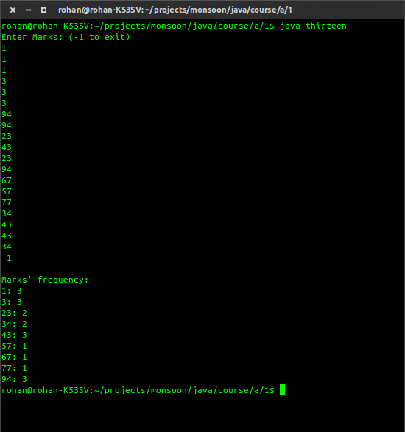
*/
import java.util.Scanner;

public class thirteen {

public static void main( String [] args )
{

int num;

int[] arr = new int[101];

Scanner s = new Scanner(System.in);

System.out.println("Enter Marks: (-1 to exit)");
do{

num = s.nextInt();

if(num!=-1)arr[num] += 1;

}while(num != -1);

System.out.println("\nMarks' frequency: ");
for(int i = 0; i < 101; i++){
if(arr[i] != 0){
System.out.println(i + ": " + arr[i]);
}
}

}
}

/*

Write a program to find out sum of digits of a given number.

Author: Rohan Verma (hello@rohanverma.net)
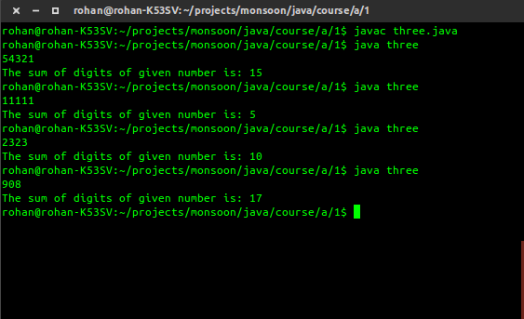
*/
import java.util.Scanner;

public class three {

public static void main( String [] args )
{
int num, sum;

//Scanner
Scanner s = new Scanner(System.in);

num = s.nextInt();

sum = 0;

while(num != 0){
//add remainder from num
sum += num % 10;
num /= 10;
}
System.out.println("The sum of digits of given number is: " + sum);
}
}

/*

Write a program to input a set of integers and count the number of primes.

Author: Rohan Verma (hello@rohanverma.net)
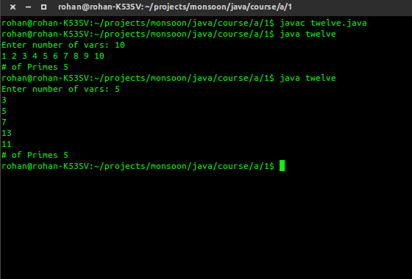
*/
import java.util.Scanner;

public class twelve {

public static boolean isPrime(int num) {
if (num == 2 ) return true;
if (num % 2 == 0) return false;
for (int i = 3; i * i <= num; i += 2)
if (num % i == 0) return false;
return true;
}

public static void main( String [] args )
{
int num, vars, count = 0;

//Scanner
Scanner s = new Scanner(System.in);

System.out.print("Enter number of vars: ");
vars = s.nextInt();
while(vars-- != 0){
if(isPrime(num = s.nextInt())){
count+=1;
}
}

System.out.println("# of Primes " + count);

}
}

/*

Write a program to generate multiplication tables for 1 ,2, ..., 10. Each table up to 10

Author: Rohan Verma (hello@rohanverma.net)
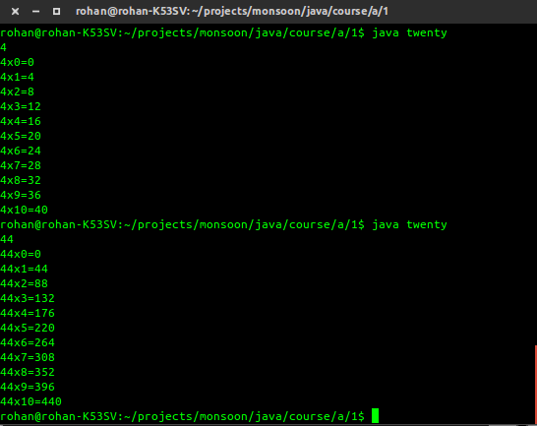
*/
import java.util.Scanner;

public class twenty {

public static void main( String [] args )
{

int num;

Scanner s = new Scanner(System.in);

num = s.nextInt();

for(int i = 0; i <= 10; i++){
System.out.println(num + "x" + i + "=" + num*i);
}

}
}

/*

Write a program to generate multiplication tables for 1 ,2, ..., 10. Each table up to 10

Modify (20) so that your output now looks like this:
2x1=2 3x1=3 ... 5x1=5
2x2=4 3x2=6 ... 5x2=10
...
...
2x10=20 3x10=30 ... 5x10=50

Author: Rohan Verma (hello@rohanverma.net)
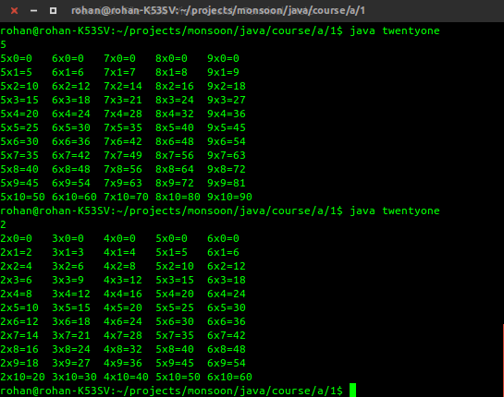
*/
import java.util.Scanner;

public class twentyone {

public static void main( String [] args )
{

int num;

Scanner s = new Scanner(System.in);

num = s.nextInt();

for(int i = 0; i <= 10; i++){
System.out.print(num + "x" + i + "=" + num*i);
System.out.print('\t');
System.out.print(num+1 + "x" + i + "=" + (num+1)*i);
System.out.print('\t');
System.out.print(num+2 + "x" + i + "=" + (num+2)*i);
System.out.print('\t');
System.out.print(num+3 + "x" + i + "=" + (num+3)*i);
System.out.print('\t');
System.out.print(num+4 + "x" + i + "=" + (num+4)*i);
System.out.print('\n');
}

}
}

/*

Write a program to print ASCII value of all characters.

Author: Rohan Verma (hello@rohanverma.net)
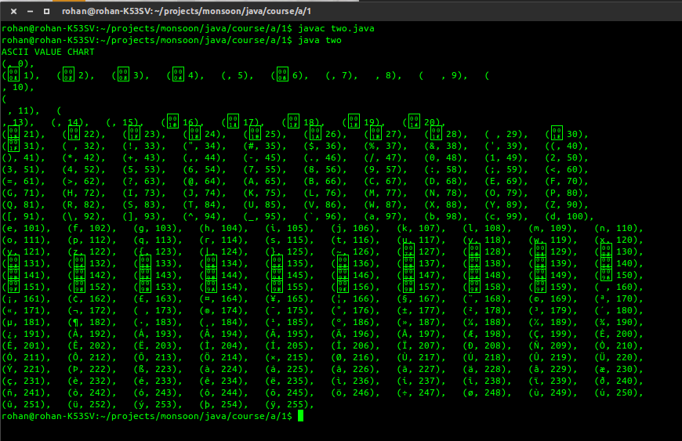
*/
import java.util.Scanner;

public class two {

public static void main( String [] args )
{
System.out.println("ASCII VALUE CHART");
for(int i = 0; i < 256; i++){
System.out.print('(');
System.out.print((char)i);
System.out.print(", ");
System.out.print(i);
System.out.print("), ");

if(i % 10 == 0) System.out.print('\n');
}
System.out.print('\n');
}
}

