# OpenCV and FFmpeg changes

OpenCV uses FFmpeg to stream video on Windows. Changes were made to each open source library in order to access the RTP NTP timestamps through the OpenCV java bindings using VideoCapture.

## OpenCV changes

Here are some changes to OpenCV to retrieve the RTP NTP timestamp with video frames.

The source code changes were branched from cclauss’s commit on 10-Feb-2017, with SHA a3475693500.

Relevant files changed:

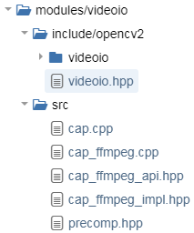

**modules/videoio/include/opencv2/videoio.hpp:**

Added two getters for the RTP time stamp:

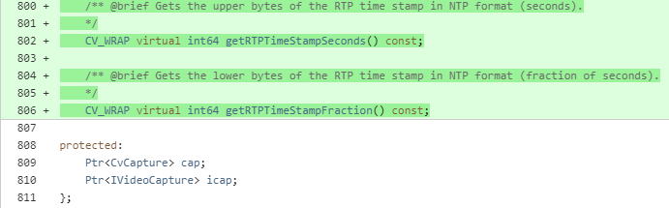

**modules/videoio/src/cap.cpp:**

Added an import:

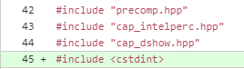

Added the implementation of the timestamp getter:

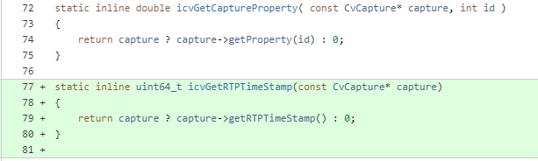

Added the C++ timestamp getters in the VideoCapture class:

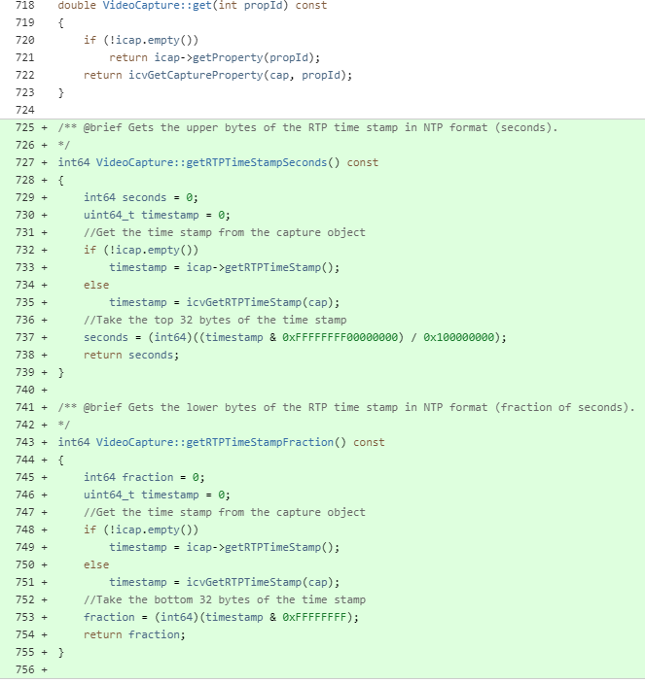

**modules/videoio/src/cap_ffmpeg.cpp:**

Added an import:



Added a method reference definition:



Added the method to the module initializer method:

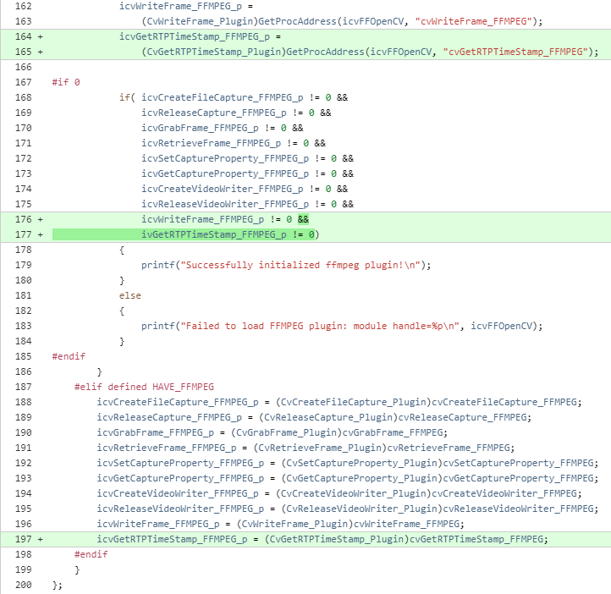

Implemented the getter interface:

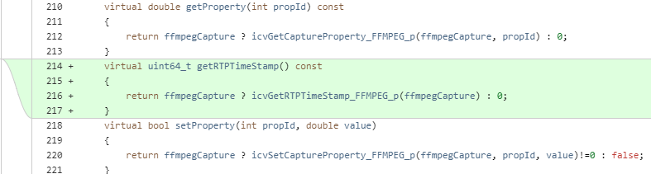

**modules/videoio/src/cap_ffmpeg_api.hpp:**

Added an import:

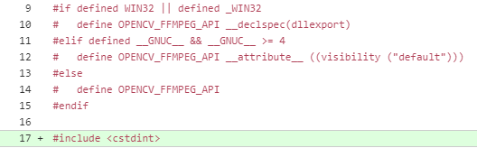

Added the method and member variable definitions to the interface:





**modules/videoio/src/cap_ffmpeg_impl.hpp:**

Added an import:



Added the getter method definition to the CvCapture_FFMPEG struct:

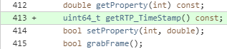

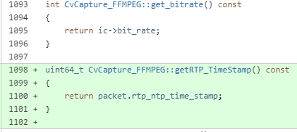

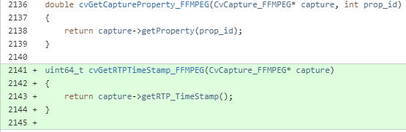

**modules/videoio/src/precomp.hpp:**

Added an import:



Added the getter definition to the CvCapture struct:



And added it to the IVideoCapture class in the cv namespace:



### OpenCV used in Java

When OpenCV is built with the Java option, it will result in the addition of two getter methods, which can be used to get the current frame time.

**org.opencv.videoio.VideoCapture.class**:

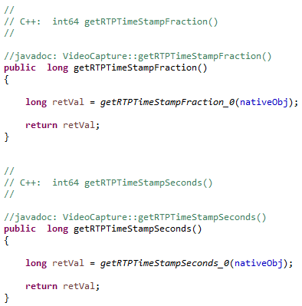

For example, this could be used like this, if you have an instance of the VideoCapture class called “videoCapture”:



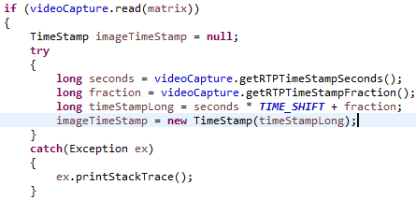

## FFmpeg changes

Here are some changes to FFmpeg (to be used by OpenCV) to retrieve the RTP NTP timestamp with video frames.

These changes were branched from Michael Niedermayer’s commit on 06-Feb-2017, with SHA 68ed682710f (Tag n3.2.3).

Relevant files changed:

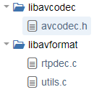

**libavcodec/avcodec.h:**

Added the NTP timestamp definition to the AVPacket struct:

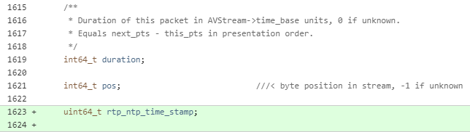

**libavformat/rtpdec.c:**

Store the ntp time stamp in the struct in the finalize_packet method:

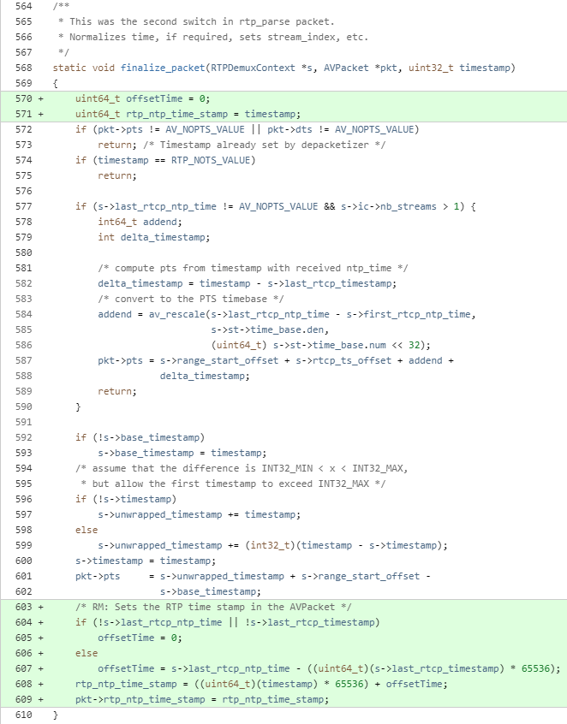

**libavformat/utils.c:**

Copy the ntp time stamp from the packet to the frame in the read_frame_internal method:

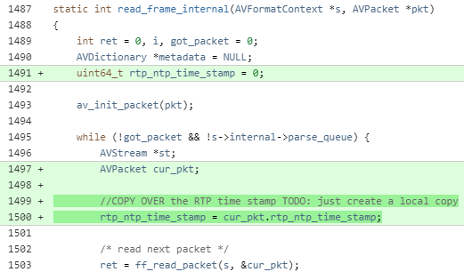

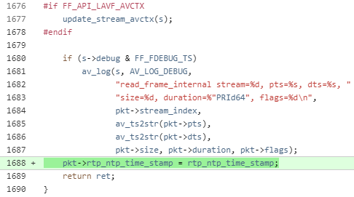

# LibVLC Changes