***Problem***:

The problem I am trying to solve is for the church I attend to be able to provide online services to its members and the church community such as, prayer requests, requests of documents such as letter of recommendation and also where members can send messages to each other.

***Idea***:

My idea is a web application where registered users can make administrative requests such as a letter of recommendation, also to generate and print income tax receipts from donations made. Church activities and schedule will be available to be viewed as a registered member or guest. Registered members will also be able to message each other directly.

***Stored Information***:

The information to be stored by the web application will be as follows:

* Logon details (username, password and status)
* Guests details for prayer request (name, category, description)
* Guests details for documentation request (name, address, document type, purpose)
* Members bio data
* Members position (current and historical)
* Details of donation / contributions made (for tax receipt computation)
  + Donations will include amount, who, purpose and when
* Recommendation request (ID, type, status, purpose and description)

***Features***:

The web application will have the following features:

* Guests will be able to view church activities and schedule
* Guests will make prayer and general requests
* Guests can make documentation requests
* Authorized user can add, edit and delete members
* Authorized user can add, edit and delete donation / contribution to web application
* Registered user can log into the web application
* Registered user can generate and print tax receipt
* Registered user can make documentations request
* Registered user can send direct messages to other members
* Registered user can view report on their donations / contributions
* Authorized user can process requests prayer and general requests
* Authorized user can process documentation requests
* Authorized user can create and update church activity/schedule

***Flows***:

* Logon

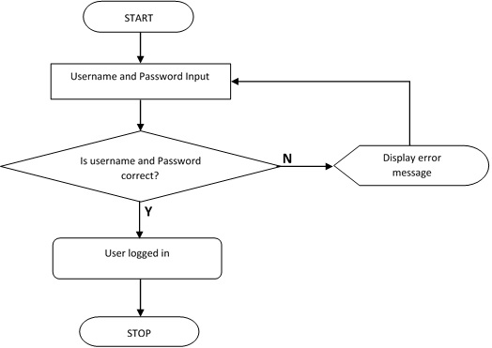

* Add Member

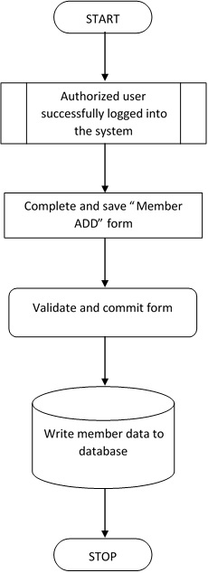

* Prayer Request – Guest

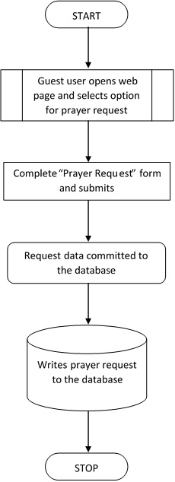

* Prayer Request – Registered User
* Document Request – Guest
* Document Request – Member
* Add Donation / Contribution
* Generate and Print Tax Receipt
* Create and Send Direct Messages