So to summarise:
- how the random forest model works
- the possibility of a risk nomogram
- ⁠⁠future research
- ⁠p values
- ⁠confidence intervals

Dataset tiny

How nomogram works
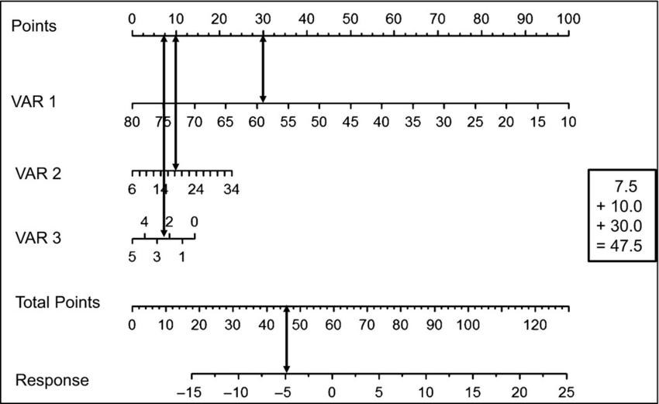
How lin reg works
- Y = mx+c
- Least squares
Result
Sens = p(pos|pos), spec = p(neg|neg)
Random forest
P values, confidence intervals not releant

