**Chapter 1**

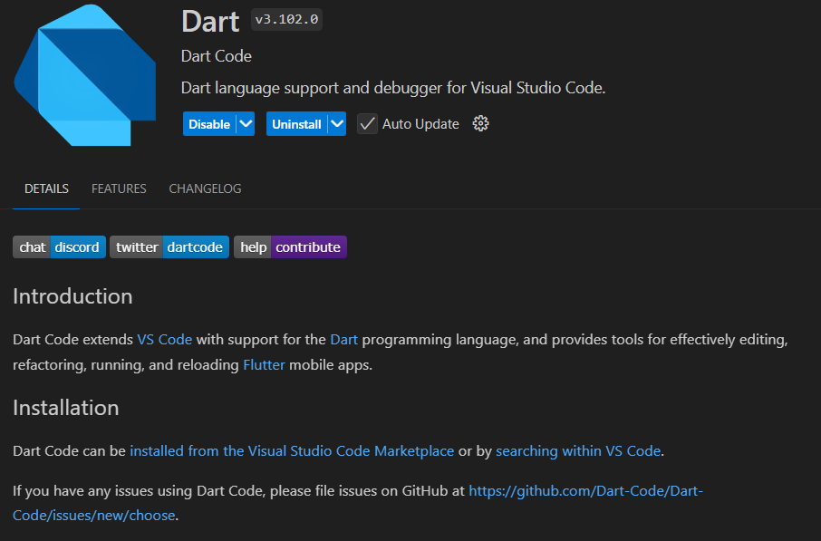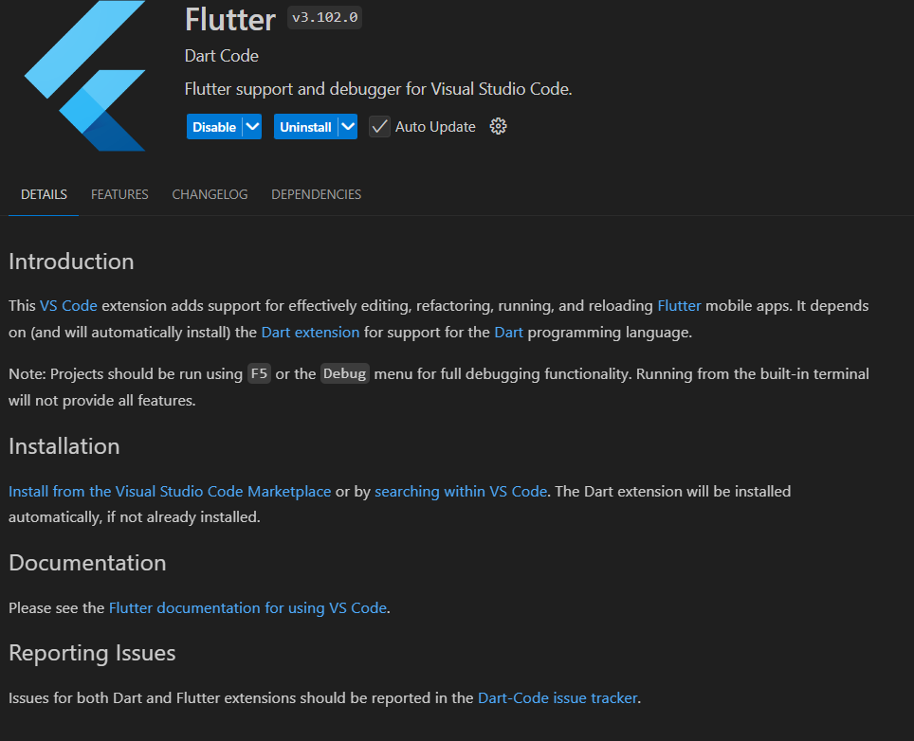To get started with Flutter development, I installed the Flutter SDK and set up **Visual Studio Code (VS Code)** as my primary development environment. First, I downloaded the Flutter SDK from the official website and extracted it to a location on my system. I then added the flutter/bin directory to my system's PATH to access Flutter commands from the terminal. After installing **VS Code**, I added the **Flutter** and **Dart** extensions from the VS Code marketplace to enable features like autocompletion and debugging. To verify that everything was set up correctly, I ran the flutter doctor command in the terminal, which helped identify any missing dependencies and guided me on how to resolve them. After setting up everything, I created my first Flutter project using the command flutter create my_first_flutter_app and ran it in VS Code with flutter run. This setup allowed me to start building cross-platform applications with Flutter efficiently, using the features of **hot reload** to see immediate changes during development