

**I&M Inter University Cyber Security Contest - 20th November 2020**

**Flag1**

**Instructions:-**

1. Log in to http://10.50.240.97/flag1
2. The challenge is to get password for user with username as flag1. Login to the system.
3. Go to “My Info” menu.
4. Get the flag contents.

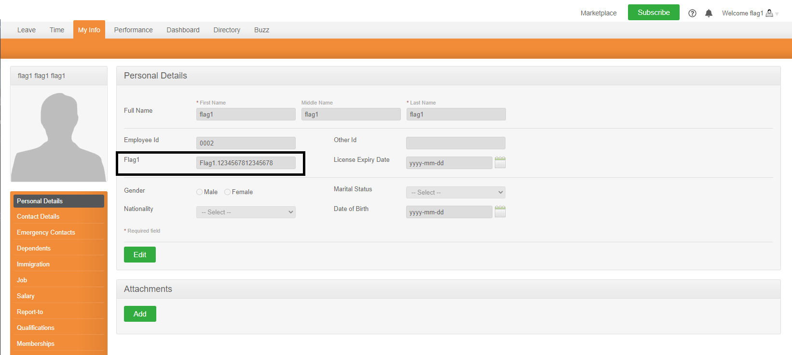

1. Send the flag contents / screenshot using your email address registered with us to [elijahsyoyi2010@gmail.com and](mailto:elijahsyoyi2010@gmail.com%20and) cc [iso@imbank.co.ke](mailto:iso@imbank.co.ke)

NOTE: - This is a dummy flag. Not the real one!!!!!!!!!!!!

**Hints:-**

1. Source code.

**Expected Solution:-**

The expected solution is in the format:-

Flag1.XXXXXXXXXXXXXXXX