

**I&M Inter University Cyber Security Contest - 20th November 2020**

**Flag3**

**Instructions:-**

1. Log in to http://10.50.240.97/flag3
2. The challenge is to find a 7 letter, all small caps and no number password/flag.
3. The idea is to make the application respond with the correct password/flag.

This happens when you insert the wrong password:-

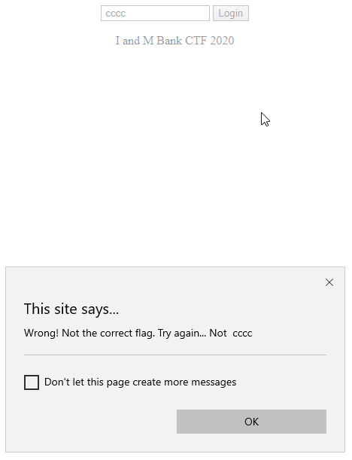

This happens you insert the correct password:-

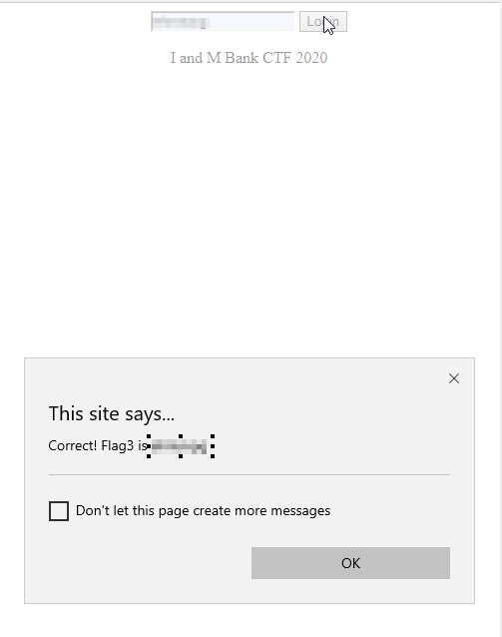

This is the correct flag we are looking for. Send this flag with your email registered to us to [elijahsyoyi2010@gmail.com](mailto:elijahsyoyi2010@gmail.com) and cc [iso@imbank.co.ke](mailto:iso@imbank.co.ke) .

**Hints:-**

1. Range is between aaaaaaa to zzzzzzz.
2. If you can infiltrate the database hosting this challenge, you will see a table with a table named with 7 letters. That is the password for this challenge. Cool, huh?

**Expected Solution:-**

The expected solution is in the format:-

XXXXXXX