Customer Shopping Behaviour Analysis
Business Problem
A leading retail company wants to better understand its customer’s shopping behaviour in order to improve sales, customer satisfaction and long term loyalty. The management team has noticed changes in purchasing patterns across demographics, product categories, and sales channels (online vs offline). They are particularly interested in uncovering which factors, such as discounts, reviews, seasons, or payment preferences, drive consumer and repeat purchases.

You are tasked with analyzing the company’s consumer behaviour dataset to answer the following overarching business question.

“How can the company leverage consumer shopping data to identify trends, improve customer engagement, and optimize marketingg and product strategies?”

1. Project Overview
The project analyzes customer shopping transactional data of 3,000 purchases of different product category. The main goal of the analysis is to uncover insights into spending pattern, customer segments, product purchases and subscription behaviour inorder to guide strategic business decisons.

2. Dataset Summary
- Rows:
- Colmns:
- Null_values: 37 missing values in review rating column

3. Exploratory Data Analysis using Python
I began with data preprocessing and cleaning using pandas
Initial Exploration: Used df.info() to check structure of the data and df.describe() for both numerical and categorical variables summary statistics
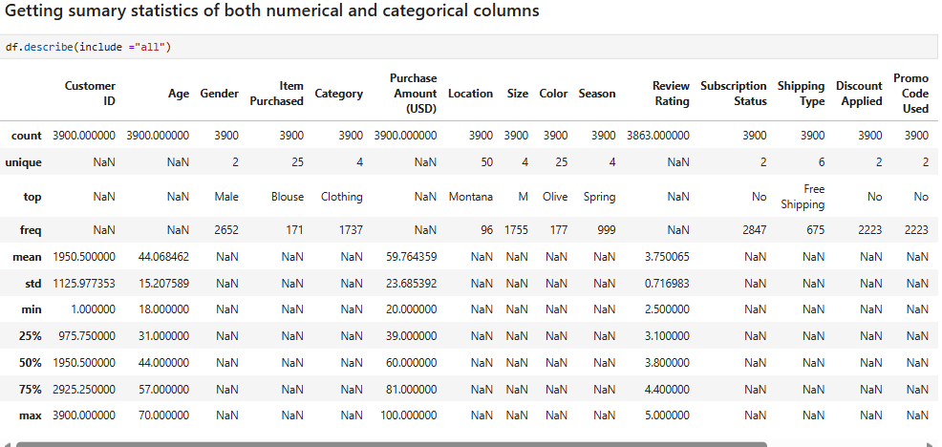

Identifying missing values: A total of 37 values were null in the review rating column and the missing values were handled by identifying the median value for each product category.
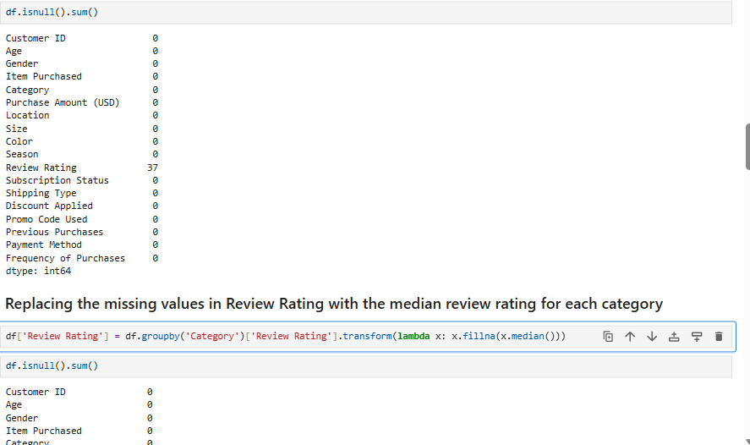

- Column Standardization: Renamed columns to snake case for better readability and documentation.

- Feature Engineering:
  - Created age_group column by binning customer age
  - Created a purchase frequency days column from purchases data to get the number of days
- Data Consistency Check: Verified if discount_applied and promo_code_used were redundant, and dropped_promo_code used column.
- Data Base Integration: Connected python script to MYSQL, and loaded the cleaned DataFrame into the database for SQL analysis.

Data Analysis Using MYSQL.
Major business questions was answered, using SQL queries
- Revenue by gender: compared total revenue generated by male vs female customers.
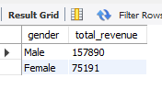
- Identified high spending discount users- identified customers who used discounts but still spent above the average purchase amount.
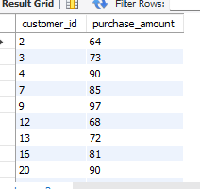

- Identified top 5 products by rating: discovered products with the highest average review ratings.
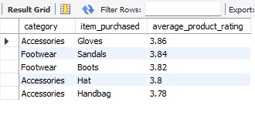
- Shipping type comparison: compared average purchase amounts between standard and express shipping
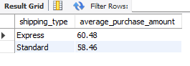
- Subscribers vs non subscribers - Compared average spend and total revenue across subscription status.
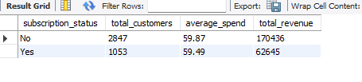
- Discount-Dependent Products - Identified 5 products with the highest percentage of discounted purchases.
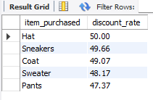
- Customer Segmentation: Grouped customers into New, Returning and Loyal segments based on purchase history.
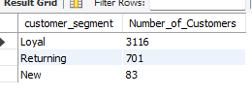
- Top Products per Category: Listed the most purchased products within each category.
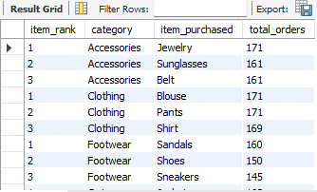
- Repeat Buyers & Subscriptions : Checked if customers with >5 purchases are more likely to subscribe.
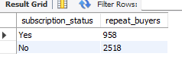
- Revenue by Age Group: Calculated total revenue contribution of each age.
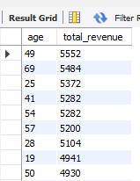

5. Dashboard: An interactive dashboard was built in PowerBI to convey insights visually
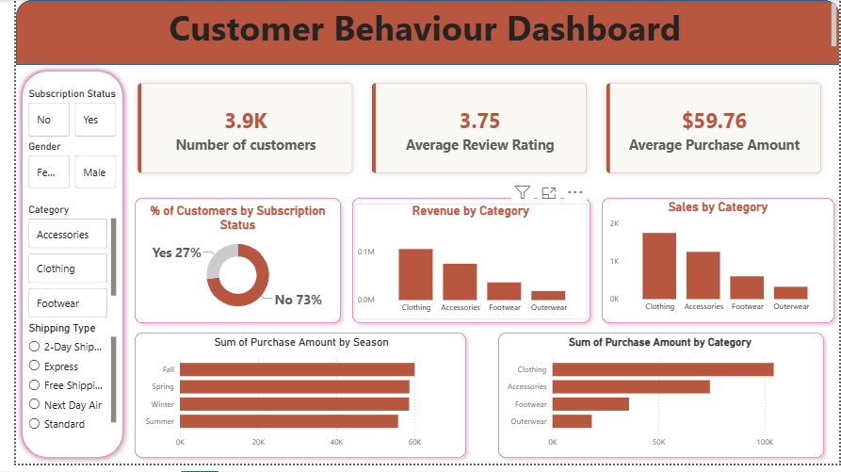

6. Business Recommendation.
- Leverage high demand for products in top performing category for saes and revenue like clothing to cross sell secondary products.
- Focus growth efforts on customer retention and repeat purchases, through targeted lifecycle marketing.
- Implement strategic marketing tailored to female demographics
- Use most purchased products in each product category as primary marketing hooks, feature these specific items on home pages, ad creatives and search ads
- Reward loyal customers with exclusive access and referral incentives.
- Convert new and returning customers into loyal buyers using targeted post purchase email sequences, personalized cross-sells and progressive rewards.
- Focus efforts on high revenue age groups and express-shipping users.

