**Go to** [**www.codecademy.com**](http://www.codecademy.com)

1. Click Create Account

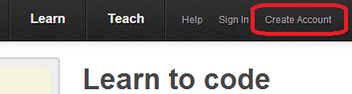

1. Enter an e-mail and name (just make an e-mail up if you don’t have one) and click Create Account

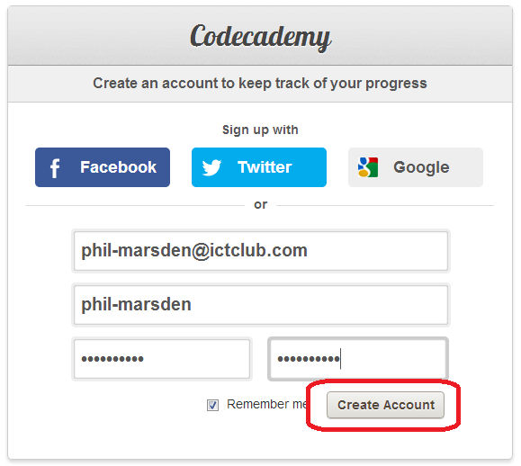

1. Click on Learn then Python

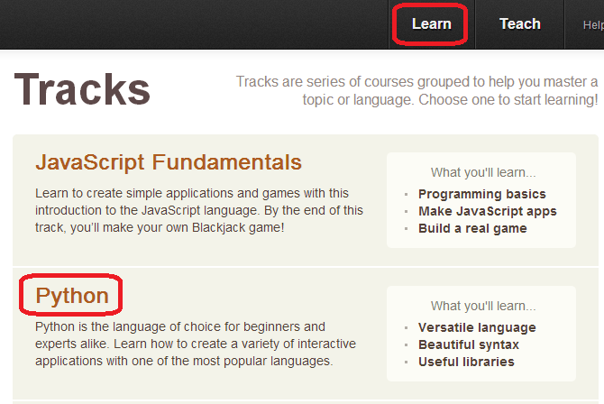

1. Click on the Python Syntax 16 Exercises

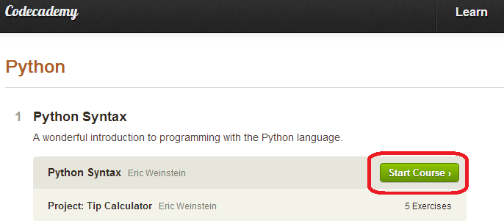

1. Click on **1. Variables and Data Types**

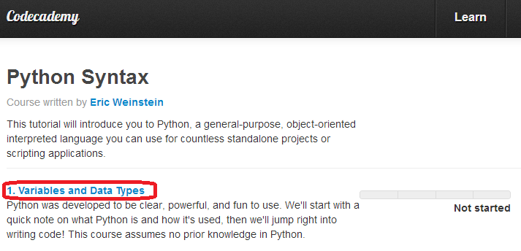

1. Start coding !!

