# Football Drop

In this game there are walls that move up the screen. The player must move a football left and right to guide the ball through the gaps in the walls.

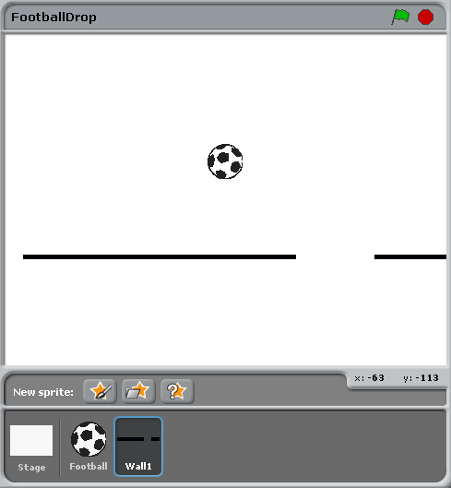

# 1. Making the ball move left and right – 1 Point

To start will we want the ball to:

* start at the top (y=160) and be in the middle (x=0)
* move left when we press the left arrow, and right when we press the right arrow.

Select the Football sprite, click on the Scripts tab and then drag and drop the scratch elements until your code looks like this:

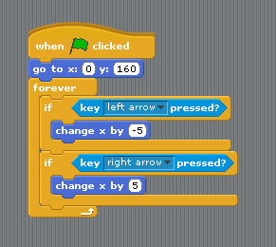

Press the green flag to check that you can move the ball left and right. Note that it won’t go down the screen yet, we’ll do that later.

# 2. Making the wall move – 1 Point

Next we want to make the wall move up the screen. We could start the wall moving when the green flag is clicked but instead we are going to use a message to tell it to start.

## Stage

Select the Scripts tab of the Stage sprite and drag and drop the scratch elements so that a message called “Wall1Start” is sent to Wall1 – this message will tell Wall1 to start moving:

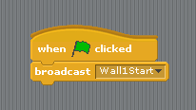

## Wall1

Each wall’s costume is just a horizontal black line with a gap in it:



The script for the wall needs to do the following:

* waits to receive a message so it knows when to start (Wall1Start sent from the Stage).
* places itself at the bottom of the screen with the gap in a random place.
* moves up 1 space at a time.
* when it hits the top, it places itself back at the bottom with the gap in a different random place.

Select the Wall1 sprite, click on the Scripts tab and then drag and drop the scratch elements until your code looks like this:

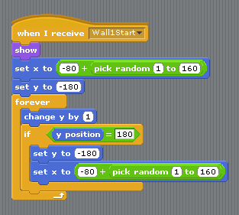

Press the green flag to check that Wall1 works.

# 3. Adding a second wall – 1 Point

Wall2 is very similar to Wall1 so we are going to copy the Wall1 sprite and then change it slightly. To do this, right click on Wall1 and select duplicate. Once it is created, select the new sprite (Sprite 1) and rename it to Wall2.

## Wall1

Firstly we need to add some code to Wall1 so that when it is halfway up the screen (y=0) it sends a “Wall2Start” message. You will need to figure out where to add this into the script for Wall1:

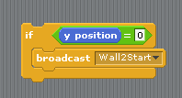

## Wall2

For Wall2 we need to change the code so we:

* hide Wall2 when we start the script (when the green flag is clicked)
* show Wall2 and start it moving at the right time.

The changes are below, can you spot them? If so, make the changes to your Wall2 script.

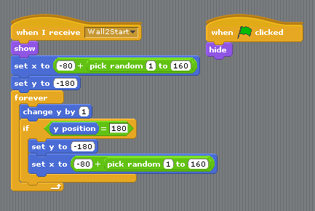

Press the green flag to check that Wall2 works.

# 4. Making the ball stop moving when it hits a wall - 2 Points

Finally we now want to make the ball:

* fall downwards 1 step at a time if it is not touching a wall.
* if it is touching a wall, to sit on top of the wall as it moves upwards.

Hint   
You will want to add the following block somewhere in the Football script and work out what goes in the yellow boxes:

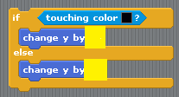

And your finished script should look like this:



# 5. Extra features

Why not try adding in these extra features:

* use a variable to control the speed of the walls and make it faster as the game goes on **(2 points)**.
* add more wall sprites by duplicating them then just change when they start, what message they send and when they send it. Hint: you may want to change the position at which they signal the next sprite **(2 points)**.
* stop the game if the ball hits the top **(1 point)**.
* a scoring system, maybe one point each time a new wall appears at the bottom **(1 point)**.
* when the ball is in the bottom half of the screen, make the ball change and award two points for when a wall appears (instead of one) **(2 points)**.