Frogger

In this game the player controls a frog who tries to cross a busy road. If the frog gets hit by a vehicle then it gets squashed.
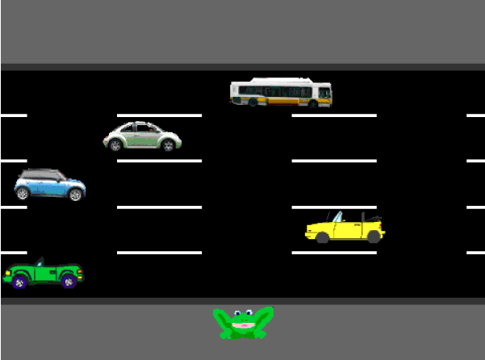

Step 1: Controlling the frog's movement – 1 point

Using the blank Frogger template, copy the following blocks into the frog's script:
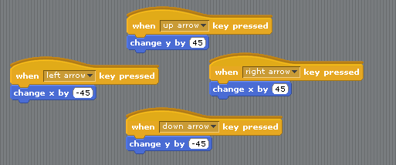
Now press the green flag button to test that the frog moves correctly. We also want the frog to start in the same position every time, so insert the following block of code into the frog's script:

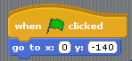

Step 2: Getting the traffic to move – 2 points

This is the script for the blue car (which is in the middle of the road):
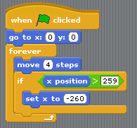
and this is the script for the yellow car:
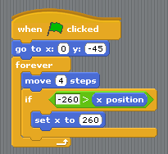
Can you work out the scripts for the other three vehicles? They should be very similar, but remember that they drive in different lanes and travel in different directions.

Make sure you test that all of the vehicles:
- Drive in the right directions
- Wrap around to the other side of the screen when they drive off the edge

Step 3: Restarting the game when the frog is hit by a vehicle – 2 points

When the frog gets hit by a vehicle, we want the following things to happen:
- The frog should disappear for 1 second
- After 1 second, the frog should re-appear at the bottom of the screen to let the player have another go

To make this work, we'll need to broadcast a “game over” event when the frog touches a vehicle. You will need to put this script in each vehicle's script:
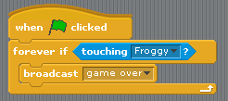
Now you need to make the frog disappear, wait for a second, and re-appear at the bottom of the screen when this event occurs. Your frog script should look like this:

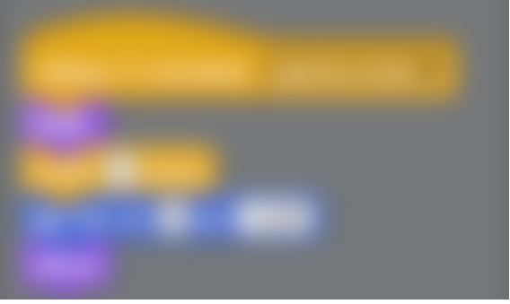
Press the green flag to test your finished Frogger game!

Extensions
So far, you've probably used this block twice:

Once when the game starts, and once when we reset the frog after it gets hit by a vehicle. Can you think of a way to only use this block once?

Hint: you will want to use a “reset frog” event.

Other things you might want to try are:
- Adding more vehicles, or using different ones.
- Add some effects when the frog gets hit
- Implement a scoring system, so that the frog get a point every time it gets to the other side of the road.
- Increase the speed of the cars as the player gets more points to make it more difficult.
- (Difficult!) Create another level (or a new game) where the frog has to cross a river by jumping on moving logs.

