
AI-Assisted Data Quality and Lineage System
AI Portfolio Project #2

September 19, 2026
RH Technology LLC
San Antonio, Texas

Contents
1. Recommended architecture 2
2. Processing workflow 2
3. Validation layers 3
Schema and business rules 3
Profiling and drift 3
ML anomalies 3
4. Core data model 4
5. Lineage design 4
6. Safe LLM integration 5
7. Approval policy 5
8. Quality score 6
9. Audit and notification requirements 6
10. Build sequence 7

Abstract
Build this as a versioned data-control platform, not merely an anomaly dashboard. The strongest portfolio implementation separates deterministic validation, statistical/ML detection, AI explanation, and human-controlled correction.
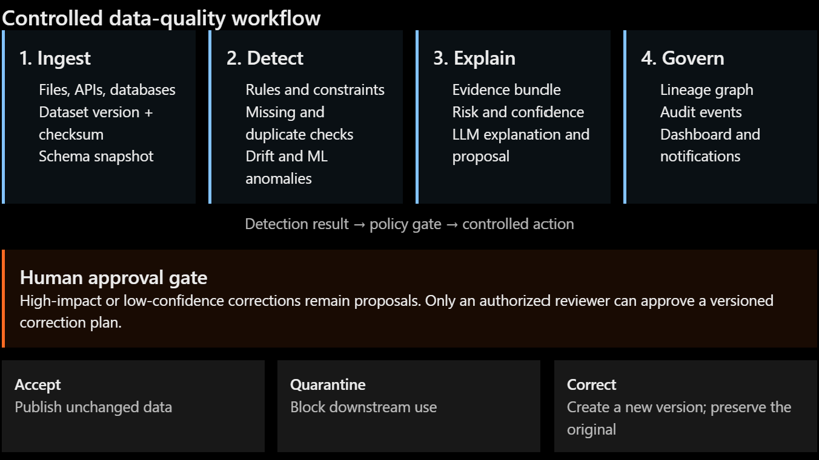

1. Recommended architecture
Component | Recommended technology | Responsibility
Web application | Next.js/React | Dashboard, dataset explorer, approval queue
API | FastAPI | Datasets, rules, findings, approvals, lineage
Background processing | Celery + Redis | Profiling, validation, ML scoring, notifications
Operational database | PostgreSQL | Metadata, rules, findings, approvals, audit history
Object storage | MinIO or S3 | Immutable raw datasets and corrected versions
Validation engine | Pandera + Great Expectations | Schema, constraints, and business rules
Profiling | Pandas or Polars | Nulls, uniqueness, statistics, distributions
Anomaly detection | scikit-learn | Isolation Forest and statistical detection
Lineage | OpenLineage-compatible events | Dataset, job, transformation, and field relationships
LLM service | OpenAI-compatible API | Evidence-grounded explanations and recommendations
Authentication | Keycloak or JWT/RBAC | Submitter, reviewer, steward, and administrator roles
Observability | OpenTelemetry + Prometheus/Grafana | Latency, failures, quality trends, model behavior
Start with Isolation Forest. An autoencoder introduces training, calibration, and explainability complexity that is rarely justified until you have substantial historical data.

2. Processing workflow
- Register an incoming dataset and calculate its checksum.
- Store the original data as an immutable dataset version.
- Capture schema, row count, field types, and source metadata.
- Run deterministic schema and business-rule validation.
- Profile missing values, duplicates, ranges, cardinality, and distributions.
- Compare the profile with an approved baseline.
- Run anomaly detection on suitable numerical features.
- Create findings containing evidence, severity, affected records, and detector version.
- Let the LLM explain findings using only that evidence.
- Generate proposed corrections, confidence scores, and risk classifications.
- Automatically accept clean data, quarantine dangerous data, or route proposals to reviewers.
- If approved, execute a deterministic correction plan and create a new dataset version.
- Record every transition in an append-only audit log.
The LLM should never receive direct database-write credentials.

3. Validation layers
Use several detectors because they answer different questions.

Schema and business rules
Examples:
- Required columns are present.
- customer_id is unique and non-null.
- email matches an accepted format.
- order_total >= 0.
- order_date <= current_date.
- Foreign keys reference existing records.
- Status values belong to an approved enumeration.
Represent rules as versioned configuration:
dataset: customers
version: 3
rules:
- id: customer-id-required
column: customer_id
check: not_null
severity: critical

- id: valid-email
column: email
check: regex
value: "^[^@]+@[^@]+\\.[^@]+$"
severity: high

Profiling and drift
Capture per-column:
- Null percentage
- Distinct count and uniqueness
- Minimum, maximum, mean, and quantiles
- Category frequencies
- String length
- Pattern frequencies
- Histogram or probability distribution
Useful drift measures include Population Stability Index, Jensen–Shannon divergence, Kolmogorov–Smirnov tests, and category-frequency changes.
A statistical difference is not automatically a defect. Seasonal sales changes, new products, and marketing campaigns can all cause legitimate drift.

ML anomalies
Train Isolation Forest on a previously approved baseline. Store:
- Feature transformations
- Training dataset version
- Model version
- Contamination threshold
- Raw anomaly score
- Threshold used for classification
Do not present the ML score as a probability unless it has been calibrated.

4. Core data model
Your PostgreSQL schema should include:
data_sources
datasets
dataset_versions
fields
validation_rules
validation_runs
findings
anomaly_models
correction_proposals
approval_requests
approval_decisions
lineage_nodes
lineage_edges
audit_events
notifications
Important relationships:
- A dataset has many immutable versions.
- A validation run evaluates exactly one dataset version.
- A finding records its detector, evidence, severity, and affected records.
- A correction proposal references one or more findings.
- An approval decision references the proposal and reviewer.
- A correction creates a new version rather than overwriting the original.

5. Lineage design
Model lineage as a directed graph:
- Dataset → dataset
- Field → field
- Job → output dataset
- Source record → corrected record
- Finding → correction proposal → approval → new version
A field-level edge should contain the transformation expression:
{
"source": "crm.customers.phone",
"target": "warehouse.customers.normalized_phone",
"transformation": "normalize_e164(phone)",
"job_version": "customer-cleanup:1.4.2"
}
For the first release, PostgreSQL tables are sufficient. Add Neo4j only if interactive multi-hop lineage becomes a genuine requirement.

6. Safe LLM integration
Send the LLM a structured evidence package rather than unrestricted data:
{
"rule": "order_total must be nonnegative",
"observed_value": -149.99,
"column_profile": {"min": -149.99, "median": 82.40},
"related_fields": {"transaction_type": "refund"},
"allowed_actions": ["leave_unchanged", "quarantine", "convert_to_refund"],
"sensitive_values_redacted": true
}
Require structured output:
{
"explanation": "The negative total conflicts with the sales rule...",
"recommended_action": "convert_to_refund",
"confidence": 0.84,
"evidence_ids": ["finding-812", "rule-17"],
"requires_human_approval": true
}
Treat confidence as an internally calibrated decision signal—not the LLM’s self-reported certainty. A stronger implementation derives confidence from rule agreement, model score, historical reviewer acceptance, ambiguity, and correction risk.

7. Approval policy
Risk | Example | System behavior
Low | Trim whitespace in an optional field | May auto-apply only if explicitly allowed
Medium | Normalize an address or category | Require review or batch approval
High | Change financial, identity, clinical, or compliance data | Always require individual approval
Critical | Delete records or alter protected identifiers | Block automated execution
Even approved changes should be executed by deterministic functions such as normalize_phone()—not by copying arbitrary LLM-generated values into production.
Use explicit states:
PROPOSED → PENDING_REVIEW → APPROVED → EXECUTED
↘ REJECTED
↘ EXPIRED

8. Quality score
Make the score explainable:
$$QualityScore=100\left(0.25C+0.20V+0.20U+0.15K+0.10S+0.10T\right)$$
Where:
- $C$: completeness
- $V$: validity
- $U$: uniqueness
- $K$: consistency
- $S$: statistical stability
- $T$: timeliness
Critical-rule failures should cap the total score rather than being hidden by strong performance elsewhere.
The dashboard should show:
- Overall and dimension-level scores
- Quality trend by dataset version
- Open findings by severity
- Drifted fields
- Anomaly distribution
- Approval backlog and aging
- Top failing rules
- Lineage impact
- False-positive and reviewer-rejection rates

9. Audit and notification requirements
Every audit event should record:
- Actor or service identity
- UTC timestamp
- Action
- Previous and new state
- Dataset and version
- Finding or proposal ID
- Rule/model/prompt version
- Evidence references
- Reviewer comments
- Correlation ID
Make the audit history append-only.
For notification simulation, create an outbox table and render Slack- and email-style messages in the UI. This demonstrates reliable delivery patterns without requiring external accounts.

10. Build sequence
A realistic implementation order is:
- Dataset upload, immutable storage, and versioning
- Schema/rule validation and profiling
- Findings API and quality dashboard
- Drift detection and baseline management
- Isolation Forest pipeline
- Lineage capture and graph view
- Evidence-grounded LLM explanations
- Correction proposals and approval workflow
- Audit history and notification simulator
- Tests, monitoring, Docker Compose, and CI
Your demo should include clean data, a schema change, duplicates, missing values, legitimate drift, anomalous records, one approved correction, and one rejected recommendation. The rejection is important—it proves the human-in-the-loop control is substantive rather than decorative.

