
Multimodal UAV cybersecurity Copilot
Ai Portfolio Project #5

September 19, 2026
rh technology LLC
San Antonio, Texas

Contents
5. Multimodal UAV Cybersecurity Copilot Outline 1
1. Recommended architecture 2
2. Technology stack 3
3. Normalize every data source 3
4. Implement detection before adding the LLM 4
GPS spoofing 4
Command injection 4
Telemetry denial of service 4
5. Create the UAV knowledge graph 5
6. Build hybrid evidence retrieval 5
7. Use an explicit investigation workflow 6
8. Simulate attacks safely 8
9. Evaluate the system 9
Detection metrics 9
Mean time to detect 9
Evidence accuracy 9
Investigation time saved 9
Agent task-completion rate 10
10. Suggested development phases 10
Phase 1: Minimum viable investigation system 10
Phase 2: Retrieval and GraphRAG 10
Phase 3: Multimodal capability 10
Phase 4: Research evaluation 11
11. Portfolio demonstration 11
12. Created the complete Multimodal UAV Cybersecurity Copilot: 11

5. Multimodal UAV Cybersecurity Copilot Outline
This should be your differentiating domain project.
Build a system that correlates:
- MAVLink telemetry
- Suricata or Zeek network events
- Equipment manuals
- Threat intelligence in STIX 2.1
- Mission logs
- Images or video frames
- ATT&CK technique mappings
The system could identify suspicious behavior, retrieve supporting evidence, explain the likely threat, and recommend containment actions. Include simulated attacks rather than presenting the application as safety certified.
Measure:
- Alert precision and recall
- Mean time to detect
- False-positive rate
- Evidence/citation accuracy
- Investigation time saved
- Agent task-completion rate
What it proves: domain expertise, multimodal AI, cybersecurity, streaming data, GraphRAG, and applied research.

Build it as a research-grade incident investigation platform with deterministic detection, GraphRAG evidence retrieval, multimodal analysis, and an approval-gated copilot. The AI should explain and recommend—not directly control the UAV.
A working starter implementation is available here:
Download multimodal-uav-cybersecurity-copilot.zip

1. Recommended architecture
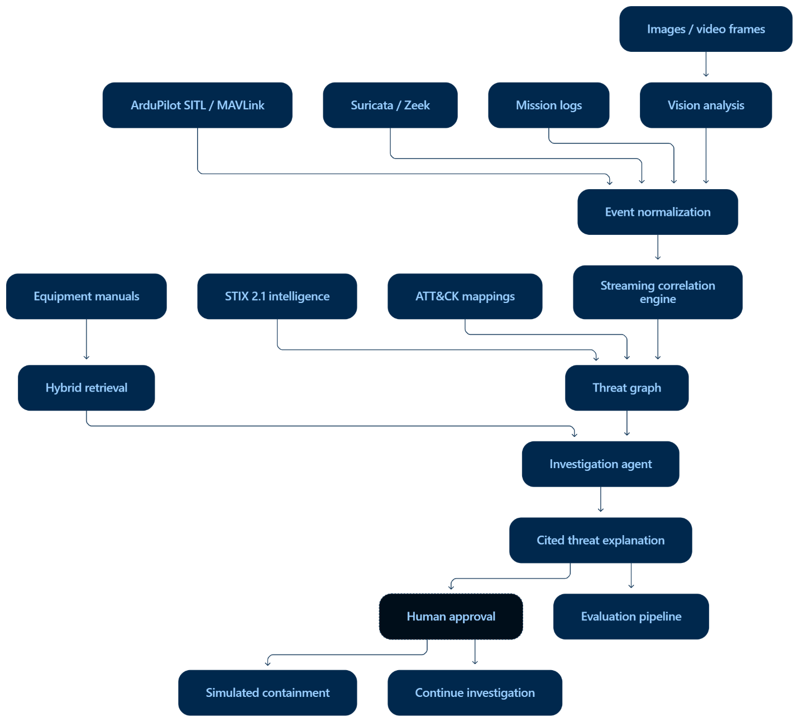

2. Technology stack
Component | Recommended technology
UAV simulator | ArduPilot SITL and MAVProxy
Telemetry ingestion | pymavlink
Event streaming | Redpanda or Kafka
Network detection | Suricata EVE JSON and Zeek logs
Backend | Python and FastAPI
Time-series storage | PostgreSQL with TimescaleDB
Vector search | PostgreSQL with pgvector
Knowledge graph | Neo4j
Object storage | MinIO
Vision analysis | OpenCV plus CLIP or a vision-language model
Document parsing | PyMuPDF, python-docx and BeautifulSoup
Threat intelligence | STIX 2.1, TAXII, OpenCTI or MISP
Agent workflow | LangGraph or a custom state machine
Dashboard | React/Next.js or the included lightweight interface
Observability | OpenTelemetry, Prometheus and Grafana
Deployment | Docker Compose initially; Kubernetes later
Start with Docker Compose. Kafka, Neo4j and Kubernetes should be added only after the simpler pipeline works; otherwise, infrastructure complexity will obscure whether the correlation logic is effective.

3. Normalize every data source
Convert incoming information into a common event model:
{
"event_id": "evt-24381",
"timestamp": "2026-09-20T14:32:17.251Z",
"source": "mavlink",
"drone_id": "UAV-01",
"mission_id": "mission-204",
"event_type": "GPS_POSITION",
"severity": 2,
"attributes": {
"latitude": 29.4241,
"longitude": -98.4936,
"altitude_m": 121.4,
"satellites": 14,
"hdop": 0.8
},
"raw_reference": "s3://evidence/mission-204/mavlink.jsonl",
"ground_truth_attack": false
}
Normalize:
- MAVLink messages such as HEARTBEAT, GPS_RAW_INT, GLOBAL_POSITION_INT, COMMAND_LONG and STATUSTEXT.
- Suricata alerts from eve.json.
- Zeek conn.log, dns.log, notice.log and custom MAVLink logs.
- Waypoints, expected corridors and mission state changes.
- Frame-level classifications, embeddings and anomaly scores.
- STIX indicators, attack patterns, relationships and observed data.
Use UTC event time, not arrival time, for correlation. UAV and network clocks may drift, so retain both timestamps and estimate clock offsets.

4. Implement detection before adding the LLM
Use transparent detection rules and statistical models.
Examples:

GPS spoofing
Trigger when several signals occur together:
- Physically implausible location change
- Sudden GPS course change
- Mission-path deviation
- GPS quality apparently remains normal
- Camera or inertial observations disagree with GPS

Command injection
Correlate:
- MAVLink commands from an unknown ground-station address
- Abnormal command frequency
- Unexpected COMMAND_LONG
- Mode changes outside the mission plan
- Suricata or Zeek evidence identifying the source

Telemetry denial of service
Correlate:
- UDP traffic spike
- Suricata flood alert
- Increasing packet loss
- MAVLink heartbeat interruption
- Delayed or missing mission-log records
A simple scoring model could be:
$$S=\sum_{i}{w_{i}}x_{i}$$
Where $x_{i}$indicates whether evidence condition $i$occurred and $w_{i}$is its validated weight. Create an alert only when the score passes a versioned threshold.
Do not let an LLM decide whether an attack occurred. Let it explain alerts created by controlled detection logic.

5. Create the UAV knowledge graph
Recommended node types:
- UAV
- Flight
- Mission
- Waypoint
- TelemetryEvent
- NetworkEvent
- ImageFrame
- DocumentSection
- STIXIndicator
- ThreatActor
- Vulnerability
- ATTACKTechnique
- Alert
- ContainmentAction
Example relationships:
TelemetryEvent → OCCURRED_DURING → Mission
NetworkEvent → OBSERVED_ON → UAV
ImageFrame → CAPTURED_DURING → Mission
Alert → SUPPORTED_BY → NetworkEvent
Alert → SUPPORTED_BY → TelemetryEvent
Alert → MAPS_TO → ATTACKTechnique
STIXIndicator → INDICATES → AttackPattern
ContainmentAction → MITIGATES → ATTACKTechnique
DocumentSection → APPLIES_TO → UAV
GraphRAG should retrieve a connected evidence subgraph, not simply the nearest text chunks.

6. Build hybrid evidence retrieval
For every investigation:
- Apply metadata filters for UAV, mission, time window and authorization.
- Search manuals using BM25 and embeddings.
- Traverse the threat graph for associated STIX indicators.
- Retrieve related ATT&CK techniques.
- Obtain telemetry and network events within the alert window.
- Retrieve representative frames.
- Rerank everything against the investigation question.
- Remove evidence that fails access-control or time-relevance checks.
Every returned item needs a stable citation such as:
mavlink://mission-204/1742.251/GPS_RAW_INT
suricata://sensor-02/alert/84931
manual://uav-x8/navigation/section-6.2
stix://indicator--3d74...
frame://mission-204/camera-1/004218

7. Use an explicit investigation workflow
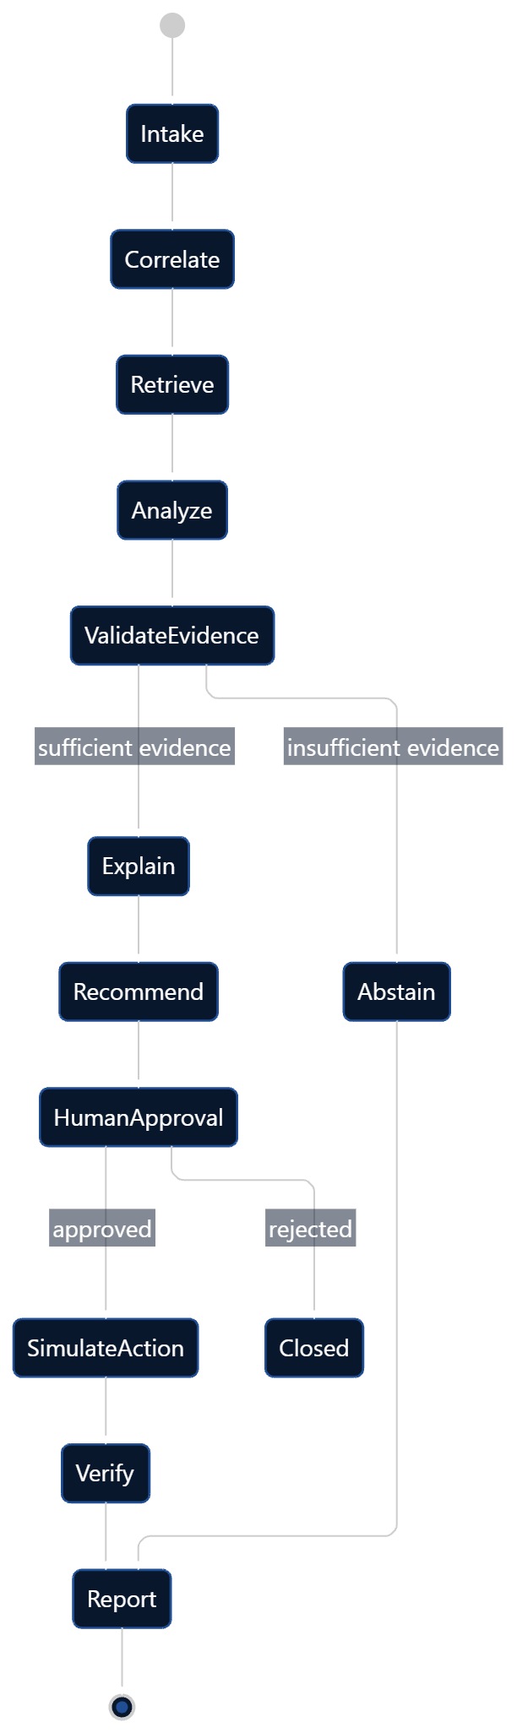
The agent should produce structured output:
{
"assessment": "Probable MAVLink command injection",
"confidence": 0.87,
"techniques": ["T0831"],
"claims": [
{
"claim": "Commands originated from an unauthorized station.",
"citations": [
"zeek://sensor-01/conn/9921",
"mavlink://mission-204/1745.210/COMMAND_LONG"
]
}
],
"recommended_actions": [
{
"action": "Reject commands from the unapproved endpoint",
"requires_approval": true,
"reversible": true
}
]
}
Reject any generated claim without supporting citations.

8. Simulate attacks safely
Use ArduPilot SITL in an isolated lab and create repeatable scenarios:
- GPS location jump or gradual spoofing
- Unauthorized mode change
- MAVLink command replay
- Command-rate burst
- Telemetry UDP flood
- Heartbeat suppression
- Mission-log interruption
- Camera obstruction
- Camera-versus-GPS inconsistency
- Benign wind deviation
- Legitimate operator intervention
- Temporary packet loss
The benign scenarios matter as much as attacks. Without difficult negative examples, precision and false-positive results will be misleading.
Record for each scenario:
- Attack type
- Start and stop time
- Expected affected components
- Expected ATT&CK mapping
- Required supporting evidence
- Expected containment recommendation
- Whether the agent should abstain

9. Evaluate the system

Detection metrics
$$Precision=\frac{TP}{TP+FP} \\ Recall=\frac{TP}{TP+FN} \\ FPR=\frac{FP}{FP+TN}$$
Report these by attack family, flight phase, vehicle type and network condition—not only as one aggregate result.

Mean time to detect
$$MTTD=\frac{1}{N}\sum_{i=1}^{N}{(}\left.t_{\text{alert},i}-t_{\text{attack},i}\right)$$
Use event timestamps so processing delays and clock errors do not corrupt the result.

Evidence accuracy
Have reviewers label each citation as:
- Supports the claim
- Partially supports it
- Irrelevant
- Contradicts it
Then calculate:
$$Citation Precision=\frac{\text{supporting citations}}{\text{all citations}}$$
Also measure citation completeness: whether every material claim has evidence.

Investigation time saved
Run controlled investigations with and without the copilot:
$$Time Saved=Median\left(T_{\text{manual}}\right)-Median\left(T_{\text{copilot}}\right)$$
Do not claim a fixed percentage based solely on an engineering estimate.

Agent task-completion rate
Define completion before testing:
- Correct threat category
- Required sources queried
- Evidence cited
- Unsupported claims avoided
- Suitable recommendation produced
- Approval checkpoint respected
- Final report created
$$Completion Rate=\frac{\text{successfully completed investigations}}{\text{total investigations}}$$

10. Suggested development phases

Phase 1: Minimum viable investigation system
- FastAPI backend
- MAVLink and Suricata/Zeek event schema
- Four attack simulations and benign scenarios
- Deterministic correlation
- Evidence citations
- ATT&CK mappings
- Investigation dashboard
- Evaluation harness

Phase 2: Retrieval and GraphRAG
- Manual ingestion
- STIX 2.1 importer
- PostgreSQL/pgvector
- Neo4j threat graph
- Hybrid retrieval
- Evidence reranking
- Citation validation

Phase 3: Multimodal capability
- Frame extraction
- Image embeddings
- Object and scene comparison
- Visual anomaly detection
- Telemetry-to-image temporal alignment

Phase 4: Research evaluation
- Versioned labeled scenario corpus
- Attack and benign-condition replay
- Analyst review interface
- Confidence intervals
- Ablation testing
- Reproducible experiment reports
An especially valuable ablation study would compare telemetry-only, telemetry-plus-network, and full multimodal correlation. That demonstrates whether the additional modalities actually improve detection rather than merely making the architecture look sophisticated.

11. Portfolio demonstration
Use a five-minute scenario:
- Start an ordinary simulated inspection flight.
- Inject a spoofed GPS movement.
- Show the route diverging from visual and mission evidence.
- Display the correlated network and MAVLink events.
- Retrieve the relevant manual section and STIX intelligence.
- Map the incident to ATT&CK.
- Generate a claim-by-claim cited explanation.
- Recommend containment.
- Require human approval.
- Display updated evaluation metrics.
This project becomes genuinely differentiating when it proves, with labeled experiments, that cross-modal correlation reduces false positives or detection time. A complex dashboard alone will not prove multimodal or GraphRAG competence.

12. Created the complete Multimodal UAV Cybersecurity Copilot:
Download
Included:
- FastAPI backend and responsive dashboard
- MAVLink, Suricata, Zeek, mission, vision, and STIX event models
- GPS spoofing, command injection, telemetry DoS, vision mismatch, and benign simulations
- Cross-source correlation and ATT&CK technique mapping
- GraphRAG-style evidence graph
- Traceable event:// citations
- Human-approval and audit endpoints
- Precision, recall, false-positive rate, MTTD, citation accuracy, estimated time saved, and task-completion metrics
- Docker Compose deployment
- Automated tests: 3 passed
- Architecture diagram and production-extension roadmap
Run it with:
docker compose up --build
Then open http://localhost:8000; API documentation is at http://localhost:8000/docs.
The project clearly identifies itself as a simulated research prototype—not safety-certified flight or aircraft-control software.

