
Inference Performance Lab
AI Portfolio Project #6

September 19, 2026
Rh Technology LLc
San Antonio, Texas

Contents
Optional advanced project: Inference Performance Lab Outline 3
6. Inference Performance Lab 3
1. Define the benchmark questions 3
2. Recommended system architecture 3
3. Suggested technology stack 4
4. Repository structure 5
5. Build a unified inference adapter 6
6. Workloads and datasets 7
7. Metrics to capture 7
Latency 7
Throughput 8
Resource consumption 8
Quality 8
Reliability 9
Cost 9
8. Experiment matrix 10
Hosted versus local 10
Quantization 10
CPU versus GPU 10
Batch size and concurrency 11
Context length 11
Prefix caching 11
Speculative decoding 12
9. Experimental controls 12
10. Result schema 13
11. Production recommendation engine 13
12. Dashboard 14
13. Reproducibility workflow 15
14. Implementation phases 15
Phase 1: Minimum viable benchmark 15
Phase 2: Load and scaling tests 16
Phase 3: Serving optimizations 16
Phase 4: Production decision support 16
15. Acceptance criteria 16
16. The conclusion your project should demonstrate 17

Optional advanced project: Inference Performance Lab Outline
Create a benchmark that compares:
- Hosted versus local models
- Quantization levels
- CPU versus GPU inference
- Batch sizes
- Context lengths
- Speculative decoding or caching
- Quality, throughput, latency, memory, and cost
Publish reproducible benchmark scripts and explain why the fastest or largest model is not necessarily the best production choice.
What it proves: model-serving and performance engineering—valuable for senior AI systems roles.

6. Inference Performance Lab
Build the Inference Performance Lab as a reproducible benchmarking platform that runs the same workloads against local and hosted language models, captures performance and quality metrics, and recommends deployment configurations based on real production constraints.
The key result should not be “Model X is fastest.” It should answer:
Which model, runtime, hardware configuration, and optimization strategy provides the best acceptable quality for a particular workload, traffic profile, latency target, and budget?

1. Define the benchmark questions
Your experiments should answer:
- How do hosted APIs compare with self-hosted models?
- How much performance and quality change under FP16, INT8, INT4, and other quantization methods?
- When does a GPU become more economical than CPU inference?
- How does batching affect throughput and individual-request latency?
- How does context length affect time to first token and memory?
- When does prefix caching materially reduce latency and cost?
- Does speculative decoding improve performance for the tested workload?
- Which configuration satisfies a given service-level objective at the lowest cost?
Avoid treating every model as interchangeable. Compare configurations within practical workload classes, such as summarization, extraction, coding, question answering, and tool selection.

2. Recommended system architecture
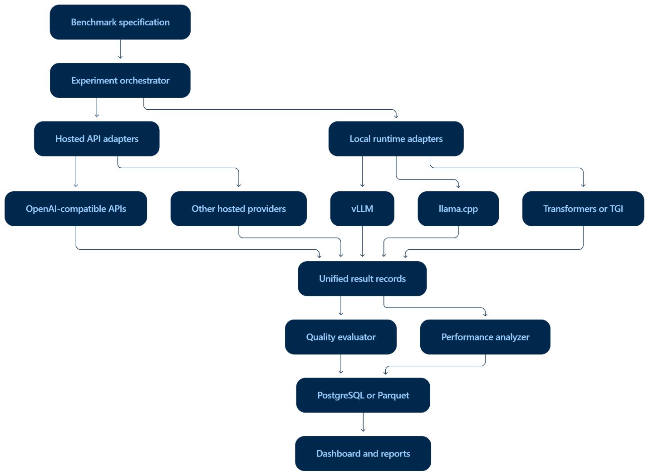
The experiment orchestrator should produce a matrix of runs instead of relying on manually executed commands.
Example experiment dimensions:
experiment:
name: summarization-context-scaling
dataset: datasets/summarization.jsonl
repetitions: 5
warmup_requests: 10
concurrency: [1, 4, 16, 32]
batch_sizes: [1, 4, 8, 16]
input_lengths: [512, 2048, 8192, 16384]
output_tokens: 256

targets:
- provider: local-vllm
model: selected-instruct-model
quantization: fp16
device: gpu

- provider: local-vllm
model: selected-instruct-model
quantization: awq-int4
device: gpu

- provider: llama-cpp
model: selected-instruct-model
quantization: q4_k_m
device: cpu

- provider: hosted
model: hosted-model-name

3. Suggested technology stack
Component | Recommended option
Experiment runner | Python, Typer, asyncio
Configuration | YAML plus Pydantic
Local GPU serving | vLLM
Local CPU serving | llama.cpp
Alternative serving | Hugging Face TGI or Transformers
Metrics | Prometheus and NVIDIA DCGM exporter
System monitoring | psutil, pynvml
Data storage | Parquet initially; PostgreSQL for the full platform
Dashboard | Streamlit or React with FastAPI
Experiment tracking | MLflow
Load generation | Locust, custom asyncio client, or both
Containers | Docker Compose
Analysis | pandas, Polars, SciPy, Plotly
Quality evaluation | deterministic metrics plus LLM judge where appropriate
CI | GitHub Actions
Use a unified OpenAI-compatible request interface wherever possible. This keeps the benchmark workload consistent across runtimes.

4. Repository structure
inference-performance-lab/
├── README.md
├── LICENSE
├── Makefile
├── pyproject.toml
├── docker-compose.yml
├── configs/
│ ├── models.yaml
│ ├── hardware.yaml
│ ├── workloads.yaml
│ └── experiments/
├── datasets/
│ ├── qa.jsonl
│ ├── summarization.jsonl
│ ├── extraction.jsonl
│ ├── coding.jsonl
│ └── tool_calling.jsonl
├── src/
│ └── inference_lab/
│ ├── cli.py
│ ├── orchestrator.py
│ ├── schemas.py
│ ├── adapters/
│ │ ├── base.py
│ │ ├── hosted.py
│ │ ├── vllm.py
│ │ ├── llamacpp.py
│ │ └── transformers.py
│ ├── workloads/
│ ├── metrics/
│ │ ├── latency.py
│ │ ├── quality.py
│ │ ├── memory.py
│ │ ├── energy.py
│ │ └── cost.py
│ ├── monitoring/
│ └── reporting/
├── dashboard/
├── scripts/
│ ├── download_models.sh
│ ├── run_matrix.sh
│ └── reproduce_report.sh
├── tests/
├── results/
└── reports/
Do not commit model weights, credentials, or large generated result files. Publish download instructions, hashes, model revisions, and compact benchmark summaries.

5. Build a unified inference adapter
Every backend should implement the same interface:
from abc import ABC, abstractmethod
from dataclasses import dataclass
from typing import AsyncIterator

@dataclass
class GenerationRequest:
prompt: str
max_tokens: int
temperature: float = 0.0
seed: int | None = None

@dataclass
class TokenEvent:
text: str
timestamp_ns: int
token_count: int

class InferenceBackend(ABC):
@abstractmethod
async def generate(
self,
request: GenerationRequest
) -> AsyncIterator[TokenEvent]:
...
The adapter should also expose configuration metadata:
- Provider and runtime
- Exact model identifier and revision
- Quantization method
- Maximum context length
- Hardware
- Runtime version
- Pricing assumptions
- Cache state
- Decoding parameters
This prevents the analysis from accidentally comparing results produced under different sampling settings.

6. Workloads and datasets
Use more than random prompts. Synthetic prompts are useful for performance isolation, but they do not establish production quality.
Create at least five workload suites:
Workload | Quality measures
Question answering | Exact match, F1, groundedness
Summarization | ROUGE, semantic similarity, factual consistency
Structured extraction | Field precision, recall, valid JSON rate
Coding | Unit-test pass rate
Tool selection | Correct tool, valid arguments, task completion
Each record should contain:
{
"id": "extract-001",
"task": "structured_extraction",
"prompt": "Extract the customer, amount, and invoice date...",
"reference": {
"customer": "Acme",
"amount": 1250.00,
"invoice_date": "2026-09-01"
},
"input_tokens_target": 2048,
"max_output_tokens": 128
}
Keep a versioned manifest recording:
- Dataset version
- Content hash
- License
- Record count
- Generation or sampling method
- Expected answer
- Scoring method

7. Metrics to capture

Latency
Record these separately:
- Time to first token, or TTFT
- Inter-token latency
- Time per output token
- End-to-end latency
- p50, p95, and p99 latency
- Queue wait time
- Server processing time
- Client-observed network time
An average alone will conceal production-impacting tail latency.

Throughput
Measure:
- Requests per second
- Input tokens per second
- Output tokens per second
- Total tokens per second
- Successful requests per second
- Throughput per dollar

Resource consumption
For local inference:
- Peak GPU memory
- Average GPU utilization
- Peak system RAM
- CPU utilization
- GPU power consumption
- CPU energy, when available
- Model-loading time
- Disk footprint

Quality
Use task-specific deterministic metrics first. An LLM judge can supplement them, but it should not be the only quality measure.
Capture:
- Task accuracy
- Structured-output validity
- Hallucination or unsupported-claim rate
- Citation correctness
- Tool-call success
- Refusal correctness
- Unit-test pass rate
- Quality confidence interval

Reliability
Also measure:
- Request failures
- Timeouts
- Rate-limit events
- Out-of-memory failures
- Malformed responses
- Retry count
- Cold-start failures
- Long-context degradation

Cost
For hosted models:
$$C_{\text{hosted}}=T_{\text{input}}P_{\text{input}}+T_{\text{output}}P_{\text{output}}+C_{\text{cached}}+C_{\text{requests}}$$
For self-hosting:
$$C_{\text{local/request}}=\frac{C_{\text{compute/hour}}+C_{\text{operations/hour}}}{\text{successful requests/hour}}$$
Report at least:
- Cost per request
- Cost per 1,000 requests
- Cost per million tokens
- Cost per successful task
- Monthly cost under projected utilization
- Break-even utilization for hosted versus local
“Cost per successful task” is especially important because a cheap model that frequently fails may be more expensive in practice.

8. Experiment matrix
Keep all non-tested variables fixed within each experiment.

Hosted versus local
Compare:
- Equivalent workload and prompt
- Same output-token ceiling
- Deterministic decoding where supported
- Multiple concurrency levels
- Cold and warm conditions
- Network latency reported separately when possible
Do not imply that a hosted proprietary model and a smaller open model differ only by hosting. This experiment compares complete deployment options, not identical model execution.

Quantization
Suggested levels:
- FP32 where practical
- FP16 or BF16 baseline
- INT8
- GPTQ INT4
- AWQ INT4
- GGUF Q8, Q6, Q5, and Q4 for llama.cpp
Measure quality after quantization. A configuration is not successful merely because it fits in memory.

CPU versus GPU
Compare:
- Same model family and revision
- Equivalent quantization where possible
- One-request interactive traffic
- Sustained concurrent traffic
- Energy and hourly-cost assumptions
- Model load and cold-start times
CPU inference may be attractive for small models, intermittent workloads, edge environments, and strict data-residency requirements even when its raw throughput is lower.

Batch size and concurrency
Test batch sizes such as:
1, 2, 4, 8, 16, 32
Test concurrency independently:
1, 4, 8, 16, 32, 64
Batch size and concurrency are not the same variable. Dynamic batching can improve aggregate throughput while increasing queue time and p95 latency.

Context length
Use controlled input lengths:
512, 2K, 4K, 8K, 16K, 32K
Measure:
- Prefill time
- TTFT
- Decode speed
- KV-cache memory
- Quality at each context length
- Information-retrieval accuracy across document positions
Long-context support in a model specification does not prove that the model uses distant information reliably.

Prefix caching
Create:
- No shared prefix
- 25% shared prefix
- 50% shared prefix
- 90% shared prefix
- Cold cache
- Warm cache
- Cache eviction scenario
Report hit rate and the full prompt structure. Otherwise, strong caching results may not generalize.

Speculative decoding
Compare the same primary model:
- Normal decoding
- Speculative decoding with draft model A
- Speculative decoding with draft model B
Record:
- Accepted speculative tokens
- Acceptance rate
- TTFT
- Decode throughput
- Additional memory
- Quality equivalence
- Performance by task type
Speculative decoding can be ineffective when draft-token acceptance is low or when prefill dominates total latency.

9. Experimental controls
This is where many public benchmarks become unreliable. Record and control:
- Exact model and tokenizer revision
- Runtime and driver versions
- CUDA version
- CPU and GPU model
- RAM and VRAM
- CPU thread count and affinity
- Power limits
- Quantization algorithm and calibration data
- Prompt template
- Sampling parameters
- Input and output token counts
- Warmup count
- Cache state
- Concurrency
- Background processes
- Hosted API region and test time
- Retry policy
- Number of repetitions
Run sufficient repetitions and publish confidence intervals. Randomly rotate the order of configurations to reduce bias caused by thermal conditions, transient API load, and time-of-day effects.

10. Result schema
Store each request as a separate observation:
{
"run_id": "run-20260920-001",
"request_id": "qa-104",
"backend": "vllm",
"model": "model-name",
"model_revision": "commit-or-version",
"quantization": "awq-int4",
"device": "gpu",
"gpu": "recorded-gpu-name",
"context_tokens": 4096,
"output_tokens": 221,
"concurrency": 16,
"batch_size": 8,
"cache_state": "warm",
"ttft_ms": 83.4,
"end_to_end_ms": 2121.7,
"output_tokens_per_second": 108.3,
"peak_vram_mb": 12742,
"quality_score": 0.91,
"estimated_cost_usd": 0.0042,
"success": true
}
Store aggregate statistics separately rather than replacing the raw observations.

11. Production recommendation engine
Allow a user to enter constraints such as:
requirements:
minimum_quality: 0.85
maximum_p95_latency_ms: 2500
monthly_requests: 1000000
maximum_monthly_cost_usd: 5000
minimum_context_length: 8192
data_must_remain_local: true
Filter out every configuration that violates a hard constraint. Rank the remaining candidates using normalized scores:
$$S=w_{q}Q+w_{t}T+w_{l}L+w_{c}C+w_{m}M$$
Where:
- $Q$: quality
- $T$: throughput
- $L$: latency score
- $C$: cost score
- $M$: memory-efficiency score
The application should show the Pareto frontier rather than pretending that one configuration wins every category.
For example:
Configuration | Quality | p95 latency | Throughput | Cost/task | Decision
Large hosted model | 94% | 1.8 s | High | $0.021 | Best quality
14B FP16 GPU | 91% | 1.4 s | High | $0.009 | Balanced
8B INT4 GPU | 87% | 0.7 s | Very high | $0.003 | Best high-volume option
8B Q4 CPU | 86% | 4.9 s | Low | $0.005 | Intermittent/private workloads

12. Dashboard
Create dashboard pages for:
- Experiment overview
Model, runtime, hardware, dataset, timestamp, and reproducibility status.
- Latency and throughput
TTFT, p50/p95/p99, tokens per second, concurrency, and saturation curves.
- Quality versus performance
Scatterplots showing quality against latency, throughput, memory, and cost.
- Context scaling
Prefill latency, memory, and accuracy as context grows.
- Quantization comparison
Memory savings and speed gains alongside quality loss.
- Cost simulator
Monthly traffic, utilization, GPU pricing, hosted token prices, and break-even point.
- Recommendation view
Hard constraints, Pareto-optimal candidates, and the reason for each recommendation.

13. Reproducibility workflow
A reviewer should be able to reproduce a benchmark with commands such as:
make setup
make download-models
make start-vllm
make benchmark CONFIG=configs/experiments/quantization.yaml
make evaluate
make report
Each published report should include:
- Git commit
- Container image digest
- Configuration files
- Dataset hash
- Model revision
- Hardware inventory
- Runtime versions
- Raw results or downloadable sample
- Analysis notebook
- Exact reproduction command
For hosted models, perfect reproduction may be impossible because providers can silently update infrastructure or model implementations. Clearly label those results as provider- and date-specific.

14. Implementation phases

Phase 1: Minimum viable benchmark
Implement:
- Hosted adapter
- llama.cpp or vLLM adapter
- One model family
- Two quantization levels
- QA and structured-extraction workloads
- TTFT, latency, throughput, memory, quality, and cost
- JSONL or Parquet results
- Basic Streamlit dashboard

Phase 2: Load and scaling tests
Add:
- Concurrent traffic
- Continuous batching
- Context-length scaling
- Cold versus warm execution
- p95 and p99 analysis
- GPU telemetry

Phase 3: Serving optimizations
Add:
- Prefix caching
- Speculative decoding
- Multiple runtimes
- CPU/GPU comparison
- Quantization quality analysis

Phase 4: Production decision support
Add:
- Cost projections
- Constraint-based recommendations
- Pareto-frontier visualization
- MLflow tracking
- PostgreSQL persistence
- Automated HTML/PDF report
- CI smoke benchmarks

15. Acceptance criteria
The finished project should demonstrate that:
- The same workload runs through every supported backend.
- Runs are driven by versioned configuration files.
- Warmup and measured requests are separated.
- Raw request-level measurements are retained.
- p50, p95, and p99 are reported.
- Quality is evaluated alongside speed.
- Local memory and utilization are measured.
- Hosted and self-hosted costs use explicit assumptions.
- Quantization results include quality-loss measurements.
- Cache and speculative-decoding tests include valid baselines.
- Results can be reproduced from a documented command.
- The recommendation engine applies business constraints.
- The report presents tradeoffs rather than declaring a universal winner.

16. The conclusion your project should demonstrate
The largest model can lose because it consumes more memory, has higher latency, supports less concurrency, and costs more than the additional quality is worth.
The fastest model can lose because malformed output, weak reasoning, or low task accuracy produces more retries and human review.
The correct production choice is usually the smallest and least expensive configuration that:
- Meets the minimum quality threshold
- Satisfies tail-latency requirements
- Handles expected concurrency
- Fits privacy and deployment constraints
- Remains reliable under realistic context lengths
- Provides operational headroom
- Minimizes cost per successful task
That evidence-based selection process—not a leaderboard—is what makes this a strong senior-level AI systems portfolio project.

