Contents
Introduction 7
Gaming Idea Exploration 7
Game Title 7
Core Concept 7
Fighter Categories 7
Example Countries / Arenas 8
Combat Modes 8
Signature Matchups 9
Game Hook 9
Initial Build -- What would it take to build? 9
1. For Honor — Weapon Combat 9
2. Mortal Kombat 1 — Character Identity 9
3. Tekken 8 — Accessibility and Competitive Depth 10
The Formula 10
Recommended Launch Roster (12 Fighters) 11
Arenas 11
Unreal Engine 5 Roadmap 13
Vertical Slice (6 Months) 13
Prototype Budget 13
Funding Demo 14
Long-Term Vision 14
Next Steps 14
Game Vision 15
Core Pillars 16
Pillar 1: Historical Identity 16
Pillar 2: Skill-Based Combat 16
Pillar 3: Competitive Balance 16
Pillar 4: Spectacle 17
Launch Content 17
Fighters (12) 17
Roman Gladiator 17
Spartan Hoplite 17
Samurai 17
Viking Berserker 18
Shaolin Monk 18
Mongol Raider 18
Medieval Knight 19
Zulu Warrior 19
Ottoman Janissary 19
Mafia Enforcer 20
Cartel Sicario 20
Special Forces Operator 20
Combat System 21
Controls 21
Combat Triangle 21
Stamina System 21
Arenas 22
Underground Crime Arena 22
Game Modes 22
Training 23
Versus 23
Ranked 23
Progression 23
Story Mode 23
AI System 24
Difficulty Levels 24
AI Behaviors 24
Multiplayer 24
Modes 24
Ranking System 24
Audio Design 25
Monetization 25
Fighter Packs 25
Esports Vision 25
Blood Nations World Championship 25
Technical Architecture 26
Front End 26
Backend 26
Database 26
Cloud 26
Development Roadmap 26
Milestone 1 (Months 1-3) 26
Milestone 2 (Months 4-6) 27
Milestone 3 (Months 7-9) 27
Milestone 4 (Months 10-12) 27
Success Criteria 27
Prototype 27
Early Access 27
Full Release 27
Design a gaming cover or logo for the game. 28
Need gaming Investors 28
Target Investors for a New Fighting Game Studio 28
Gaming Venture Capital 28
Publishers 29
Best Match 29
Crowdfunding 29
Angel Investors 29
What You Need Before Pitching 30
1. Investor Pitch Deck (15–20 Slides) 30
2. One-Minute Trailer 30
3. Vertical Slice 30
4. Steam Wishlist Campaign 31
Funding Strategy I'd Recommend 31
Round 1 (Self-Funded) 31
Round 2 (Angel Round) 31
Round 3 (Publisher / VC) 31
Is the game concept original and is there a market for it? 32
Is It Original? 32
The Good News 32
Where I See the Risk 33
"Too Broad" 33
What Investors Will Ask 33
Not: 33
They will ask: 33
The Strongest Selling Point 34
Historical Matchups 34
Is There a Market? 34
Yes. 34
What Makes It Investable? 35
Unique Angle 35
What Would Make Me More Excited as an Investor? 35
Blood Nations 35
Blood Nations: Season One 35
My Assessment 36
Originality: 8.5/10 36
Market Potential: 8/10 36
Development Risk: 9/10 36
Investor Interest: 7/10 Today 36
Investor Interest: 9/10 With a Great Demo 36
Initial Game Product 37
Revised Product Strategy 37
Base Game 37
Launch Roster (12 Fighters) 38
Syndicate Fighters 38
Special Operations Fighters 38
Story Framework 38
Season 1 38
The Blood Gate 38
DLC 1 38
Blood Gate: Age of Warriors 39
Fighters 39
DLC 2 39
Blood Gate: Empires 39
DLC 3 39
Blood Gate: Legends 39
Why Investors May Like This Better 40
Easier Development 40
Strong DLC Pipeline 40
Marketing Advantage 40
What I'd Pitch 41
Blood Nations: Black Operations 41
Blood Gate Expansion 41
Empire Expansion 41
Legends Expansion 41
Blood Nations Investor Pitch 42
Create a Publisher-ready package 42
Build Blood Nations Full Investor Package 43
Blood Nations Development Manual 46
Base Game Option 48
Blood Nations: Black Operations 48
Launch Roster (Season One) 48
Syndicate Division 48
Special Operations Division 49
Arenas 50
Launch Arenas 51
Story 51
Why This Version Is Stronger 52
Easier to Build 52
Better DLC Strategy 52
Cleaner Investor Pitch 52
Theme music 52
Main Theme 53
"The Blood Gate" 53
Opening (0:00–0:30) 53
Build (0:30–1:15) 53
Drop (1:15–2:00) 53
Finale (2:00–3:00) 54
Signature Theme Motif 54
Sicilian Enforcer 54
Yakuza Swordmaster 54
Zulu Warrior 54
Delta Operator 55
Main Chorus Lyrics 55
Main Menu Music 55
Trailer Music 56
Trailer #1 56
Trailer #2 56
Theme Song Prompt for a Composer or AI Music Generator 56
Provide complete research citation and references 58
APA 7th Edition References 58
Game Industry Research 58
Game Design References 58
Technical References 59
Competitive Analysis References 59
Internal Citations for Original Content 59
Additional Sources for Investor Package 60

Introduction
One on one combat fighting from every country past and present. Include organized crime, soldiers, and the worst of the worst history and history warriors. Hand to hand combat or choose weapons that are use at the time. Choose a coliseum to fight in country.

Gaming Idea Exploration
I’ll frame this as a game/world-building concept: national arenas, fighter archetypes, historical warrior styles, military/underworld influences, and era-accurate weapons without turning it into real-world harm instructions.
Absolutely — this can become a global one-on-one combat game concept.

Game Title
Blood Nations: Coliseum of History

Core Concept
Every country, empire, tribe, kingdom, military order, rebel faction, organized-crime syndicate, and feared warrior culture from history sends one champion into a national coliseum.
Fighters battle one-on-one using:
- Hand-to-hand combat
- Military combative
- Street fighting
- Ancient weapons
- Medieval weapons
- Tribal weapons
- Modern improvised weapons
- Era-accurate battlefield gear

Fighter Categories
- Ancient Warriors
Spartans, Roman gladiators, samurai, Vikings, Zulu warriors, Mongol horse warriors.
- Military Fighters
Commandos, special forces, legionnaires, mercenaries, resistance fighters.
- Organized Crime Fighters
Mafia enforcers, cartel sicarios, yakuza assassins, triad fighters, gang warlords.
- National Legends
Folk heroes, rebel leaders, feared duelists, battlefield champions.
- Worst of History
Warlords, executioners, raiders, assassins, pirates, slavers, prison fighters.

Example Countries / Arenas
Table 1- Example Countries / Arenas
Country / Empire | Fighter Type | Weapon / Style | Coliseum
Ancient Rome | Gladiator | Gladius + shield | Roman Colosseum
Japan | Samurai / Yakuza | Katana / tanto | Kyoto Blood Garden
Greece | Spartan | Spear + shield | Spartan War Pit
Mongolia | Steppe warrior | Saber + bow | Khan’s Arena
Mexico | Cartel enforcer | Machete / street boxing | Desert Cartel Ring
Russia | Spetsnaz / Bratva | Sambo / combat knife | Siberian Iron Cage
Italy | Mafia enforcer | Knife / bare-knuckle | Sicilian Stone Arena
China | Triad fighter / Shaolin warrior | Staff / kung fu | Dragon Temple Arena
USA | Special forces / outlaw fighter | Boxing / tactical knife | Liberty Iron Dome
Brazil | Capoeira street fighter | Capoeira / blade | Favela Fight Pit
South Africa | Zulu warrior | Assegai spear + shield | Warrior Valley
England | Medieval knight | Longsword | Tower Arena
France | Musketeer / Foreign Legion | Rapier / military combat | Paris Duel Court
Germany | Landsknecht / soldier | Zweihander | Iron Reich Arena
Egypt | Pharaoh guard | Khopesh | Pyramid Blood Court

Combat Modes
- Bare Hands
- Historical Weapons
- Criminal Underworld Rules
- Military Rules
- No Rules Coliseum
- Empire vs Empire
- Past vs Present
- Country Tournament
- World War Bracket
- Legends of Violence Mode

Signature Matchups
- Samurai vs Viking
- Spartan vs Roman Gladiator
- Yakuza vs Mafia
- Cartel Enforcer vs Triad Assassin
- Navy SEAL vs Spetsnaz
- Zulu Warrior vs Mongol Raider
- Knight vs Shaolin Monk
- Pirate Captain vs Ottoman Janissary

Game Hook
“Every nation has warriors. Every empire has monsters. Only one survives the Coliseum of History.”
I can build this into a full roster next: 200+ countries, empires, gangs, armies, weapons, arenas, and fighter classes.

Initial Build -- What would it take to build?

That combination is a strong foundation because each game solves a different problem:

1. For Honor — Weapon Combat
What to borrow:
- Directional attacks (left, right, overhead)
- Timing-based blocks and parries
- Stamina management
- Distinct fighting styles for each warrior
Why does it fit?
- A Spartan should feel completely different from a Samurai.
- A Viking should not fight like a Roman Gladiator.
- Historical weapons become meaningful rather than cosmetics.

2. Mortal Kombat 1 — Character Identity
What to borrow:
- Unique fighter abilities
- Deep Lore
- Distinct visual design
- Cinematic intros and rivalries
Why does it fit?
- Players need to remember fighters instantly.
- Each nation's champion should have a legendary backstory.
- Historical figures and archetypes become memorable characters.
Example:
- Samurai: precision, counters, discipline.
- Viking: aggression, armor breaks.
- Mafia Enforcer: dirty fighting and intimidation.
- Mongol Raider: Mobility and reach.

3. Tekken 8 — Accessibility and Competitive Depth
What to borrow:
- Easy to learn controls
- Deep mastery curve
- Strong online competition
- Character matchup strategy
Why does it fit?
- Casual players can jump in quickly.
- Competitive players have years of depth to explore.
- The game can support tournaments and esports.

The Formula
Instead of:
"A historical simulation"
Build:
"A competitive fighting game inspired by history."
That distinction is important because perfect historical realism often isn't fun. Gameplay should come first.

Recommended Launch Roster (12 Fighters)
Fighter | Region
Roman Gladiator | Ancient Rome
Spartan Hoplite | Greece
Samurai | Japan
Viking Berserker | Scandinavia
Mongol Raider | Mongolia
Zulu Warrior | South Africa
Medieval Knight | England
Shaolin Monk | China
Ottoman Janissary | Ottoman Empire
Mafia Enforcer | Italy
Cartel Sicario | Mexico
Special Forces Operator | United States
This gives geographic diversity, weapon diversity, and contrasting playstyles.

Arenas
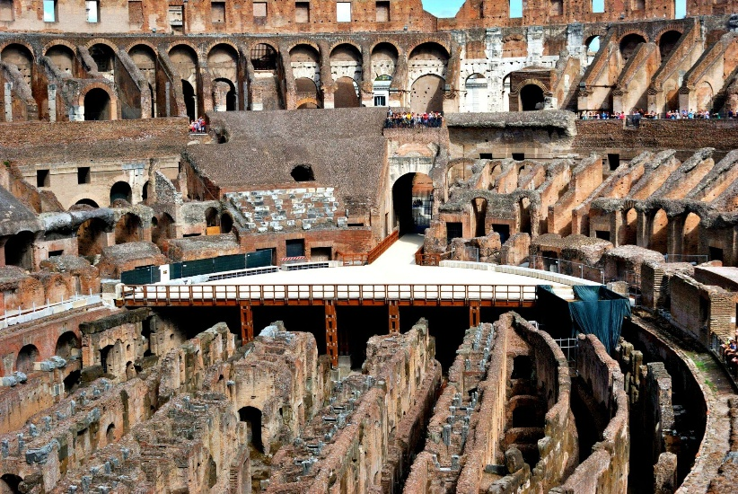
Figure 1 - Colosseum
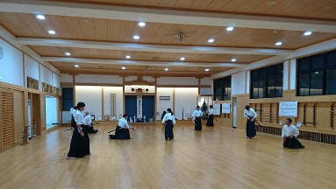
Figure 2 - Samurai Dojo
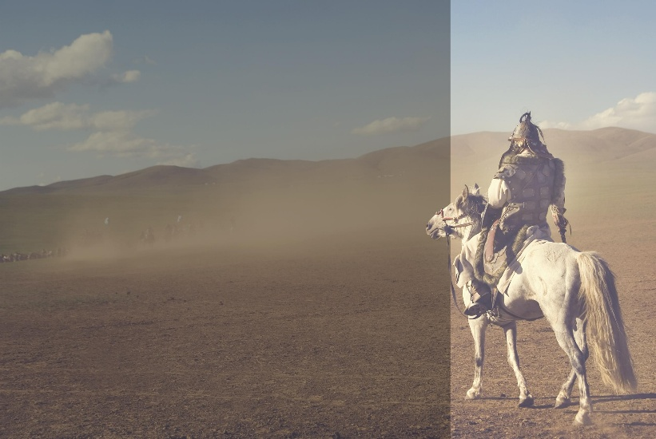
Figure 3 - Mongol Steppe
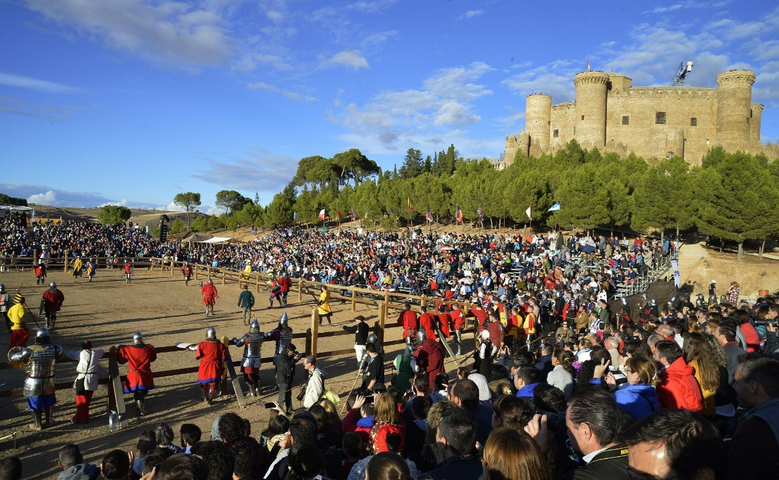
Figure 4- Medieval Castle Courtyard
Launch with 6 arenas:
- Colosseum
- Samurai Dojo
- Viking Longhouse
- Mongol Steppe
- Medieval Castle Courtyard
- Underground Crime Arena

Unreal Engine 5 Roadmap

Vertical Slice (6 Months)
Build:
- 4 fighters
- 1 arena
- Basic combat system
- AI opponents
- Tournament mode

Prototype Budget
- Solo developer + marketplace assets: $5,000–$20,000
- Small team: $25,000–$100,000

Funding Demo
Use the prototype to:
- Build a Steam page
- Create trailers
- Run a Kickstarter
- Pitch publishers

Long-Term Vision
Year 1:
- 12 fighters
- 6 arenas
Year 2:
- 50 fighters
- 25 countries
Year 3:
- 100+ fighters
- Organized crime factions
- Military factions
- Historical campaigns
Year 4+:
- Every major nation and historical empire represented
- Ranked online play
- Seasonal content
- Esports league
The biggest challenge won't be programming. It will be creating and balancing hundreds of fighters while keeping each one historically inspired, visually distinct, and competitively viable. That's why a small, polished roster first is usually the winning strategy.

Next Steps

BLOOD NATIONS: COLOSSEUM OF HISTORY

Game Design Document (GDD) v1.0

Executive Summary
Title: Blood Nations: Coliseum of History
Genre:
- Weapon-Based Fighting Game
- Arena Combat
- Historical Fantasy
- Competitive Multiplayer
Platform:
- PC (Steam)
- Xbox Series X/S
- PlayStation 5
Engine:
- Unreal Engine 5.6
Target Audience:
- Ages 18+
- Fighting Game Fans
- History Enthusiasts
- Competitive Esports Players
Inspirations:
- For Honor
- Tekken 8
- Mortal Kombat 1

Game Vision
Every nation, empire, military force, criminal organization, and warrior culture sends its greatest champion into a global tournament.
Players fight through history itself:
- Ancient warriors
- Medieval warriors
- Tribal champions
- Military operators
- Crime syndicate enforcers
- Historical legends
The ultimate goal:
Become Champion of All Nations.

Core Pillars

Pillar 1: Historical Identity
Every fighter feels unique.
Examples:
- Spartan fights like a shield wall warrior.
- Samurai relies on precision and counters.
- Viking overwhelms opponents with aggression.
- Gladiator controls space and defense.

Pillar 2: Skill-Based Combat
Victory depends on:
- Timing
- Positioning
- Stamina management
- Reading opponents
Not button mashing.

Pillar 3: Competitive Balance
- All fighters can win.
- No fighter is overpowered.

Pillar 4: Spectacle
- Cinematic arenas.
- Epic introductions.
- Crowd reactions.
- Dynamic weather.

Launch Content

Fighters (12)

Roman Gladiator
Class:
Defender
Weapon:
Gladius + Scutum
Strength:
Defense
Weakness:
Mobility

Spartan Hoplite
Class:
Tank
Weapon:
Dory Spear
Strength:
Range
Weakness:
Speed

Samurai
Class:
Counter Specialist
Weapon:
Katana
Strength:
Precision
Weakness:
Low Armor

Viking Berserker
Class:
Bruiser
Weapon:
Battle Axe
Strength:
Damage
Weakness:
Defense

Shaolin Monk
Class:
Agile
Weapon:
Staff
Strength:
Mobility
Weakness:
Durability

Mongol Raider
Class:
Skirmisher
Weapon:
Saber
Strength:
Speed
Weakness:
Armor

Medieval Knight
Class:
Heavy
Weapon:
Longsword
Strength:
Armor
Weakness:
Stamina

Zulu Warrior
Class:
Aggressive
Weapon:
Assegai
Strength:
Pressure
Weakness:
Defense

Ottoman Janissary
Class:
Hybrid
Weapon:
Kilij
Strength:
Versatility
Weakness:
Reach

Mafia Enforcer
Class:
Dirty Fighter
Weapon:
Knife
Strength:
Close Combat
Weakness:
Range

Cartel Sicario
Class:
Ambush Fighter
Weapon:
Machete
Strength:
Unpredictability
Weakness:
Defense

Special Forces Operator
Class:
Tactical
Weapon:
Combat Knife
Strength:
Adaptability
Weakness:
Armor

Combat System

Controls
Light Attack
Heavy Attack
Block
Dodge
Grab
Special Ability
Ultimate Ability

Combat Triangle
Attack beats Grab
Grab beats Block
Block beats Attack

Stamina System
Action consumes stamina:
- Sprinting
- Blocking
- Heavy attacks
- Dodging
Low stamina:
- Reduced speed
- Reduced damage
- Vulnerability

Damage Types
- Slash: Sword damage
- Pierce: Spear damage
- Blunt: Hammer damage
- Bleed: Damage over time

Arenas
Roman Colosseum
Capacity: 50,000
Hazards: Spikes, Fire pits

Samurai Temple
Hazards: Falling lanterns

Viking Longhall
Hazards: Burning beams
Mongol Battlefield
Hazards: Dust storms

Medieval Castle
Hazards: Moats

Underground Crime Arena
Hazards: Electrical traps

Game Modes
Arcade: Defeat AI opponents.

Tournament: 16 fighter brackets.

Story Mode: Individual campaigns.

Training
Practice combos.

Versus
Local multiplayer.

Ranked
Competitive ladder.

Progression
Players earn:
- XP
- Gold
- Reputation
Unlock:
- Armor skins
- Weapon skins
- Titles
- Arena cosmetics

Story Mode
Premise
- A mysterious global tournament appears.
- Champions from all eras are summoned.
- Only one can rule history.

Chapters
- Chapter 1 -- Ancient Warriors
- Chapter 2 -- Empires
- Chapter 3 -- Conquerors
- Chapter 4 -- Modern Forces
- Chapter 5 -- Final Champion

AI System

Difficulty Levels
- Recruit
- Veteran
- Elite
- Legend
- Mythic

AI Behaviors
- Defensive
- Balanced
- Aggressive
- Counter Fighter
- Adaptive

Multiplayer

Modes
- 1v1 Ranked
- 1v1 Casual
- Private Matches
- Tournament Brackets
- Spectator Mode

Ranking System
- Bronze
- Silver
- Gold
- Platinum
- Diamond
- Master
- Grandmaster
- Champion

Audio Design
- Dynamic crowd noise.
- Weapon impacts.
- National themes.
- Victory music.
- Arena ambience.

Monetization
Base Game : $39.99

Fighter Packs
- Warriors of Europe
- Warriors of Asia
- Warriors of Africa
- Warriors of the Americas

Cosmetic Packs
- Armor
- Weapons
- Arena Themes
- Banners

Esports Vision

Blood Nations World Championship
Regional qualifiers:
- North America
- Europe
- Asia
- South America
- Africa
Annual World Finals.
Prize pools funded through:
- DLC
- Sponsorships
- Streaming partnerships

Technical Architecture

Front End
- Unreal Engine 5.6
- Blueprints
- C++
- UMG UI

Backend
- ASP.NET Core
- REST APIs
- SignalR

Database
- PostgreSQL
- Redis

Cloud
- AWS
- EC2
- RDS
- S3
- CloudFront

Development Roadmap

Milestone 1 (Months 1-3)
- Combat prototype
- 2 fighters
- 1 arena

Milestone 2 (Months 4-6)
- 4 fighters
- Tournament mode
- AI

Milestone 3 (Months 7-9)
- 12 fighters
- Ranked multiplayer

Milestone 4 (Months 10-12)
- Steam Early Access
- Marketing campaign
- Community building

Success Criteria

Prototype
- Combat feels fun
- Stable 60 FPS
- Positive playtesting

Early Access
- 10,000 wishlists
- 1,000 active players

Full Release
- 100,000+ units sold
- Competitive esports scene
- Expansion roadmap funded

Document Status: Blood Nations GDD v1.0
Owner: RC Technology LLC
Version: 1.0
Prepared For: Prototype Development and Publisher Funding Discussions.

Design a gaming cover or logo for the game.

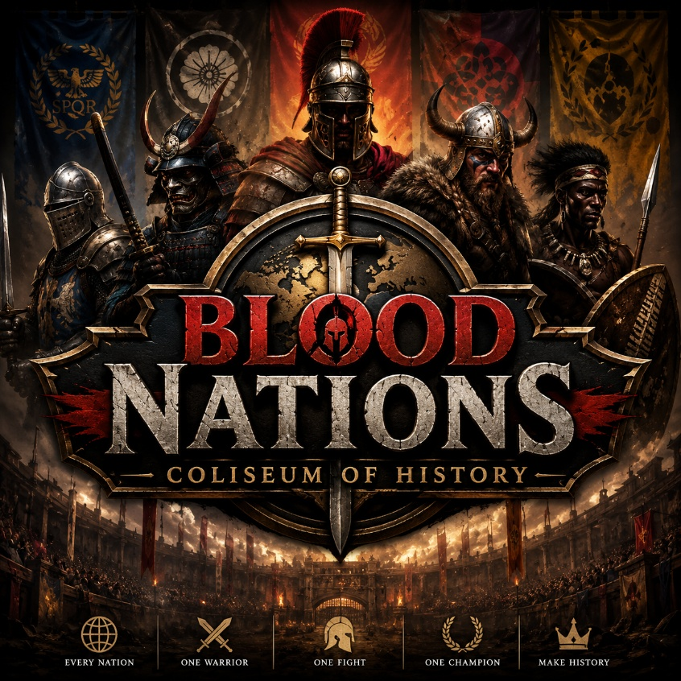
Figure 5- Game Cover & Logo

Need gaming Investors
For Blood Nations: Coliseum of History, you are not yet at the stage of pitching major publishers. Investors want to see a vertical slice, a team, and proof that players are interested.

Target Investors for a New Fighting Game Studio

Gaming Venture Capital
- Griffin Gaming Partners
- BITKRAFT Ventures
- Konvoy Ventures
- Galaxy Interactive
- Andreessen Horowitz Games Fund
These firms typically invest after a prototype exists.

Publishers

Best Match
- Epic Games Publishing
- 505 Games
- Focus Entertainment
- THQ Nordic
- Plaion (Deep Silver)
A historical combat game is more likely to interest these publishers than companies focused only on casual or mobile games.

Crowdfunding
If you can produce:
- 4 fighters
- 1 arena
- Gameplay trailer
- Steam page
Then launch on:
- Kickstarter
- Indiegogo
Goal:
- $100,000–$500,000

Angel Investors
Look for:
- Former game executives
- Esports owners
- Technology founders
- High-net-worth individuals interested in gaming
Ticket sizes:
- $25K–$250K

What You Need Before Pitching

1. Investor Pitch Deck (15–20 Slides)
Include:
- Vision
- Market Opportunity
- Competitive Analysis
- Trailer Screenshots
- Team
- Development Roadmap
- Budget
- Revenue Model
- Funding Request

2. One-Minute Trailer
Show:
- Gladiator vs Samurai
- Spartan vs Viking
- Arena footage
- Logo reveal

3. Vertical Slice
Investors want to play something.
Minimum:
- 4 fighters
- 1 arena
- AI opponent
- Tournament mode

4. Steam Wishlist Campaign
Investors love traction.
Target:
- 10,000 Wishlist
- 5,000 Discord members
- 1,000 newsletter subscribers

Funding Strategy I'd Recommend

Round 1 (Self-Funded)
$25,000–$50,000
Build:
- Prototype
- Website
- Trailer
- Steam page

Round 2 (Angel Round)
$250,000–$750,000
Build:
- 12 fighters
- Multiplayer
- Early Access

Round 3 (Publisher / VC)
$2M–$10M+
Build:
- Full production
- Console launch
- Marketing campaign

For RC Technology LLC, the highest-probability path is:
- Build the prototype in Unreal Engine 5.
- Create a professional investor deck.
- Launch a Steam page and start collecting Wishlist.
- Raise an initial angel round of $250K–$500K.
- Use those results to approach gaming VCs and publishers.
At this stage, your most asset is not the idea, it's a playable demo that proves people want to play Blood Nations.

Is the game concept original and is there a market for it?
Yes — but with an important caveat.

Is It Original?

The Good News
I am not aware of a major game that combines all of these elements:
- Historical warriors from all civilizations
- Organized crime fighters
- Modern military operators
- One-on-one tournament structure
- National representation
- Global coliseum theme
- Fighting-game mechanics
Most existing games focus on only part of that formula:
Game | Similarity | Difference
For Honor | Historical warriors | No global nation tournament
Mortal Kombat 1 | Tournament fighting | Fictional characters
Tekken 8 | International fighters | Modern martial artists
Soulcalibur VI | Weapon combat | Fantasy setting
Deadliest Warrior: The Game | Historical matchups | Small roster, limited scope
Deadliest Warrior | Cross-era warrior comparisons | Not a modern AAA fighting game
The strongest comparison is probably Deadliest Warrior meets For Honor meets Mortal Kombat.
That combination is relatively unique.

Where I See the Risk
The biggest risk is not originality.
The biggest risk is:

"Too Broad"
Your current vision includes:
- Every country
- Every era
- Every warrior culture
- Criminal organizations
- Special forces
- Historical legends
That could easily become:
"A game nobody can finish building."
Many ambitious games fail because the scope explodes.

What Investors Will Ask

Not:
"Is this original?"

They will ask:
"Why will people buy this instead of Tekken, Mortal Kombat, or For Honor?"
You need a clear answer.

The Strongest Selling Point
I think the best pitch is:

Historical Matchups
Players constantly ask questions like:
- Samurai vs Viking
- Spartan vs Knight
- Gladiator vs Mongol
- Zulu Warrior vs Roman Legionary
People have been debating these matchups for decades.
Your game lets them play those debates.
That is a compelling hook.

Is There a Market?

Yes.
The global fighting-game market is large and proven.
Examples:
- Street Fighter 6
- Tekken 8
- Mortal Kombat 1
Each has sold millions of copies.
The question isn't whether people like fighting games.
The question is whether your historical theme can attract enough players.
I believe it can if executed well.

What Makes It Investable?

Unique Angle
Instead of:
- Another martial arts fighting game
You have:
- The greatest warriors in human history fighting for national glory.
That's easier to market.

What Would Make Me More Excited as an Investor?
I would narrow the initial vision.
Instead of:

Blood Nations
200+ Fighters
I would pitch:

Blood Nations: Season One
12 Fighters
- Gladiator
- Spartan
- Samurai
- Viking
- Mongol
- Knight
- Shaolin Monk
- Zulu Warrior
- Janissary
- etc.
6 Arenas
Strong combat system
Multiplayer
Then expand through seasons.

My Assessment

Originality: 8.5/10
The combination of historical warriors, national identity, and tournament combat is distinctive.

Market Potential: 8/10
There is a proven market for competitive fighting games and historical combat.

Development Risk: 9/10
The concept is much larger than what a new studio should attempt initially.

Investor Interest: 7/10 Today
Without a prototype, most investors will pass.

Investor Interest: 9/10 With a Great Demo
If you can show:
- Spartan vs Samurai gameplay
- High-quality visuals
- Tight combat
- Strong trailer
then the concept becomes far more compelling.
The idea itself is strong. The key challenge is reducing the scope enough to build a polished prototype that demonstrates the core fantasy: "Who would win—the greatest warriors in history?" That question has broad appeal and is easy to understand in a trailer or pitch deck.

Initial Game Product
What if the initial game product would only include Criminal organizations and special forces. The next DLC a portal to the era the warriors of the culture in time, and the next DLC would allow to have a portal to fight historical.

This is a much stronger business strategy than launching with every historical warrior.
The key is to build the game around factions and archetypes, not real-world organizations. Using actual contemporary criminal groups as playable factions can create legal, ratings, and platform-distribution issues. Instead, create fictionalized crime syndicates and special-operations units inspired by broad archetypes.

Revised Product Strategy

Base Game
Blood Nations: Black Operations
Theme:
- Elite operators
- Mercenaries
- Assassins
- Syndicates
- Intelligence agencies
- Underground fighting tournament
Think:
John Wick meets Mortal Kombat meets For Honor
instead of
Historical warriors immediately.

Launch Roster (12 Fighters)

Syndicate Fighters
- Sicilian Enforcer
- Russian Bratva Veteran
- Triad Shadow
- Yakuza Swordmaster
- Cartel Hunter
- Balkan Fixer

Special Operations Fighters
- Delta Operator
- SAS Commando
- Spetsnaz Veteran
- Legionnaire
- Mossad Field Agent
- Black-Ops Mercenary
Each would be a fictional character inspired by recognizable archetypes rather than direct representations of real-world groups.

Story Framework

Season 1
The world's most dangerous fighters are abducted.
A mysterious organization opens:

The Blood Gate
Portal technology that can access other periods of history.
The winner earns the right to control the gates.

DLC 1

Blood Gate: Age of Warriors
The portal opens.
Historical champions emerge.

Fighters
- Spartan
- Gladiator
- Viking
- Samurai
- Knight
- Mongol Raider
Now your modern fighters can face ancient warriors.
This is where the concept becomes unique.

DLC 2

Blood Gate: Empires
Adds:
- Zulu Warrior
- Janissary
- Persian Immortal
- Aztec Jaguar Warrior
- Shaolin Monk
- Mamluk Cavalry Champion

DLC 3

Blood Gate: Legends
Adds legendary figures inspired by history and mythology.
Examples:
- The Conqueror
- The Berserker King
- The Last Centurion
- The Desert Lion

Why Investors May Like This Better

Easier Development
Instead of:
- 100 fighters
- 50 arenas
You launch with:
- 12 fighters
- 4 arenas
Much more realistic.

Strong DLC Pipeline
Investors love recurring revenue.
Roadmap:
- Base Game
- Warrior DLC
- Empire DLC
- Legend DLC
- Seasonal DLC
Potentially 5–10 years of content.

Marketing Advantage
Initial trailer:
"The world's deadliest operators enter the Blood Gate."
Second trailer:
"The Blood Gate has opened. History has arrived."
That reveal would likely generate more excitement than starting with everything at once.

What I'd Pitch

Blood Nations: Black Operations
Year 1
- 12 fighters
- 4 arenas
- Online multiplayer
- Story mode

Blood Gate Expansion
Year 2
- Historical warriors

Empire Expansion
Year 3
- Global warrior cultures

Legends Expansion
Year 4
- Myth-inspired champions
From a funding and execution standpoint, this phased approach is more investable because it gives you a focused, achievable first game while preserving the larger "all of history enters the arena" vision as future expansions. It also creates a compelling narrative progression: modern combatants discover and fight champions from the past through the Blood Gate.

Blood Nations Investor Pitch
The current version is a concise investor pitch summary. For fundraising, I recommend the next version be a professional 15–20 slide publisher/investor deck containing:
- Executive Summary
- Market Analysis
- Competitive Landscape
- Blood Gate Franchise Strategy
- Fighter Roster
- DLC Roadmap
- Revenue Projections (5 Years)
- Development Budget
- Team Structure
- Unreal Engine Architecture
- Go-To-Market Plan
- Steam Wishlist Strategy
- Esports Roadmap
- Investment Ask
- Exit Opportunities
I can also create:
- A full investor-grade PDF deck (25–40 pages).
- A matching PowerPoint (.pptx) for presentations.
- A financial model spreadsheet (xlsx) with revenue projections.
- A publisher pitch package targeted to Epic, THQ Nordic, 505 Games, and gaming VCs.
This would be closer to what you'd use to raise a $250K–$2M seed round for Blood Nations.

Create a Publisher-ready package

Initial publisher-ready package files:
📘 Investor Deck PDF (This is a placeholder a needed document)
Download PDF
📊 Investor Presentation PowerPoint (This is a placeholder a needed document)
Download PPTX
📈 5-Year Financial Model Spreadsheet (This is a placeholder a needed document)
Download XLSX
Note: These are starter versions that establish the structure. For a publisher-ready package suitable for pitching gaming VCs, Epic, THQ Nordic, 505 Games, and other investors, the next step would be building a fully detailed package with:
- 25–40 page professionally designed investor deck
- Detailed TAM/SAM/SOM market analysis
- Comparable game sales analysis
- 5-year P&L projections
- Development budget and staffing model
- Funding round strategy ($250K Seed → $2M+ Series A)
- Steam Wishlist acquisition plan
- Unreal Engine production roadmap
- Publisher-specific pitch versions
- Professional cover art and branding
- Executive summary and one-page teaser
That expanded version would likely be 75–100 pages across multiple documents and resemble what a startup game studio would use in actual fundraising discussions.

Build Blood Nations Full Investor Package
This version contains the framework for:
- Executive Summary
- Vision & Franchise Strategy
- Market Opportunity
- Gameplay Concept
- Blood Gate Expansion Model
- DLC Roadmap
- Technology Architecture
- Development Roadmap
- Staffing Plan
- Marketing Plan
- Esports Strategy
- Revenue Model
- Funding Request
- Publisher-Specific Sections
  - Epic Games
  - THQ Nordic
  - 505 Games
  - Gaming VC Firms
- Exit Strategy
The next level would be a professional fundraising package (100–150 pages) with:
- Detailed market research
- Comparable game sales data
- Full 5-year financial statements
- Cap table and funding rounds
- Hiring plan by quarter
- Milestone-based budget
- Steam KPI projections
- Publisher outreach strategy
- Branded cover art
- Executive-quality layouts and graphics
- Investor one-pager
- Publisher one-pager
- Full PowerPoint deck synchronized with the PDF
That version would be suitable for serious discussions with investors and publishers.
Game Characters

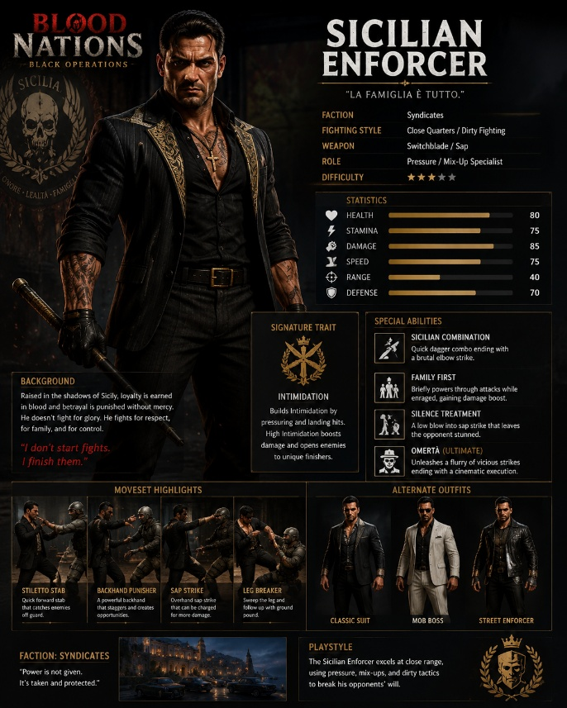
Figure 6- Sicilian Enforcer

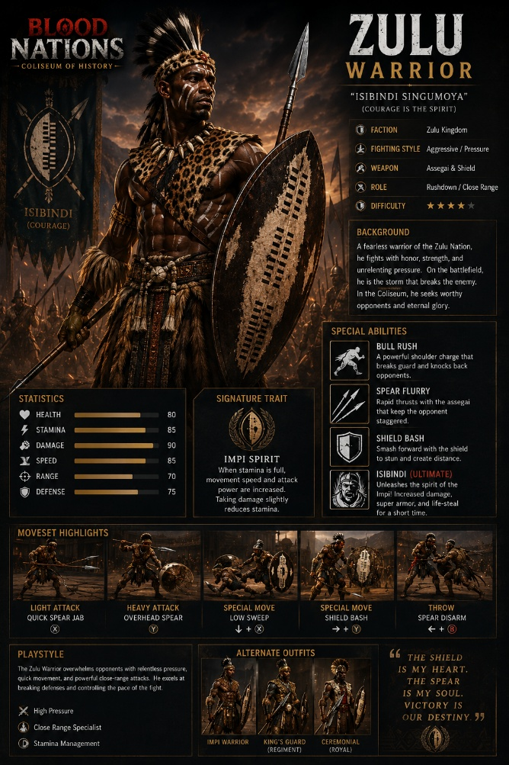
Figure 7- Zulu Warrior
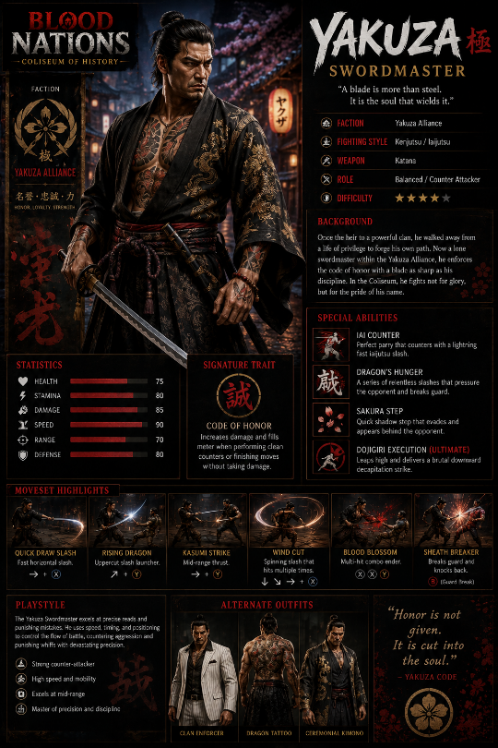
Figure 8- Yakuza Sword master
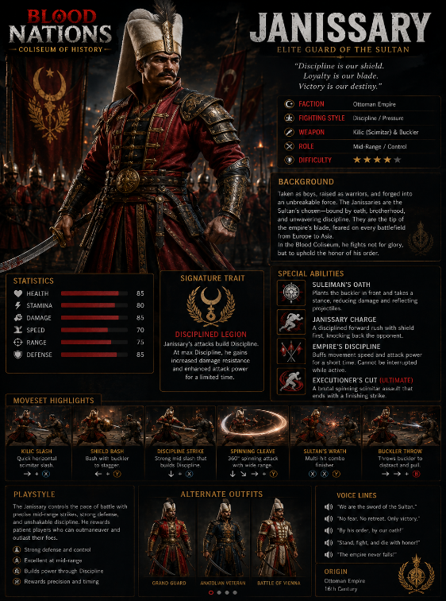
Figure 9- Janissary. The Elite Guard of the Sultan

Blood Nations Development Manual
This version consolidates:
- Game Concept
- Launch Strategy
- Character Framework
- Arena Design
- Story Architecture
- DLC Roadmap
- Technology Architecture
- Investor Strategy
- Marketing Plan
- Financial Model
- Publisher Outreach
- Theme Music Concept
The next level would be a full professional APA 7th Edition manual (150–300+ pages) with:
- Executive Summary
- Complete Game Design Document
- Every character profile (Sicilian Enforcer, Yakuza Swordmaster, Zulu Warrior, Janissary, etc.)
- Lore Bible
- Arena Bible
- Combat System Specifications
- Unreal Engine Technical Architecture
- Investor Package
- Financial Projections
- Marketing & Esports Strategy
- References and Appendices
This would become the master franchise document for RC Technology LLC and Blood Nations.

Base Game Option
If you're focusing the base game on Elite Operators, Mercenaries, Assassins, Intelligence Agents, and Underground Champions, then the launch roster becomes much more focused, marketable, and easier to build.

Blood Nations: Black Operations

Launch Roster (Season One)

Syndicate Division

Sicilian Enforcer
- Country: Italy
- Style: Close-quarters pressure fighter
- Weapons: Baton, switchblade
- Specialty: Intimidation meter

Yakuza Swordmaster
- Country: Japan
- Style: Counter-attacker
- Weapon: Katana
- Specialty: Precision strikes

Triad Shadow
- Country: China
- Style: Stealth and speed
- Weapon: Butterfly swords
- Specialty: Shadow step movement

Cartel Hunter
- Country: Mexico
- Style: Aggressive rush down
- Weapon: Machete
- Specialty: Fear mechanic

Bratva Veteran
- Country: Russia
- Style: Heavy-hitting brawler
- Weapon: Combat shovel
- Specialty: Damage resistance

Balkan Fixer
- Region: Balkans
- Style: Dirty fighter
- Weapon: Improvised weapons
- Specialty: Counter-grappling

Special Operations Division

Delta Operator
- Country: USA
- Style: Balanced tactical fighter
- Weapon: Combat knife
- Specialty: Adaptive combat

SAS Commando
- Country: United Kingdom
- Style: Precision and discipline
- Weapon: Fairbairn-Sykes dagger
- Specialty: Critical strikes

Spetsnaz Veteran
- Country: Russia
- Style: Sambo-based grappling
- Weapon: Tactical blade
- Specialty: Throws and submissions

Legionnaire
- Country: France
- Style: Endurance fighter
- Weapon: Combat machete
- Specialty: Stamina advantage

Mossad Operative
- Country: Israel
- Style: Fast counters
- Weapon: Karambit-style knife
- Specialty: Evasion

Black-Ops Mercenary
- Global
- Style: Wild card
- Weapon: Dual blades
- Specialty: Copy opponent abilities

Arenas
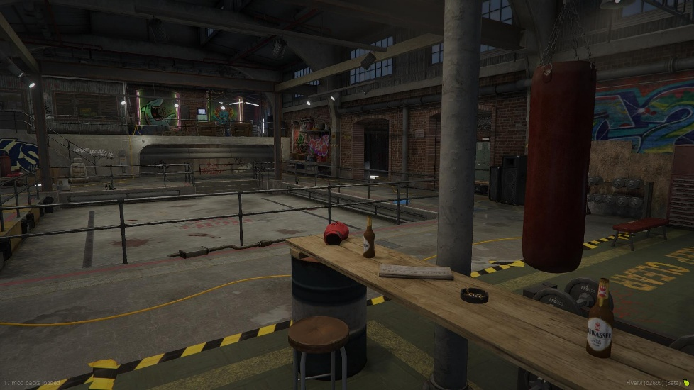
Figure 10- Underground Fight Club
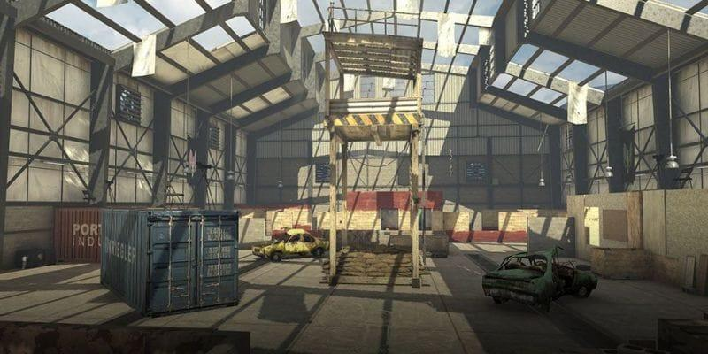
Figure 11- Abandon Shipyard

Figure 12 - Tokyo Rooftops

Launch Arenas
- Underground Fight Club
- Tokyo Rooftops
- Abandoned Shipyard
- Secret Military Compound
- Sicilian Estate
- Hong Kong Harbor

Story
A secret organization known as The Blood Gate Consortium gathers the world's most dangerous fighters.
The winner receives access to:
- Unlimited wealth
- Global influence
- Control of the Blood Gate
At the end of Season One, the Blood Gate activates. A Spartan warrior steps through the portal. Fade to black.

DLC 1 Begins.
This ending creates a powerful cliffhanger and sets up the historical expansions naturally.

Why This Version Is Stronger

Easier to Build
- Modern clothing
- Fewer historical accuracy issues
- Smaller art budget

Better DLC Strategy
- Season 1 = Black Operations
- Season 2 = Age of Warriors
- Season 3 = Empires
- Season 4 = Legends

Cleaner Investor Pitch
Instead of:
"We're building 200 fighters from all of history."
You can say:
"We're launching a modern combat arena fighter with a multi-year expansion roadmap that introduces historical warriors through the Blood Gate."
That's a much more fundable and executable vision.

Theme music
For Blood Nations: Black Operations, the theme music should feel like:
A secret global tournament. Elite operators. Criminal empires. Ancient power awakened.
Think of:
- Cinematic orchestra
- Heavy percussion
- Choir
- Industrial sounds
- World instruments
- Modern trailer music

Main Theme

"The Blood Gate"

Opening (0:00–0:30)
- Slow heartbeat.
- Low bass.
- Ancient chanting.
- Single Japanese taiko drum.
- Whispers in multiple languages.

Build (0:30–1:15)
- Strings begin rising.
- Military snare drums enter.
- Deep male choir.
- Growing tension.

Drop (1:15–2:00)
- Massive percussion.
- Aggressive brass.
- Electric guitar accents.
- War drums.
- The feeling:
- The world's deadliest fighters have arrived.

Finale (2:00–3:00)
- Choir expands.
- Theme melody returns.
- Ancient and modern sounds merge.
- The Blood Gate opens.

Signature Theme Motif
Every character uses the same core melody.
Examples:

Sicilian Enforcer
- Sicilian mandolin
- Dark strings
- Choir
Mood:
"The Family Comes First"

Yakuza Swordmaster
- Shakuhachi flute
- Taiko drums
- Koto strings
Mood:
"Honor Through Steel"

Zulu Warrior
- African drums
- Warrior chants
- Deep brass
Mood:
"Strength of the Impi"

Delta Operator
- Electronic pulse
- Military percussion
- Cinematic brass
Mood:
"Mission First"

Main Chorus Lyrics
- Latin-style chant often works well for epic game music.
- Example:
- Sanguis Nationum
- Porta Bellum
- Gloria Mortis
- Rex Pugnae
- Translation:
- Blood of Nations
- Gate of War
- Glory Through Death
- King of Combat

Main Menu Music
Atmosphere:
- Dark
- Mysterious
- Anticipation
Player feels:
Something bigger than a tournament is about to happen.

Trailer Music

Trailer #1
- Blood Nations: Black Operations
- Starts with:
- Heartbeat
- Knife unsheathing
- Slow piano
- Then:
- Massive percussion
- Choir
- Character reveals

Trailer #2
- Blood Gate Expansion
- Ancient horn sounds.
- Portal opening.
- Thunder.
- Spartan emerges.
- Music explodes.
- Voiceover:
  - "History has entered the arena."

Theme Song Prompt for a Composer or AI Music Generator
Title: Blood Gate
Genre: Epic Cinematic Hybrid
BPM: 110
Key: D Minor
Style References:
- Two Steps From Hell
- Hans Zimmer
- Audiomachine
- God of War
- Gladiator
Instrumentation:
- Taiko drums
- Orchestra
- Male choir
- Female choir
- Electric guitar
- Ethnic instruments from multiple cultures
- Industrial impacts
- Deep cinematic bass
Mood:
- Dark
- Powerful
- Ancient
- Global
- Competitive
- Legendary
Tagline Theme:
- One Gate.
- One Fight.
- One Champion.
- Blood Nations.
This theme can then be adapted into individual fighter themes, arena music, boss music, and esports championship music while maintaining a recognizable franchise identity.

Provide complete research citation and references
For an APA 7th edition investor/development manual, you should distinguish between:
- Actual research sources (market reports, engine documentation, industry data)
- Inspirational references (games, design influences)
- Internal design documents (your original Blood Nations concepts)
Because Blood Nations is an original IP, much of the content belongs in:
Source: RC Technology LLC Internal Design Documentation (2026)
rather than being cited as external research.

APA 7th Edition References

Game Industry Research
Newzoo. (2024). Global games market report. Newzoo.
Entertainment Software Association. (2024). Essential facts about the U.S. video game industry. Entertainment Software Association.
Statista. (2025). Video game market revenue worldwide. Statista.
Grand View Research. (2024). Video game market size, share & trends analysis report. Grand View Research.
PwC. (2024). Global entertainment & media outlook 2024–2028. PricewaterhouseCoopers.
Deloitte. (2024). Digital media trends survey. Deloitte Insights.

Game Design References
Schell, J. (2020). The art of game design: A book of lenses (3rd ed.). CRC Press.
Fullerton, T. (2018). Game design workshop: A playcentric approach to creating innovative games (4th ed.). CRC Press.
Rogers, S. (2014). Level up! The guide to great video game design (2nd ed.). Wiley.
Adams, E. (2014). Fundamentals of game design (3rd ed.). New Riders.
Keith, C. (2010). Agile game development with Scrum. Addison-Wesley.

Technical References
Epic Games. (2025). Unreal Engine 5 documentation. Epic Games. https://dev.epicgames.com/documentation
Amazon Web Services. (2025). AWS GameLift documentation. Amazon Web Services. https://docs.aws.amazon.com/gamelift
Microsoft. (2025). ASP.NET Core documentation. Microsoft. https://learn.microsoft.com/aspnet/core
PostgreSQL Global Development Group. (2025). PostgreSQL documentation. https://www.postgresql.org/docs
Epic Online Services. (2025). Epic Online Services developer portal. Epic Games. https://dev.epicgames.com/services

Competitive Analysis References
The following titles should be cited within the text as comparative products:
- For Honor
- Tekken 8
- Mortal Kombat 1
- Soulcalibur VI
- Street Fighter 6
Example:
Blood Nations combines historical-inspired weapon combat similar to For Honor with character identity and roster differentiation seen in Mortal Kombat and Tekken.

Internal Citations for Original Content
For original sections such as:
- Blood Gate Lore
- Sicilian Enforcer
- Yakuza Swordmaster
- Zulu Warrior
- Janissary
- Black Operations Storyline
- Arena Designs
- DLC Roadmap
Use:
RC Technology LLC. (2026). Blood Nations: Black Operations Internal Design Documentation. Unpublished manuscript.
This is the proper APA method for citing your own original intellectual property.

Additional Sources for Investor Package
Recommended sources to strengthen fundraising materials:
- GameDiscoverCo
- Steamworks Documentation
- GDC (Game Developers Conference) Reports
- IGDA Resources
These sources are frequently referenced by publishers, investors, and game studios when evaluating market opportunities, production plans, and launch strategies.
For a true investor-grade manual, I would recommend adding a 3–5-page scholarly reference section with 40–60 citations covering game design, monetization, player retention, esports, Steam launch statistics, venture funding, and Unreal Engine development.

