WISP User’s Guide

April 21, 2011

Table of Contents

Table of Contents 2
Part 1: User’s Guide 3
Introduction 3
Program Startup/Shutdown 4
Hardware Configuration / Defining Output Locations 4
Defining Special Keys 5
Setting up File Paths 5
Running an Experiment 5
Processing Experimental Results Files 6
Creation of New Output Formats 6
Updating Results Files 7
Experiment Screen 7
Phase Screen 7
Item Screen 8
Repeat on Failure 8
Repeats Allowed 8
Event Screen 9
Stimulus Filetypes 9
Stimulus Location 9
Start/Stop/Failure Conditions 10
Part 2: Case Study of a Headturn Experiment 11
Description of the Experiment 11
Implementation 11
Create a New Experiment 11
Configure Output Locations 11
Create the Training Phase 12
Create the Training Item 12
Create the Training Events 12
Conditions for Continuous Sound event 13
Conditions for Center Stimulus 1 13
Conditions for Side Stimulus 1 13
Conditions for Center Stimulus 2 13
Conditions for Side Stimulus 2 14
Conditions for Center Stimulus 3-12, Side Stimulus 3-12 14
Create the Testing Phase 14
Create a Testing Item 14
Create Testing Item Events 15
Create Additional Testing Items 16
Running the Experiment 16
Processing Experimental Results Files 16

Part 1: User’s Guide

Introduction
WISP is a set of Matlab functions (and associated software) which allows the user to design and run psychological experiments with infant participants. The program supports the presentation of audio, still image, and video stimuli at “output locations” which are characterized by screen coordinates (a computer monitor or a region of a monitor) and one or more audio channels on a sound card. While the experiment is running, the experimenter presses keys to indicate where the participant is looking. Conditions can be defined so that the progress of the experiment is contingent on the looking behavior of the participant – for example, so that a trial continues until a specified amount of on-target looking has accumulated.

As illustrated in Figure 1, Experiments consist of Phases, where each Phase is composed of Items. Items include one or more Events, or presentations of stimuli.

Phase 1
Item 1
Events
Item K
Events
...
Phase N
Item 1
Events
Item L
Events
...
...
Figure 1: Experiments have a hierarchical structure of Phases, Items, and Events.

When the experiment is executed, the Phases will either run in order (as depicted in Figure 2) or randomly. Within each Phase, Trials will run as instances of Items. To understand the difference between Items and Trials, consider that an Item may involve presentation of a stimulus at a random location, while a derived Trial will involve presentation of the stimulus at a specific location, which has been chosen randomly.

Phase 1
Trial 1
Events
Trial m*K
Events
...
Phase N
Trial x+1
Events
Trial x+r*L
Events
...
...
Figure 2: A running experiment consists of trials, which are instances of items.

Program Startup/Shutdown
If Matlab is running and the program is in the path, start the program by typing “wisp” and pressing the Enter key. You will be prompted to select an experiment settings file. If you select a file, then those settings will be loaded; otherwise, a new experiment will be created.

To exit the program either select the “File/Quit” menu item, or click on the “X” icon in the upper right corner. You will always be asked if you would like to save any changes to the currently-loaded settings file. If you would like to save to a different file, select Cancel and then select the “File/Save As…” menu item.

Hardware Configuration / Defining Output Locations
The “Settings/Output Locations” menu item opens the Hardware Configuration window, which is used to define Output Locations. The defining features of an Output Location are:
- Name
- Response Key
- Audio device and channel(s)
- Video display coordinates and the audio device/channels used for the audio track in a video

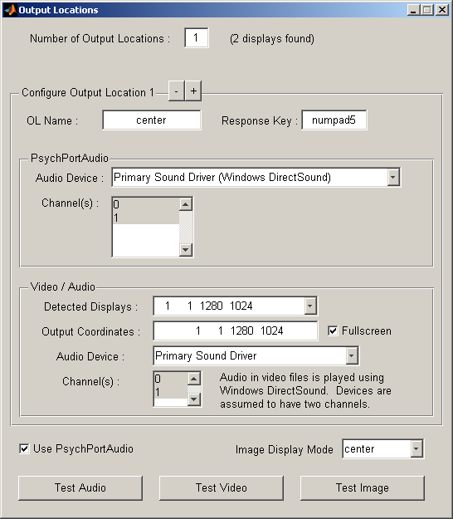Figure 3: The Output Locations window is used to select screen coordinates and audio channels where output will be presented.
For best results, the selected Audio Device should be a Windows DirectSound device. Other devices may not support playing multiple sounds concurrently, or may have higher latency. Audio, video, and image output can be tested using the buttons at the bottom of the form. When the desired Output Locations have been defined, close the window to return to the experiment screen.

The video output coordinates are in the form [x1 y1 x2 y2], where (x1, y1) define the upper left corner and (x2, y2) define the lower right corner of the Output Location window, measured from the upper left corner of the primary display. The coordinates of the detected displays are provided; these may form a helpful starting point. If an output location is intended to use the full screen, checking the Fullscreen box will yield better results than setting the “correct” coordinates alone.

The “Use PsychPortAudio” checkbox determines which of two methods is used to play audio files. If the box is checked, files will be loaded into Matlab and played using PsychPortAudio, which is part of PsychToolbox. This approach should work well for small files, but large files may cause Matlab to run out of memory. If the box is not checked, audio files are played using the same mechanism as video files. Accordingly, the audio device and channels will be selected using the Video / Audio panel.

The “Image Display Mode” control determines how images are displayed.
“Center” displays images at their native resolution, centered within the output location.
“Fit” displays images scaled to fit within the output location, preserving their original aspect ratios.
“Stretch” displays images stretched to fill the output location, without regard for their original aspect ratios.

Defining Special Keys
In addition to the keys associated with output locations, several other keys can be defined to have special meanings. The menu item “Settings/Configure Keys” opens a window where keys can be assigned to “End Trial”, “End Phase”, “End Experiment”, and “Pause”. To assign a key, place the cursor in the appropriate box, and simply press the key.

“End Trial” immediately ends the current trial and moves to the next.
“End Phase” ends the current phase, and moves to the next.
“End Experiment” immediately ends the current experiment.
“Pause” pauses the experiment at the end of the current trial. Press any key to resume the experiment.

Setting up File Paths
The menu item “Settings/File Paths” opens a window where file paths can be set. When using the file selection dialog to select a stimulus file, the initial directory will be the “Default Stimulus Path”. When an experiment has run, the results will be saved to a file in the “Results File Path”.

Running an Experiment
To run the currently-loaded experiment, click Run in the Experiment menu. As many fields as desired may be filled out, and then click the Run Experiment button to begin execution of the experiment.

It is possible to display information about the running experiment at a specified location, making it easy to embed information in a video recording of a run. Enable “Show Info Slides” to display an information slide before and after the experiment runs. This slide will be displayed for 2 seconds, and will show the experiment name, the first condition, the subject ID, and the date and time specified on the Run screen. Enable “Show Trial Information” to display an information slide which will be visible throughout the experiment. This slide will show the experiment name, subject ID, phase name, and trial number.

When the experiment is complete, a results file will be saved with a name based on the date and time, as well as the experiment name and the subject id. The results file contains Matlab code which creates a structure containing a complete specification of the experiment as well as the results. In general, a post-processing step will be required to transform the results to a form more suitable for analysis.

Processing Experimental Results Files
The results files created when an experiment runs are not in a format which can be imported into other programs. The Process Results tool can be used to transform results files to a format suitable for import into analysis software such as SPSS, Excel, or R. To process the results, click the “Results/Postprocess Results” menu item. Use the Select Files button to open a file selection dialog box. Selected files will appear in the listbox. Then select an output format appropriate for the type of experiment.
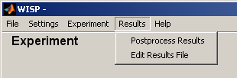Figure 4: Select Postprocess Results on the Results menu.

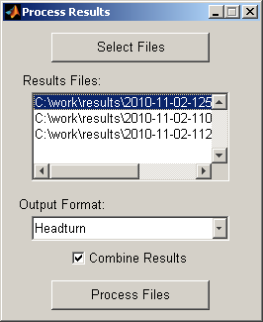Figure 5: The Process Results dialog is used to select experiment results files and an output format.
If more than one results file has been selected, the files can be processed into individual output files, or a single combined output file. This option is controlled by the Combine Results checkbox.

Use the Process Files button to process all selected files. The output file(s) will be created in the same directory as the results files. Individually-processed files will be named based on the results filename and the output format, while combined results will have names based on the processing time and output format only.

For example:
2010-10-04-1532_Headturn_1021.txt →
2010-10-04-1532_Headturn_1021_Headturn.txt

2010-10-04-1532_Headturn_1021.txt →
2010-10-04-1547_Headturn_1022.txt →
2010-10-04-1601_Headturn_1023.txt →
2010-10-04-1627_Combined_Results_Headturn.txt

Creation of New Output Formats
Addition of new output formats requires modification of ProcessResults.m. The file must be modified in three places. First, the name of the new format must be added to the cell array of strings OUTPUT_FORMATS. This name will be used to identify the format on the Postprocess Results window. Second, an entry must be added to the switch…case statement which determines which subfunction should be used to create the output data from the results. Finally, that subfunction must be written. The subfunction should have a name of the form createOutput_XXXXXX, where the output type is substituted for XXXXXX. For example, the function for processing Headturn results is called createOutput_headturn.

Updating Results Files
Information about a particular experimental session can be entered on the Run screen before the session begins. This information can subsequently be modified by selecting Edit Results File on the Results menu. After presenting a results file selection dialog, the program will display a form which is preloaded with the information from the results file. The fields can be edited as necessary, and then the Save Results and Close button must be used to commit the changes to the file. Closing the form without pressing that button will leave the results file unchanged.

Experiment Screen
The Experiment screen provides the top-level view of the experiment, showing the name of the experiment (Experiment ID), a list of the phases in the experiment, and the ordering of the phases.

The buttons to the left of the Phase list can be used to manipulate the list as follows:

Button Name | Function
New | Create a new phase (named “New Phase”).
Edit | Open the selected phase in the Phase screen.
Copy | Duplicate the selected phase.
Delete | Remove the selected phase.
Up | Move the selected phase one position up in the list.
Down | Move the selected phase one position down in the list.

These functions can also be accessed by right-clicking on an entry in the list.

The Phase Order control determines whether the phases run sequentially or in a random sequence. In either case, each phase will run exactly once.

Phase Screen
The Phase screen is similar in structure to the Experiment screen, showing the Phase ID, the Item List, and the Trial Order. Additionally, the Repetitions box can be used to control the number of times each item is repeated, and the Phase End Condition box controls the end conditions for the phase.

Trial Order | Description
Sequential | Run the items sequentially; repeat [Repetitions] times.
Random with Replacement | For each trial, randomly select one of the items to run. Each selection is independent, so some items may run more than others.
Random without Replacement | Each item will run [Repetitions] times, but the order of trials will be randomly generated.
Random within Blocks | Run each of the items once, randomly ordered; repeat [Repetitions] times, randomizing the order each time.

Phase End Condition | Description
Fixed | Run all trials, as determined by Trial Order and Repetitions.
Time | End the phase if the duration of the phase exceeds the specified amount of time.
Contingent | End the phase if the constructed expression is true.

The Contingent Phase End Condition can depend on either the sum or average of continuous on-target looks for a set of trials, or a comparison between sets of trials.

Phase end conditions are evaluated after each trial.

Item Screen
An item consists of one or more events, each of which represents the playback of a stimulus (audio, video, or image) file. The timing of event playback is controlled by start/stop conditions defined for each event. For this reason, the order of events in the Event List is unimportant (unlike the order of phases in the Phase List on the Experiment screen, for example).

The controls below the Event List control whether failed trials are repeated, and if so, how.

Repeat on Failure
- None. Failed trials are not repeated.
- Immediate. Failed trials are repeated immediately.
- End of Phase. Failed trials are repeated at the end of the current phase.
- Random within Phase. Failed trials are repeated at a random point among the remaining trials in the current phase.
- End of Block. Failed trials are repeated at the end of the current block.
- Random within Block. Failed trials are repeated at a random point among the remaining trials in the current block.

Repeats Allowed
- One. Repeat a failed trial only once.
- Until Successful. Repeat a failed trial until it is successful.

Note that the Repeats Allowed control only is applicable when Repeat on Failure is set to a value other than None.

If a repeated trial contains events which randomly select the output location, balancing of the output selection will not be applied; each random selection will be made independently.

Event Screen
An event is the presentation of a stimulus, which can be an audio, video, or image file. The event screen allows the user to specify a stimulus filename, an output location (or locations), and start/stop/failure conditions.
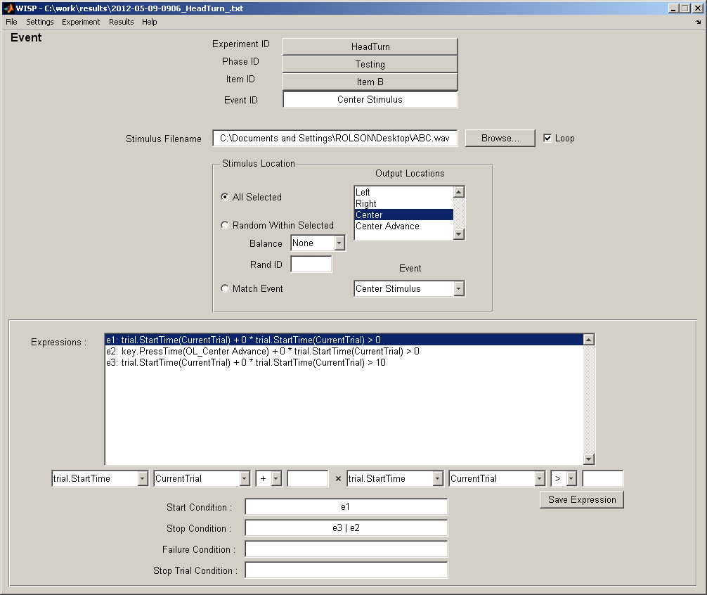Figure 6: Event screen.

Stimulus Filetypes
For best performance, it is recommended that all stimulus files should be located on a local hard disk. In some cases, the latency associated with accessing files on a network may prevent correct presentation of an experiment.

Audio files must be WAV format. File format conversion can be accomplished using MPlayer at a Command prompt. For example, (assuming the MPlayer executable is in the path), a file “sample.mp3” can be converted to “output.wav” using the command:

mplayer –quiet –vo null –vc dummy
–ao pcm:waveheader:file=”output.wav” “sample.mp3”

If Matlab throws an “Out of Memory” error when playing an experiment which uses lengthy audio files, it may be necessary to reduce the audio sample rate. The “-srate” parameter can be used to set the sample rate. For example, to see the sample rate to 8000 Hz, the above command could be changed to:

mplayer –quiet –vo null –vc dummy –srate 8000
–ao pcm:waveheader:file=”output.wav” “sample.mp3”

Video files may be any format which can be played by MPlayer. A list of supported file formats can be found at http://www.mplayerhq.hu/. Performance may vary depending on the selected file format.

Image files may be BMP, JPEG, GIF, or PNG. For best performance, BMP files should be used. In comparison tests, the code to display BMP files executed in approximately 14 ms, while other image file formats required approximately 180 ms. An image conversion tool has been provided in the Settings menu (Settings/Convert Images to BMP).

Looping
The Loop check box applies to audio and video files. If checked, the stimulus will loop until the event is stopped. If Loop is not checked, the end of the audio or video file will cause the event to end, assuming the event has not been stopped by other means.

Stimulus Location
The stimulus location may be fixed, random, or set to match the location of another event.
- All Selected. The stimulus will be presented at all of the locations selected in the Output Locations listbox.
- Random Within Selected. The stimulus will be presented at one of the locations selected in the Output Locations listbox. If Balance is set to None, the output location will be a randomly selected; otherwise, the randomization of output locations will be balanced, either over all trials in the phase, or over all trials in a block. An identifier (Rand ID) may optionally be specified. If multiple events have a common Rand ID and have Balance set to Block or Trials, then the combination of those events will be balanced.
- Match Event. The stimulus will be presented at the same locations as another event, which is specified in the Event drop-down box.

Conditional Behavior
Conditions for starting and stopping stimuli, as well as for determining whether the stimulus is considered to have failed, are defined using expressions. These expressions are assembled using the controls below the expressions list. Once appropriate values have been selected or entered, the expression is stored by clicking on the Save Expression button. A text representation of the expression then appears in the expression listbox, preceded by a label. Expressions will be labeled e1, e2, and so on; these labels are used in the Start/Stop/Failure/End Trial Condition boxes. Expressions can be combined to create complex conditions using Matlab’s logical operators (&, |, ~). Parentheses can be used to group expressions as necessary. All expressions are based either on time elapsed since a reference point, or a duration; in either case, all times are expressed in seconds.

The event conditions are evaluated at different times depending on their types. The start condition is evaluated at regular intervals before the event starts. When the start condition evaluates as true, then the event starts. The stop condition and stop trial condition are evaluated at regular intervals while the event is running. In either case, if the condition evaluates as true, stimulus playback will stop, and the event (and trial, for the stop trial condition) will end. The failure condition is evaluated at the end of the trial. If the failure condition evaluates to true, then the event (and hence, the trial) will be considered to have failed.

An unspecified condition evaluates as false. If the failure condition is unspecified, for example, then the event will never be considered to have failed. Only the start condition is required for stimuli with a fixed length (non-looping videos and sounds), while both a start and stop condition is required for stimuli with an indeterminate length (images and looping videos or sounds).

The controls used to create expressions refer to properties appropriate to the type of object selected (trial, event, or key) as described in the table below.

Property | Meaning
trial.StartTime | Time since start of trial
event.StartTime | Time since start of event
event.StopTime | Time since end of event
key.PressTime | Time since key was most recently pressed
key.Duration | Duration of most recent keypress
key.TrialDuration | Accumulated keypress time during the current trial
key.ReleaseTime | Time since key was most recently released

Part 2: Case Study of a Headturn Experiment

Description of the Experiment
The Headturn Preference Procedure (HPP) places an infant in a booth where visual and audio stimuli can be presented in three locations: in front of the infant, and to either side. The experiment consists of two phases, each of 12 trials. During the first phase (training), a sound plays continuously for all trials. Each trial begins with a visual stimulus at the center. Once the infant looks at the center location, a stimulus is displayed at either the right or left side. The stimulus is shown until the infant looks away from the side stimulus for more than two continuous seconds.

In the second (testing) phase, the sound begins to play only after the infant looks at the side stimulus, and the sound stops playing at the end of each trial. The side stimulus is presented until either the accumulated on-target looking time has reached 15 seconds, or the infant looks away from the stimulus for 2 seconds.

Four different stimulus sounds are used in the testing phase.

Implementation
The testing phase consists of three blocks of four trials, where each trial consists of a central stimulus followed by a side stimulus with one of the four sounds. Each of the four sounds will occur once in a block, and the stimulus side will be randomly balanced within each block.

Because there is continuous sound (i.e., a single extended stimulus) throughout the entire training phase, the entire phase must be implemented within a single item. A stimulus cannot span multiple trials.

Create a New Experiment
Select File/New Experiment to create a new experiment. Enter an experiment name (e.g., “Headturn”) in the Experiment ID text box, and create an experiment file by selecting Save Experiment As… from the File menu. Give the file a meaningful name such as Headturn.txt.

Configure Output Locations
Three output locations must be defined: right, left, and center. A fourth “dummy” output location will also be defined so that a key can be assigned to initiate the side stimuli. Click the Settings/Output Locations menu item to configure output locations.

First, set the number of output locations to 4. Then configure the locations so that they are named Left, Right, Center, and Center Advance. If the keyboard which will be used to run the experiment has a numeric keypad, reasonable choices for the corresponding response keys might be numpad4, numpad6, numpad8, and numpad5. Set the sound and video device parameters so that they match your hardware setup.

Create the Training Phase
Click on the New button next to the Phase List on the Experiment screen to create a new phase. Click the Edit button to move to the Phase screen. Change the name of the phase from New Phase to Training Phase. Make sure that Repetitions is set to 1 and the Phase End Condition is set to Fixed. The setting for Trial Order doesn’t matter, as there will only be a single trial.

Create the Training Item
Click the New button to create a new item. Then click on the Edit button next to the Item List on the Phase screen to open the Item screen for the new item. Set the Item ID to Training Item.

Create the Training Events
The training item will require one event for the continuous sound, and two events (one center stimulus and one side stimulus) for each training trial.

Click the New button to create a new event, and then click Edit to open the Event screen. Set the Event ID to Continuous Sound. Select the stimulus file by entering the filename in the Stimulus Filename box, or click on the Browse button to select the file using a file selection dialog. Set the Stimulus Location radio button to All Selected, and select Center in the Output Locations list. We will return to define the Start and Stop Conditions after all of the events have been created. Click on the Item ID button labeled Training Item to return to the Item screen.

Using a similar procedure, create an event named Center Stimulus 1. Select a stimulus movie file. Set the Stimulus Location radio button to All Selected, and select the Center output location.

Create another event named Side Stimulus 1. Select a stimulus movie file. Set the Stimulus Location to Random Within Selected, Balance to Trials, and Rand ID to 1. Note that Rand ID can be any unique string, and the number one has no particular significance here. Select both the Left and Right output locations.

Now return to the Item screen, and use the copy button to make eleven copies each of the Center Stimulus and Side Stimulus events. For convenient reference, rename these as Center Stimulus 2, Center Stimulus 3, etc…. After the renaming is complete, there should be 25 events in total: Continuous Sound, Center Stimulus 1, …, Center Stimulus 12, Side Stimulus 1, …, Side Stimulus 12.

Conditions for Continuous Sound event
Now return to the Continuous Sound event to define the Start and Stop Conditions. The event should start at the beginning of the trial, and should end at the end of Side Stimulus 12. Enter an expression using the Expression drop-down boxes and text boxes as below:
Click Save Expression, and the expression will appear in the Expressions list with a label e1.

e1: trial.StartTime(CurrentTrial) + 0 * trial.StartTime(CurrentTrial) > 0

In similar fashion, create an expression which will be true when Side Stimulus 12 has ended. Note that this expression could not have been created before the Side Stimulus 12 event had been created.

e2: event.StopTime(Side Stimulus 12) + 0 * trial.StartTime(CurrentTrial) > 0

Set the Start Condition to e1 and the Stop Condition to e2.

Conditions for Center Stimulus 1
Center Stimulus 1 should start at the beginning of the trial, and should end when the Center Advance key has been pressed. Create expressions:

e1: trial.StartTime(CurrentTrial) + 0 * trial.StartTime(CurrentTrial) > 0
e2: key.PressTime(OL_Center Advance) + 0 * trial.StartTime(CurrentTrial) > 0

Set the Start Condition to e1 and the Stop Condition to e2.

Conditions for Side Stimulus 1
Side Stimulus 1 should start when Center Stimulus 1 is complete, and stop when the infant looks away for more than two seconds. Create expressions:

e1: event.StopTime(Center Stimulus 1) + 0 * trial.StartTime(CurrentTrial) > 0
e2: key.ReleaseTime(Correct) + 0 * event.StartTime(CurrentTrial) > 2

Set the Start Condition to e1 and the Stop Condition to e2. There is an implicit assumption here that no “Correct” key has been pressed prior to the start of the event.

Conditions for Center Stimulus 2
Center Stimulus 2 should start at the end of Side Stimulus 1 and end when the Center Advance key has been pressed (at a time after the start of the event). Create expressions:

e1: event.StopTime(Side Stimulus 1) + 0 * trial.StartTime(CurrentTrial) > 0
e2: event.StartTime(Center Stimulus 2) – 1 * key.PressTime(OL_CenterAdvance) > 0

Set the Start Condition to e1 and the Stop Condition to e2. Expression e2 can be read as “The time since the start of the current event minus the time since the Center Advance key was pressed is greater than zero.” Before the Center Advance key has been pressed during Center Stimulus 2, the time since the previous press of the Center Advance key will be greater than the time since the start of the event, and the expression will be false.

Conditions for Side Stimulus 2
Side Stimulus 2 should start at the end of Center Stimulus 2, and should end when the infant looks away for more than two seconds after looking during the event. Create expressions:

e1: event.StopTime(Center Stimulus 2) + 0 * trial.StartTime(CurrentTrial) > 0
e2: event.StartTime(Side Stimulus 2) – 1 * key.ReleaseTime(Correct) > 0
e3: key.ReleaseTime(Correct) + 0 * trial.StartTime(Current Trial) > 2

Set the Start Condition to e1 and the Stop Condition to e2 & e3.

Conditions for Center Stimulus 3-12, Side Stimulus 3-12
The remaining events in the Training Item should have conditions which follow the form of those for Center Stimulus 2 and Side Stimulus 2.

Create the Testing Phase
Click on the Experiment ID button to return to the Experiment screen, and click the New button to create a new phase. Click the Edit button to open the new phase on the Phase screen, and rename it Testing. The testing phase will consist of three blocks of four trials. Each item should run once in each block, randomly ordered. Set the Trial Order to Random within Blocks, and set the number of Repetitions to 3. The Phase End Condition can remain at the default value of Fixed.

The only difference between the four items will be the audio stimulus, so it will be most efficient to create one of the items, make three copies, and make the necessary changes to the copies.

Create a Testing Item
Click the New button on the Phase screen to create a new item, and click Edit to open the item on the Item screen. Rename the item Item A. Leave Repeat on Failure set to None.

Create Testing Item Events
The item will consist of three events: an attention-getting stimulus will appear at the central output location, followed by a visual stimulus on either the right or left side, and an audio stimulus which begins after the infant looks at the side stimulus.

Click the New button to create a new Event, and click the Edit button to open it on the Event screen. Rename the event Center Stimulus. Select a stimulus file using the Browse button or enter the filename. Set the Stimulus Location to All Selected, and select the Center output location.

The Center Stimulus should start at the beginning of the trial, and end when the Center Advance key has been pressed, so create the following expressions:

e1: trial.StartTime(CurrentTrial) + 0 * trial.StartTime(CurrentTrial) > 0
e2: key.PressTime(OL_Center Advance) + 0 * trial.StartTime(CurrentTrial) > 0

Set the Start Condition to e1 and the Stop Condition to e2.

Return to the Item screen to create a new event, and click Edit to open it on the Event screen. Rename the event Side Stimulus, and select a stimulus file. The stimulus location should be set to Random within Selected, with Balance set to Blocks, and the Rand ID set to some unique string. The same balance settings will be used for the Side Stimulus event in all four items in the block, so within a block, half of them will be presented on one side, and half on the other. Select both the Left and Right output locations.

The Side Stimulus should begin at the end of the Center Stimulus, and should end either after 15 seconds of on-target looking time have accumulated, or when the infant has looked away from the stimulus for more than two seconds. Create the expressions:

e1: event.StopTime(Center Stimulus) + 0 * trial.StartTime(CurrentTrial) > 0
e2: key.TrialDuration(Correct) + 0 * trial.StartTime(CurrentTrial) > 15
e3: key.ReleaseTime(Correct) + 0 * trial.StartTime(CurrentTrial) > 2

Set the Start Condition to e1, the Stop Condition to e2 | e3, and the Failure Condition to e3. Although Repeat on Failure has been set to None for this item, setting the Failure Condition here will make it easier to enable repeating failed trials in the future, if desired.

Return to the Item screen to create a new event, and edit it on the Event screen. Rename the event Side Sound. Select the stimulus .wav file, and set the Stimulus Location to Match Event, where the selected event is Side Stimulus.

The sound should begin to play when the “Correct” key is first pressed, indicating that the infant has looked at the side stimulus. It should stop playing when the side stimulus ends. (Alternatively, it could be set to stop using the same expressions that were used to define the stop condition for the Side Stimulus.) Create the expressions:

e1: key.PressTime(Correct) + 0 * trial.StartTime(CurrentTrial) > 0
e2: event.StopTime(Side Stimulus) + 0 * trial.StartTime(CurrentTrial) > 0

Set the Start Condition to e1 and the Stop Condition to e2.

Now return to the Phase screen by clicking on the Phase ID button. Create three copies of Item A by clicking on the Copy button. Rename these as Item B, Item C, and Item D. Within each item, edit the Side Sound event to select the correct sound file for the item.

Create Additional Testing Items
Return to the Phase screen by clicking the Phase ID button. Create three copies of Item A, rename these as Item B, Item C, and Item D, and select the appropriate sound files for the Side Stimulus events within each item.

With these changes, the experimental design is complete.

Running the Experiment
Select the “Experiment/Run” menu item to open the Run screen. The fields on that screen can be completed with information about the participant, tester, and other information, depending on the requirements of the study.

Press the Run Experiment button to begin execution of the experiment. During the experiment, use the keys associated with the output locations to indicate where the participant is looking. If necessary, use the special keys to terminate the trial, phase, or experiment.

A status window will be visible during the experiment; it will indicate the progress of the experiment, and will display a message if the experiment is paused.

When the experiment is complete, the results file will be written. The Run screen will become visible again. At this point, selecting the “Experiment/Edit” menu item will return to the experiment design screens.

Processing Experimental Results Files
Select the “Results/Postprocess Results” menu item to open the Process Results window. Use the Select Files button to choose the results file, and then select the Headturn output format. Press the Process Files button to transform the results file into a format suitable for import into other analysis software.

