**How to Install CYPOS**

1. **Extract the downloaded file and double click the setup.exe file**

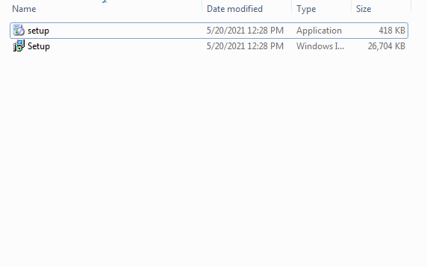

2. Double-click on the downloaded file to install.

3. Click on **Next.**

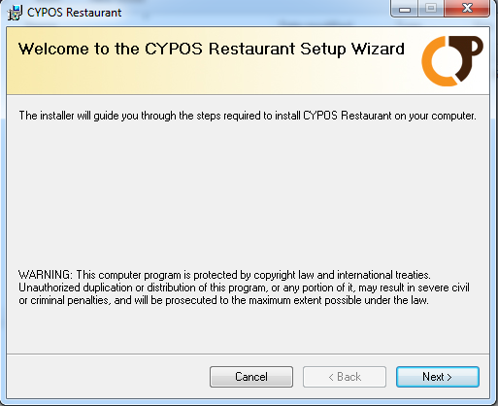

4. The default installation folder is selected, and click on **Next.**

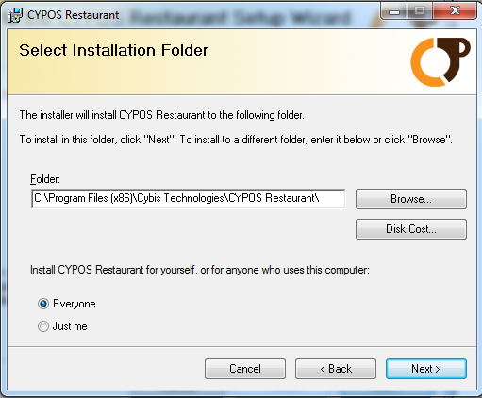

5. Click on **Next** to confirm installation.

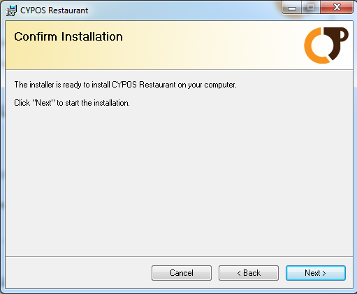

7. Wait till the installation is completed.

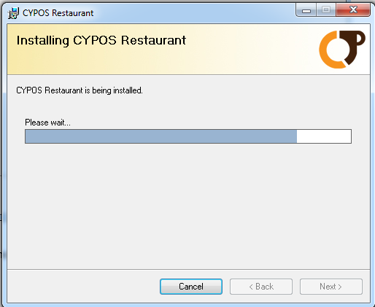

8. Click on **Close** after installation to close the window and run the CYPOS application.

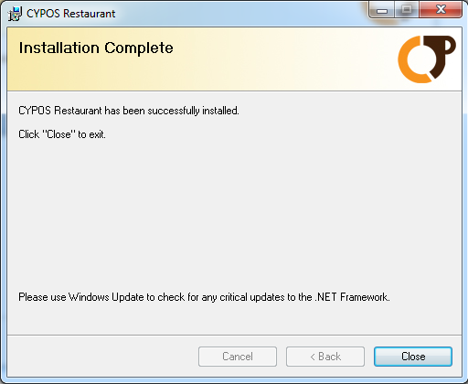

**Before you run the application attach the downloaded database files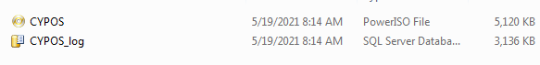 Attach SQL Database Via SQL Server Management Studio**

If you want to attach SQL database MDF file through SQL Server Management studio then you need to connect to an instance of the SQL DB Engines and explore it.

* Firstly open SQL Server Management Studio

**Go to Start button -> All Programs –> MS SQL Server -> SQL Server Management Studio**

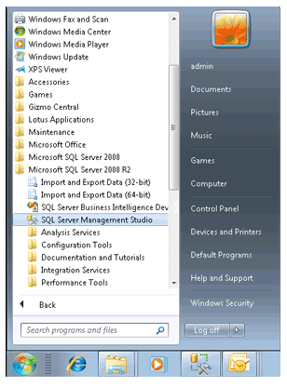

* Please wait for few moments so that it opens and then **Login** in it by entering its credential details

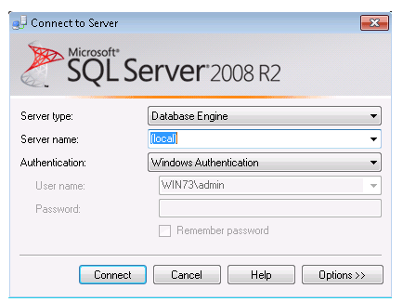

* Then suddenly next window showing the **object explorer items** on left side **(local)(SQL Server 10.50.1600 – WIN 73/Admin)** click on it. After clicking on it its sub elements list opens.

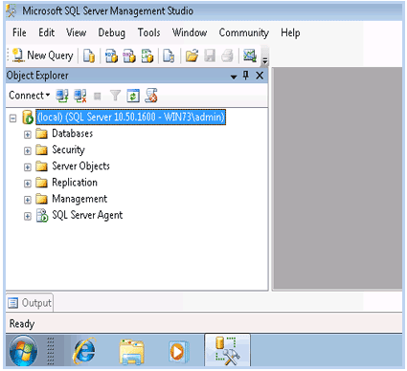

* Select and **Right click** on **Databases** then choose **Attach option**

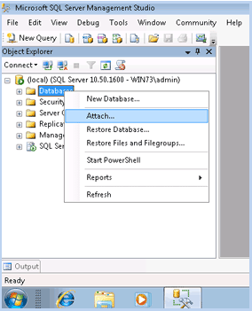

* On clicking Attach option the window appears on the screen call**Attach Database Window** then click on **Add button**

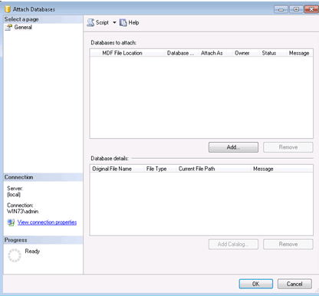

* It displays a list of **SQL Server database Files** select it and click on **Ok Button**

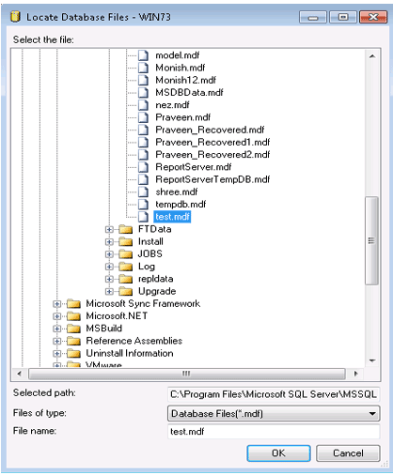

* Now **Confirm** the MDF file and LDF file location and go to **Ok Button**

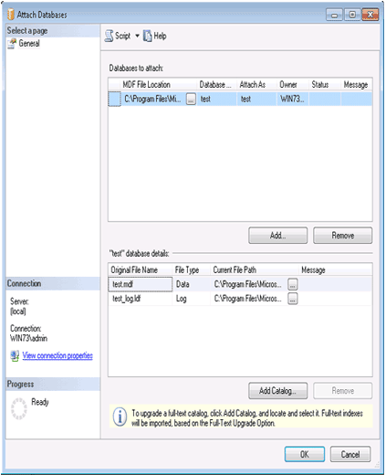

* Now **successfully** you have attached Database Name **Test** to the **SQL Server** through **SQL Server Management Studio**

