Using a process-based simulation to develop transport factors for a risk index tool
Val Snow ª , Rogerio Cichota ^{b} , Linda Lilburne ^{c} , Richard McDowell ^{a, d} , Shirley Vickers ^{c}
(a) Bioeconomy Science Institute – AgResearch, New Zealand
(b) Bioeconomy Science Institute – Plant and Food Research, New Zealand
(c) Bioeconomy Science Institute – Manaaki Whenua, New Zealand; (d) Lincoln University, New Zealand
Presenting author email: val.snow@agresearch.co.nz

Summary
Risk index tools have the potential to assist farmers in making strategic decisions regarding their farm design while managing losses of nutrients to water bodies. Most risk index tools are based on scores and rankings but these methods struggle to take account of interactions between elements of the physical environment. Process-based simulation models are designed to take account of these interactions and may be a viable alternative to score-based methods. Here we describe the development of a database of transport factors using a process-based model that is designed for a risk index tool.

Introduction
Management nutrient losses from farmed landscapes to maintain or improve water quality is challenging because of the complexity of the biophysical relationships within the farm systems. Risk index tools have the potential to assist farmers in making strategic decisions regarding their farm design. They can also assist policy makers, regulators and catchment groups in their activities.

Methodology and Results
Describe the methodology applied and present the key findings and results of the research. Highlight the relevance of the work described for advancing the state-of-the-art of environmental modelling and software development.
Most risk index tools are based on scores and rankings. While individual elements of the scoring-based methods are conceptually easy to explain, there are substantial challenges in explaining the effects, or lack of nuance, of some combinations of scores. For example, a given fertiliser application amount in an environment with a low potential for plant growth (and therefore uptake of that fertiliser) does not pose the same risk in low- or moderate-rainfall areas as in high-rainfall areas. Scoring based methods struggle to cope with these nuances. In contrast, process-based simulation models are intrinsically designed to take account of these interactions and advances in the availability of weather and soil information for running such models can make them a viable alternative to score-based methods
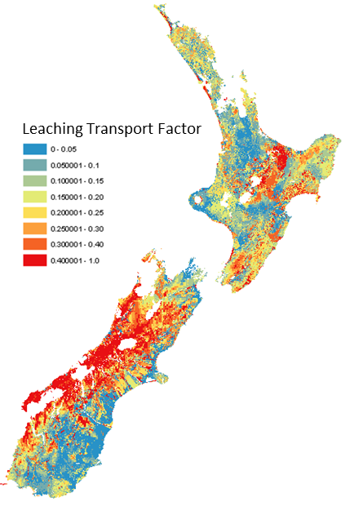
Figure 1. Leaching transport factors for January under rainfed conditions.
We used the APSIM model (Holzworth et al., 2018, revision 7317) with a pasture land cover and a spike of nitrogen fertiliser to quantify transport factors. Through each month across 41 years of weather data, 450 kg N /ha of urea fertiliser was applied in separate simulations in both rainfed and irrigated conditions. The simulations were repeated across all valid combinations of weather (Cichota et al., 2008; Tait et al., 2006) and soil properties (Lilburne et al., 2012; Vogeler et al., 2022) in the farmed areas of New Zealand. A leaching transport factor was calculated by dividing the amount of leaching after two years by the input (450 kg N ha) and taking the median across the 41 years. For runoff transport factors the value was the amount of accumulated runoff in the 30 days after the middle of the month divided by 200 mm. Again, this was calculated for each month and then the median was taken. See (Snow et al., 2024) and (McDowell et al., 2024) for additional information.
Some outputs from this database are shown in Figure 1. There is no formal quantitative validation that is possible for transport factors, so a combination of sense-checking was used with a small panel of experts examining more detailed versions of Figure 1 against changes in weather and soil conditions. Additionally, the transport factors were applied to a selection of experiments with measured, albeit short-term, losses of nitrogen (McDowell et al., 2024).
While suggesting that these transport factors are acceptable for a first version of the risk index tool, we acknowledge that several improvements should be considered for future versions. These include: an improved treatment of runoff transport factors that are more analogous to the leaching transport method; addressing concerns that the method here may not fully address the risks posed by vegetable production (which has plants with shallow root systems, substantial durations with bare soil, and high fertiliser inputs); and considering if a median value of a transport factors across many years is appropriate when farming activities change every year. It is anticipated that these issues will be addressed in future versions of the database.

Conclusions
We used a process-based model to calculate transport factors by month for rainfed and irrigated conditions across the farmed areas of New Zealand. These factors slot into a Risk Index Tool intended to support implementation of New Zealand’s freshwater policy. The method provides nuances in the transport factors that are not feasible when using more traditional scoring-based techniques.

Acknowledgements
We gratefully acknowledge funding from the Our Land and Water National Science Challenge and the APSIM Initiative (www.apsim.info) which takes responsibility for APSIM’s software.

References
Cichota, R., Snow, V. O., & Tait, A. B. (2008). A functional evaluation of the Virtual Climate Station rainfall data. New Zealand J. of Agricultural Research, 51, 317–329. https://doi.org/10.1080/00288230809510463
Holzworth, D., Huth, N. I., et al. (2018). APSIM Next Generation: Overcoming challenges in modernising a farming systems model. Env. Model. & Soft., 103, 43-51. https://doi.org/10.1016/j.envsoft.2018.02.002
Lilburne, L. R., Hewitt, A. E., & Webb, T. W. (2012). Soil and informatics science combine to develop S-map. Geoderma, 170, 232-238. https://doi.org/10.1016/j.geoderma.2011.11.012
McDowell, R.W., Snow, V.O., Tamepo, R., Lilburne, L., et al. 2025. A risk index tool to minimize the risk of nitrogen loss from land to water. J Environ Qual. 54(1), 233–245. https://doi.org/10.1002/jeq2.20660.
Snow, V., Cichota, R., Lilburne, L., McDowell, R., Vickers, S., 2024. A method to derive nitrogen transport factors for NZ's agricultural lands. MethodsX. 13, 102814. https://doi.org/10.1016/j.mex.2024.102814.
Tait, A., Henderson, R., Turner, R., & Zheng, Z. (2006). Thin plate smoothing interpolation of daily rainfall for New Zealand using a climatological rainfall surface. International Journal of Climatology, 26, 2097–2115.
Vogeler, I., Lilburne, L., Webb, T., Cichota, R., Sharp, J., Carrick, S., Brown, H., & Snow, V. (2022). S-map parameters for APSIM. MethodsX, 9, 101632. https://doi.org/10.1016/j.mex.2022.101632

