Learning-Augmented Process-Based Models for Adaptive Irrigation under Climate Variability
Raymond Houé Ngouna ª , Philippe Berton ^{b}, Fabien Dauriac ^{c}
(a) Université de Technologie de Tarbes Occitanie Pyrénées, Laboratoire Génie de Production, 47 Avenue d’Azereix 65000 Tarbes, France
(b) Rives et Eaux du Sud-Ouest, BP 449 Chemin de Lalette, 65000 Tarbes, France
Presenting author email: raymond.houe-ngouna@uttop.fr

Summary
This study presents a learning-augmented, process-based modelling framework for adaptive irrigation management under climate variability. A physically based soil water balance model provides a consistent representation of soil–plant–atmosphere interactions, while learning components are introduced to improve irrigation decision making. Three irrigation management scenarios are compared, ranging from conventional rule-based control to learning-based and hybrid configurations. Simulation experiments under identical climatic forcing show that learning-based strategies enhance adaptivity and water-use efficiency relative to static rules, while highlighting the need for physically informed constraints. The results demonstrate the potential of learning-augmented process models as environmental decision support tools for irrigation management.

Introduction
Despite significant advances in hydrological and agro-environmental modelling, the translation of these tools into operational irrigation decision making remains limited. Farmers and water managers require actionable, context-specific guidance, whereas many existing irrigation tools rely on static rules or offline analyses that struggle to adapt to climate variability and evolving field conditions. Process-based soil water balance models provide a physically grounded representation of soil–plant–atmosphere interactions and are widely used in environmental modelling and decision support contexts because of their interpretability and consistency with biophysical principles (Allen et al., 1998; Jones et al., 2003). However, in practice, such models are most often coupled with heuristic or fixed irrigation strategies, which restrict their ability to support adaptive decisions under nonstationary climatic conditions.
In parallel, learning-based approaches have emerged as promising alternatives for irrigation scheduling by exploiting sensor data and historical observations (Liakos et al., 2018). When used in isolation, however, purely data-driven methods may lack robustness and physical consistency when extrapolated beyond observed conditions. Recent work therefore emphasizes hybrid approaches that integrate learning mechanisms within process-based models, aiming to combine physical realism with adaptive capabilities (Reichstein et al., 2019; Willard et al., 2022). In this context, the present study investigates a learning-augmented, process-based modelling framework for adaptive irrigation under climate variability, with the objectives of comparing rule-based and learning-based strategies and assessing how different levels of learning integration influence soil water dynamics and irrigation outcomes.

Methodology and Results
The modelling framework is based on a process-based soil water balance model that simulates the temporal evolution of soil water storage $S_{t}$ as a function of precipitation, evapotranspiration demand, irrigation inputs, and drainage. Soil water storage is evaluated relative to agronomic thresholds, namely field capacity $S_{fc}$ and wilting point $S_{wp}$, which provide physically meaningful indicators of irrigation adequacy and water stress.
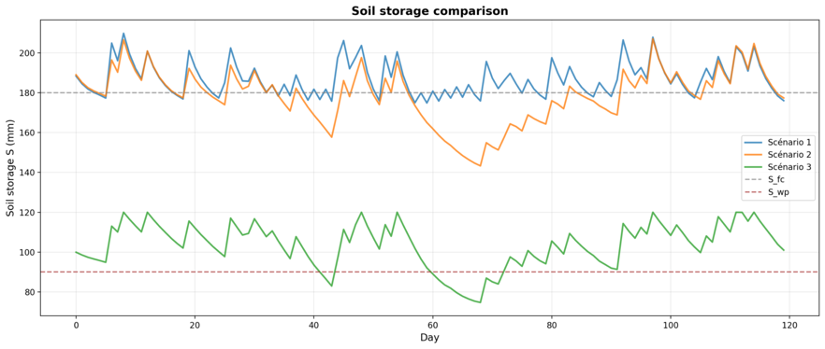
Three irrigation management scenarios are examined under identical climatic forcing and initial conditions. Scenario 1 represents a conventional approach in which the process-based model is coupled with a rule-based irrigation strategy. Scenario 2 replaces heuristic rules with a learning-based controller that adapts irrigation decisions using available observations and simulated system states. Scenario 3 further augments the process-based model by integrating learning components that influence the system response, leading to modified soil water dynamics.
Figure 1 compares the resulting soil water storage trajectories over a representative irrigation season. The rule-based strategy maintains soil water storage close to field capacity, resulting in stable but conservative irrigation behaviour. The learning-based controller exhibits greater adaptivity, allowing soil water storage to vary more dynamically in response to climatic conditions while generally remaining above the wilting point threshold. In contrast, the learning-augmented configuration operates in a lower soil water regime, frequently approaching the wilting point, reflecting more aggressive water-saving decisions.
Figure 1. Comparison of soil water storage dynamics under three irrigation management scenarios. Dashed lines indicate field capacity (S_fc) and wilting point (S_wp).
Overall, the comparison highlights that learning-based strategies can enhance adaptivity relative to static rule-based control, but also that increased learning integration may amplify sensitivity to agronomic constraints. From an environmental modelling and software perspective, these results illustrate how learning augmentation modifies process-driven system behaviour and underline the importance of embedding learning mechanisms within physically meaningful models when developing adaptive irrigation decision support tools.

Conclusions
This work explored learning-augmented, process-based models for adaptive irrigation management under climate variability. The comparative analysis shows that learning-based irrigation strategies can improve adaptivity relative to conventional rule-based control, leading to more responsive soil water dynamics. At the same time, stronger learning augmentation may induce more aggressive water-saving behaviour, increasing sensitivity to agronomic thresholds. These findings highlight the importance of embedding learning mechanisms within physically meaningful process models and constraints. From an environmental modelling and software perspective, the proposed framework illustrates how hybrid approaches can extend traditional irrigation decision support tools while preserving interpretability and environmental relevance.

References
Allen, R. G., Pereira, L. S., Raes, D., & Smith, M. (1998). Crop evapotranspiration-Guidelines for computing crop water requirements. FAO Irrigation and drainage paper 56. Fao, Rome, 300(9), D05109.
Jones, J. W., Hoogenboom, G., Porter, C. H., Boote, K. J., Batchelor, W. D., Hunt, L. A., Wilkens, P. W., Singh, U., Gijsman, A. J., & Ritchie, J. T. (2003). The DSSAT cropping system model. European Journal of Agronomy, 18(3–4), 235–265.
Liakos, K. G., Busato, P., Moshou, D., Pearson, S., & Bochtis, D. (2018). Machine learning in agriculture: A review. Sensors, 18(8), 2674. https://doi.org/10.3390/s18082674.
Reichstein, M., Camps-Valls, G., Stevens, B., Jung, M., Denzler, J., Carvalhais, N., & Prabhat. (2019). Deep learning and process understanding for data-driven Earth system science. Nature, 566, 195–204. https://doi.org/10.1038/s41586-019-0912-1.
Willard, J., Jia, X., Xu, S., Steinbach, M., & Kumar, V. (2022). Integrating physics-based modeling with machine learning: A survey. ACM Computing Surveys, 55(3), Article 51. https://doi.org/10.1145/3514228.

